Google Cloud Machine Learning Engineer

# Big Data and ML Fundamentals

## Heading 2

### Heading 3

#### Heading 4

# How Google Does ML

Readings

[What it Means to be AI First](https://d3c33hcgiwev3.cloudfront.net/y_xUkGKXRpu8VJBil1abiA_cecd078455c64cd8a6d7210aae2f2baf_READINGS---What-is-it-means-to-be-AI-first.pdf?Expires=1630972800&Signature=lgC3jySOHDHJJ2suEb8vOpN0UCodgJh3T7n6ggocj5zfwMgHxfwqH60-y7aPX5WYaLvFO9f2td2WfaxWTgQ7~y3RY9oC87J4l8bfHaC3AM~aMNEXBbPLVpsAYDGuR5D0VmrEAJG-Su-7qGX17FQB5JcW1793Qej~dJSaZnzd7KQ_&Key-Pair-Id=APKAJLTNE6QMUY6HBC5A)

# Launch into ML

# Introduction to Tensorflow

# Feature Engineering

## Week1 Raw Data to Features

## Preprocessing and feature creation

## Feature Crosses

## TensorFlow Transform

# Art and Science of ML

## The Art of ML

Objectives:

* Generalize your model
* Tune batch size and learning rate
* Optimize your model
* Apply the concept sin TensorFlow code

### Introduction

Overfitting when loss function on test data starts to point upwards.

Use early stopping

Or use regularization

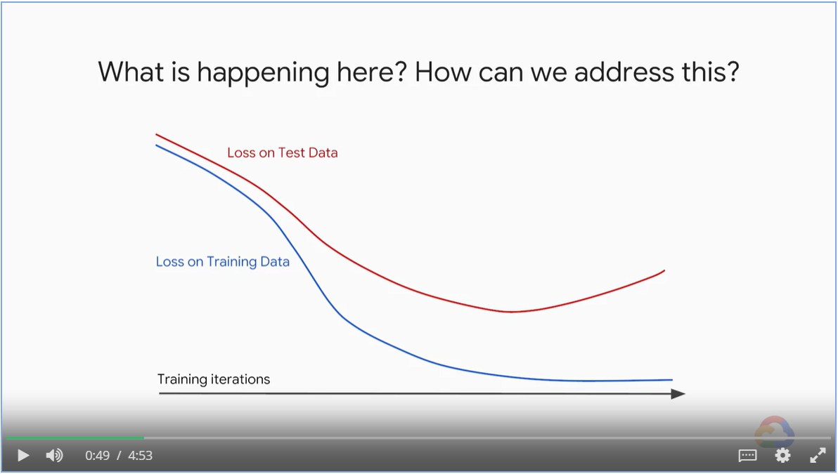

The blue region in the bottom left corner is an symptom of over complex model capturing noise.

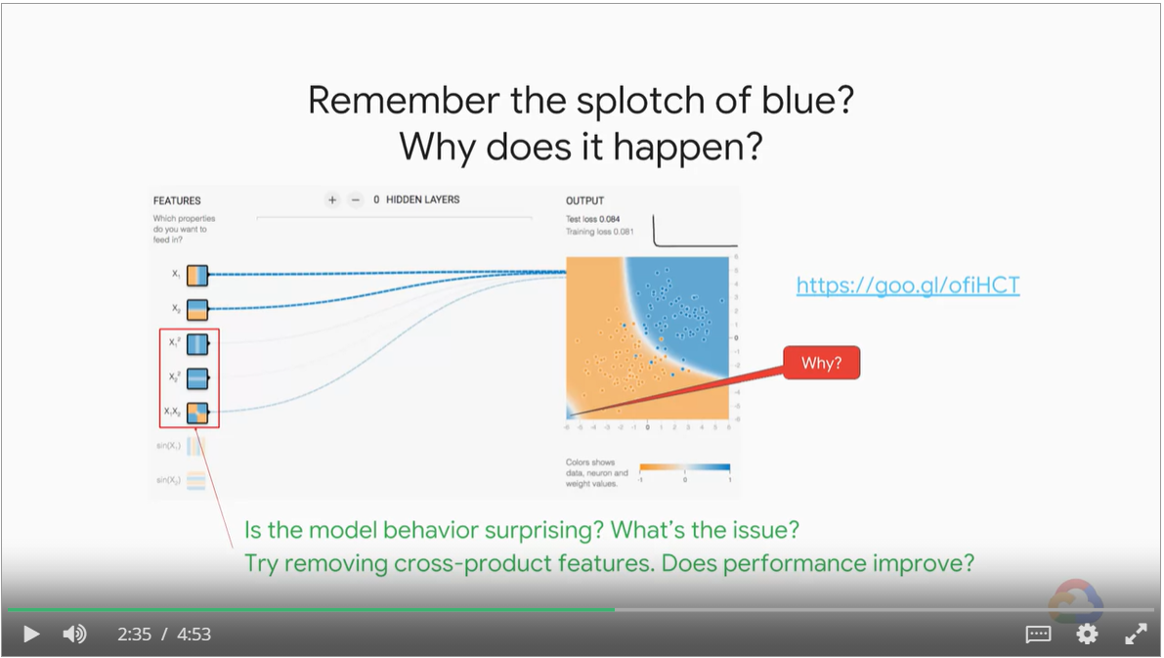

### Regularization

Penalize complex model

Balance model accuracy with complexity.

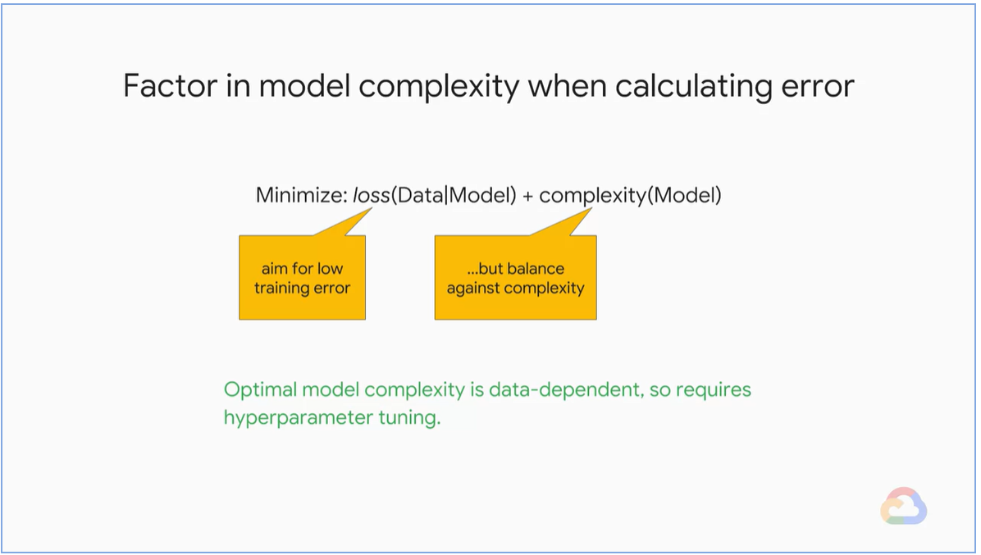

Techniques in Model Generalization:

* Early Stopping
* Parameter Norm Penalties
  + L1 Regularization
  + L2 Regularization
  + Max-norm regularization
* Dataset Augmentation
* Noise Robustness
* Sparse Representation

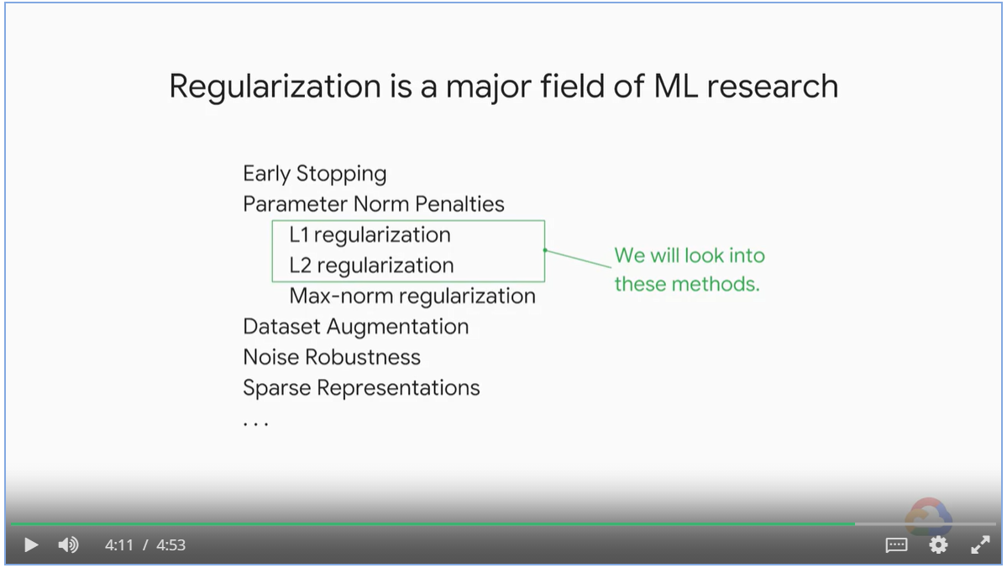

### L1 & L2 Regularization

How do we measure model complexity?

* In L1 and L2 regularization, model complexity is represented as the magnitude of the weight vector
* In Linear Algebra, the magnitude of the vector is represented by the norm function

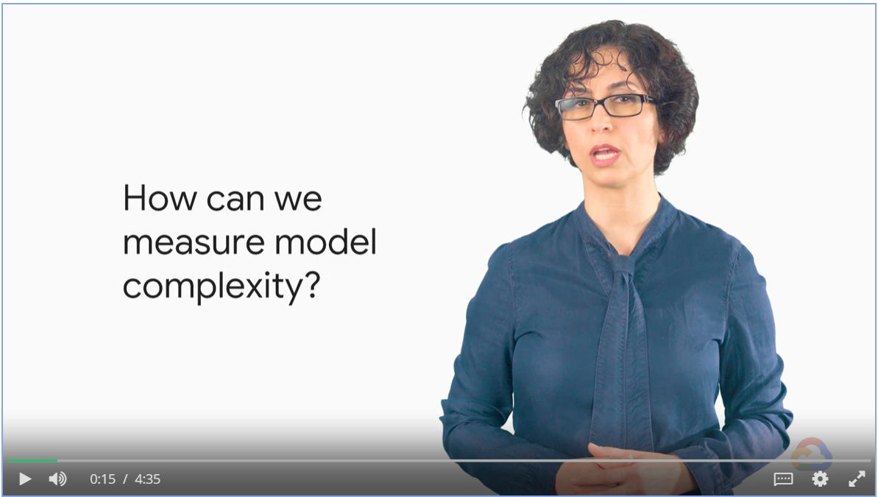

#### L2 vs L1 Norm

L2 Norm is the Euclidean distance. As the weights are squared, we denote the normal as w2

L1 Norm is the sum of the absolute values

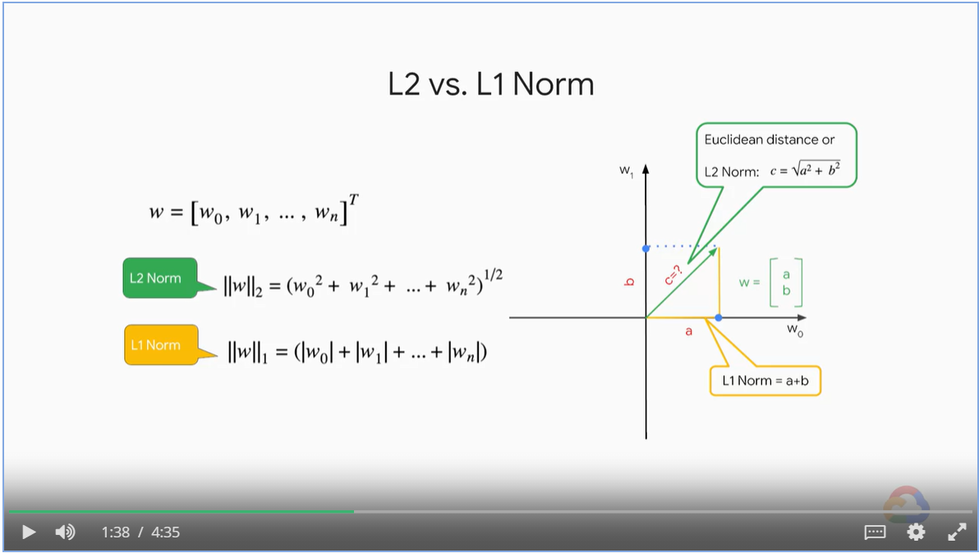

* Reducing model complexity means keep the norm under certain threshold
* When visualized
* L2 norm confines the weights around a circle with smooth edge

**-->** All weights become smaller

* L1 norm confines the weights in a square (with extreme zero values)

**-->** Unimportant weights as zero, feature selection.

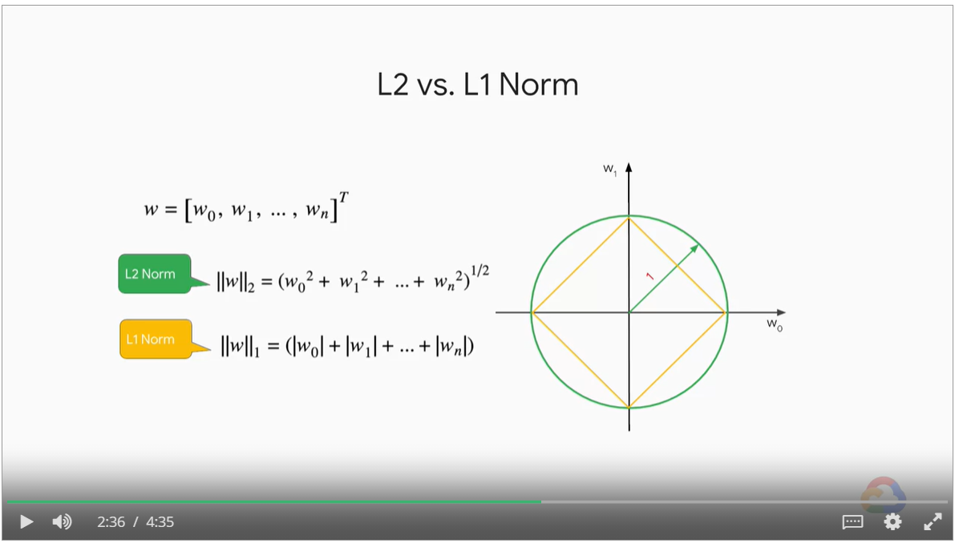

In practice, we use square of L2 Norm, multiplied by λ

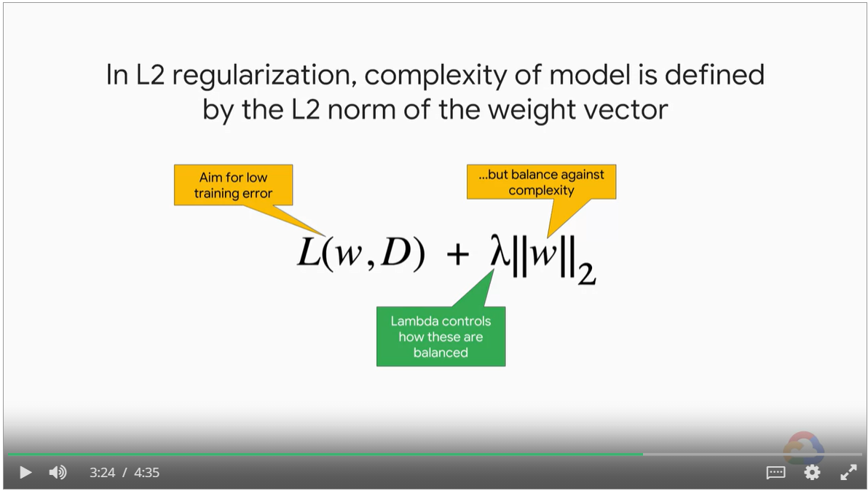

### Lab: Regularization

#### Without regularization

* All weights participate in model complexity
* Model is complex, is remembers noises
* Test loss won’t converge

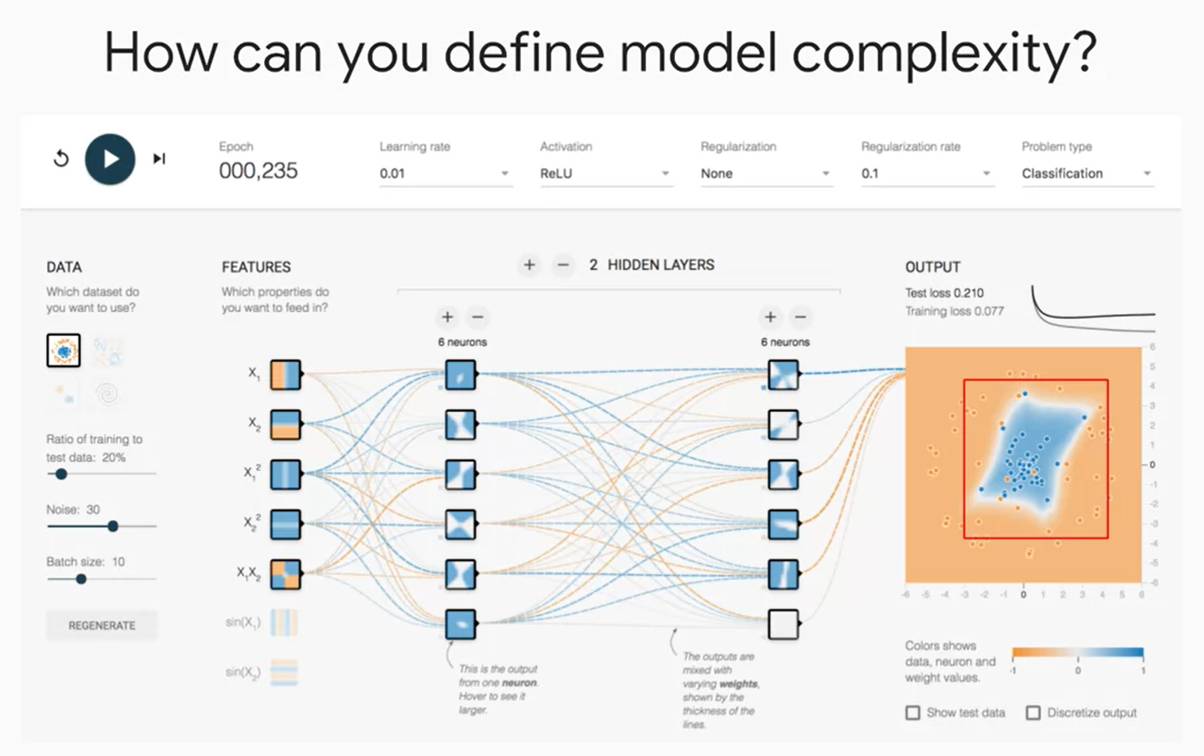

#### With L1 regularization

* Only two features participate in the model
* Noise is ignored
* Test loss converge together with training loss.

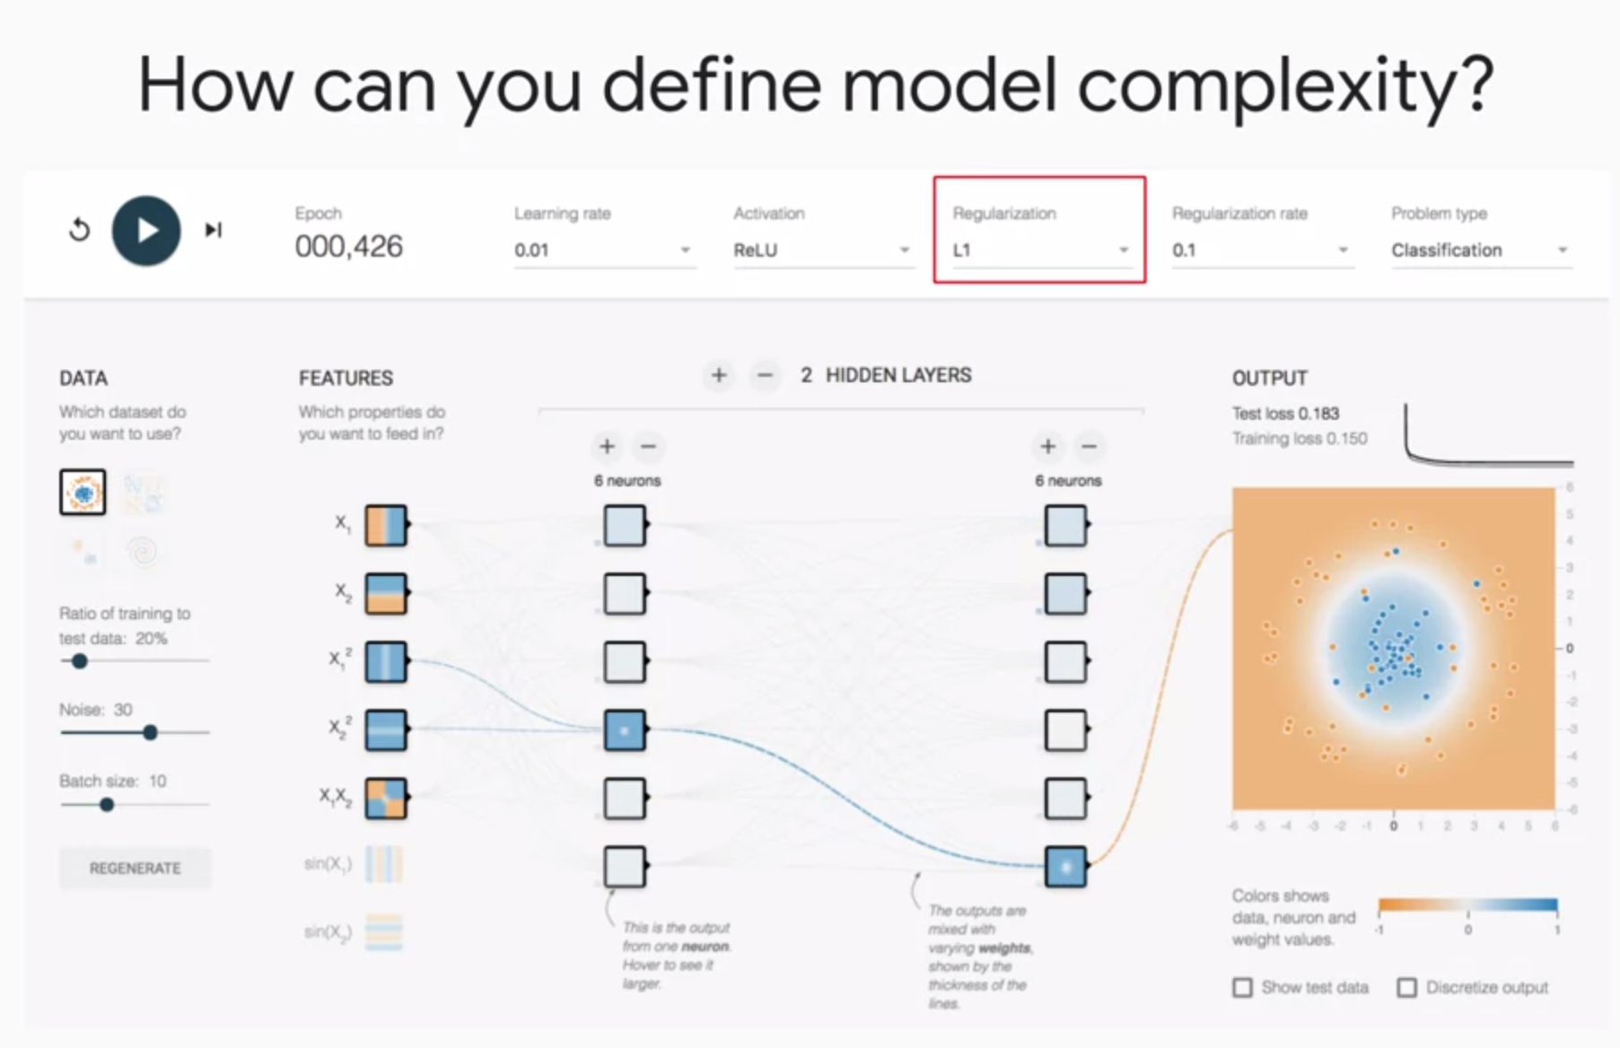

#### With L2 Regularization

* All features have weights as output (even though it is hard to see in the picture)
* Noises are not included
* Test and training loss converge together

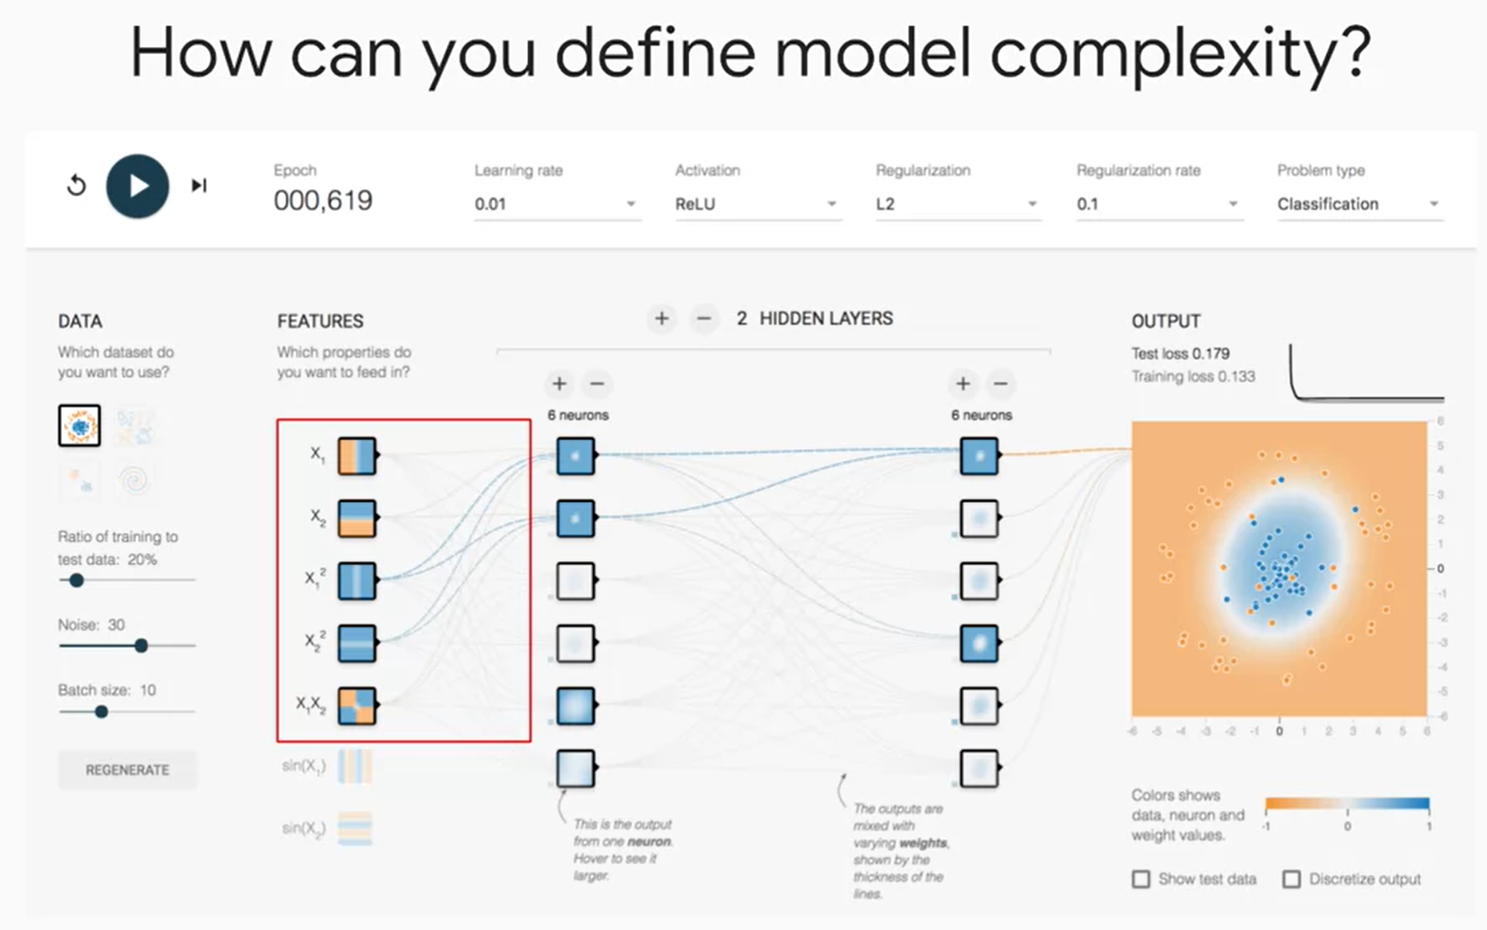

#### Adjusting regularization rate

* Regularization rate at 0.1 have the model converge nicely
* Regularization rate of 1 is too much. Model cannot learn anything.

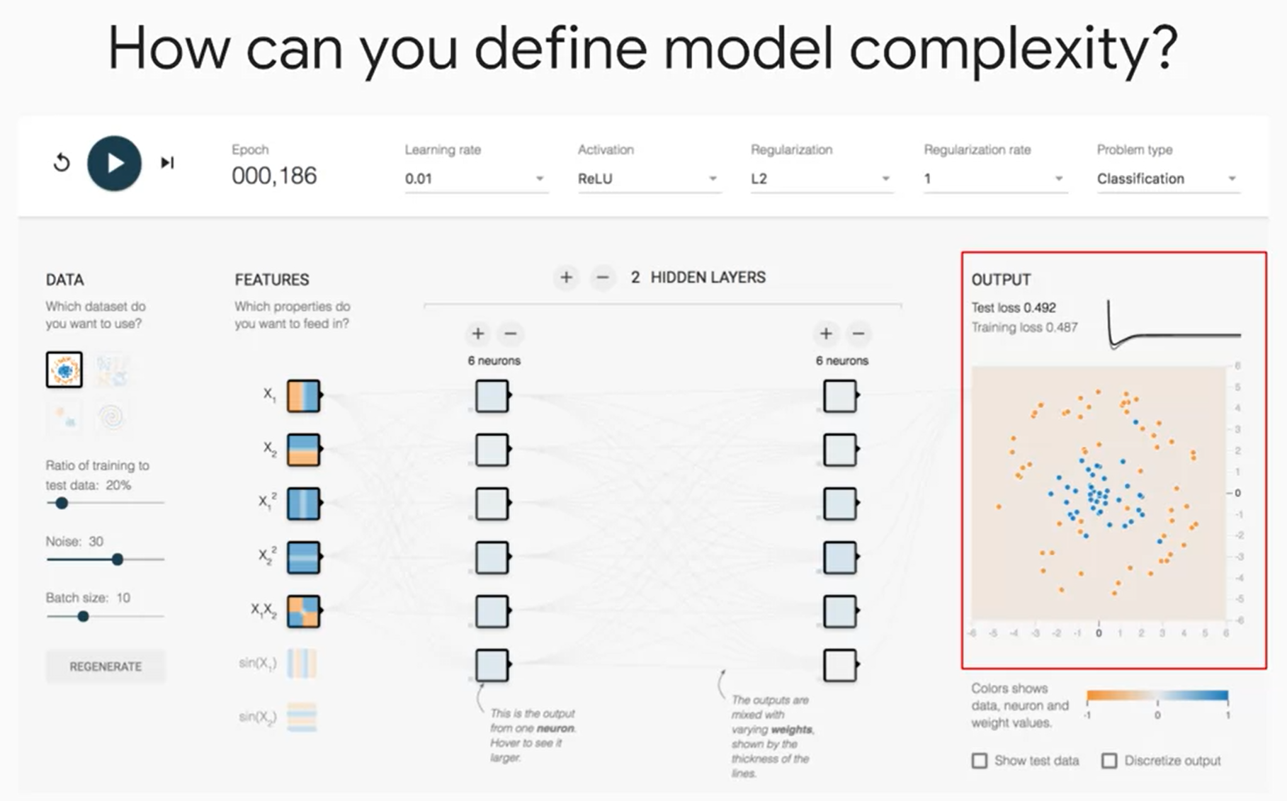

### Learning Rate and Batch Size

* Learning rate controls the size of the steps in weight space.
* Too small learning rate will take a long time to train
* Too big will cause the model to bounce around

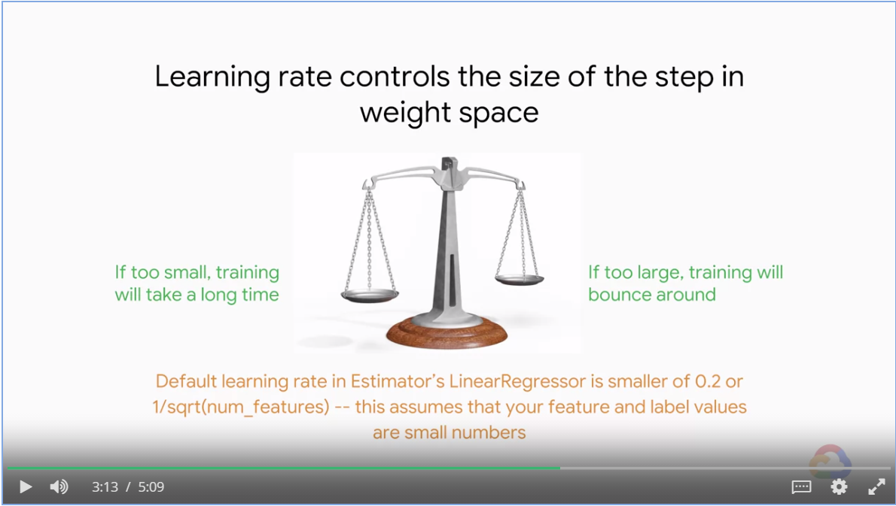

* Batch size controls the number of samples that gradient is calculated on
* 40-100 tends to be a good range of batch size and it can go as high as 500

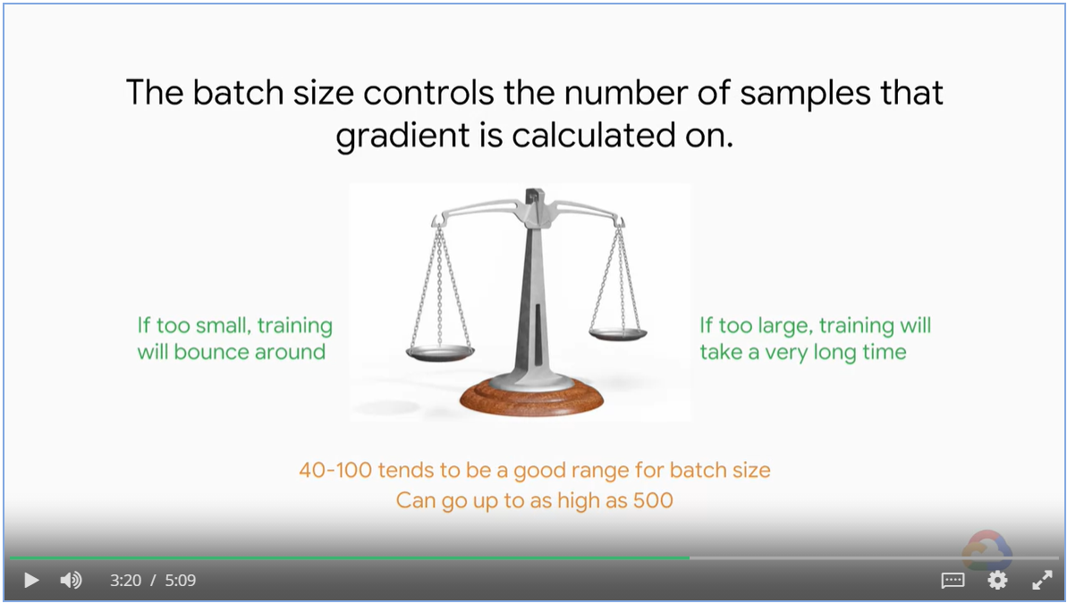

Shuffle your training data so that the training set is a good representation of the real world data.

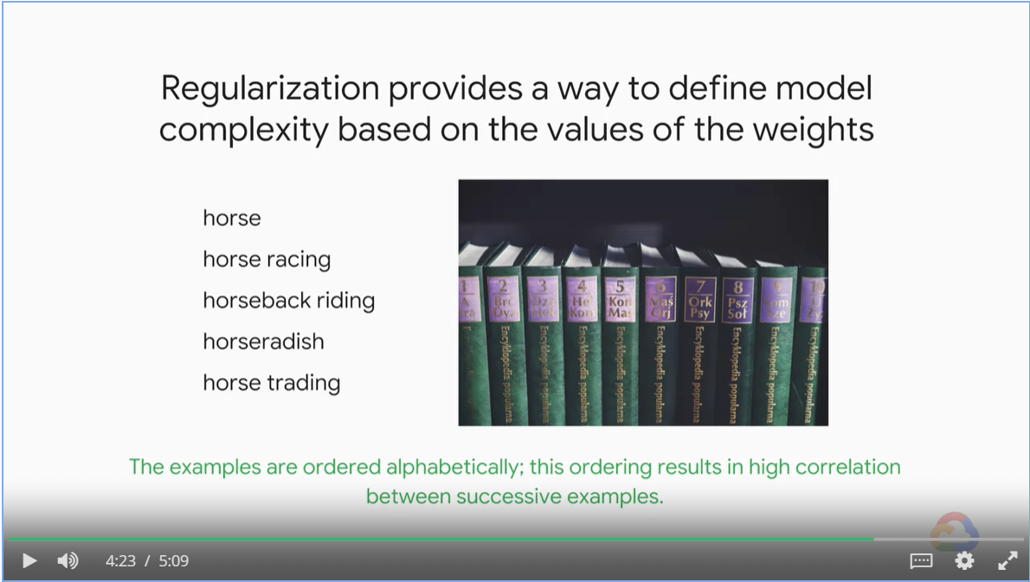

## Hyperparameter Tuning

Objectives

* Difference between parameters and hyperparameters
* Think beyond simple grid search algorithms

### Parameters vs Hyperparameters

* ML models are mathematical functions with parameters and hyper-parameters
* Parameters are weights and bias that change during model training
* Hyper-parameters are set before training

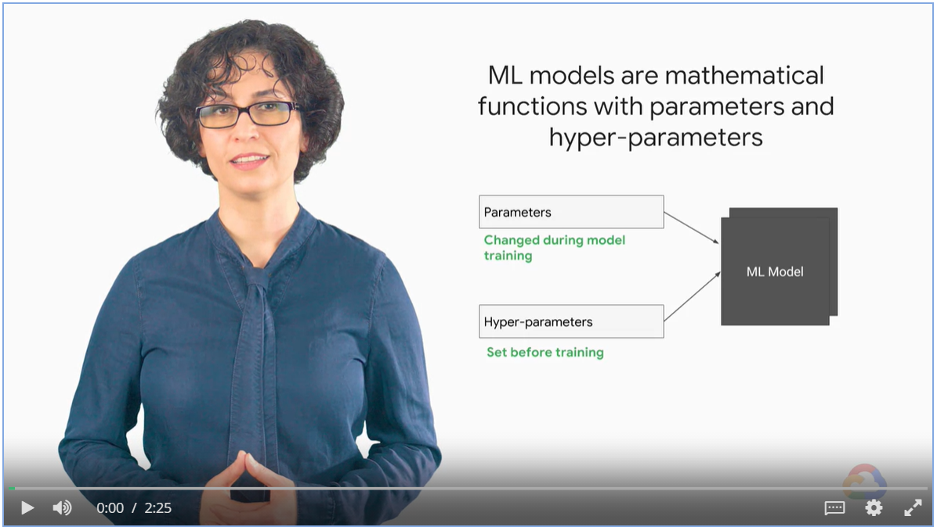

### Illustration of learning rate and batch size

Epoch * batch_size = 70% of dataset

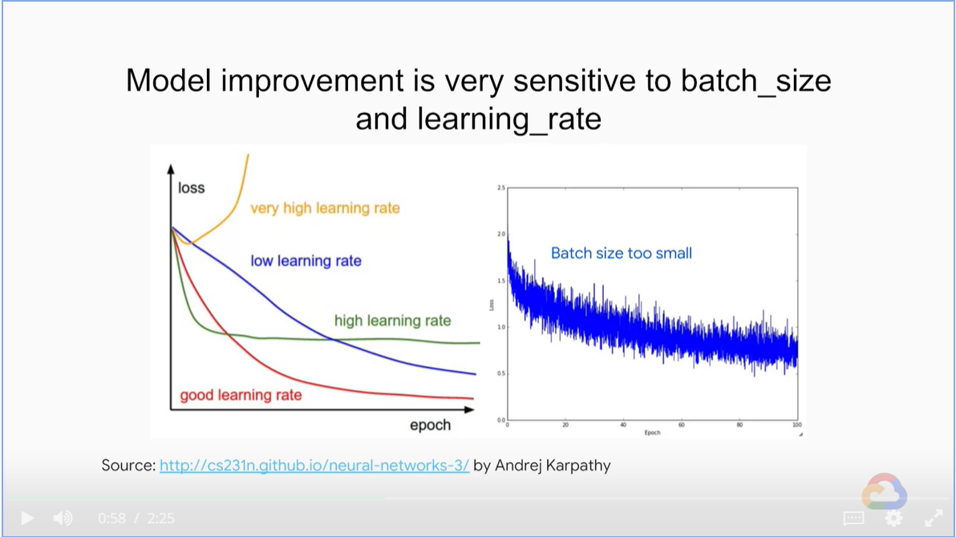

### Think Beyond Grid Search

* Cloud ML Engine helps you tune the parameter

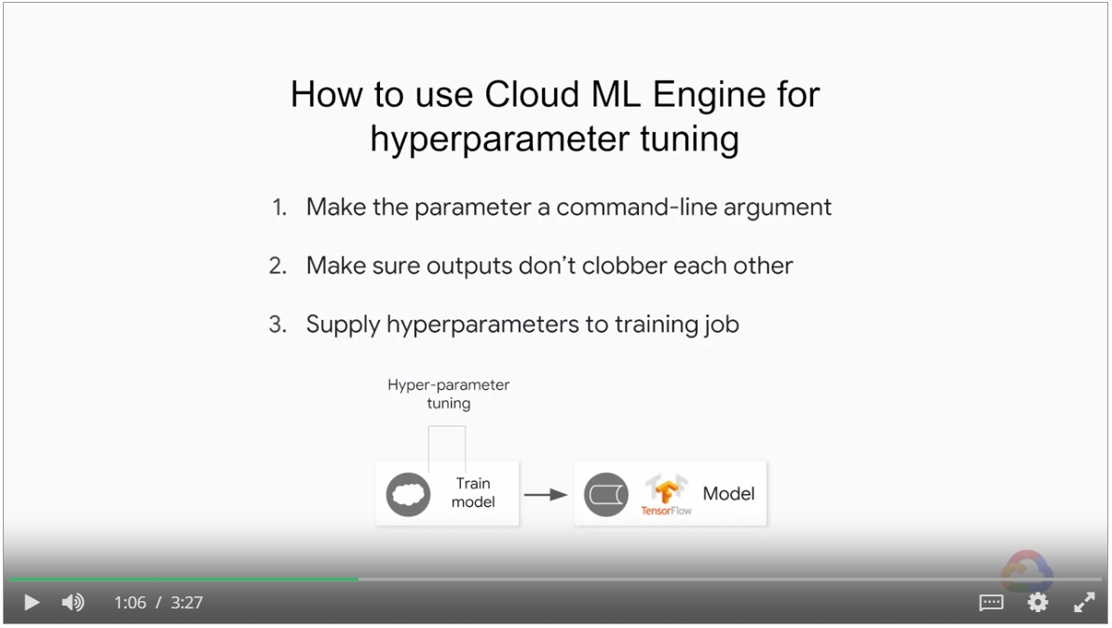

1. Make the hyperparameters as command-line arguments

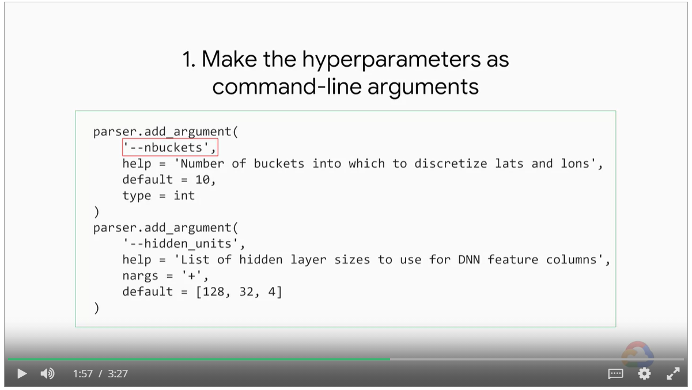

Use smart naming conventions so that the output files don’t clobber each other

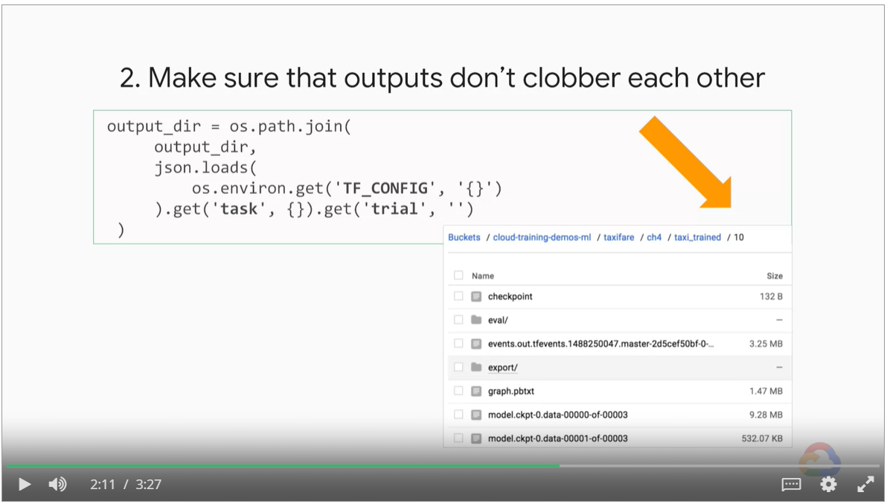

Supply hyperparameters to training jobs in YAML files.

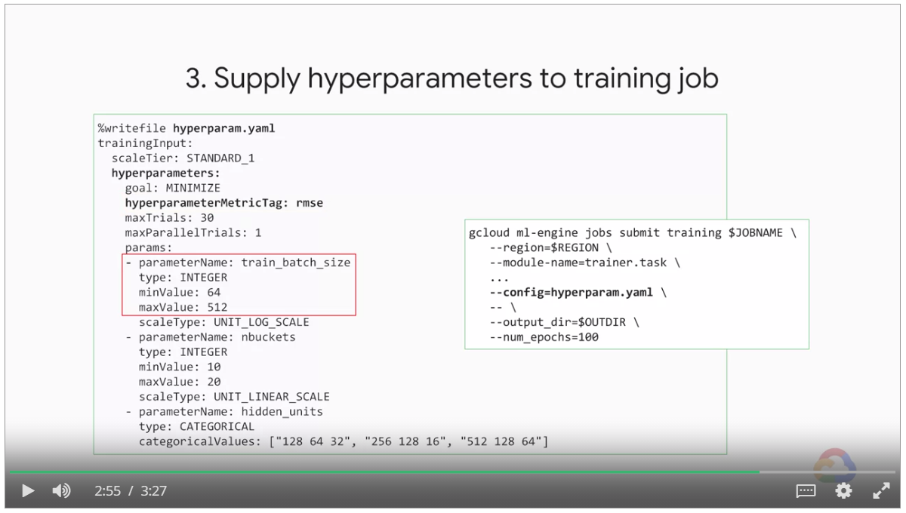

## A Pinch of Science

### Regularization for sparsity

* Feature crosses lead to lots of input nodes, many of them have zero weights.
* How to remove zero weight features?

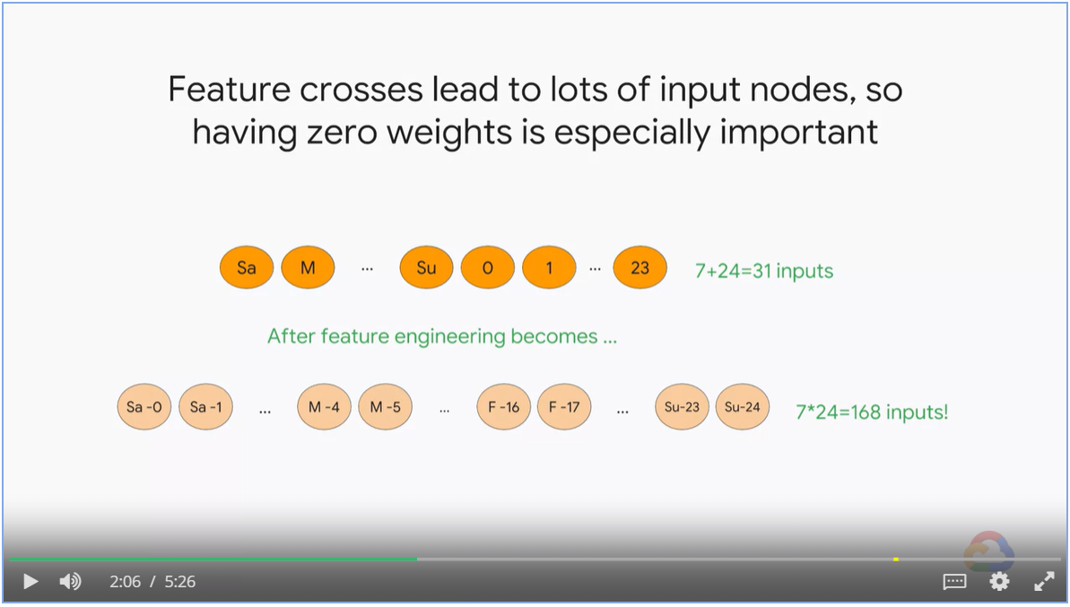

#### L0 Norm

* We could simply count the number of features with zero weights and discard them
* This is called L0-norm and it is an NP-hard, non-convex optimization problem

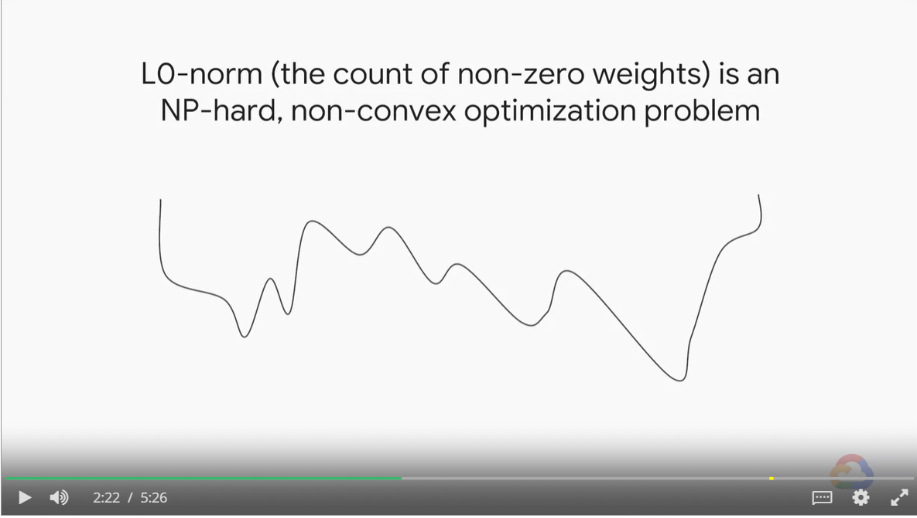

#### Weight distribution of L1 and L2 Norm

* L2 have much of the weights centered around zero, with small values
* L1 have much of the weights be exact zero.

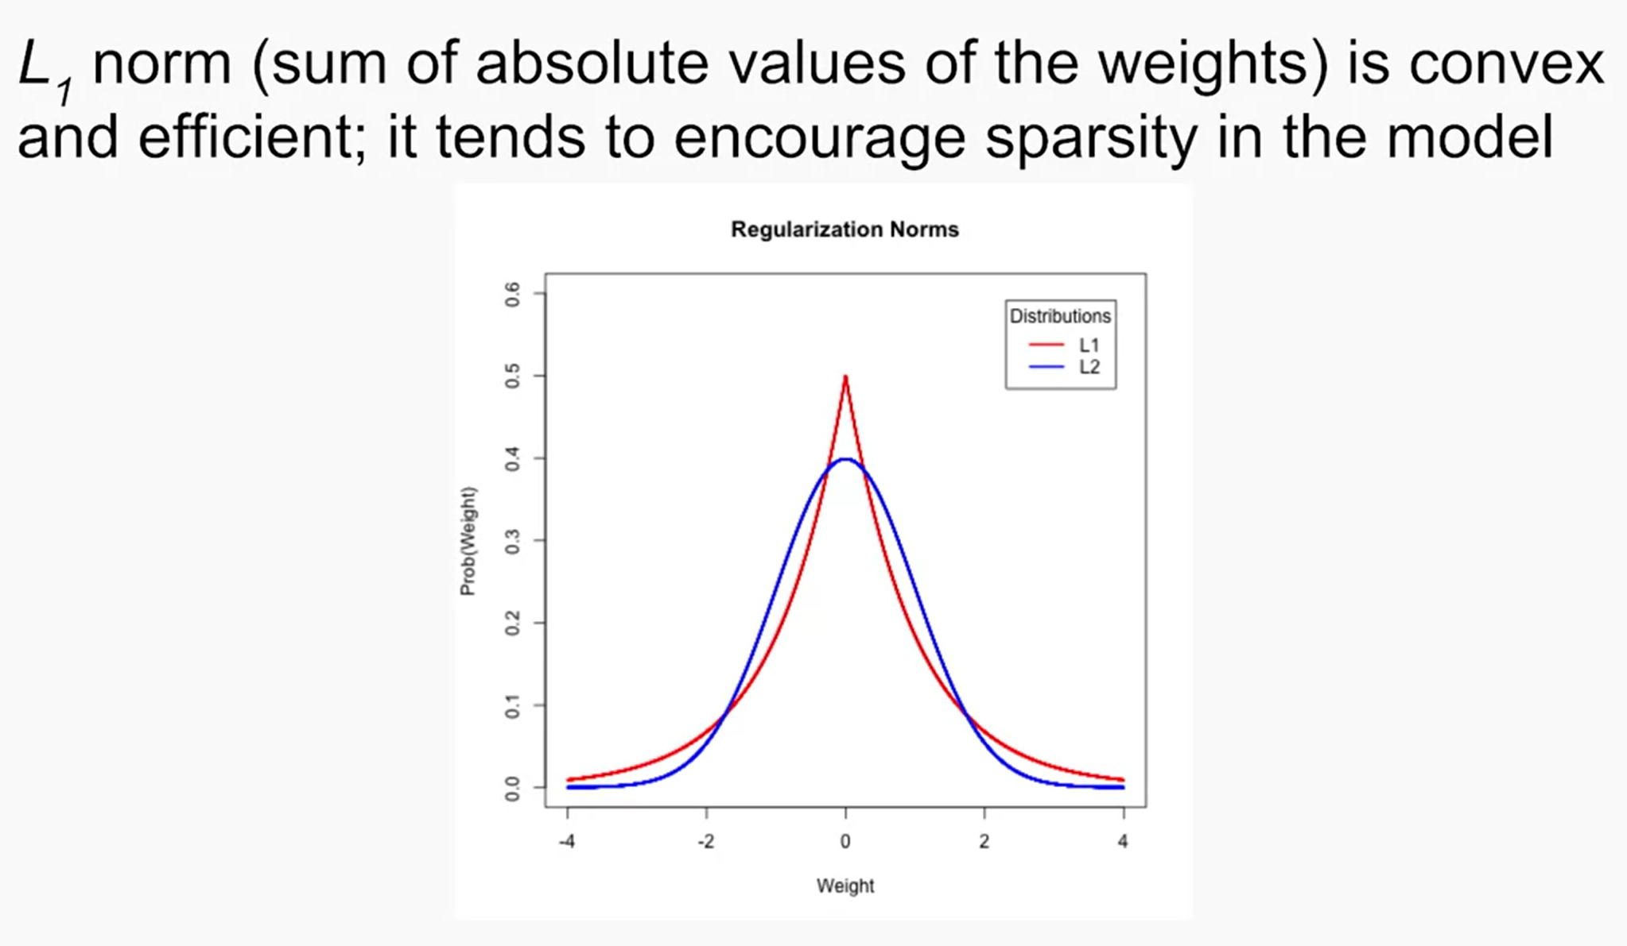

#### ElasticNet

* ElasticNet is combination of both L1 and L2 regularization
* We get the good effects of both L1 and L2

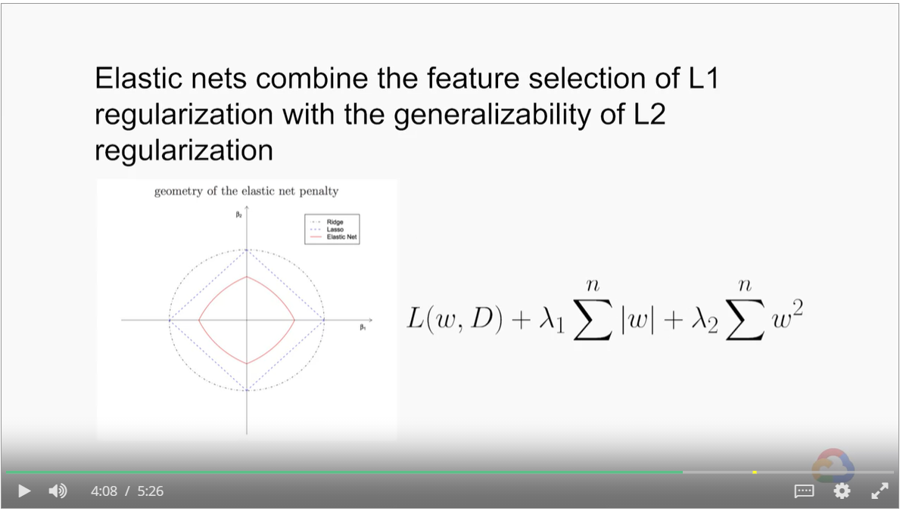

### Logistic Regression

* Predict coin flip results for all coins, fair, bent, large, small and etc
* Features: angel of bent, size, mass, coin toss velocity and angle

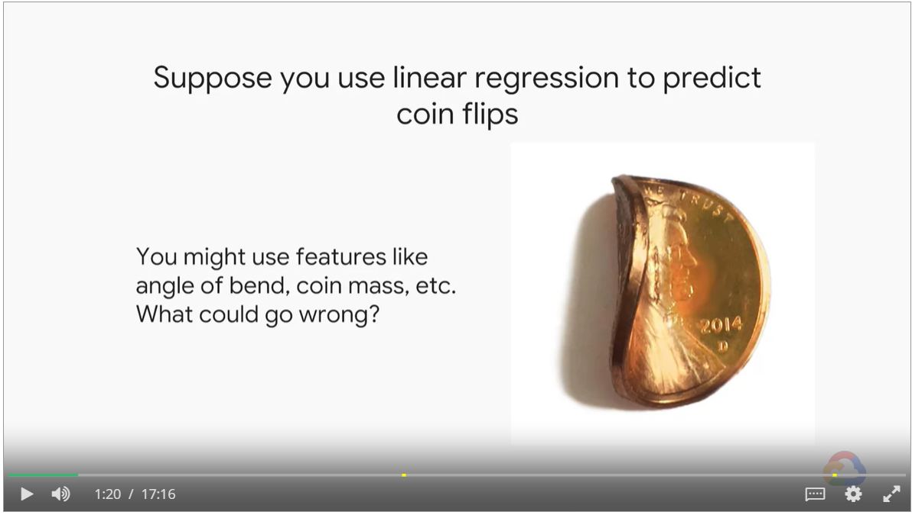

#### First Attempt: Linear Regression

* Label will be 0 and 1
* With linear regression and rmse as loss function, our prediction can be outside the range of 0 and 1.
* A model that minimizes squared error is under no constraint to treat as a probability in 0 to 1.

#### Improvement: Logistic Regression

* With sigmoid function, we take the weighted sum (a linear model) as input, squashes it smoothly between zero and one
* The weighted some is called the logit
* In training, gradient descent will constantly drive the loss function to close to zero, weights will become infinitely large. With output close to one, weights / logits become positive infinite.
* Without regularization, weights will become positive infinites or negative infinites

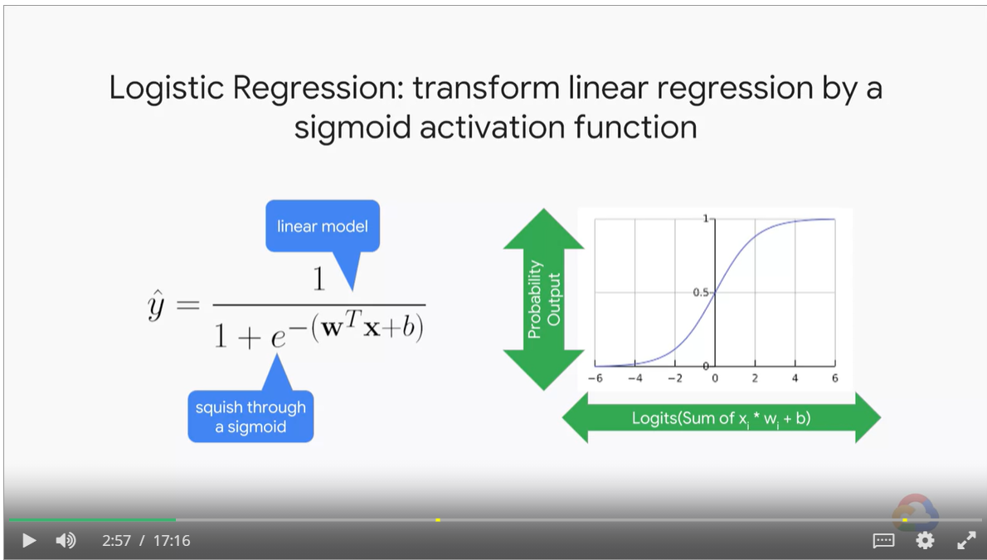

#### Logistics Regression as Probability Estimate

* Mathematically, the outputs of a sigmoid can be considered probabilities
* Embedding vectors, which is internally informative. But the output values cannot be considered as probability.
* Lots of output activation functions, could give you a number between zero and one. But **only sigmoid** is proven to be a calibrated estimate of the training dataset **probability of occurrence**.
* **Turn** binary classification problem into probabilistic problem

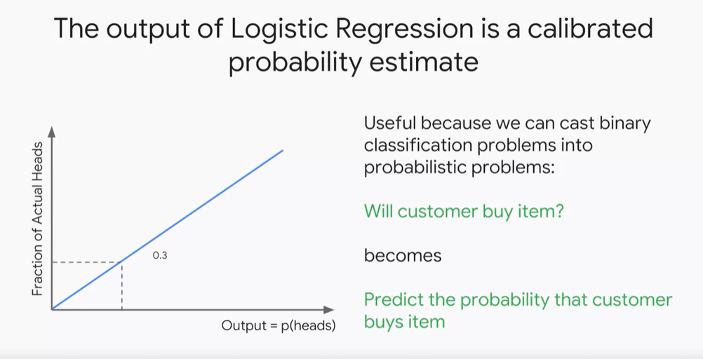

#### Cross-entropy as loss function

* Cross-entropy grows exponentially when the predict is close to the opposite to the prediction

Cross-entropy diminishes to zero when the prediction is right

* Cross-entropy is a good loss function to reward correct predictions and penalize incorrect ones.

However, it causes problem in gradient descent.

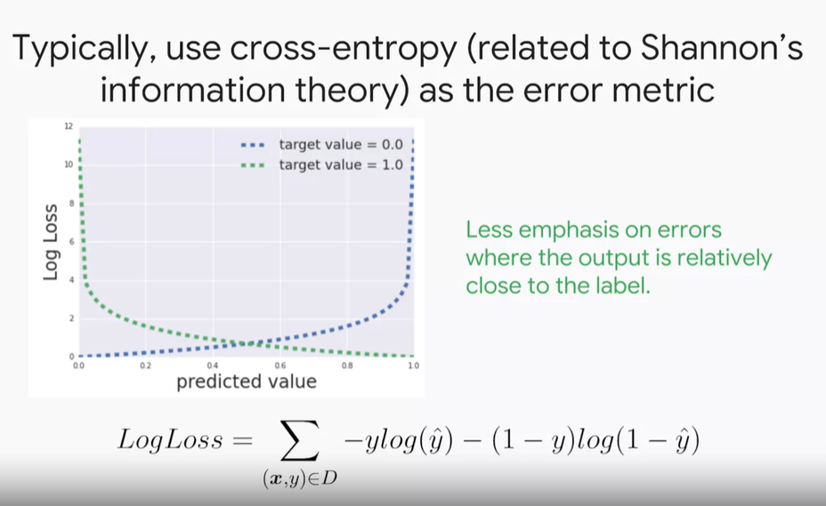

#### Regularization in Logistics Regression

* Helps stop weights being driven to positive and negative infinity.
* Helps logits stay away from asymptotes which can halt training.

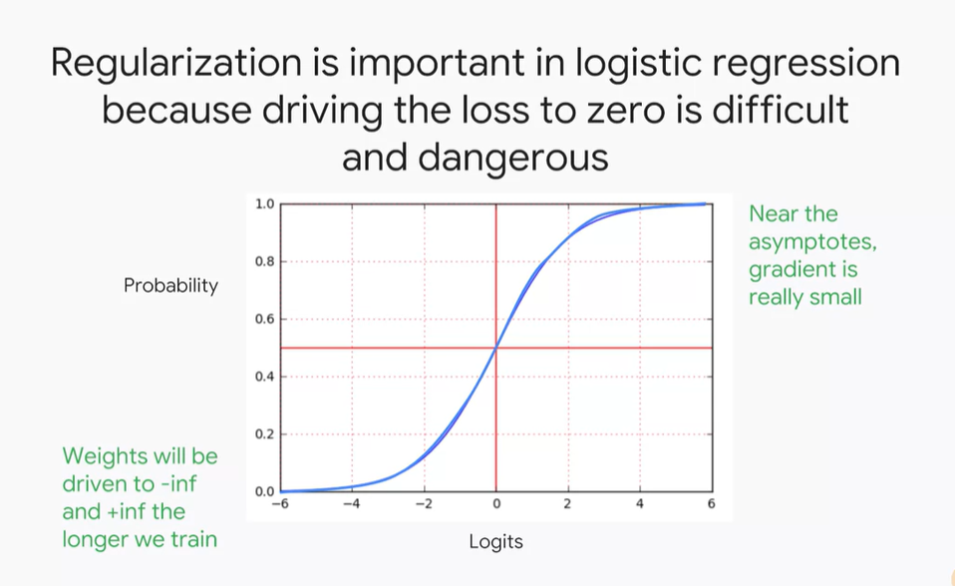

#### Regularization and Early stopping

* We use both regularization and early stopping to prevent model from overfitting

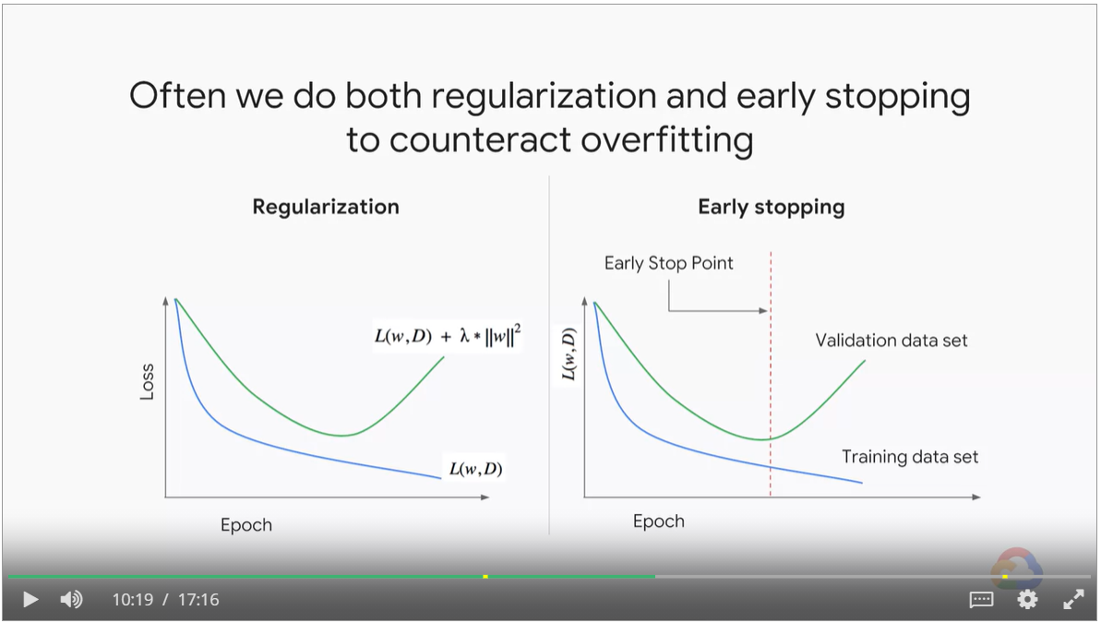

#### ROC Curve

* Use ROC curve to choose the decision threshold based on decision criteria.

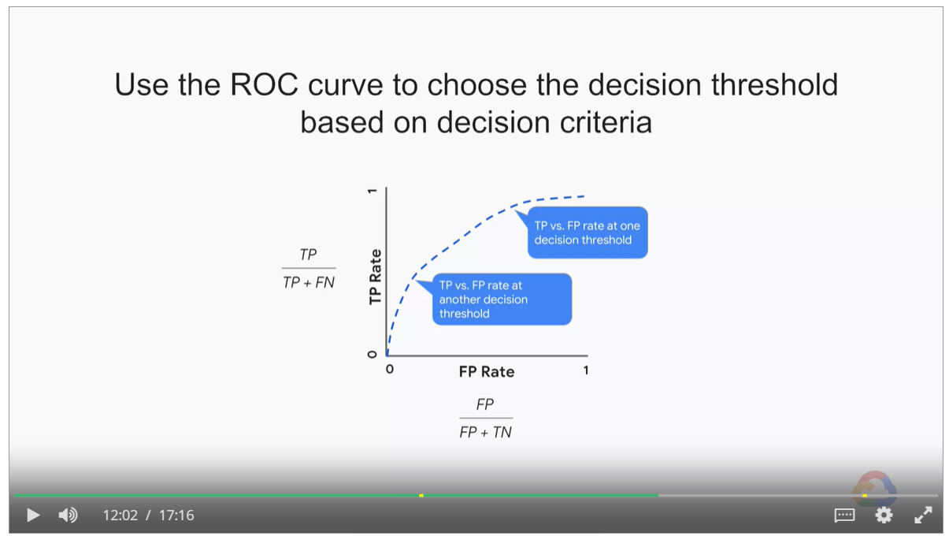

#### AUC

* Area under the curve provides an aggregate measure of performance across all possible classification thresholds.

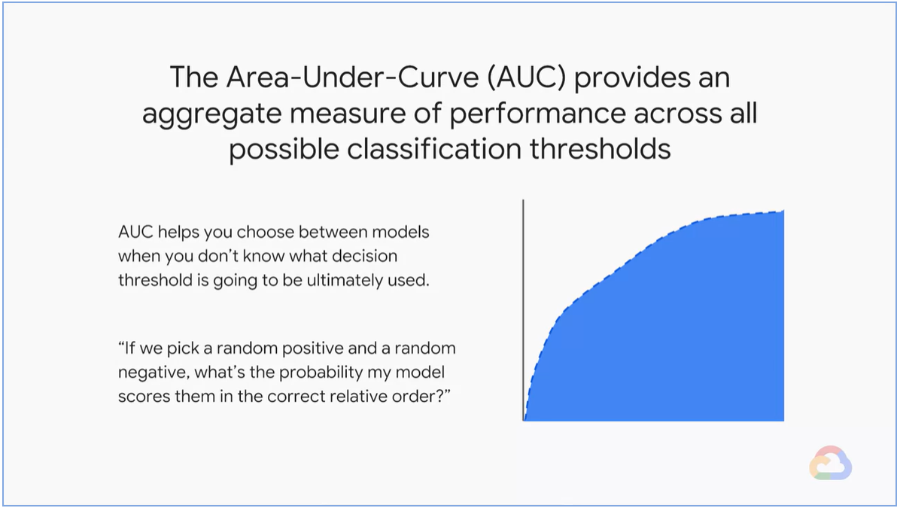

## The Science of Neural Networks

### Overview of Neural Networks

* Feature cross helps to increase model accuracy.
* In this case, we cross x1 and x2 and get x3. X3 = X1 * X2

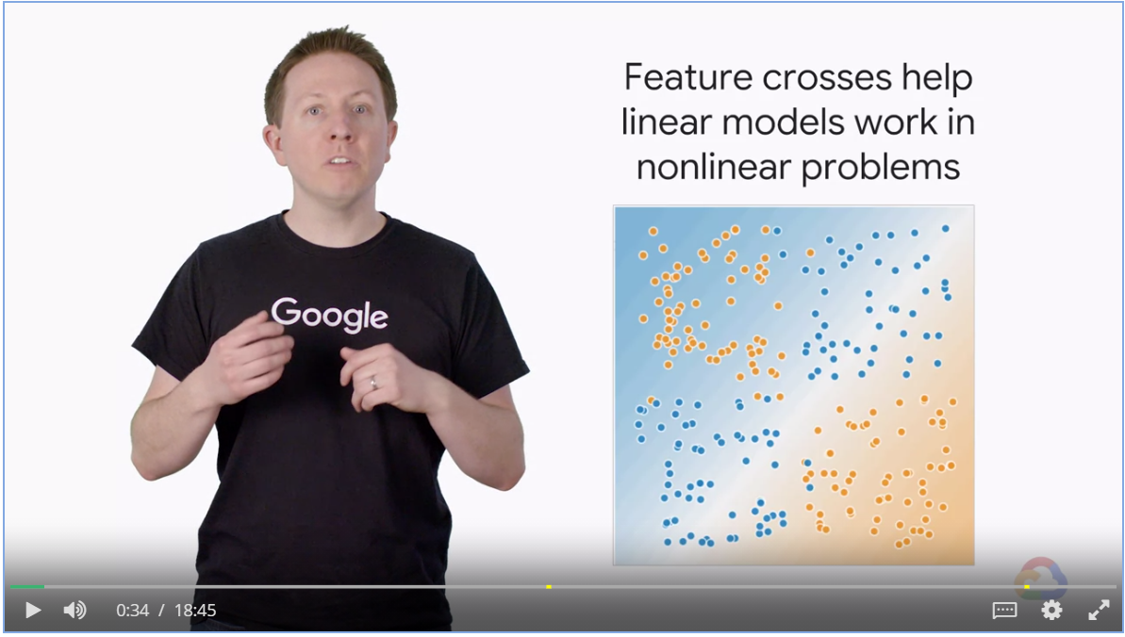

#### When feature crossing stops working

* There is a limit to feature engineering

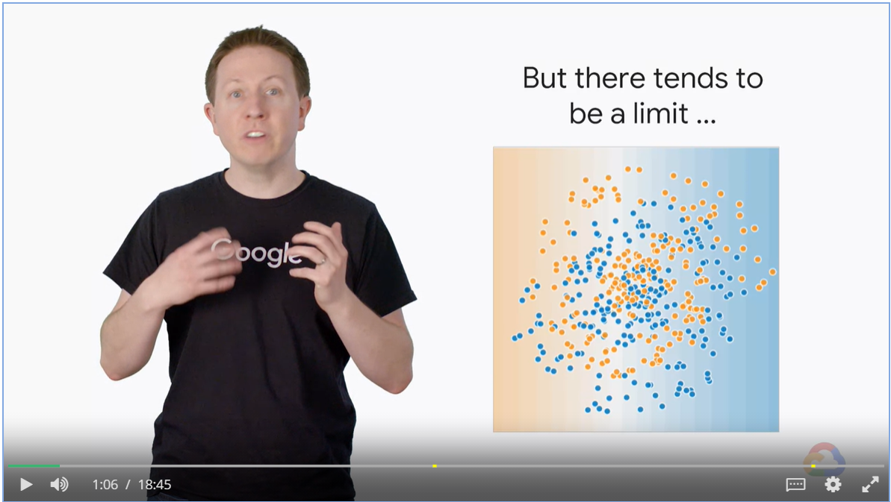

#### Combine features in Neural Networks

* Neural networks can algorithmically create very complex feature crossing in transformations.
* These feature crossings are captured in multiple layers and their weights.
* NN is not necessary a better alternative to feature crossing, but it is a flexible alternative that works well.

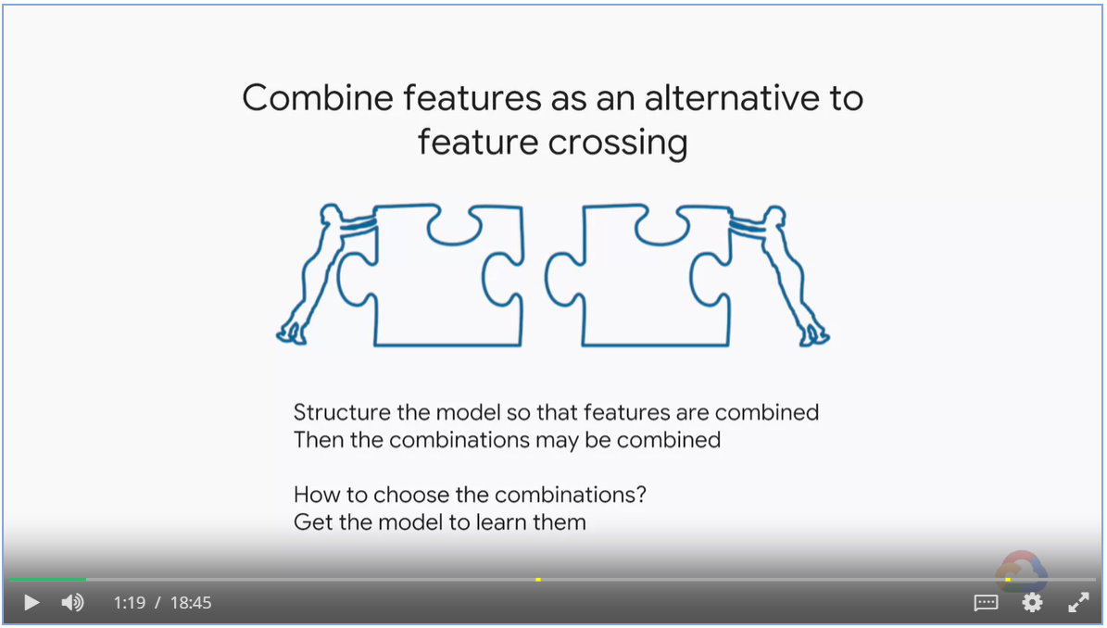

#### Linearity

* Adding a hidden layer, the model is still linear

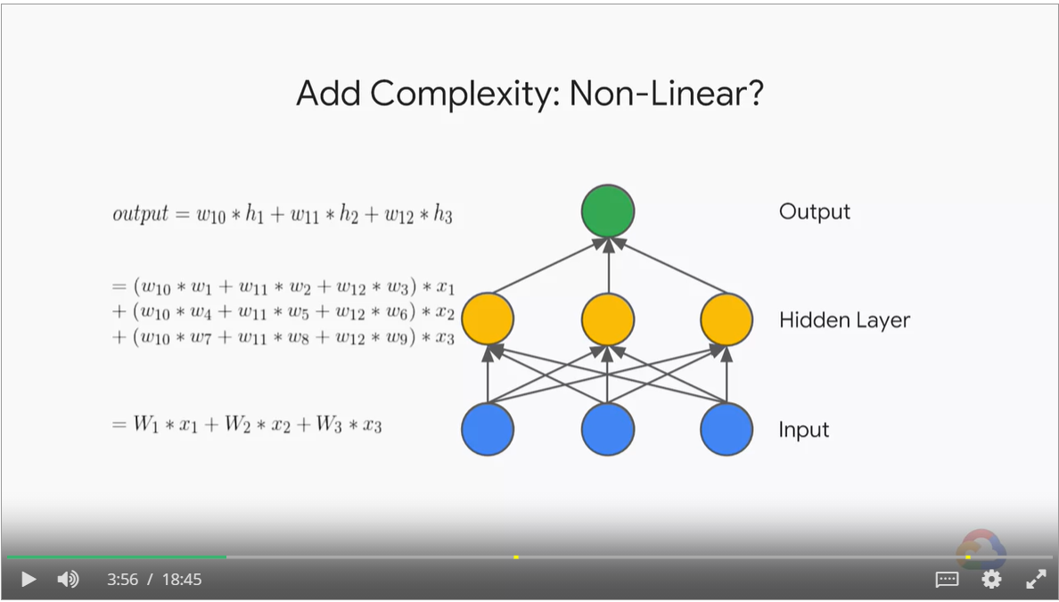

#### Non-Linear activation function

* Adding a non-linear transformation layer, a.k.a. activation function will make the model none-linear

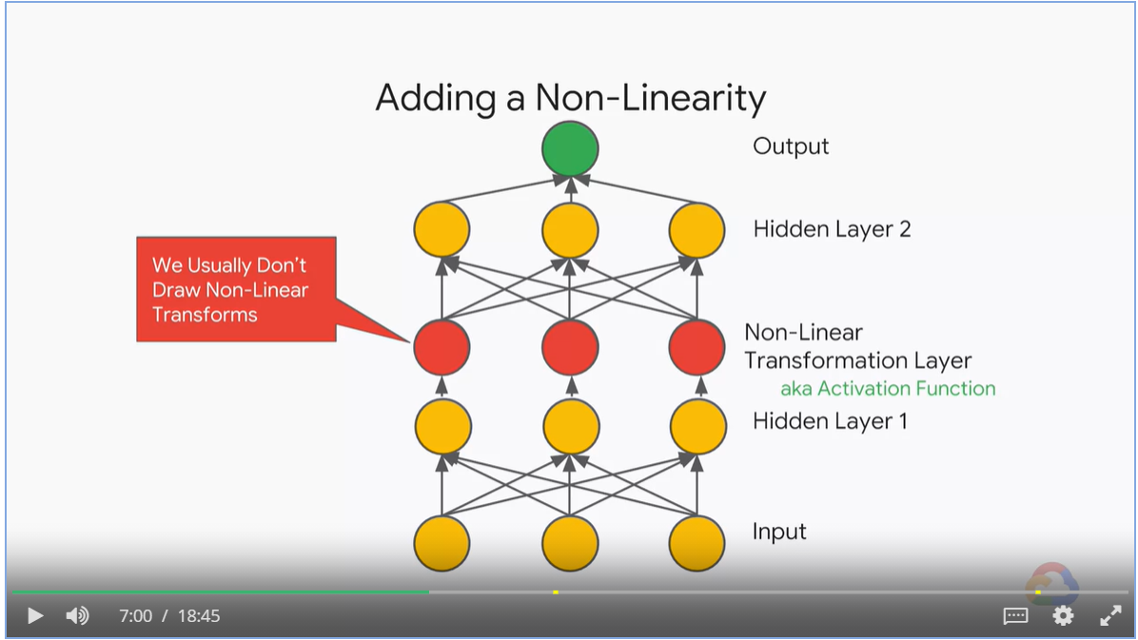

#### Variants of ReLU

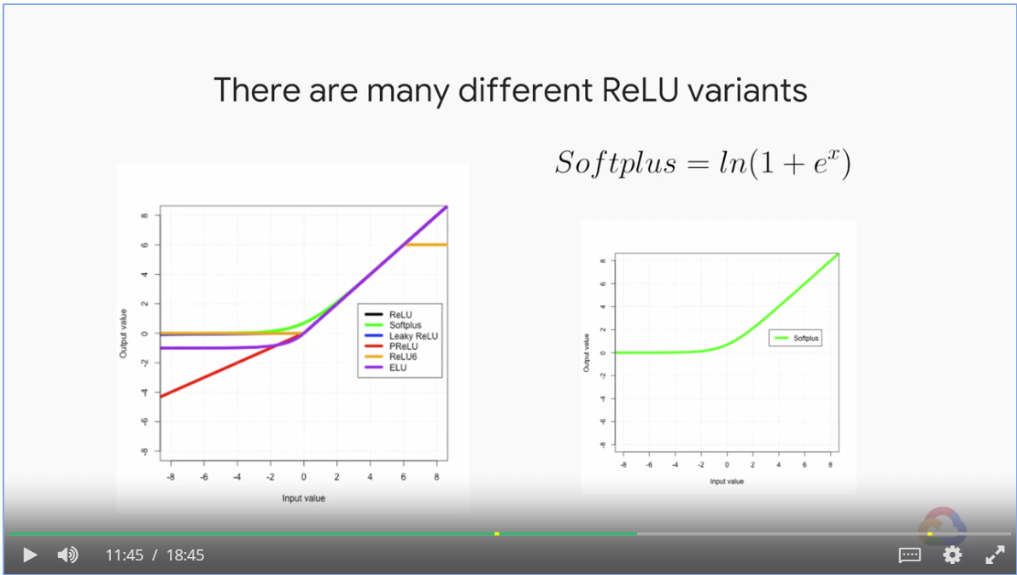

Complex Neural Nets

* We are creating a stock of data transformation that rotate, stretch an squeeze my data.
* The purpose is to transform the data into a high dimension
* Fit nicely by a hyperplane for regression
* Separated nicely by a hyperplane for classification

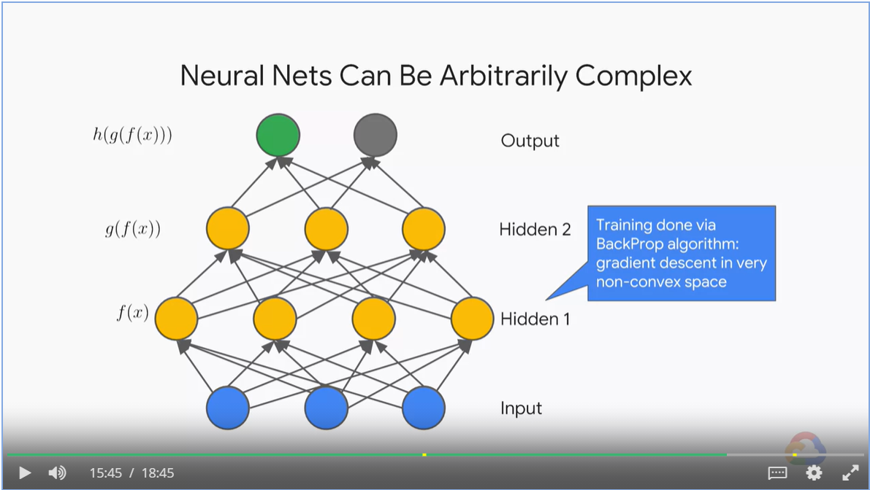

* Adding neurons brings new dimension into vector space.
* 4 neurons constitute a R4 vector space.

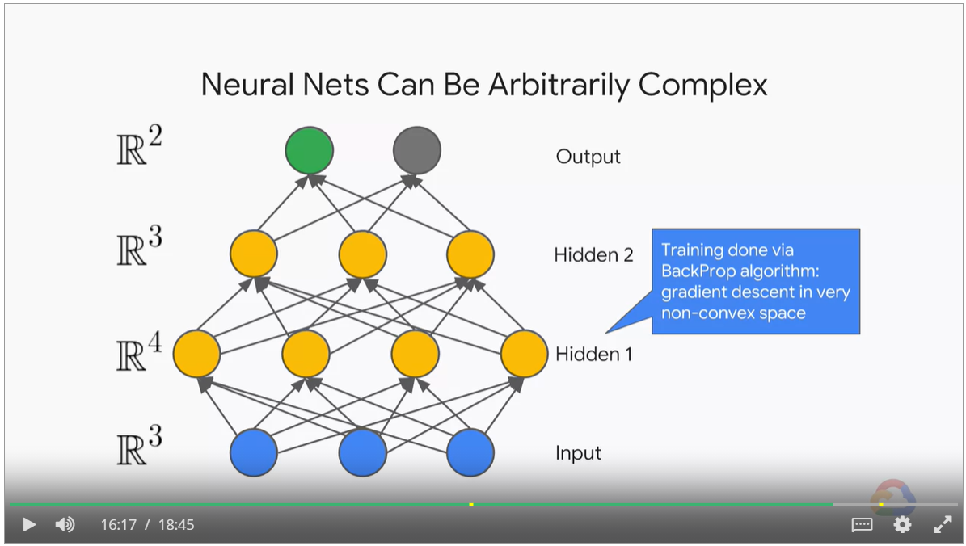

Adding neurons in the output layer brings in more labels in multi-class classification problem

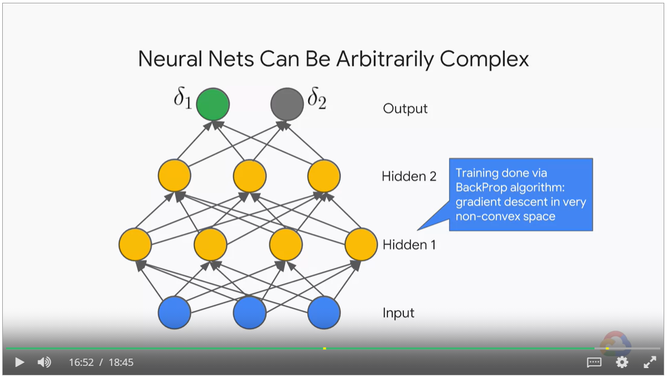

* To increase dimension, we add neurons
* To increase function composition, we add layers
* With multiple labels, we add outputs.

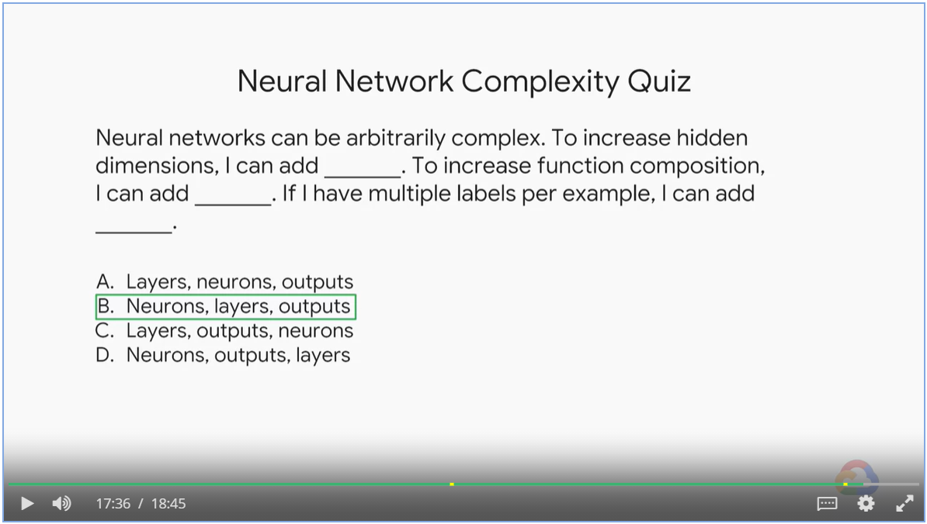

### Training Neural Networks

#### Gradients Can Vanish

* Each additional layer in your network can successively reduce signal vs. noise.
* With sigmoid or tanh activation function, you begin to reach the asymptotic regions of the function.
* The gradients are getting closer to zero and your training will begin to halt.
* Use non-linear, non-saturating activation functions such as ReLU, ELU and etc.

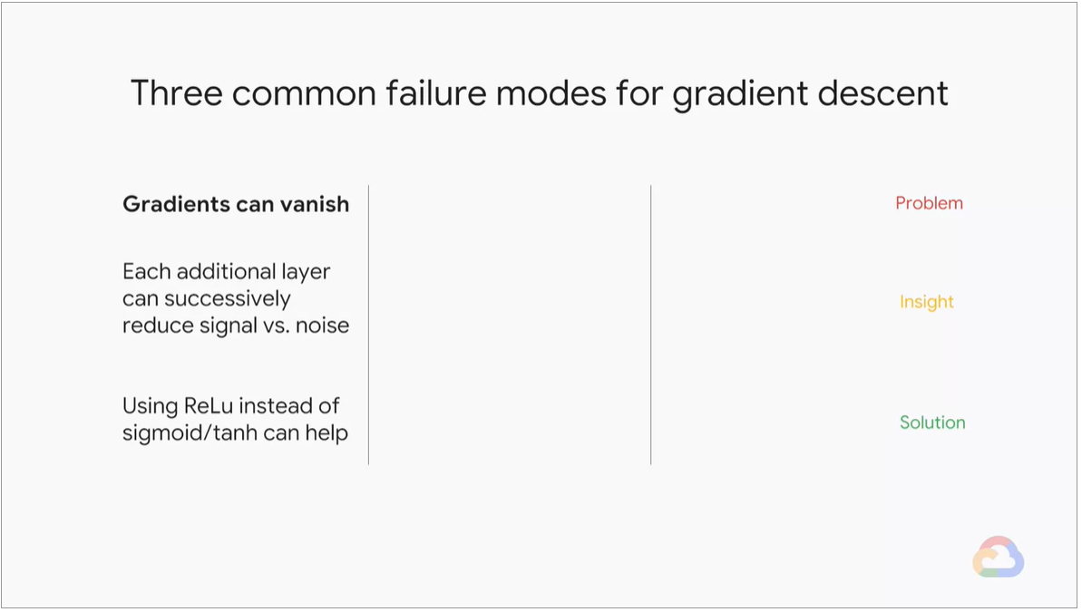

#### Exploding gradients

* Even we start with a small gradient such as value of 2, it can compound through deep sequential models and the gradients and weights will explode.
* Use weight regularization and smaller batch size to counter the problem.
* Use gradient clipping to counter the problem.
* Use batch normalization to counter the problem

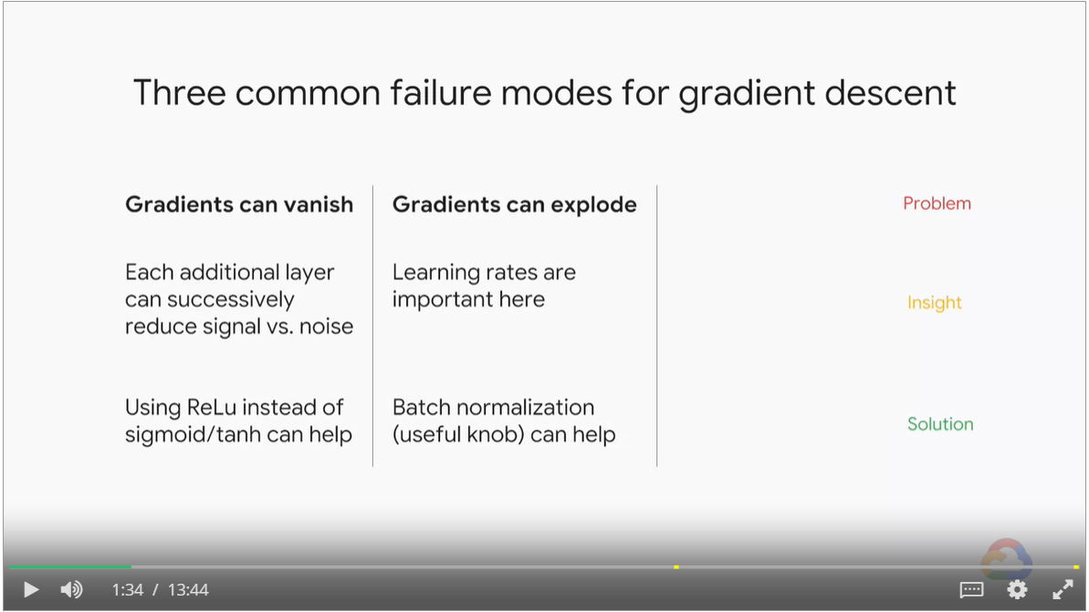

#### Dead layers

* Monitor fraction of zero weights in TensorBoard
* Lower your learning rate.

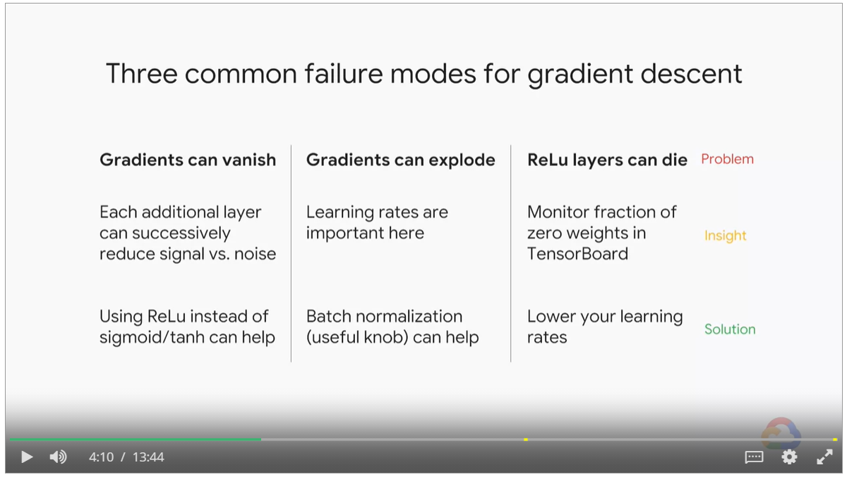

#### Scale feature values properly

* An indicator for soup deliciousness. Chicken ingredient measured in liters and beef ingredient measured in milliliters.
* Stochastic gradient descent might have a hard time converging well since the optimal learning rate for those two features is likely different.
* Having feature small and centered around zero will help with training.

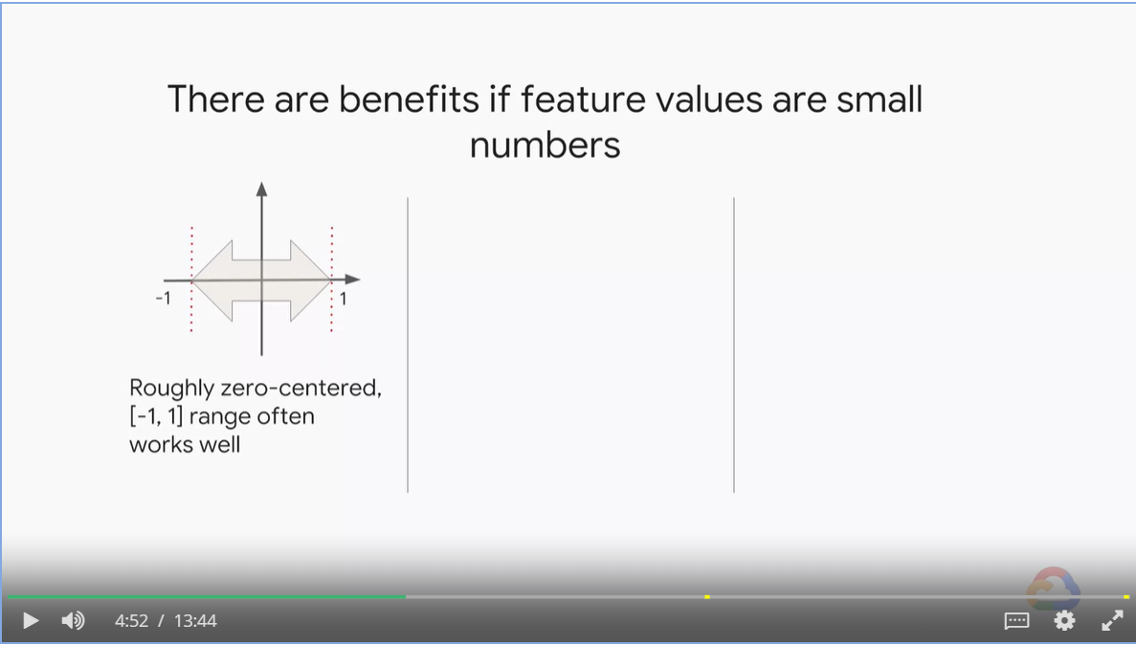

#### Batch normalization

* Batch normalization not only keeps the initial input features, but also intermediate features, within a healthy range.

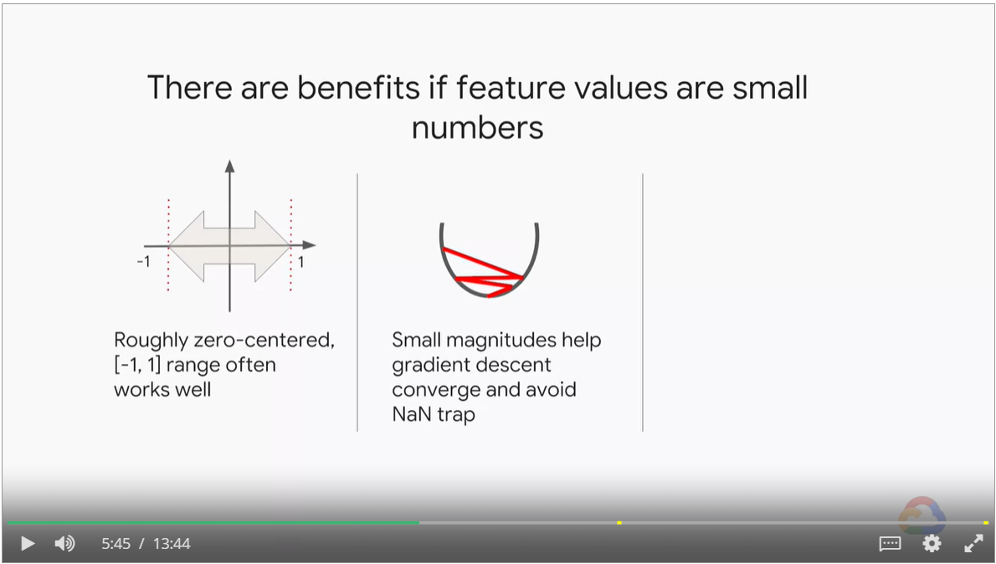

#### Outliers

* Avoiding outliers help with generalization.
* Detect outliers in preprocessing and discard them as one possible strategy.

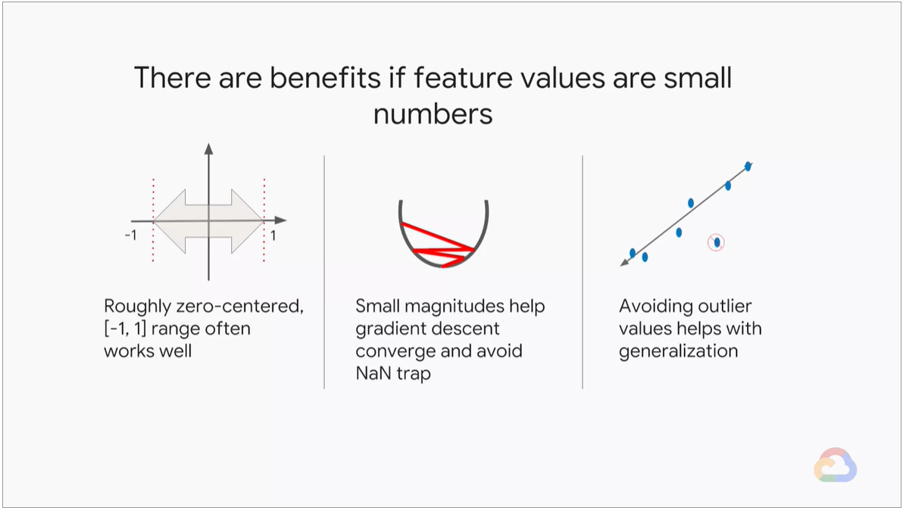

#### Feature scaling

* Normalization / Linear scaling, range between 0 and 1
* Hard capping
* Log scaling
* Standardization, mean at 0 and standard deviation at 1

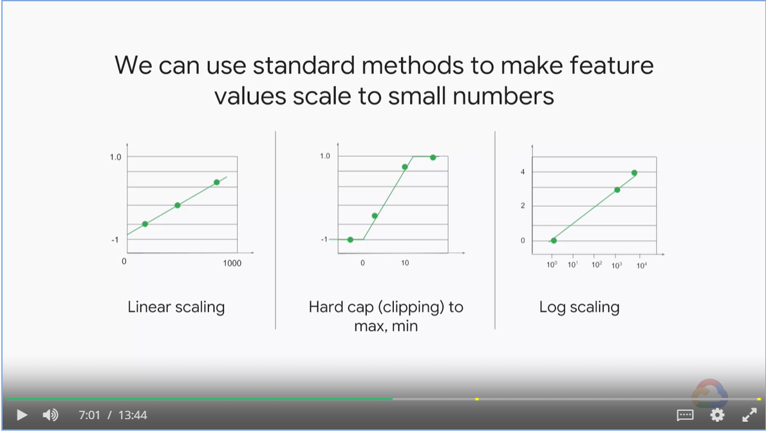

#### Dropout Layers are a form of regularization

* Some training layers use a keep rate, as oppose to dropout rate.
* Dropout creates an ensemble of models.

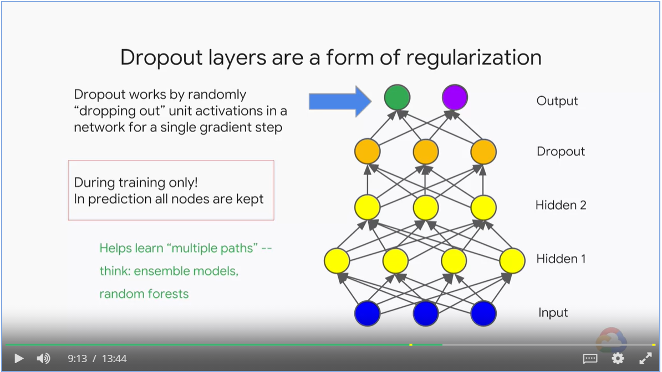

Dropout quiz

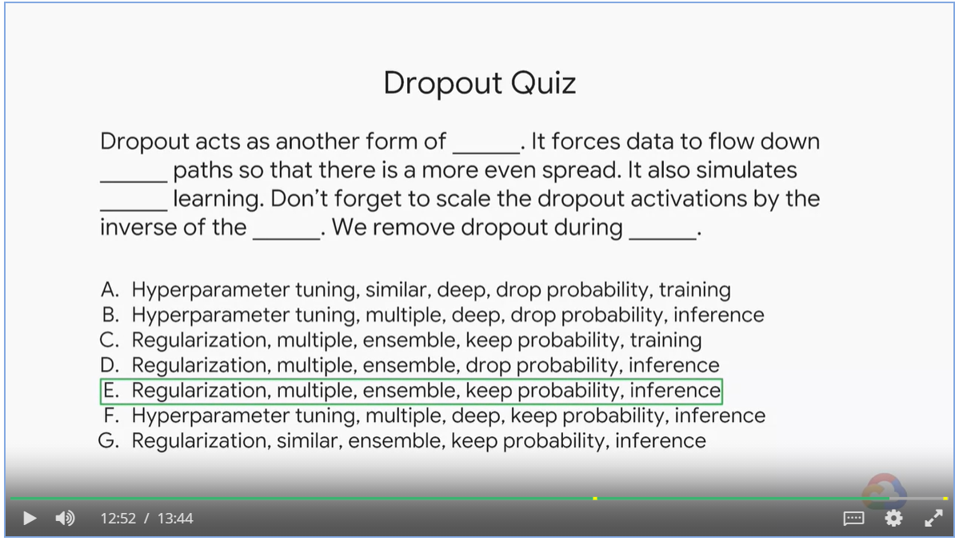

### Multi-Class Neural Networks

#### One-vs-all

* Some problems: the scale of the confidence values might be different for each of the binary classification models.
* Each binary classification model sees very unbalanced data distribution since for each one, the negative class is the sum of all the other classes.

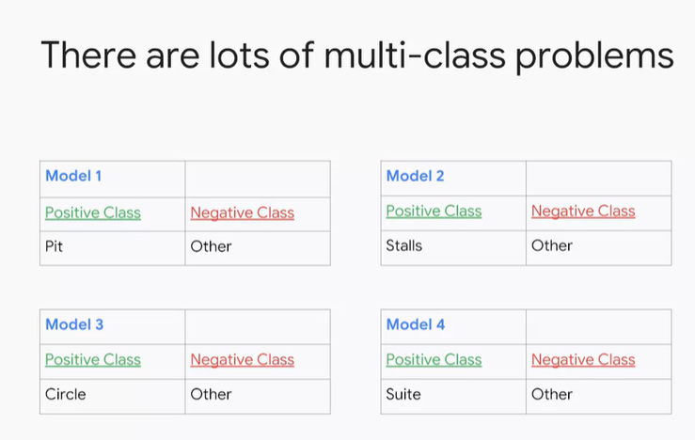

#### One-vs-one

* Large number of combinations: n * (n-1) / 2
* This does not solve the ambiguity problem because based on the input distribution, it could end up having the same number of votes for different classes.

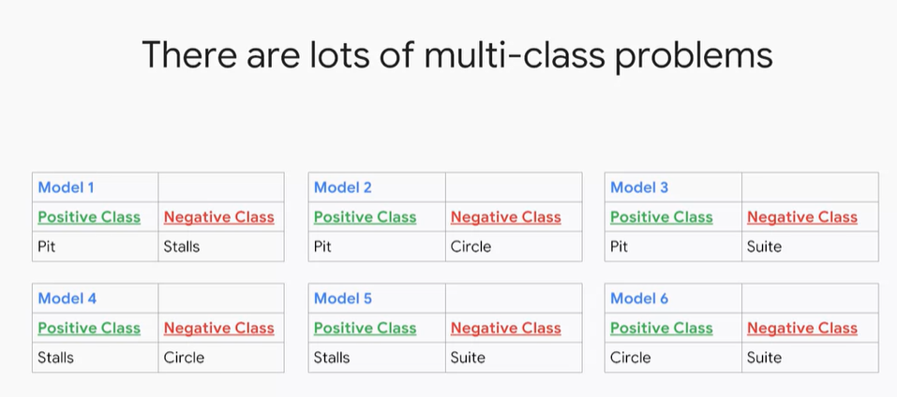

#### Use separate output nodes for each possible class

* Label is a vector with length of number of classes, with one of them being 1 and the rest 0.
* We could have millions of classes and therefore, millions of output labels, each will need to be back propagated through the network, making it very computational expensive.

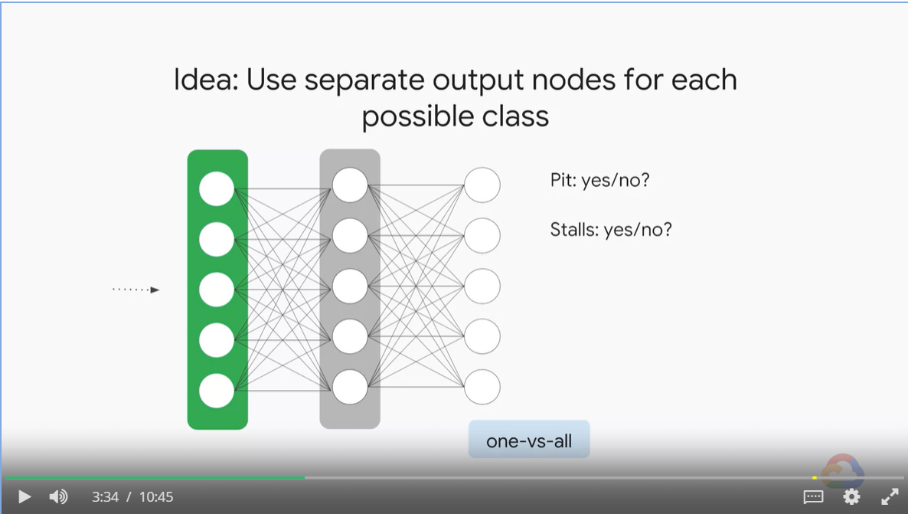

#### Softmax

* We add a constraint: the sum of outputs equals to one, called softmax.

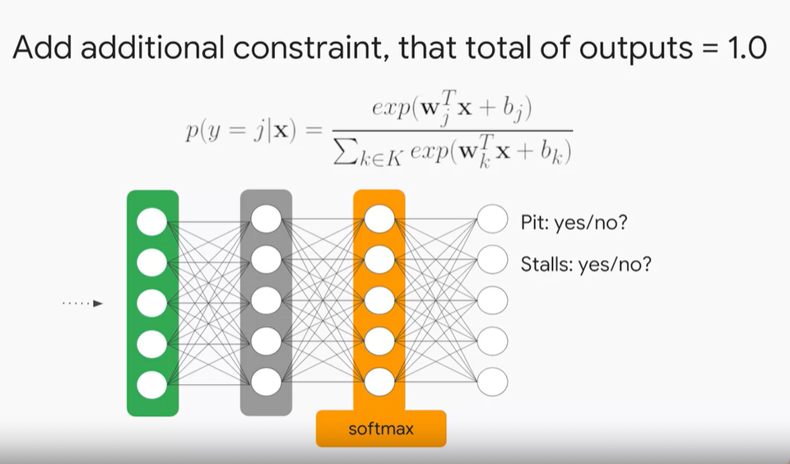

#### Multi-class, multi-label Classification Problem

* Probability of each class be between 0 and 1.
* In tensor flow, use sigmoid_cross_entropy_with_logits

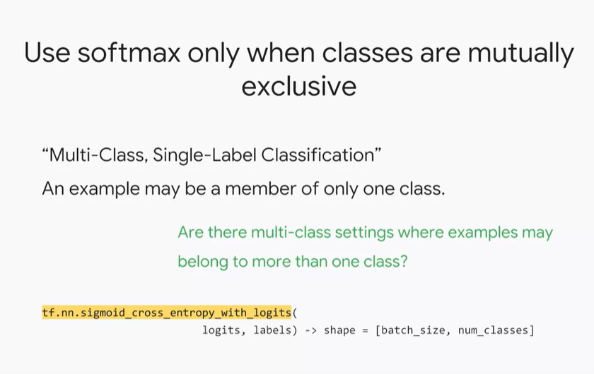

#### Computational expensive with large number of classes

* We need to evaluate every output node for every example.
* A single step of 100 output node network is like a 100 step of a single output network.

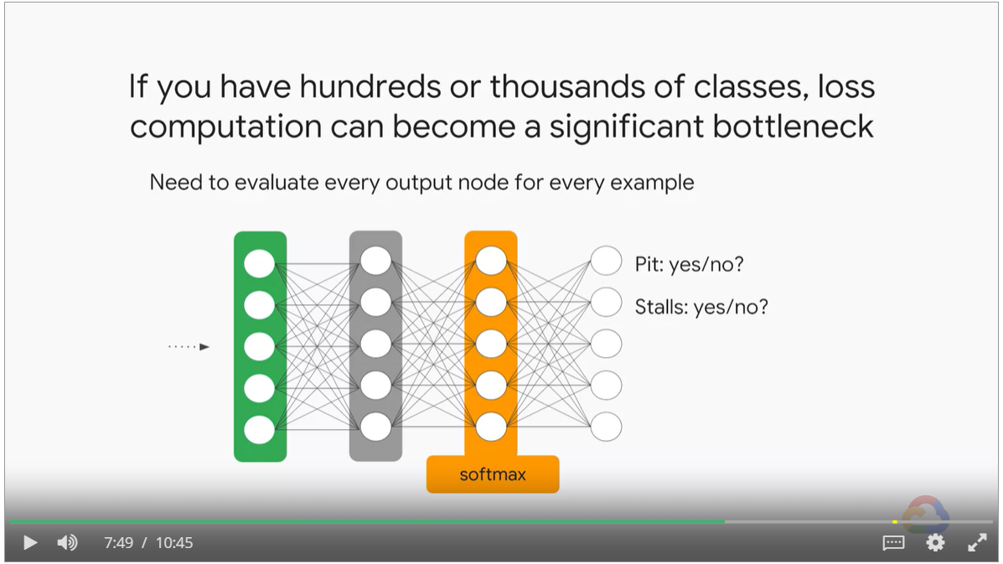

#### Approximate versions of softmax exists

* **Candidate sampling** calculates for all the positive labels, but only for a random sample of negatives.   
  tf.nn.sampled_softmax_loss
* **Noise-contrastive** approximates the denominator of softmax by modeling the distribution of outputs.   
  tf.nn.nce_loss

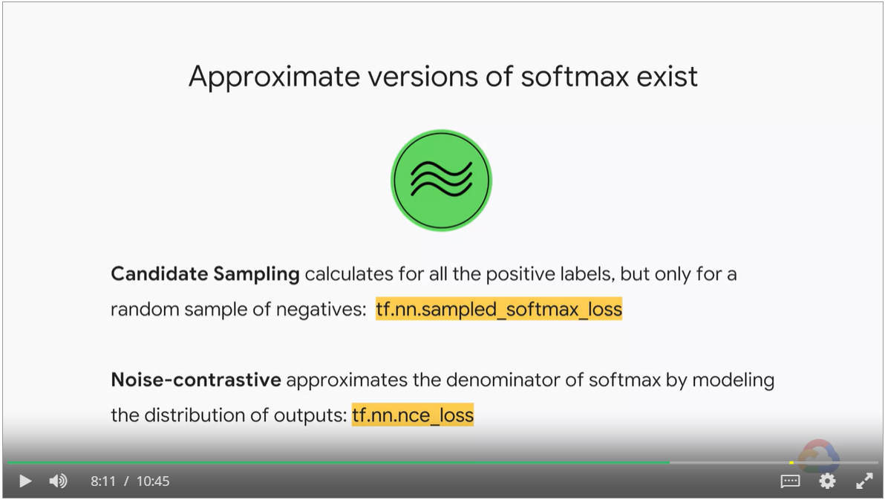

#### Softmax Quiz

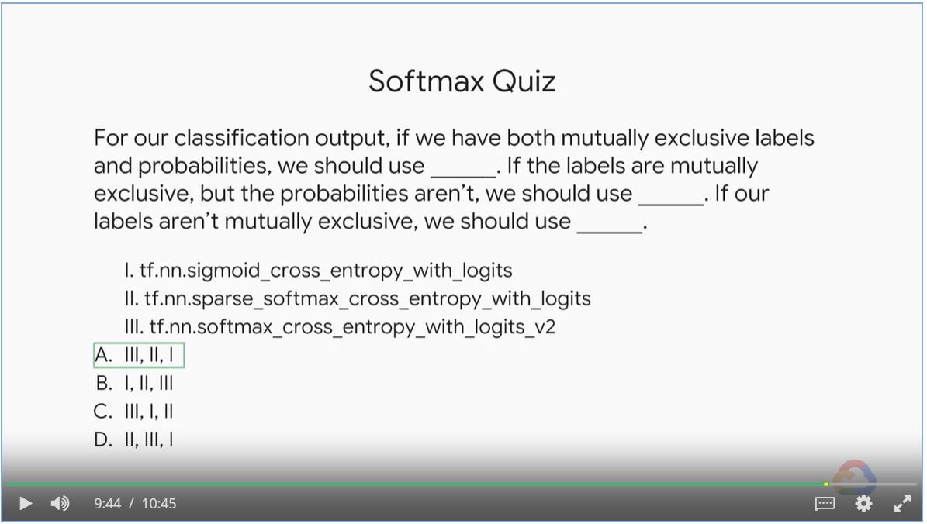

## Embeddings

#### Feature cross

* Embeddings works well with feature crosses.
* Not limited to feature crosses or even to structure data. Embeddings appear in image models and text models.
* Yellow and green nodes are embeddings. The weights are learned.
* Embedding learns the features in a lower dimension

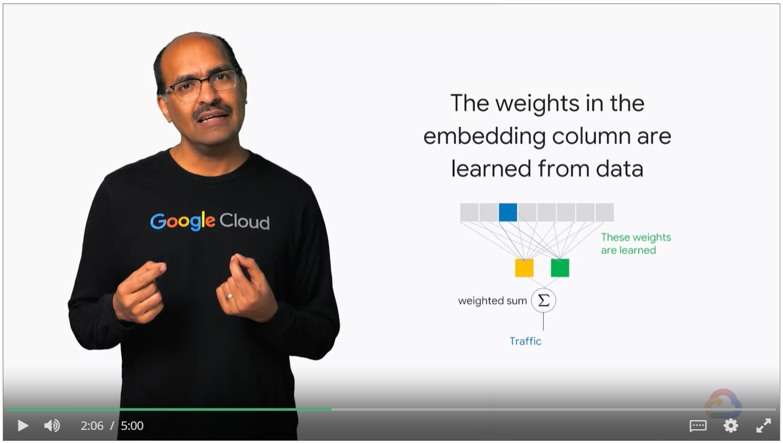

* Green box captures pedestrian traffic and yellow box automobile traffic
* All information in the hour of day and day of week as it pertains to traffic is shoehorned into just two numbers
* Times that are similar in terms of traffic get real valued numbers that are closer together
* Times that are different in terms of traffic get real valued numbers that are different.

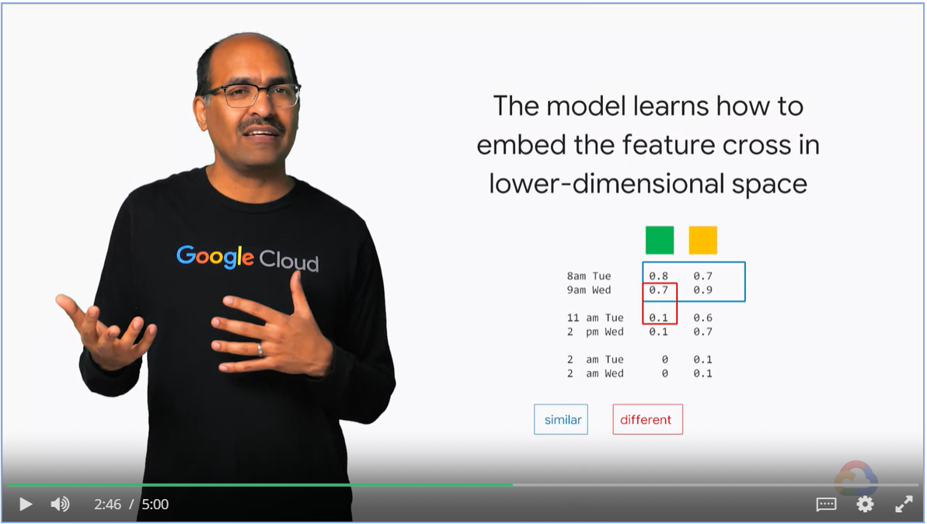

#### Transfer learning

* Use the traffic model to predict TV viewership
* As TV viewship depends on the same latent factor, “are the people in this city on the move”

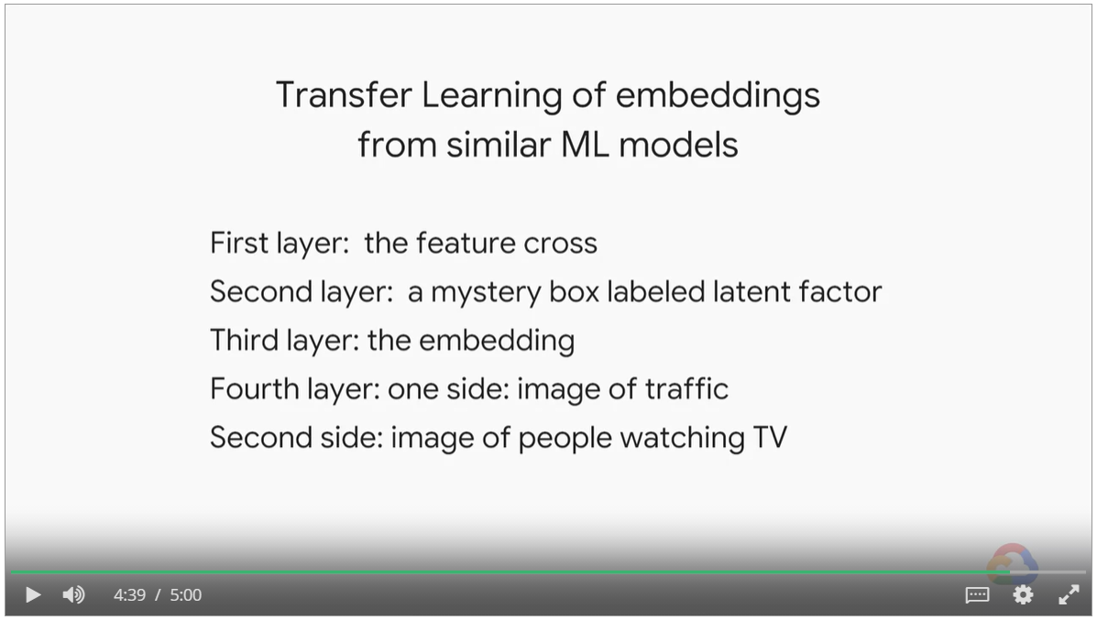

#### Recommendations

* How to recommend movies to customers
* Input is sparse matrix of 1 million customer and 500k movies
* What embedding to use?

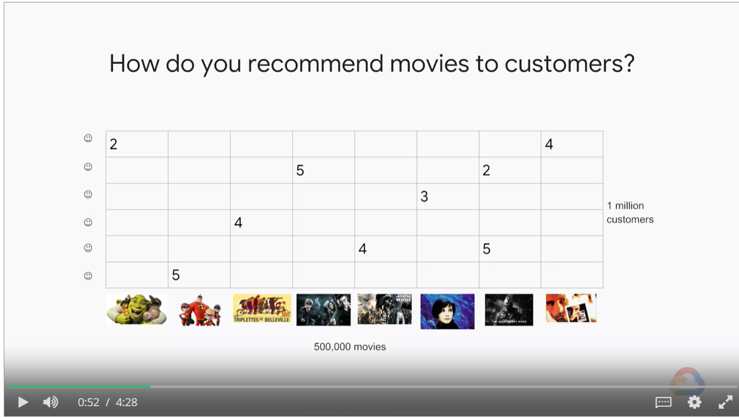

Organize movie by age

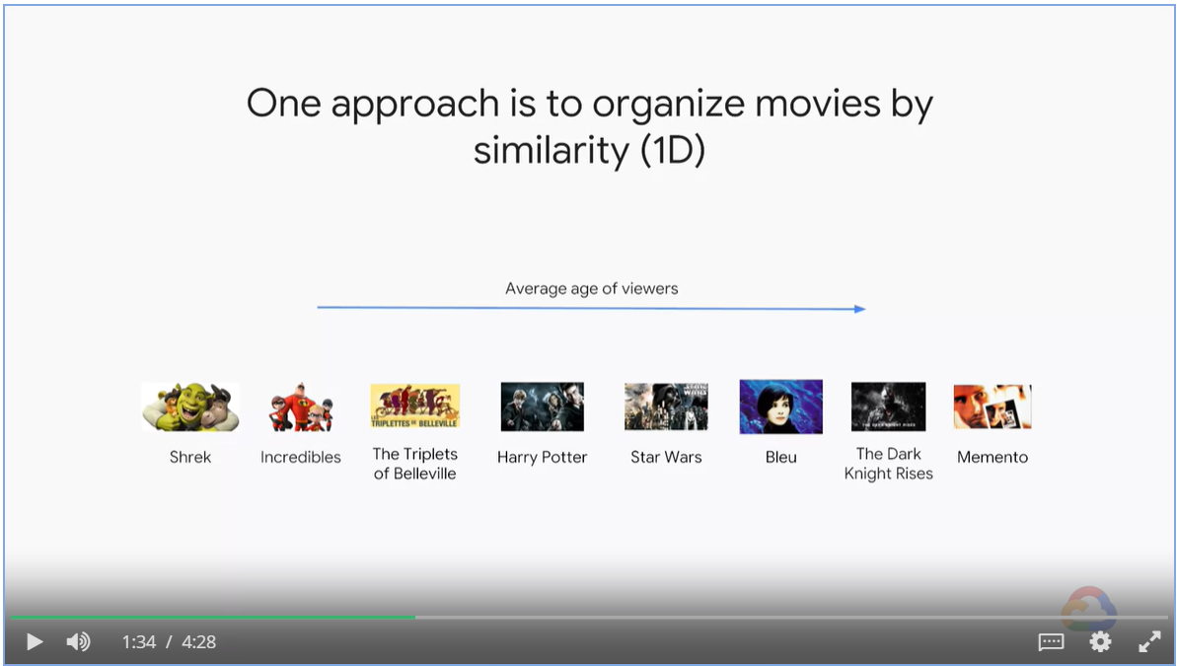

Organize movie by gross ticket sales

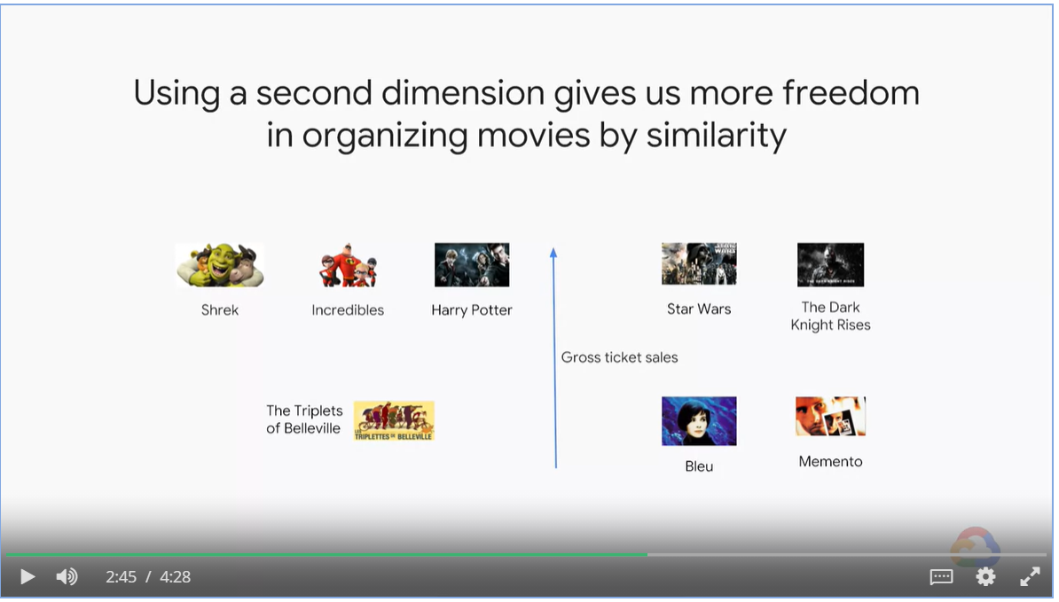

#### Dimenions

* Movies has IDs, one-hot encoded. We have 500k movies, the dimension of input layer is of dimension N = 500k
* We use embedding layer with dimension D to approximate the N dimension input.

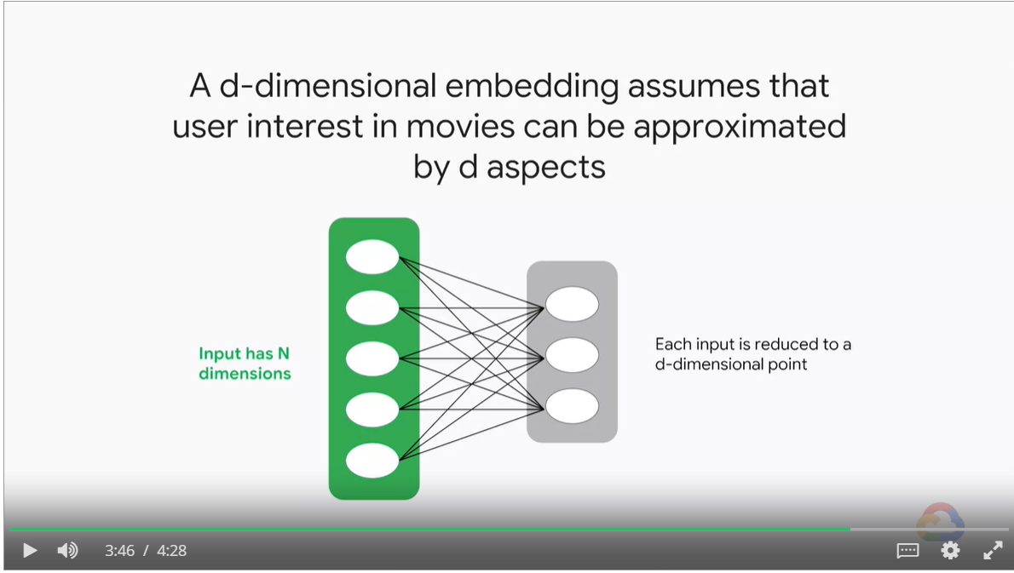

#### Benefits of embedding layers with lower dimension

* Easier to train the model, less weight to optimize.

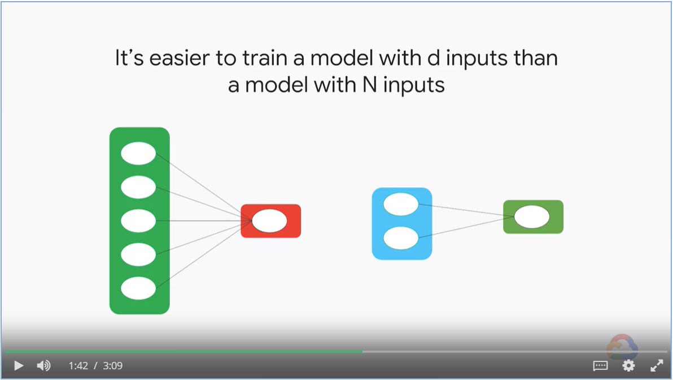

#### Sparse Tensors

* Dense representations are inefficient in space and compute

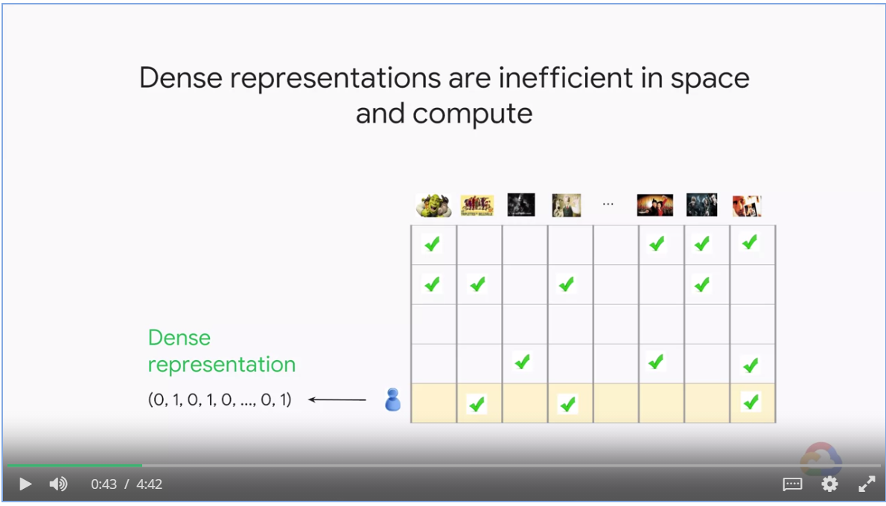

* Sparse tensors are efficient inn space and quick to compute
* TensorFlow can carry out math operations on sparse tensors directly.

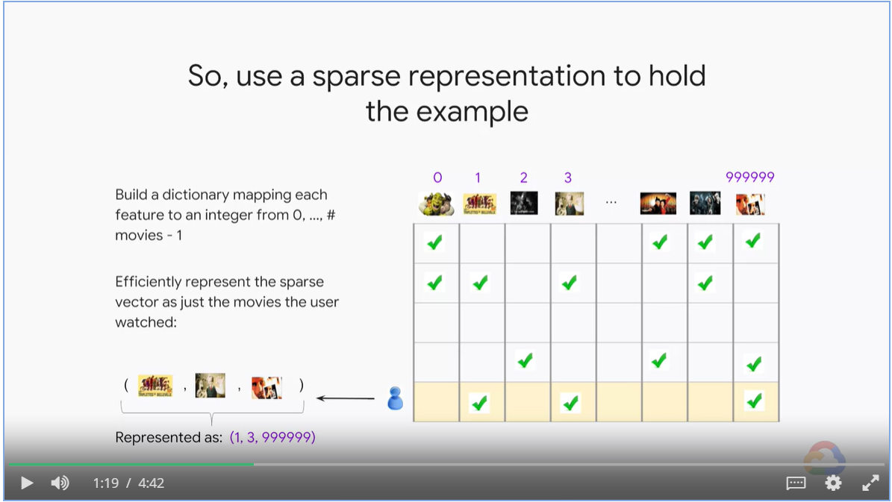

#### Embeddings on text input

* Embeddings are feature columns that function like layers

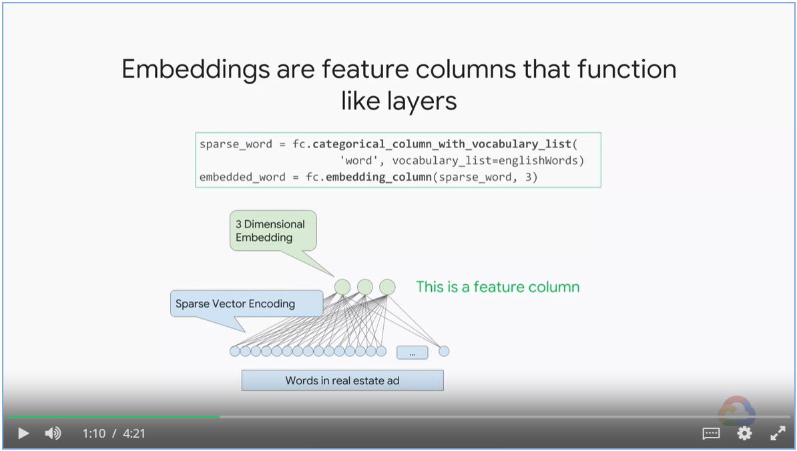

* The weights of the embedding layers are learned through backprop just as with other weights.

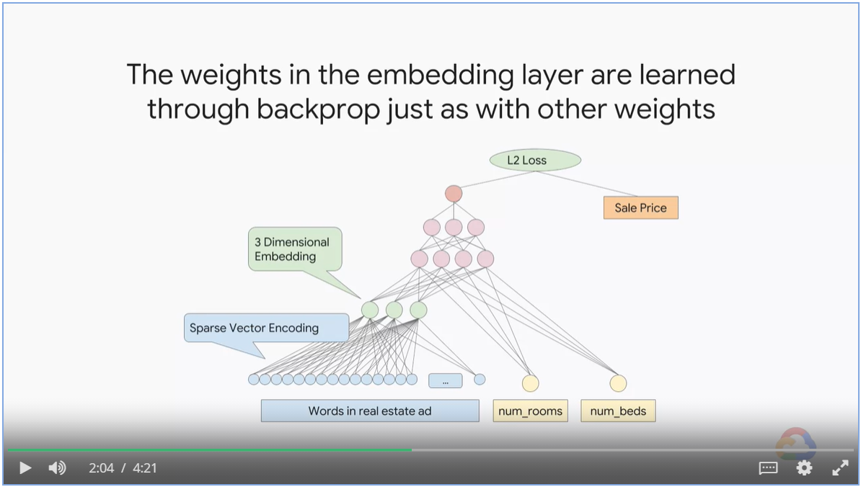

# Production ML Systems

## Introduction

### Architecting ML systems

* Your ML code only accounts for 5% of your project effort
* Many other parts make up the ML system

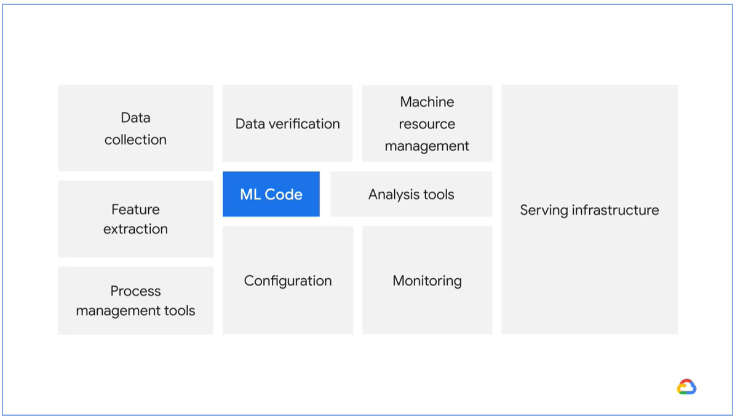

## Week 1: Data Extraction, Analysis and Preparation

Delivering ML model to production

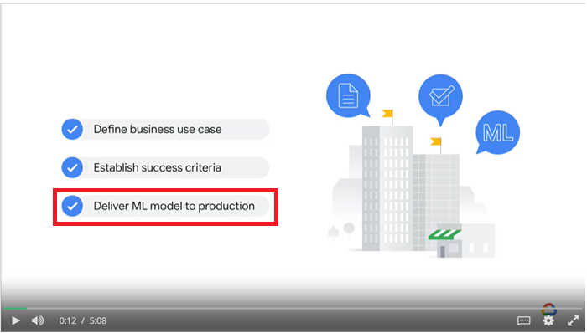

### Data Extraction

* Data are extracted as streaming or batch
* Data might be structured or unstructured

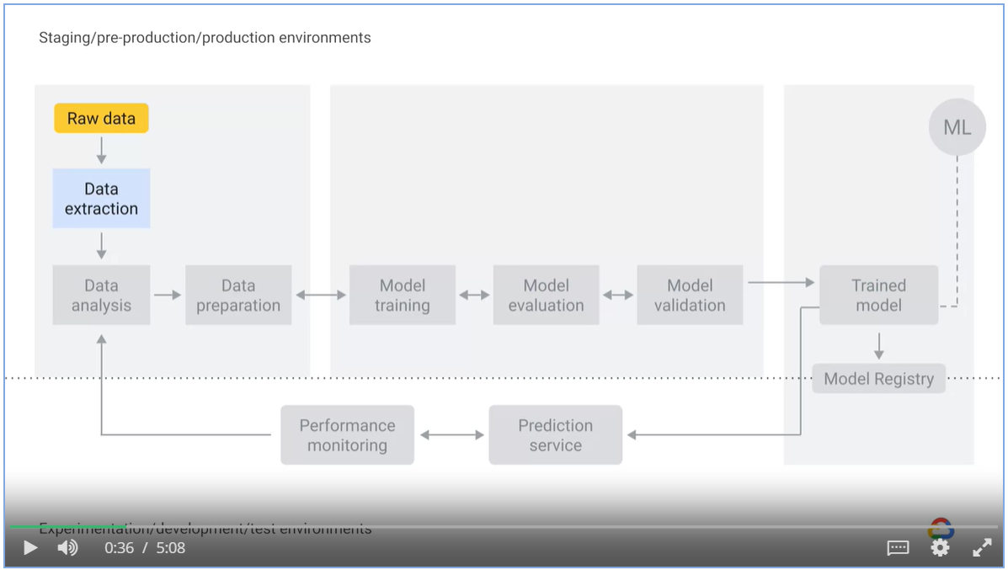

### Data Analysis

* EDA

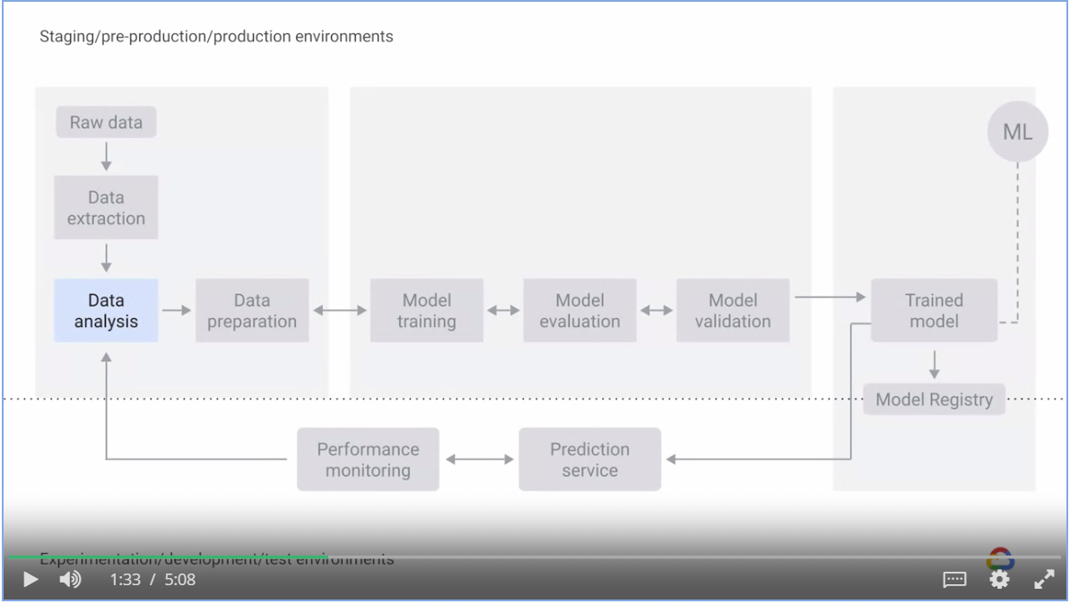

* Use visualized graphs to find outliers, anomalies, trends and data distribution
* Computer summary statistics

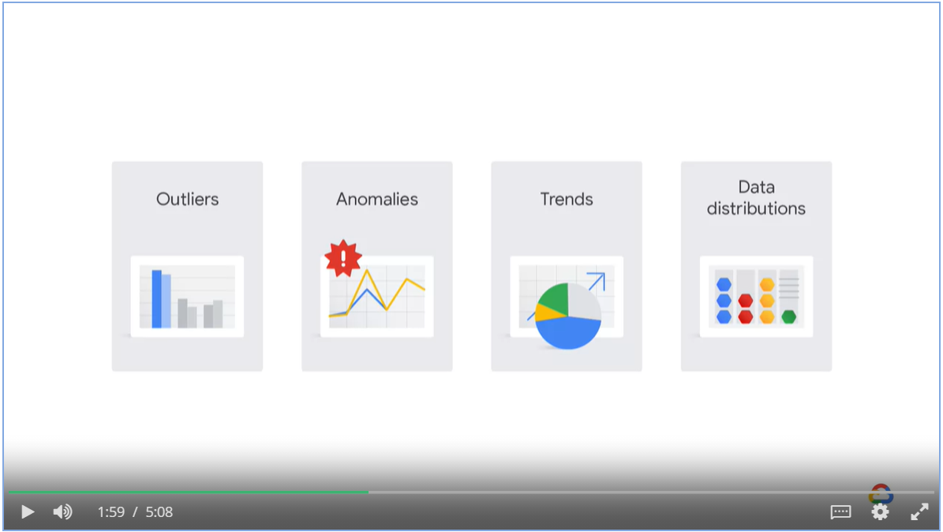

#### Example

* Identity columns changes over time
* A drop in the performance of your model will give you a warning
* Use EDA to plot the distribution of those numbers
* Build pipelines with tests.

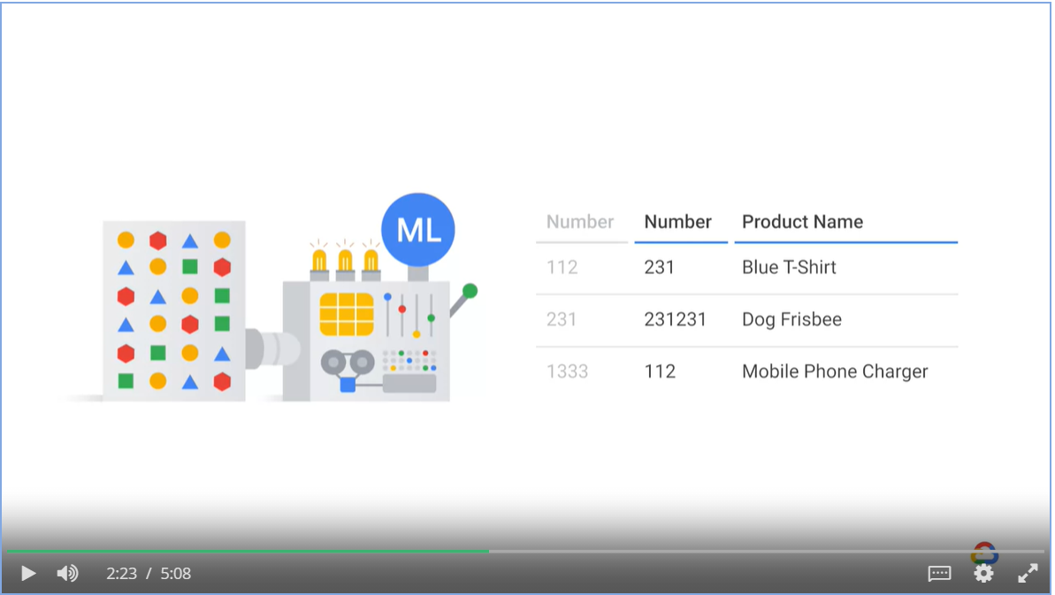

### Data Preparation

* Data preparation includes data transformation and feature engineering.
* For all non-numeric columns, other than timestamp. BigQuery ML performs a one-hot encoding transformation

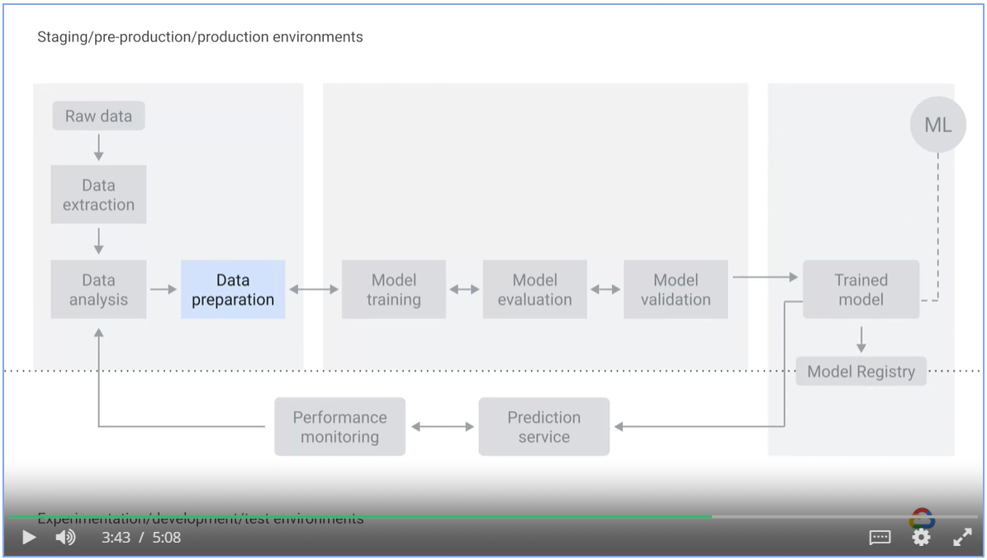

### Model training, evaluation and validation

* Model training is the process of feeding an ML algorithm with data to help it identify and learn good values for the feature set.
* Model evaluation aims to estimate the generalization accuracy of a model on future unseen or out of sample data.
* In contrast to model evaluation component which is performed by humans.

For model validation component, it evaluates the model against fixed thresholds and alerts engineer when things go wrong.

* Both model evaluation and model validation has the responsibility to ensure that the models are good before moving them into a production environment.

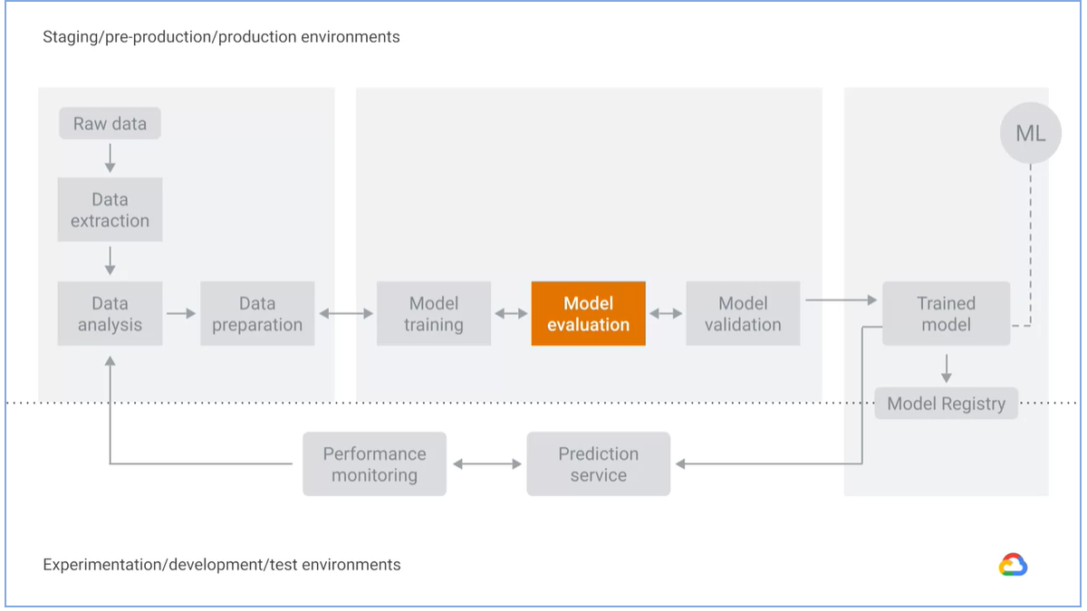

### Trained Model, prediction service and performance monitoring

* Model is kept in a model registry.
* A registry keeps meta data such as
  + who trained and published the model
  + which dataset were used to train the model
  + what is the metrics to measure performance and etc.

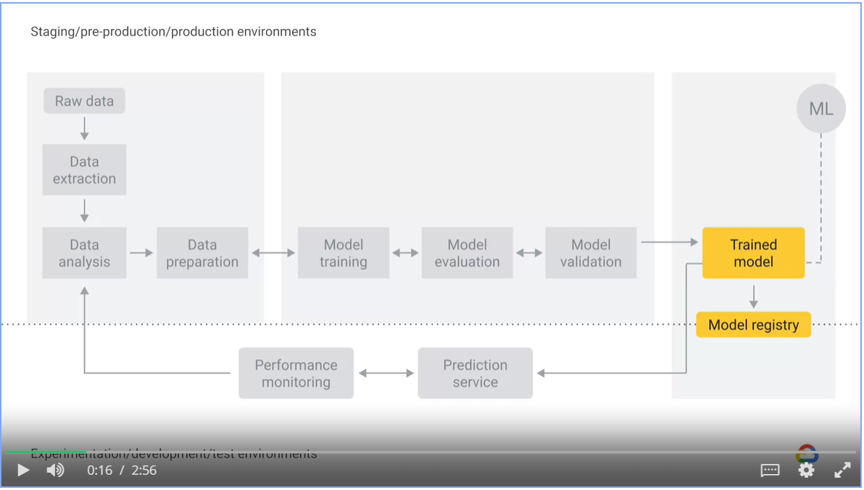

* Prediction or inference is the step where we get to answer the question we pose.

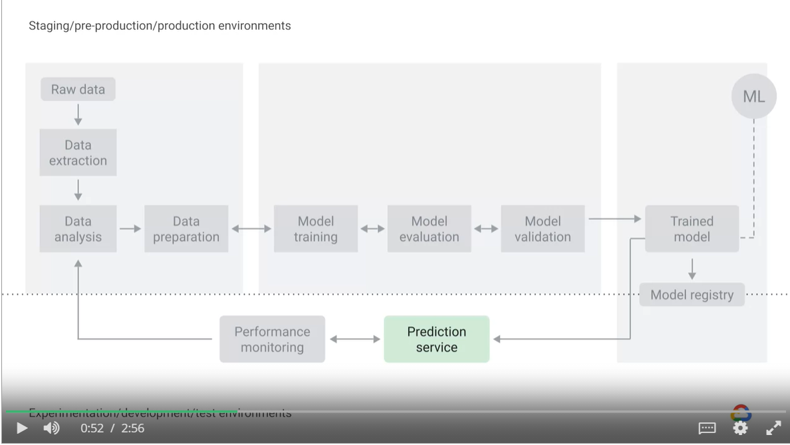

* Google AI Platform Prediction pipeline serialize a model in pickle format
* It exposes the model in REST API as a prediction service.
* AI Platform prediction service can host models trained in popular frameworks such as TensorFlow, XGBoost and Scikit-Learn

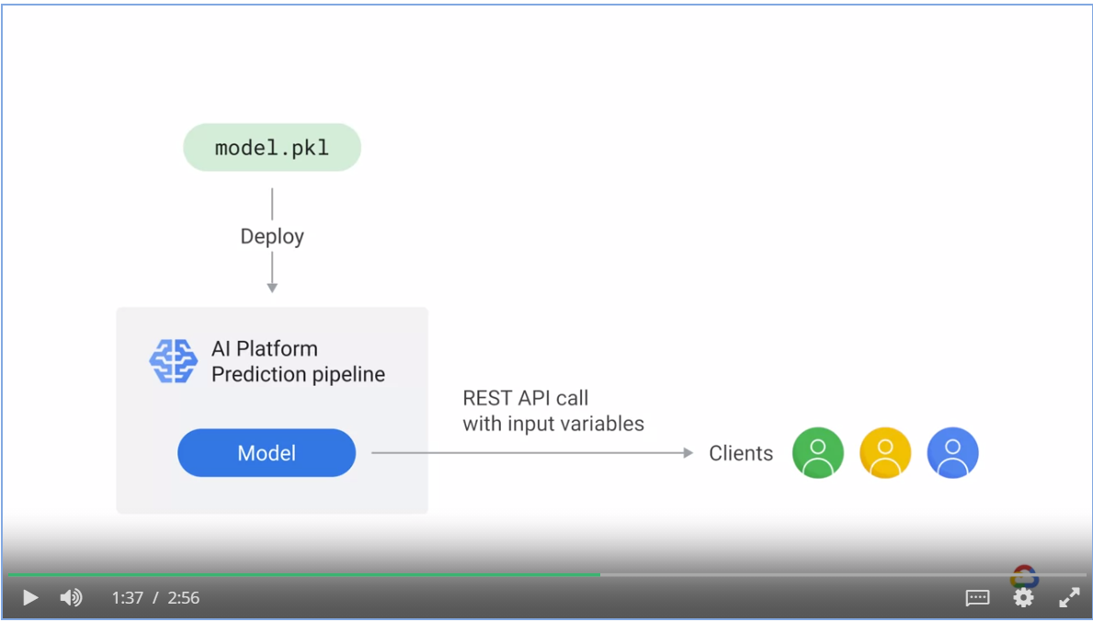

* Monitoring lets you detect model performance degradation or model staleness
* The output of monitoring is feed into the data analysis component, which could trigger a new round of experiment.

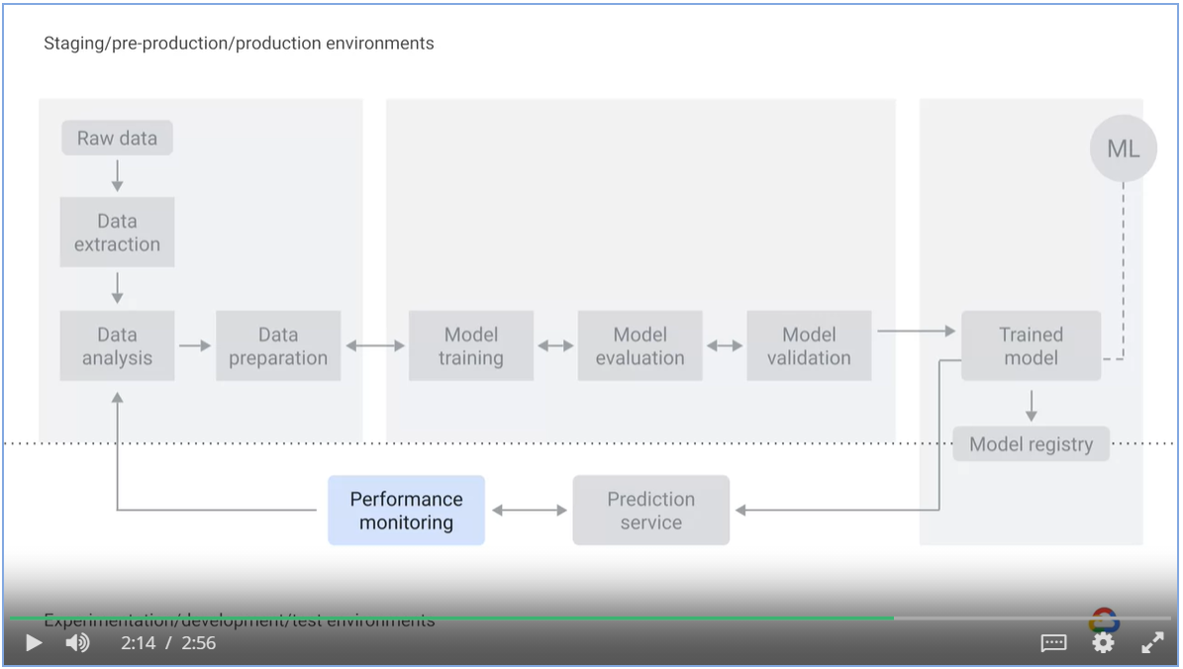

Use Google’s Cloud Monitoring to monitor your models

* Traffic pattern, error rates, latency and resource utilization

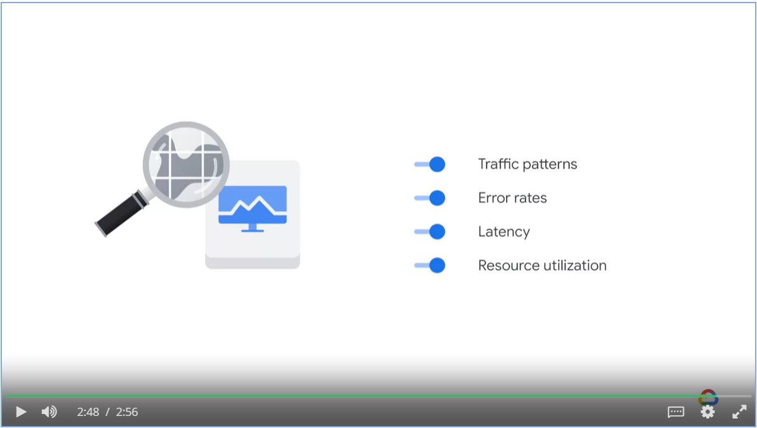

## Week 1: Design Decisions

### Static vs Dynamic training

* If the relationship you are trying to model is constant and it resembles physics, a statically trained model may be sufficient.
* If the relationship you are trying to model tends to change, then a dynamically trained model might be more appropriate.

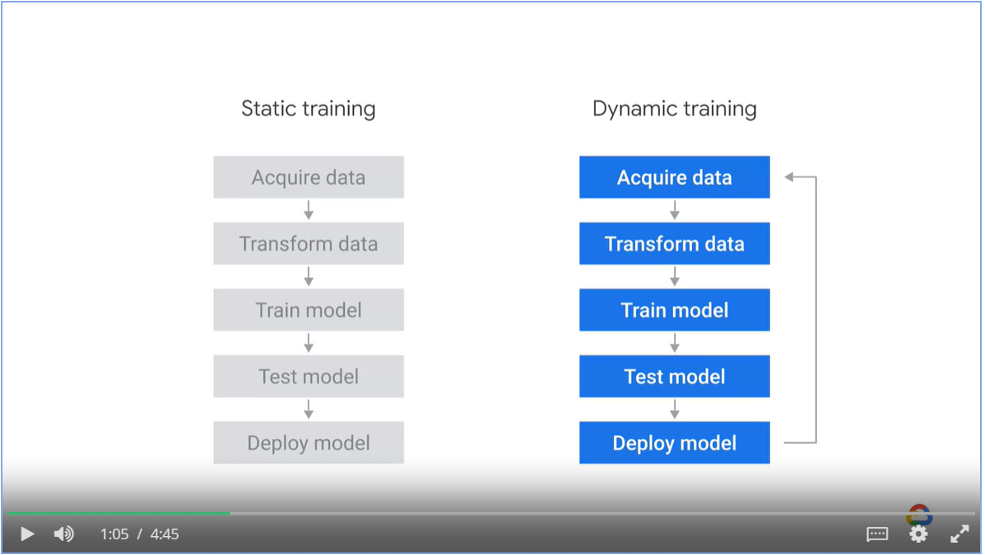

Examples of static and dynamic models

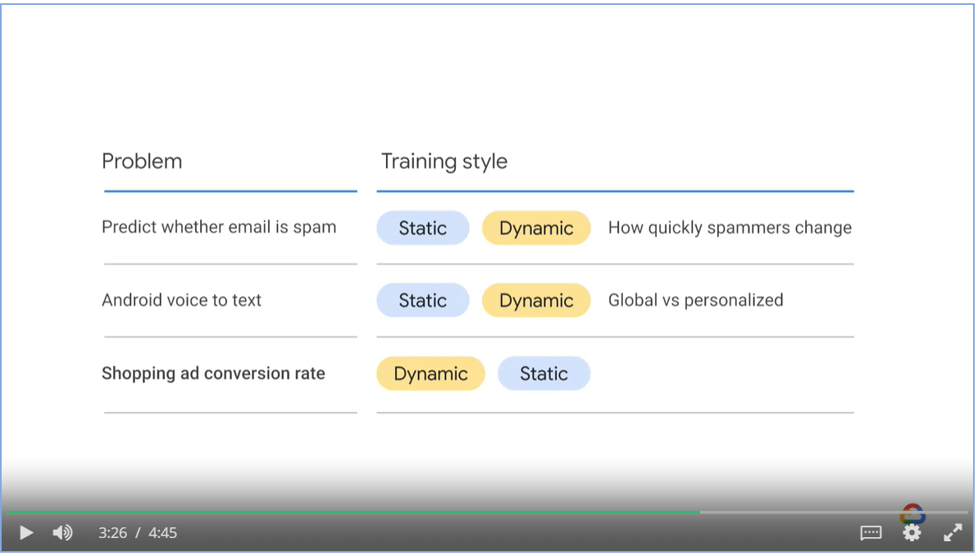

### Three Dynamic training architecture

* Cloud Functions
* App Engine
* Data-flow

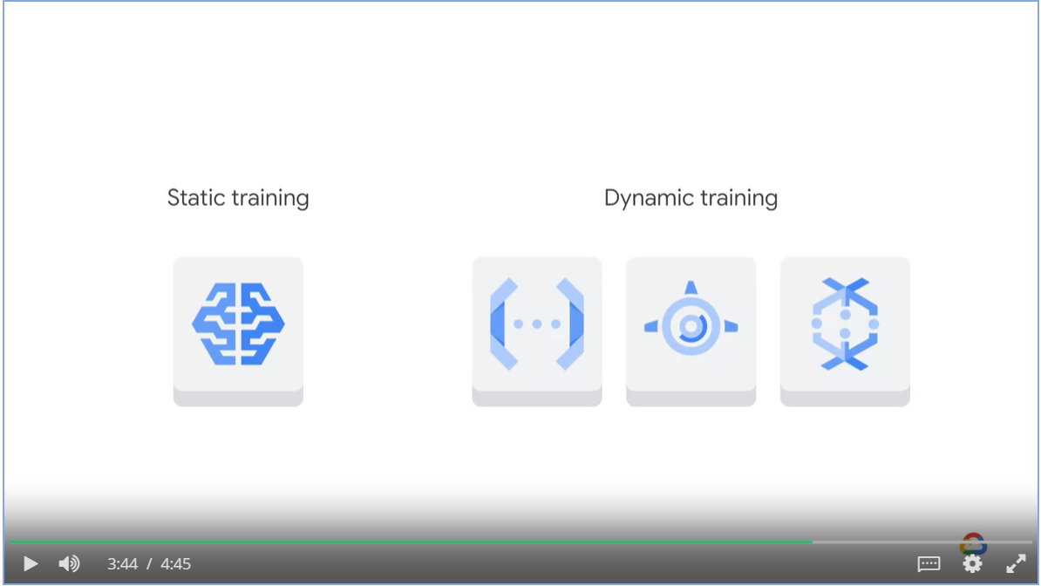

#### Training with Cloud Functions

1. A new data file appears in Cloud storage
2. Cloud function is launched
3. It starts AI platform training job
4. AI platform writes out a new model.

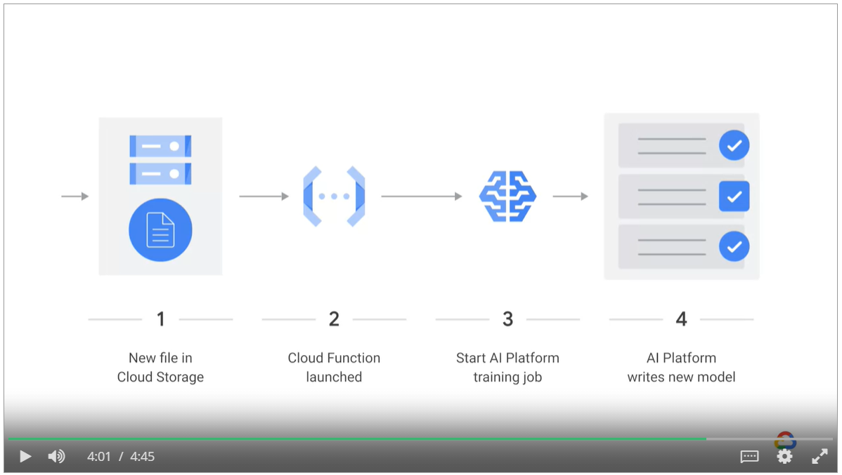

#### Training with App Engine

1. User makes web request in App Engine
2. AI platform training job is launched
3. AI platform writes new model to cloud storage
4. Statistics of the training job are displayed to the user when the job is completed

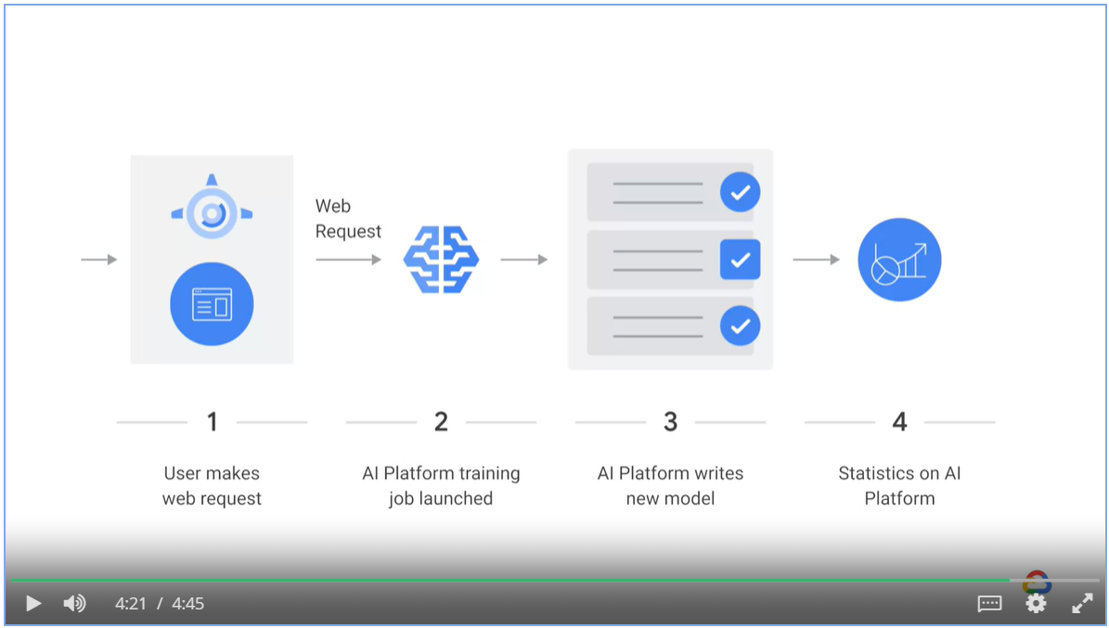

#### Training with Dataflow

1. Streaming messages are ingested into Pub/Sub
2. Messages are aggregated in Dataflow and is stored in BigQuery
3. AI platform jobs are launched on the arrival on new data in BigQuery
4. A new model is deployed

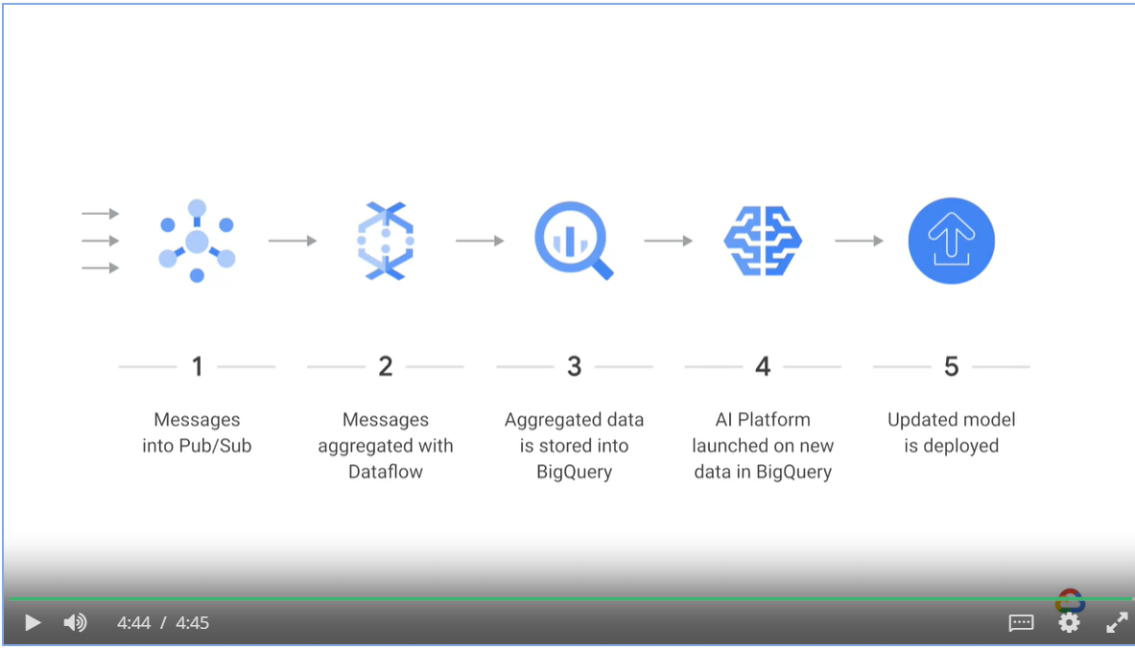

### Serving Design Decisions

* Aim to minimize average latency.
* Similar to what we do to optimize IO performance where we use cache, here we use a table.
* Static training computes the label ahead of time, and serves by looking up the table.
* Dynamic serving computes the table on demand.

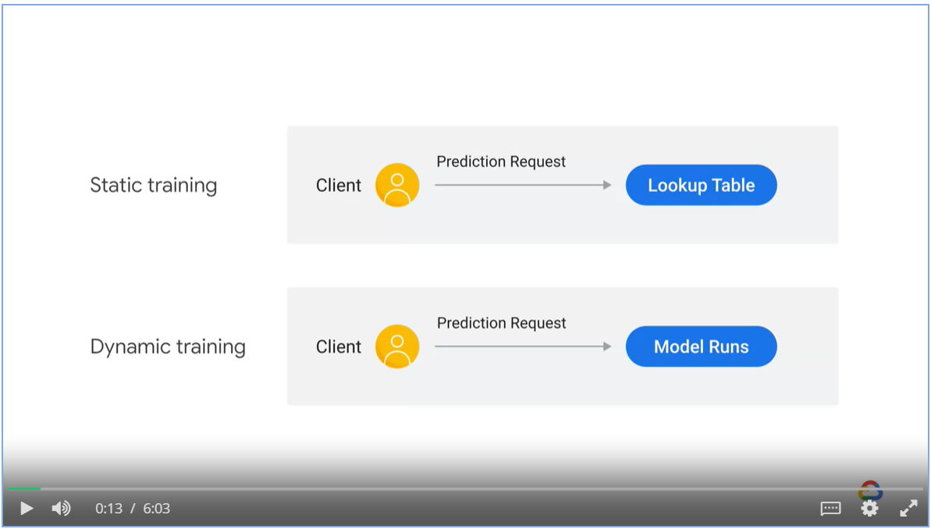

#### Peakedness vs cardinality

* Peakedness refers to how concentrated the distribution of the prediction workload is
* Cardinality refers to the number of values in a set.

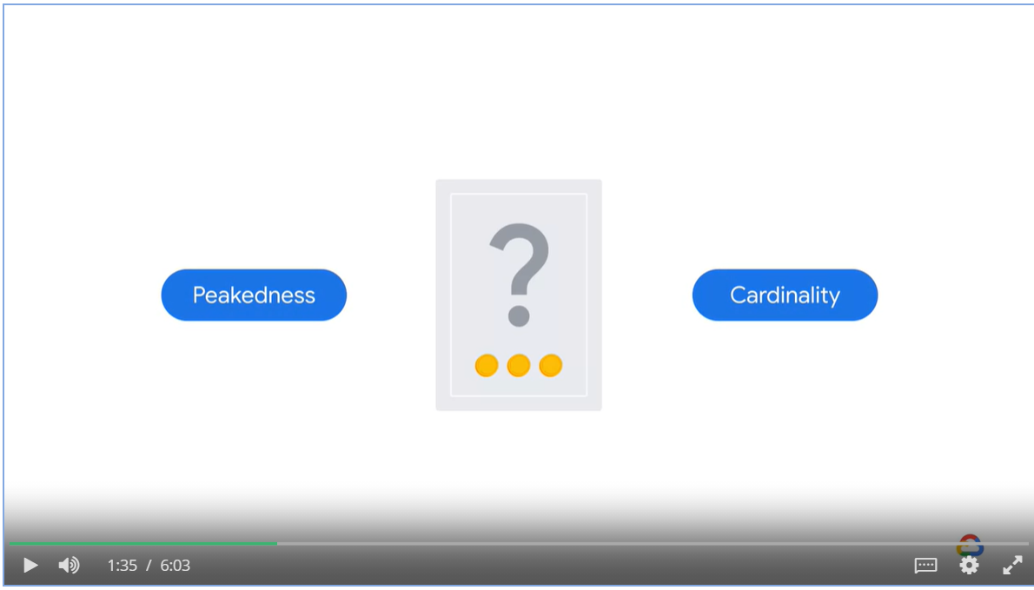

Predicting the next word will be highly peaked as a small number of words account for the majority of words used.

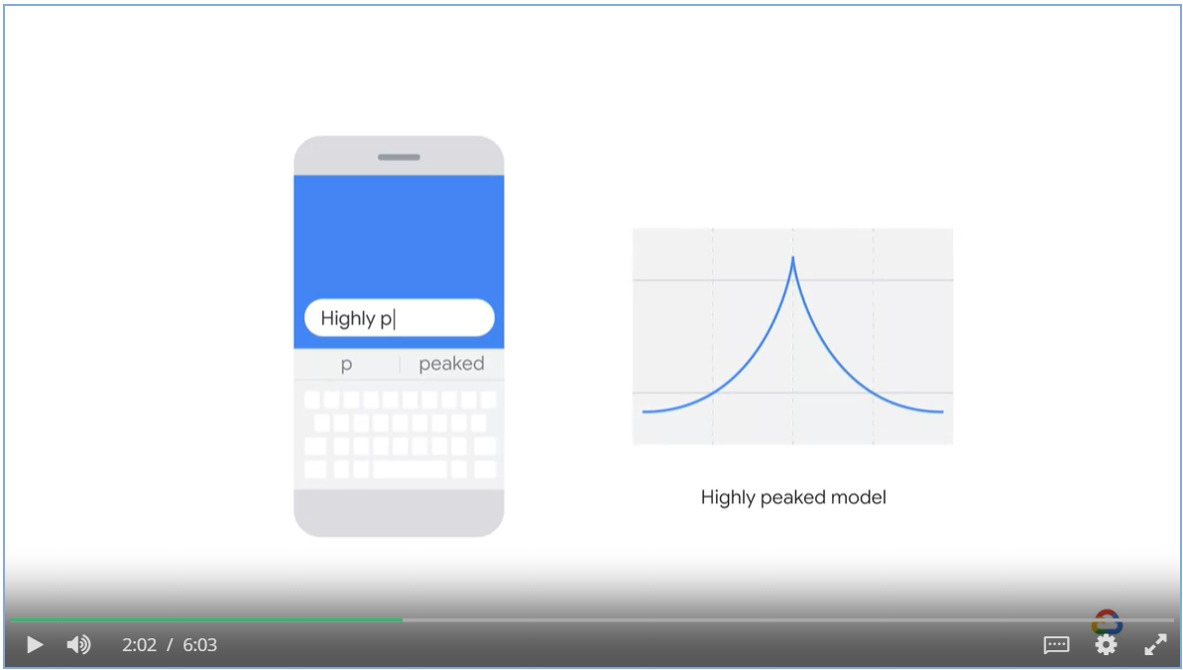

A model predicts revenues for all sales verticals will be flat

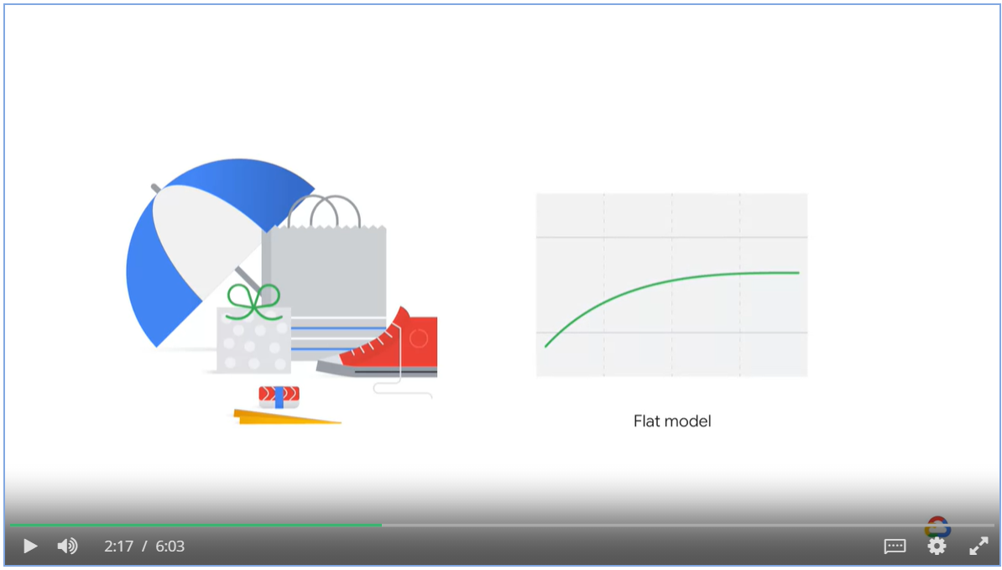

A model that predicts revenue based on organization division number has low cardinality

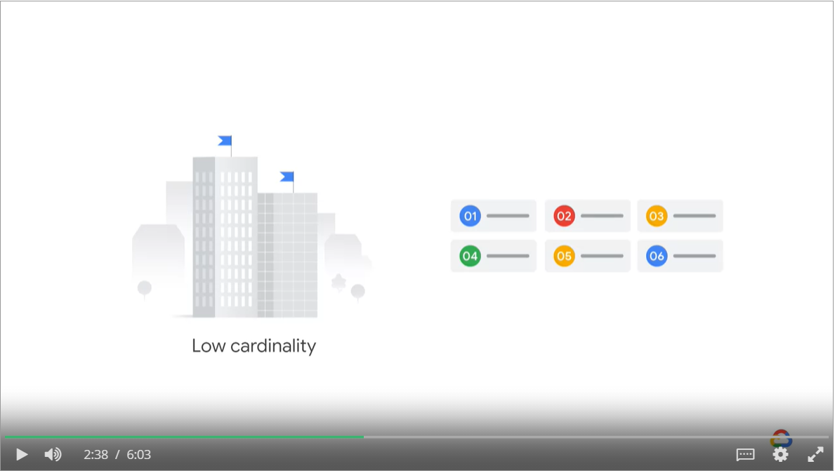

A model that predicts use life time value given an user id on an e-commerce platform has high cardinality.

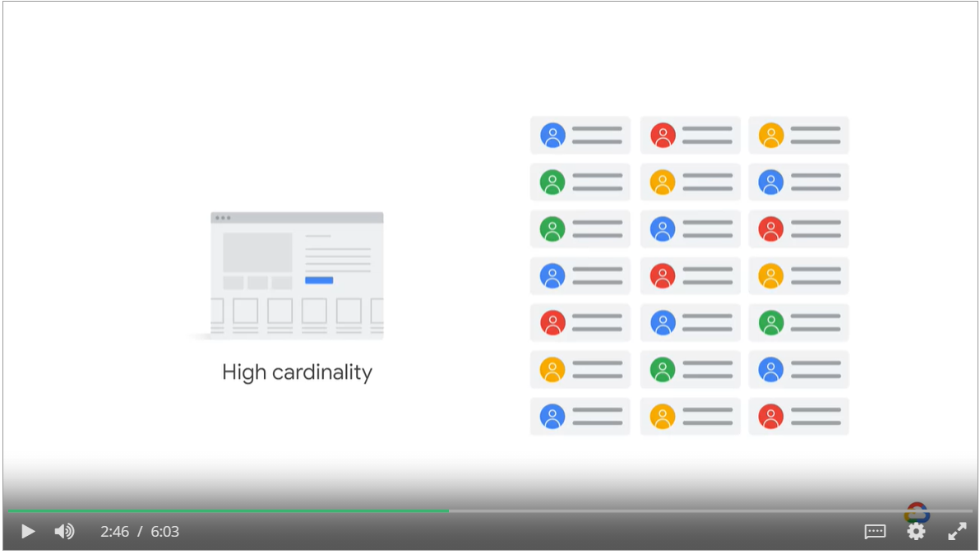

* With low cardinality, use static serving with a lookup table
* With high cardinality and evenly distributed workload, use dynamic on demand serving.
* Use hybrid approach where most frequent workloads are pre-computed and cached

and tails are calculated on demand.

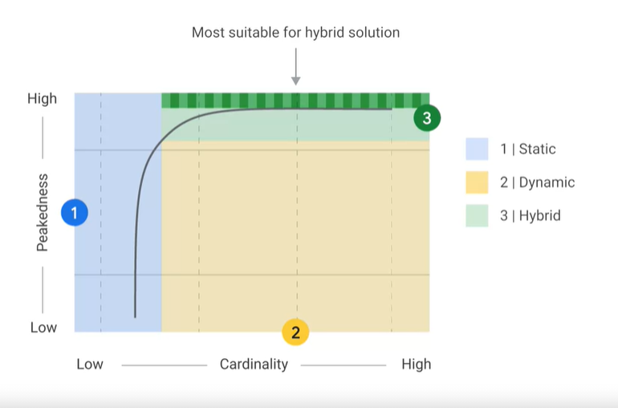

User case scenarios

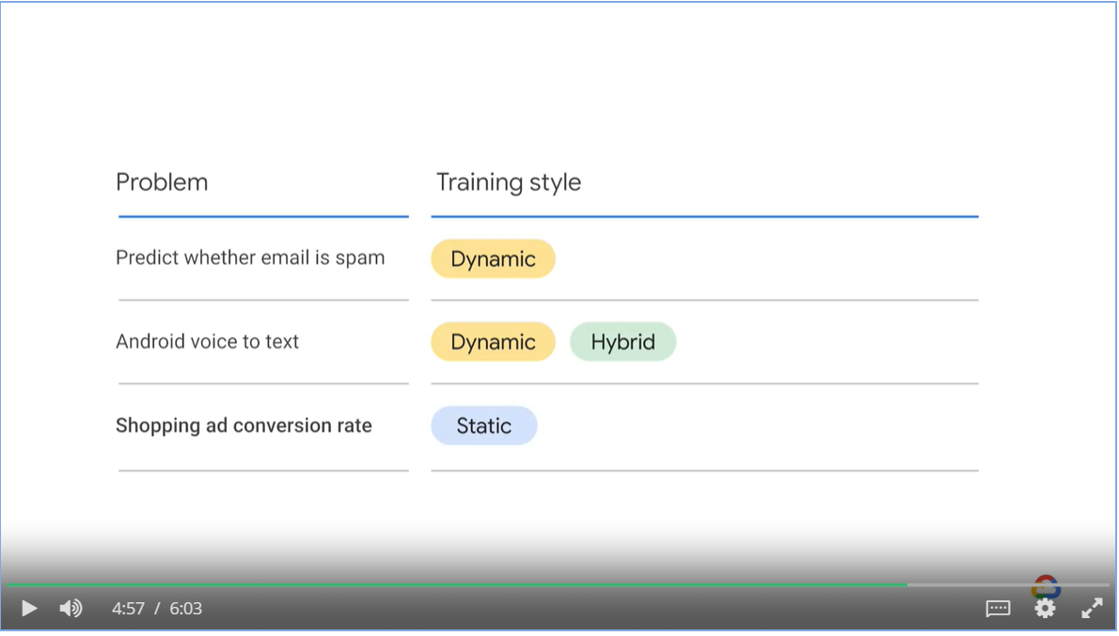

#### Three steps to static serving

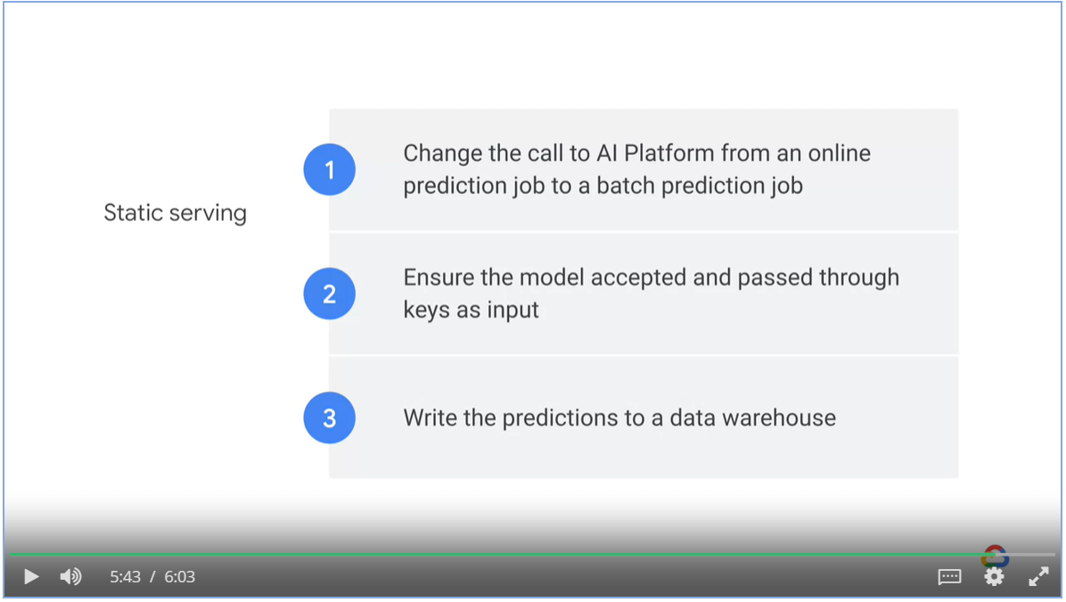

## Using Vertex AI

* Vertex AI brings together the Google Cloud Services for building ML under one unified UI and API.

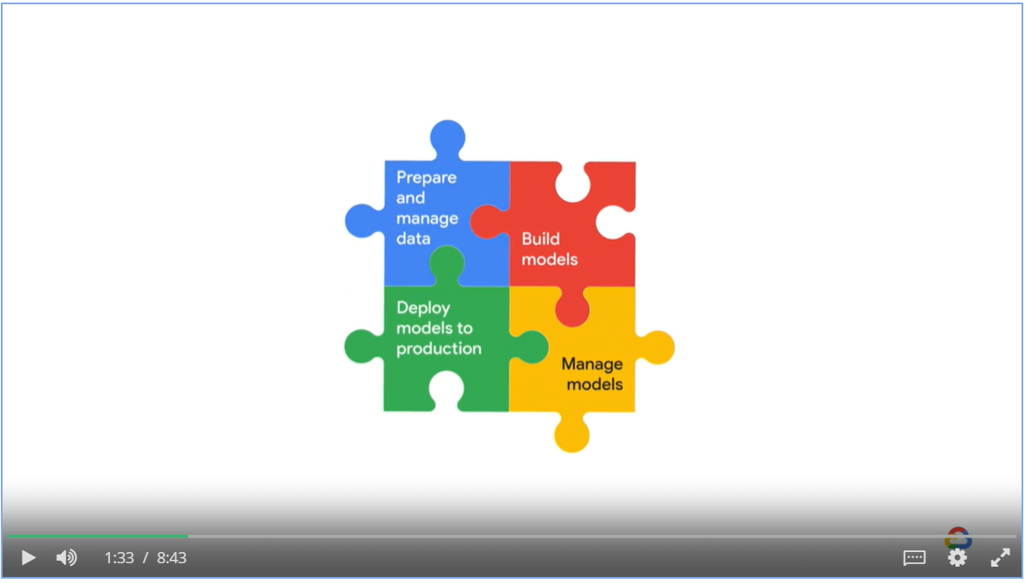

## Week 2: Designing Adaptable ML Systems

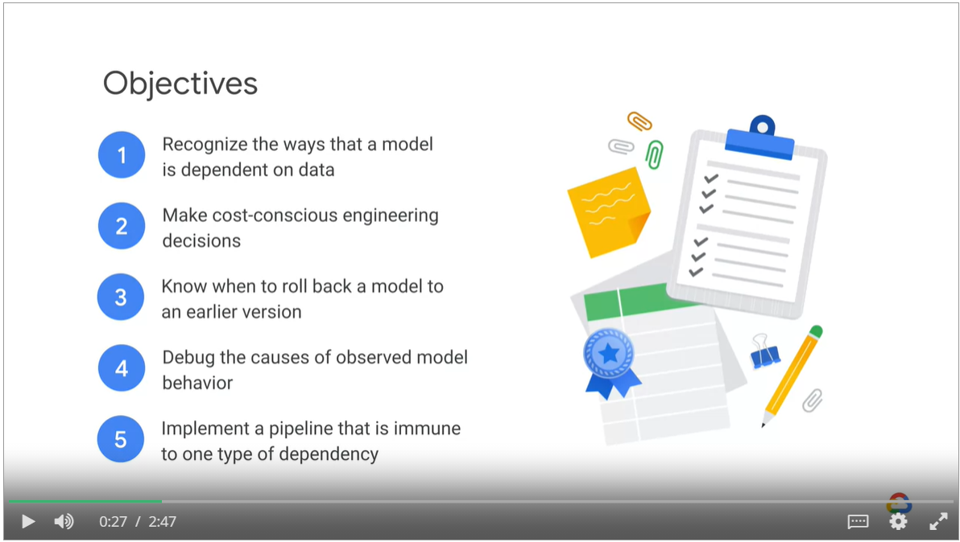

### Adapting to Data

What is likely to change?

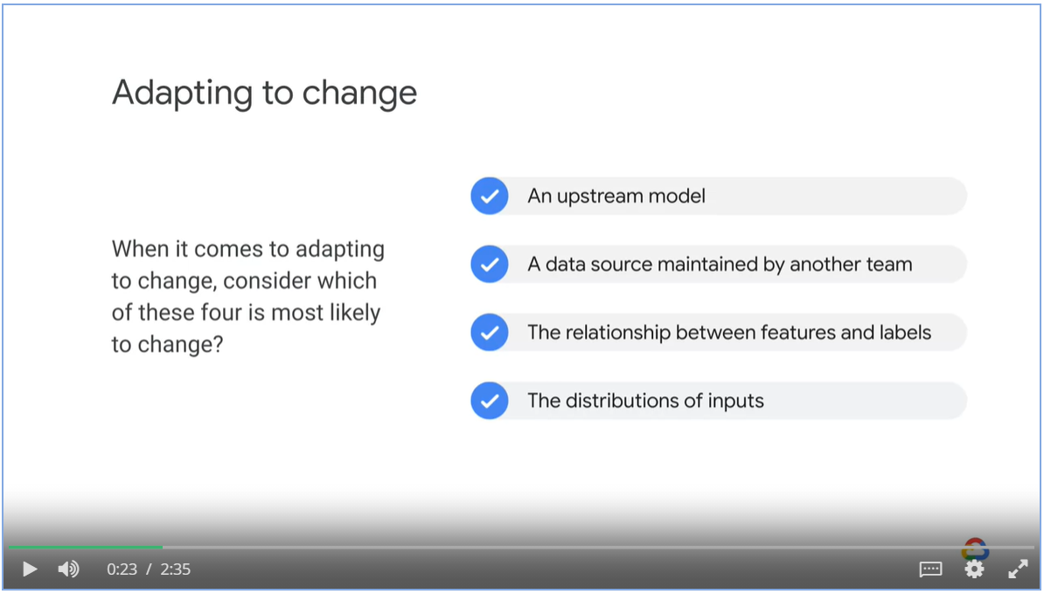

#### Scenario 1: Decoupled upstream data producers

* Data science team consumes website logging data from web dev team
* Web dev teams creates a new logging page without notifying the data science team.
* Decoupled upstream data producers

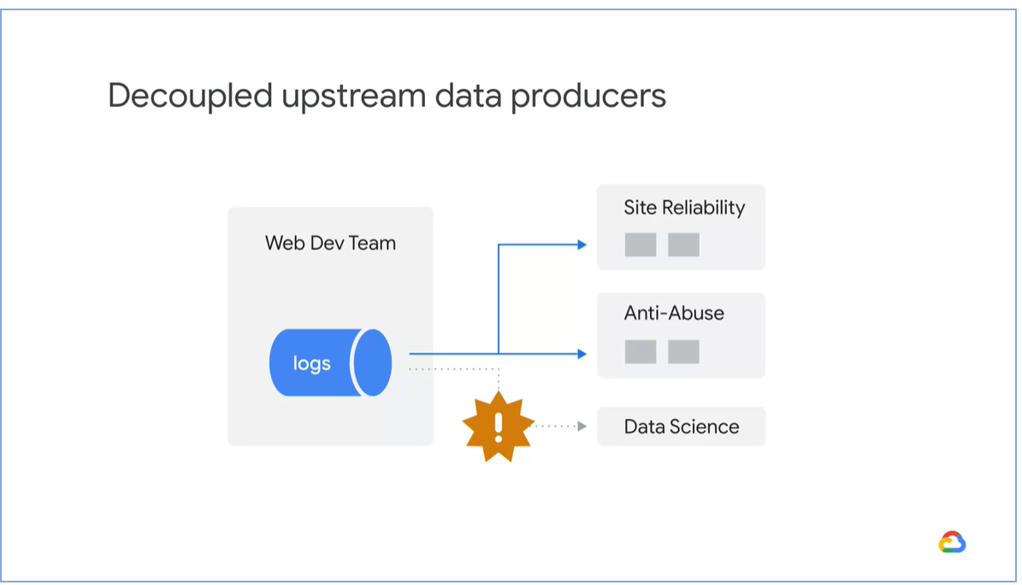

Making a local version of the upstream model and keep it updated.

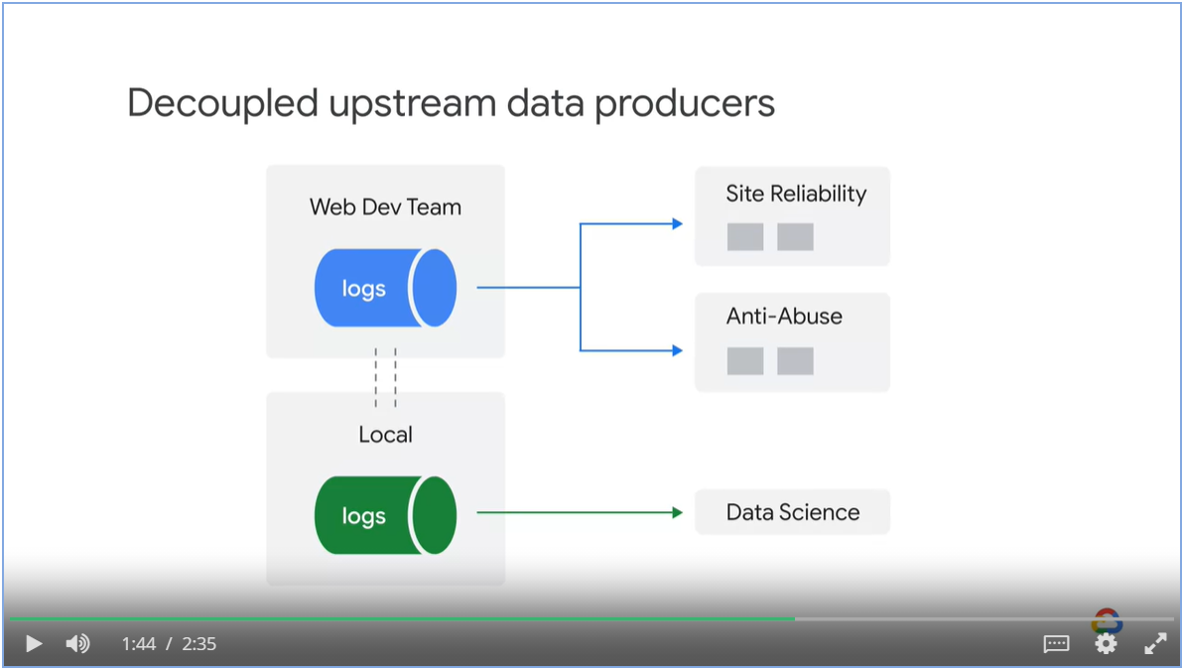

#### Scenario 2 – Changes in features

* Team is under pressure and hastily include all features into the model
* One feature is causal (useful) while other threes are correlated.
* Overtime, the correlated features become uncorrelated and model performance degrades.

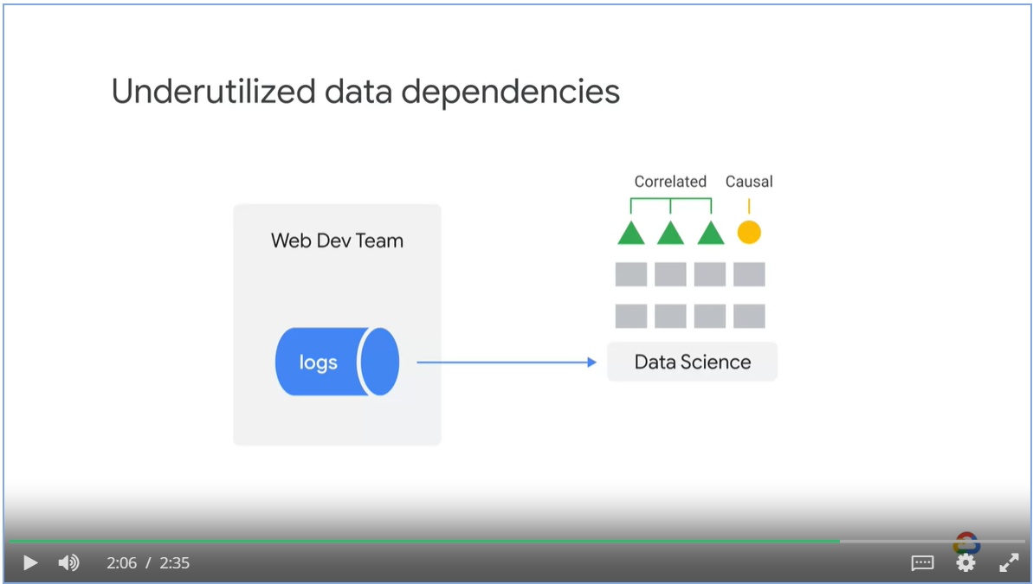

Actions:

* Carefully exam each feature before putting it into the model
* Leave one feature out to see the impact on the model

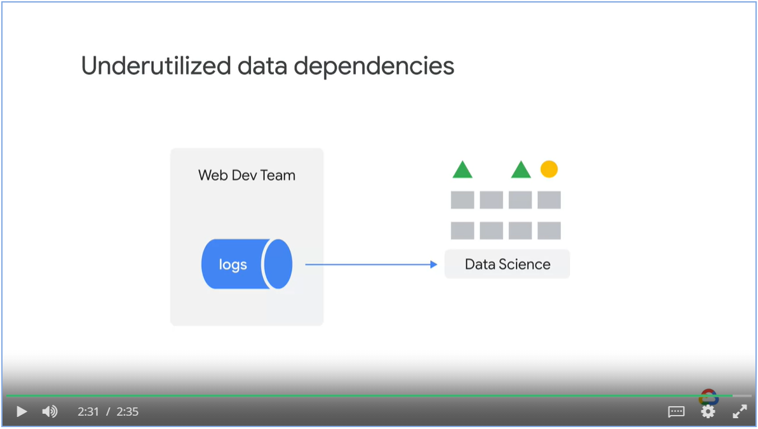

#### Changes in the distribution

The statistical term for changes in the likelihood of observed values like the model inputs is **changes in the distribution**.

* Label distribution can change
* Baby weights are higher in 1984 compared to 1969.

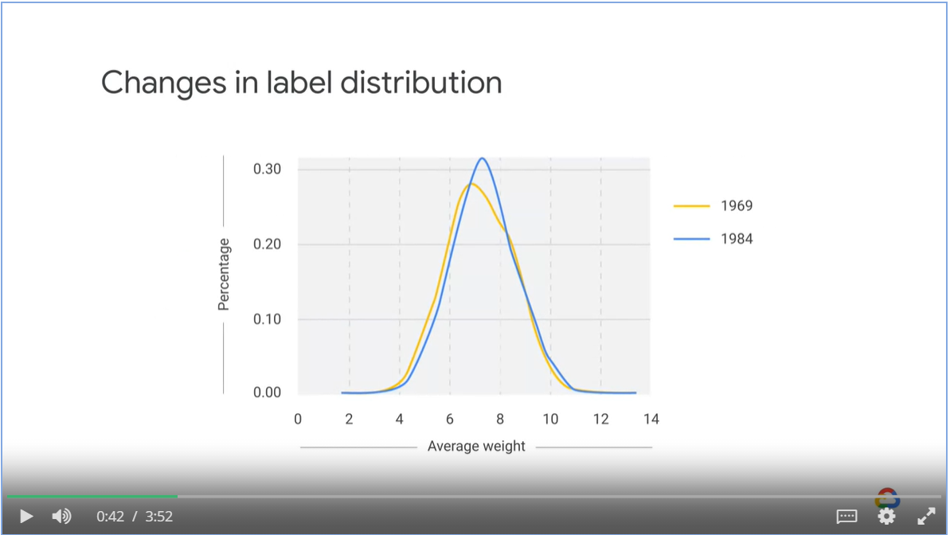

* Change in feature distribution
* Postal code could change every year

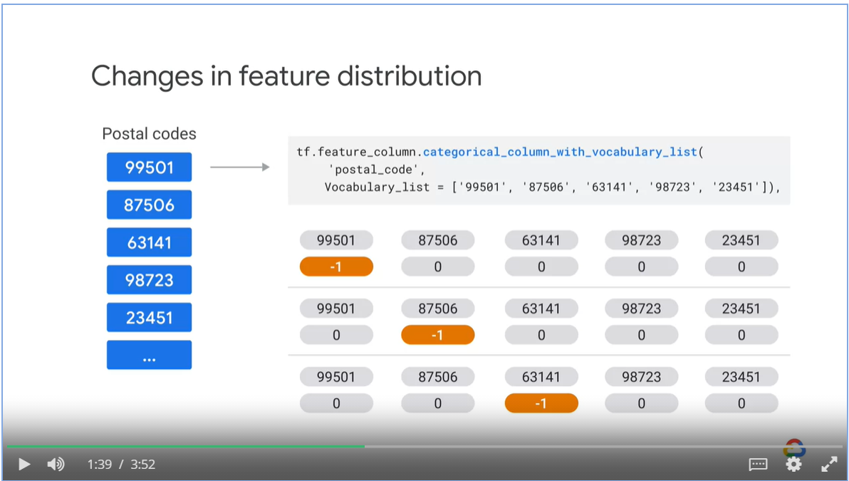

* New postal code is not one-hot encoded.
* Model is forced to make prediction outside the data range that it has seen, a.k.a **extrapolation**.
* **Interpolation** means the model is generalizing within the bounds of what we’ve previously seen.

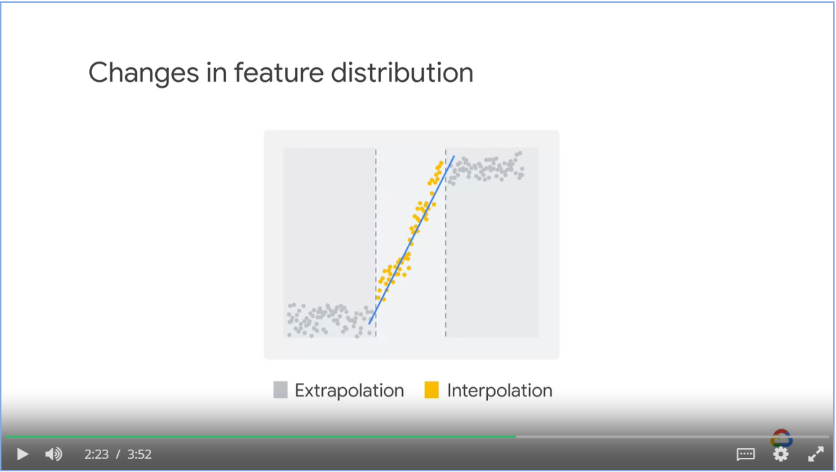

To combat change distributions

* Monitoring

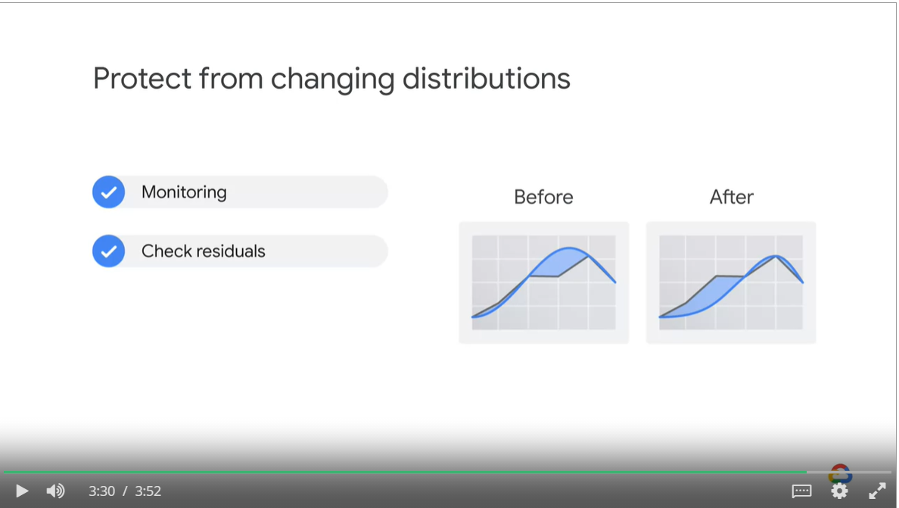

* Emphasize data recency – write model / loss function so it treats recent data more seriously

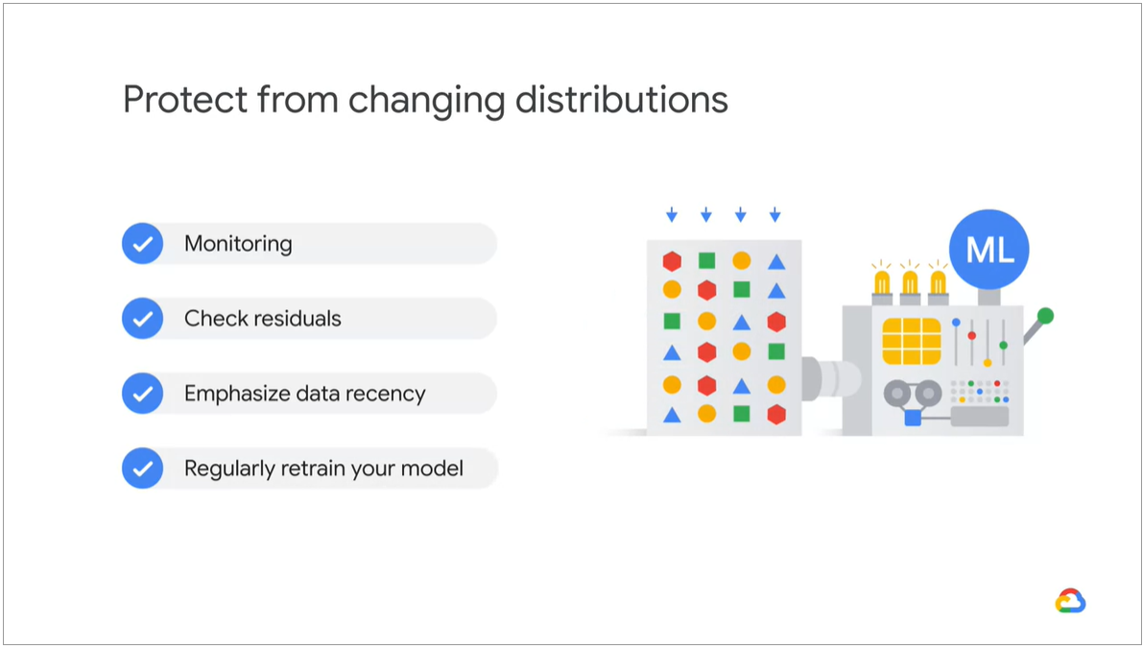

#### Labe: Adapting to Data

Ablation analysis studies the impact of individual feature on model performance

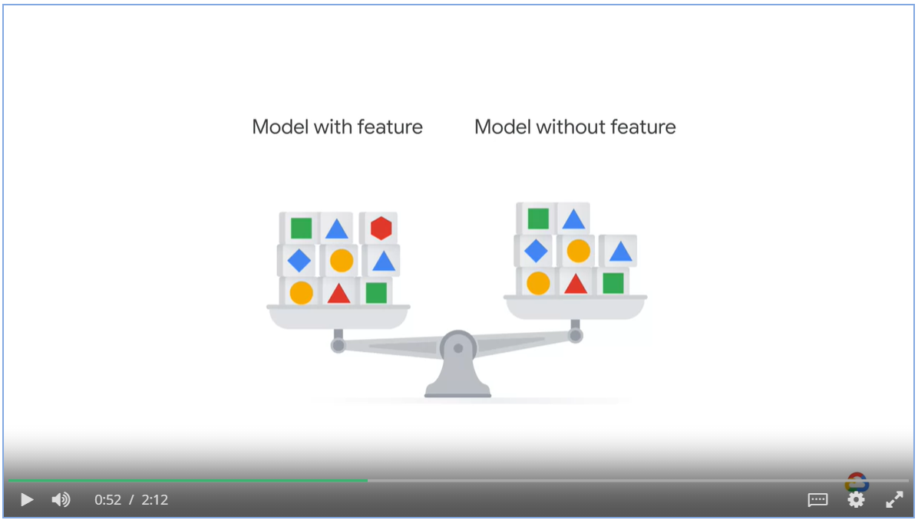

Ablation analysis will reveal legacy features and bundled features

* Legacy features are made redundant by implementation of new features
* Bundled features work well as a whole but not individually and introduce unnecessary dependencies.

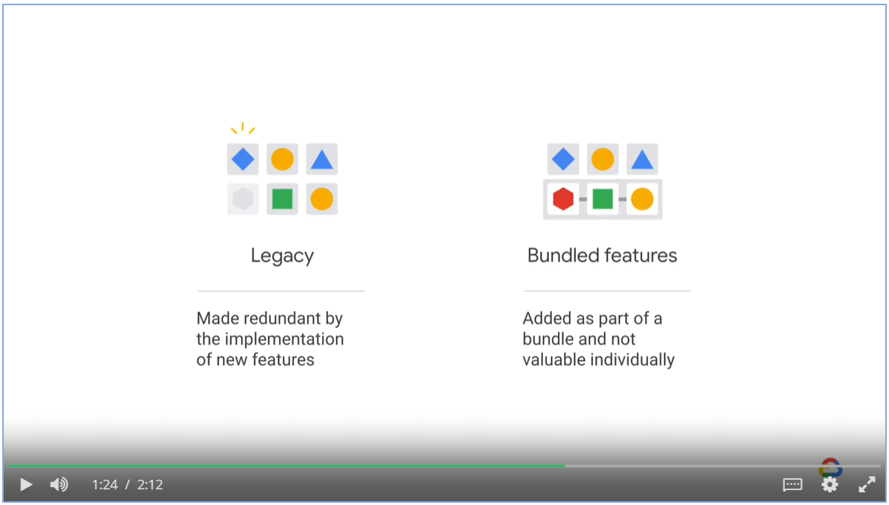

Code Smell

Introduction new features that requires a proprietary code base

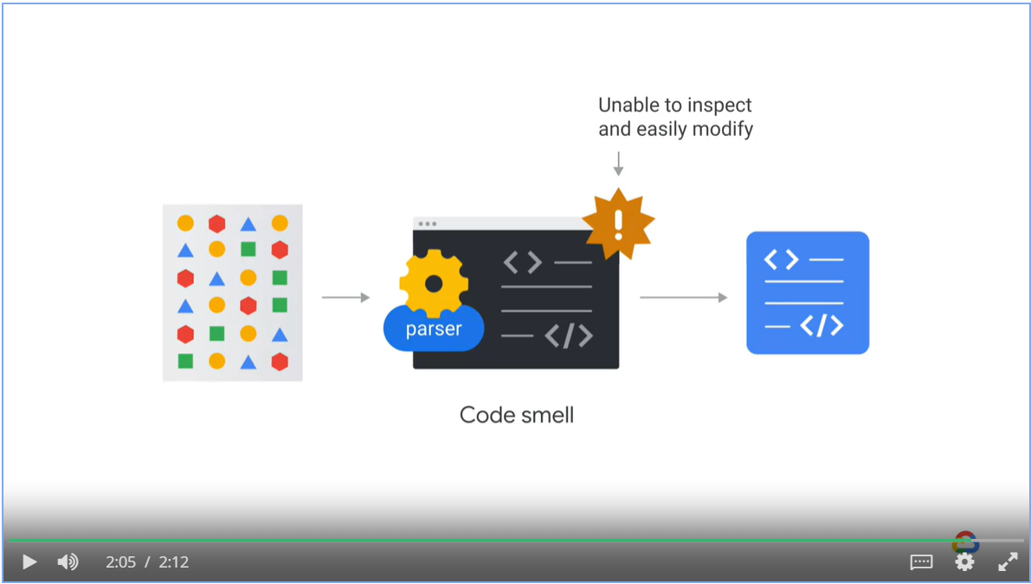

Right and wrong decisions

* Model that predicts cancer performs well in training and testing

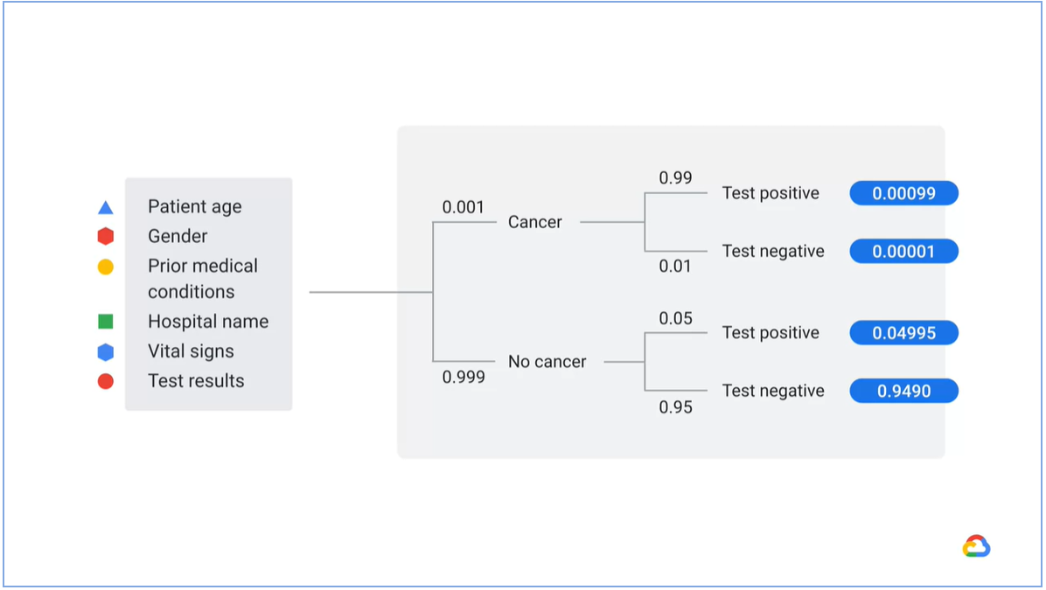

* In production, the feature hospital name is unavailable because patients have not been assigned to hospital.
* Model still attempts to make prediction and treat unavailable hospital name as out-of-vocabulary buckets

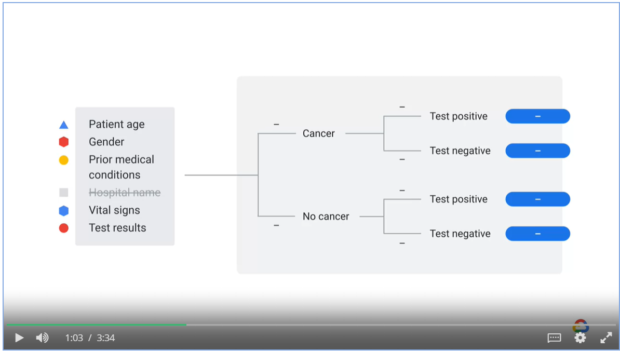

Data Leakage

* When data is somehow leaking into the training data is called data leakage
* In data leakage, model might learn to predict the majority class
* We might train the model using an unknown feature at production time

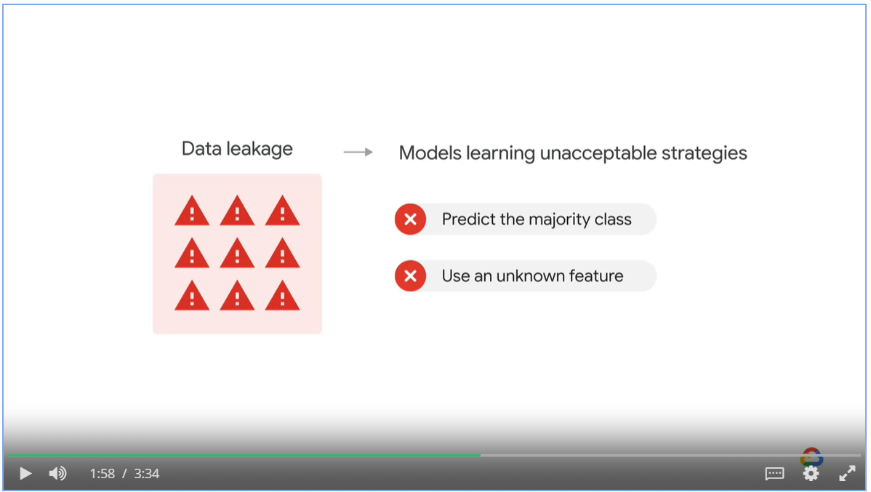

#### System failure

* A product recommendation model based on user click and purchase behavior
* On Black Friday, the transaction and payment server goes down while the website is still running
* The model interprets this as no one who licks is buying anything

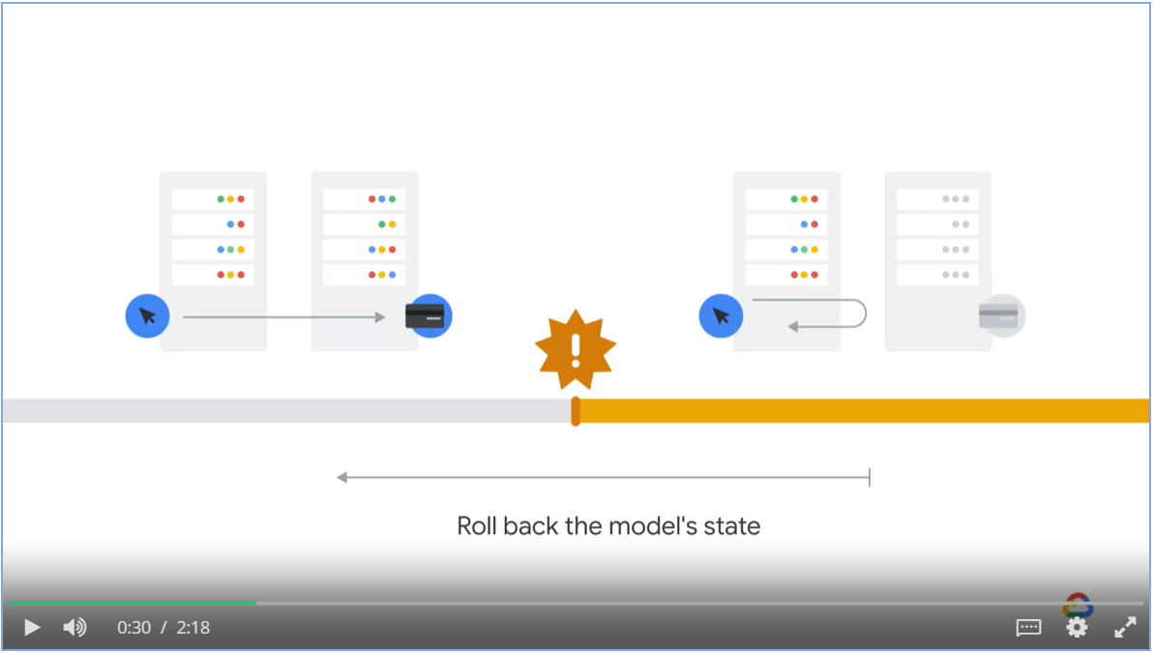

* You need to have an ML pipeline that can role back the model state prior to data pollution.

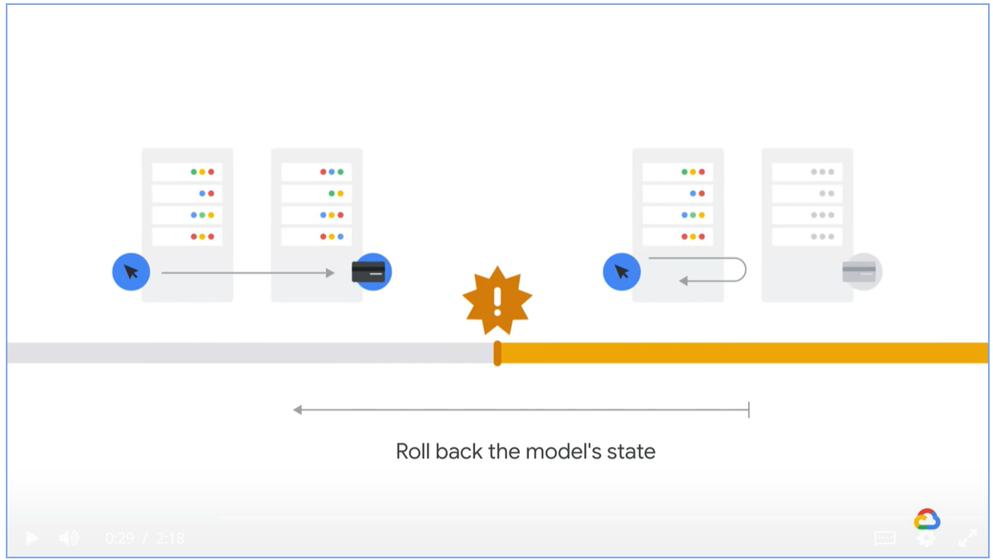

Scenario 2: Cold start

* Build a product recommendation system using **static** model

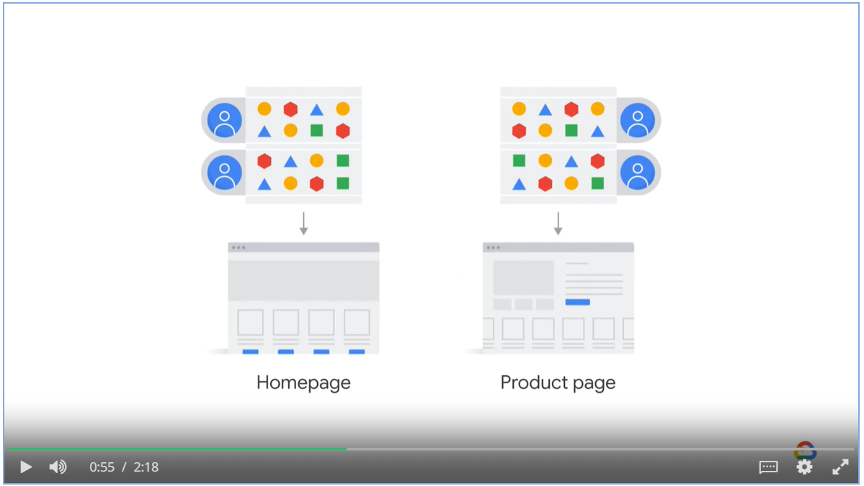

* New users, products and patterns come in
* The model keeps recommending the old product, users start to ignore the recommendation.

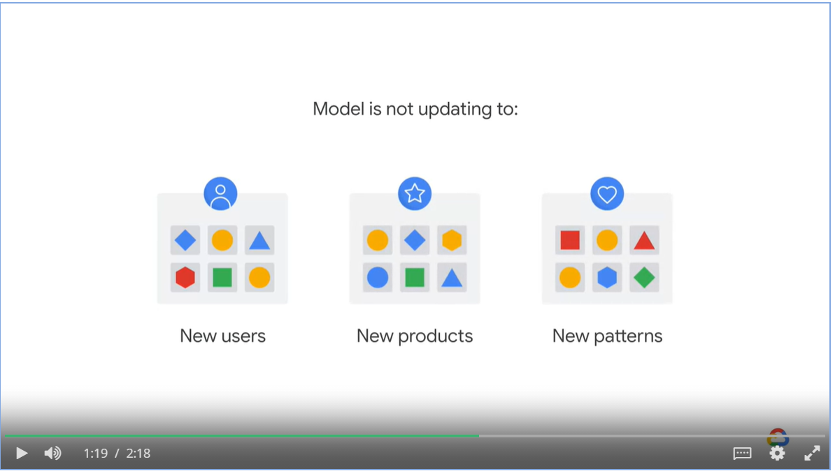

#### Concept drift

Why does ML model performance degrade over time? ML algorithms make assumptions:

* Instances are generated at random according to some probability distribution D
* Instances are independent and identically distributed
* That D is stationary with fixed distributions

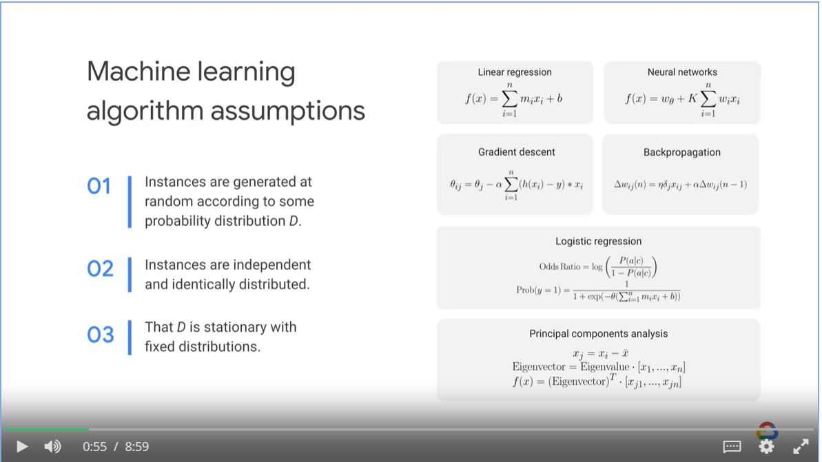

Drift is the change in an entity with respect to a baseline

* Ideally, the data used to train and used in production come from the same distribution, a static model will suffice.
* In reality, the data in production will drift from the baseline data used in training, causing problems.

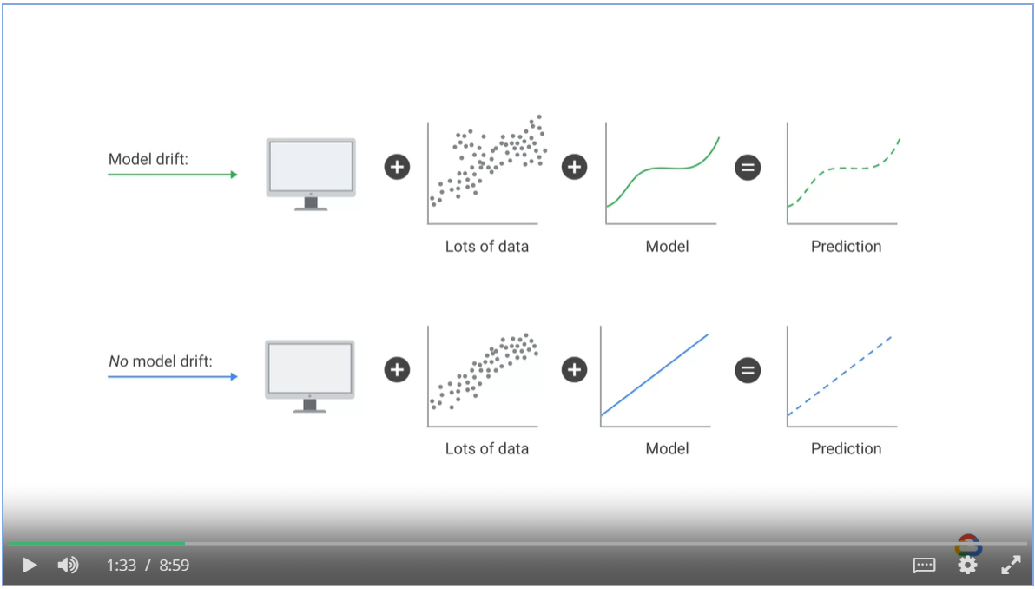

##### Types of drift in ML models

* **Data drift**: A change in P(X) is a shift in the model’s input data distribution
* **Concept drift**: A change in P(Y|X) is a shift in the actual relationship between the model inputs and the outputs
* Prediction drift: A change in P(Y’’|X) is a shift in the model’s predictions.
* Label drift: A change in P(Y Ground Truth) is a shift in the model’s output or label distribution

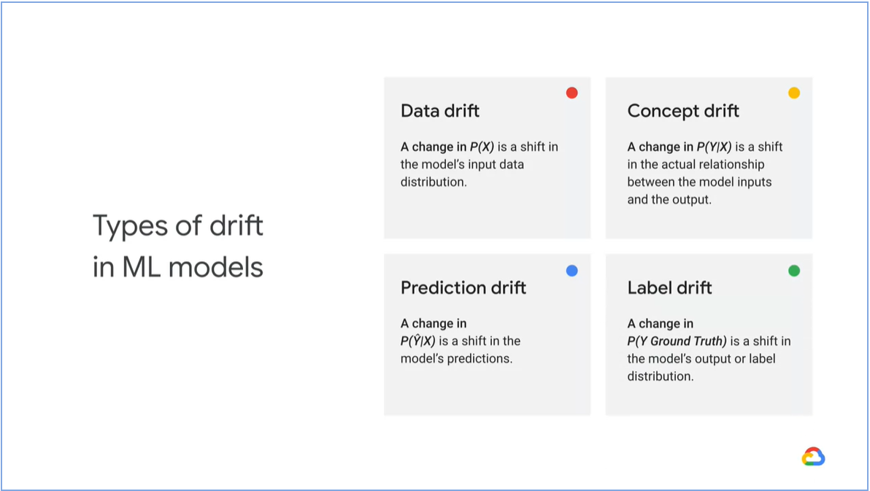

Data drift, feature drift, population and covariate shift all describe changes in the data distribution of the inputs.

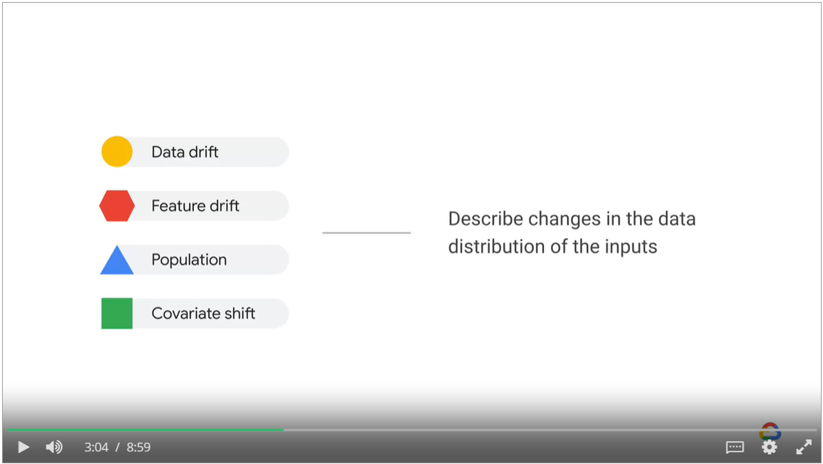

To overcome concept drift

* Extract test data from production system, feed it into the model as an additional to the historical training data set.

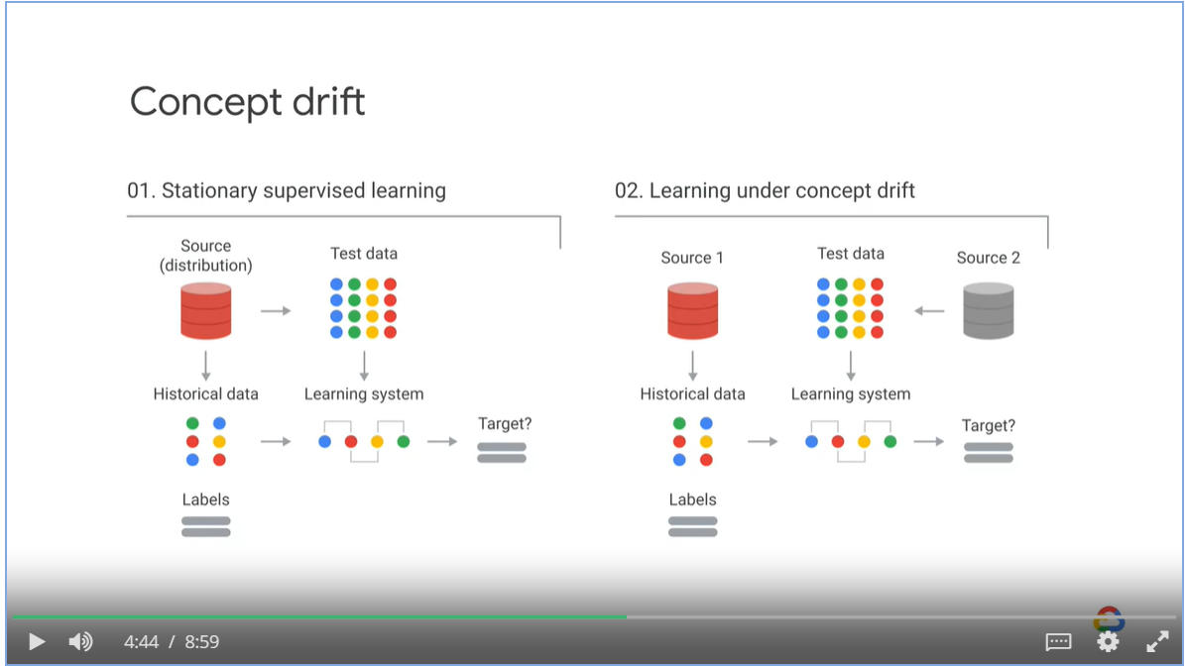

##### A Probabilistic Definition

Concept drift can happen

* Feature space drift
* Decision boundary drift
* Or both

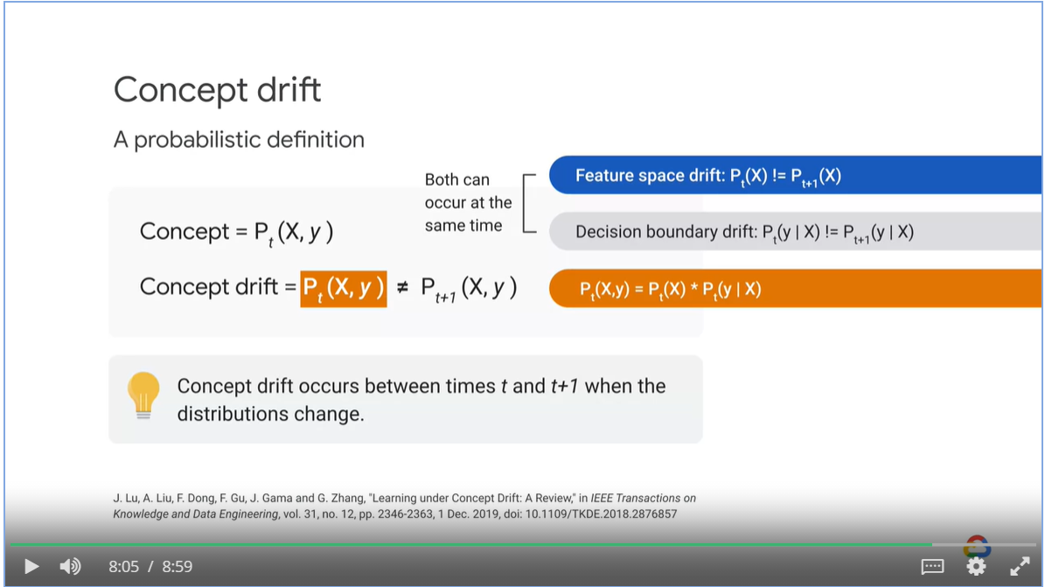

Feature drift can happen in different forms

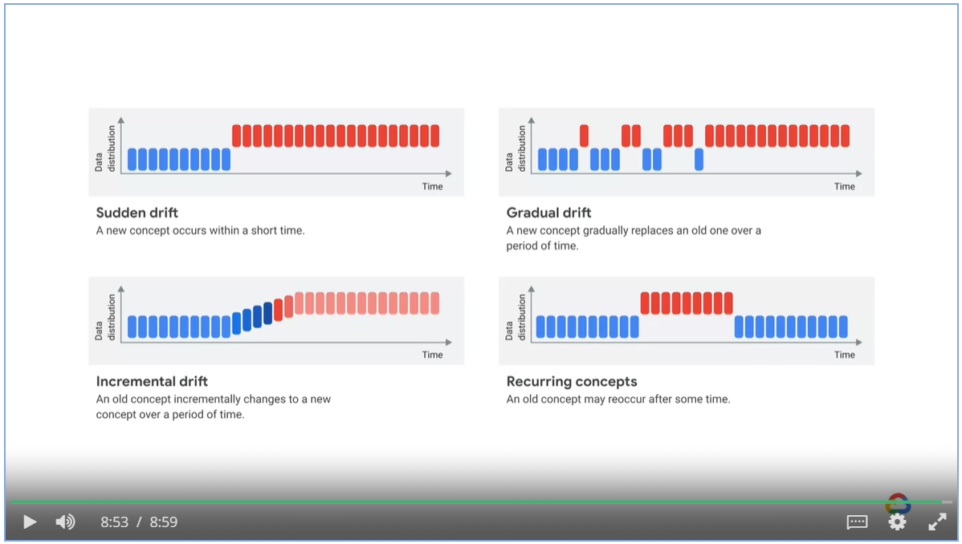

#### Actions to mitigate concept drift

* If you diagnose data drift, enough of the data needs to be labeled to introduce new classes and the model retrained
* If you diagnose concept drift, the old data needs to be relabeled and the model retrained.

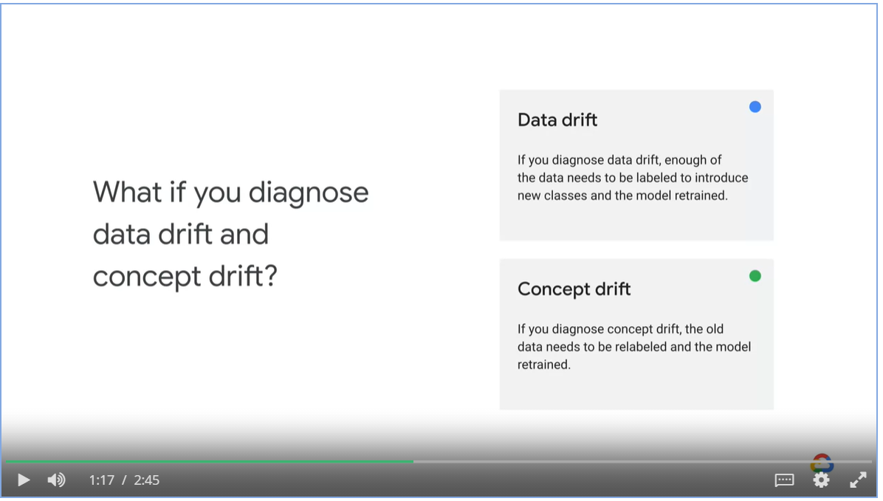

* Design your systems to detect changes

Periodically retrain the model using recent historical data

* Use an ensemble approach to train

Use old model as a starting point for the new model.

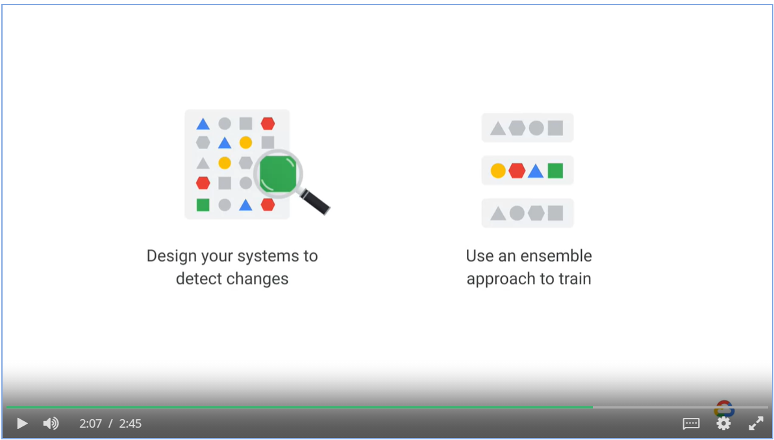

### TensorFlow Data Validation

* TensorFlow Data Validation is a library for analyzing and validating machine learning data in the “ingestion and validation” phase.
* It can
* Validate continuously arriving data
* Detect training / serving skew

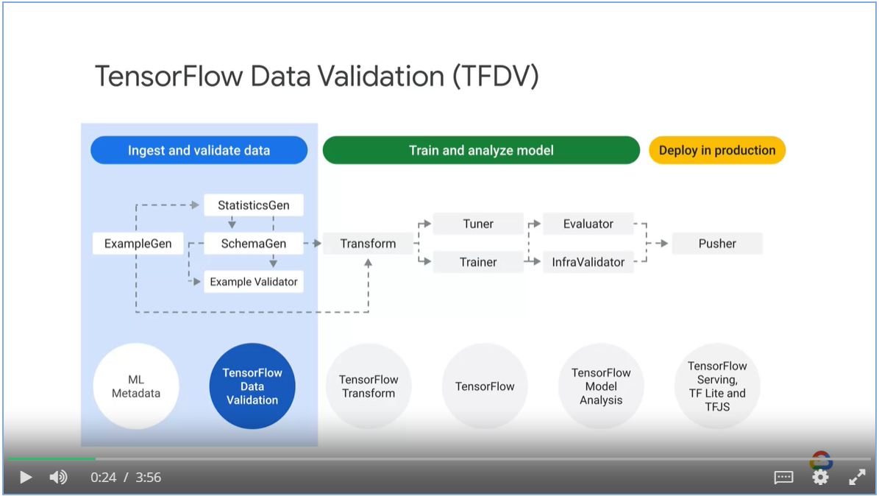

Reasons to analyze and transform your data

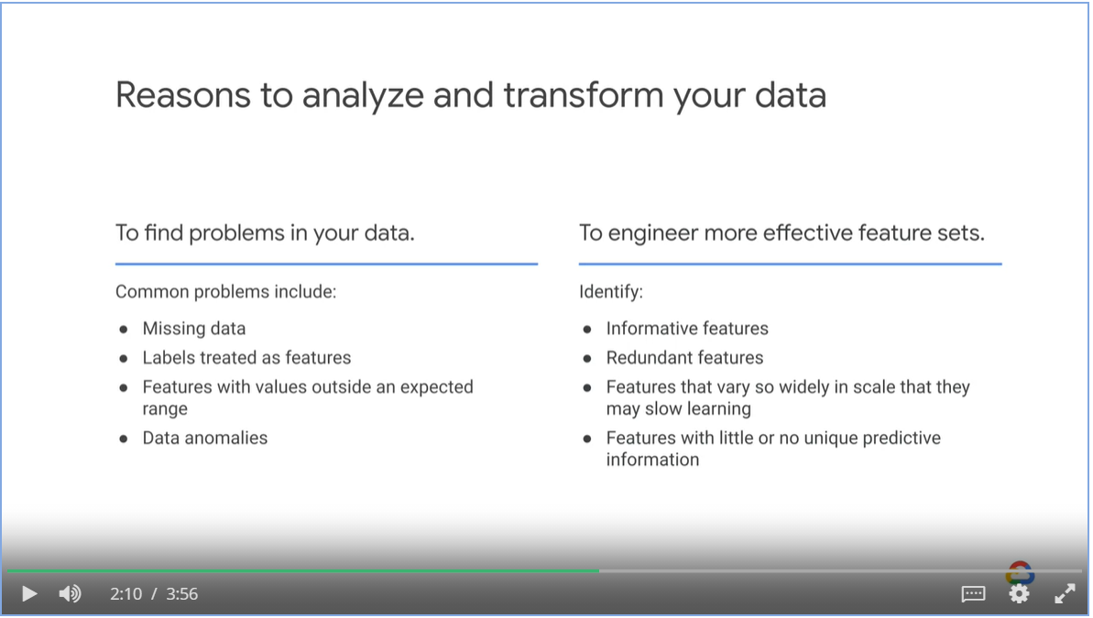

##### Validate continuous arriving data

1. Generate statistics / schema from day 1
2. On day 2 and 3, validate against schema generated in day 1

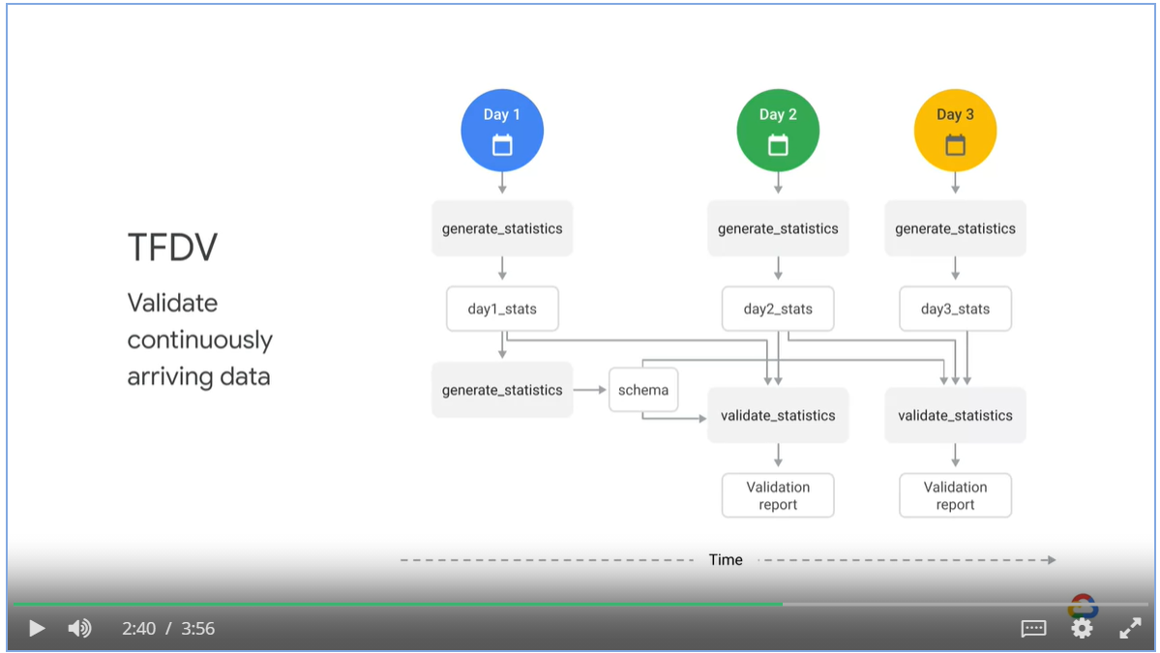

##### Detect data skew

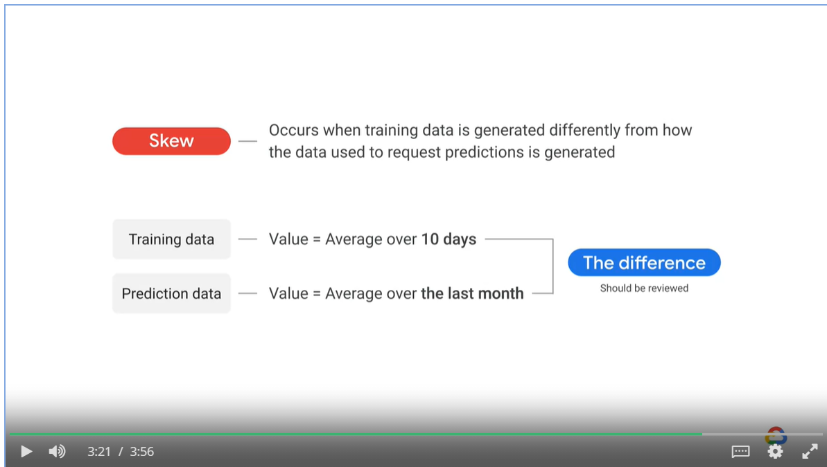

##### Components of TFDV

* StatisticsGen, SchemaGen and ExampleValidator

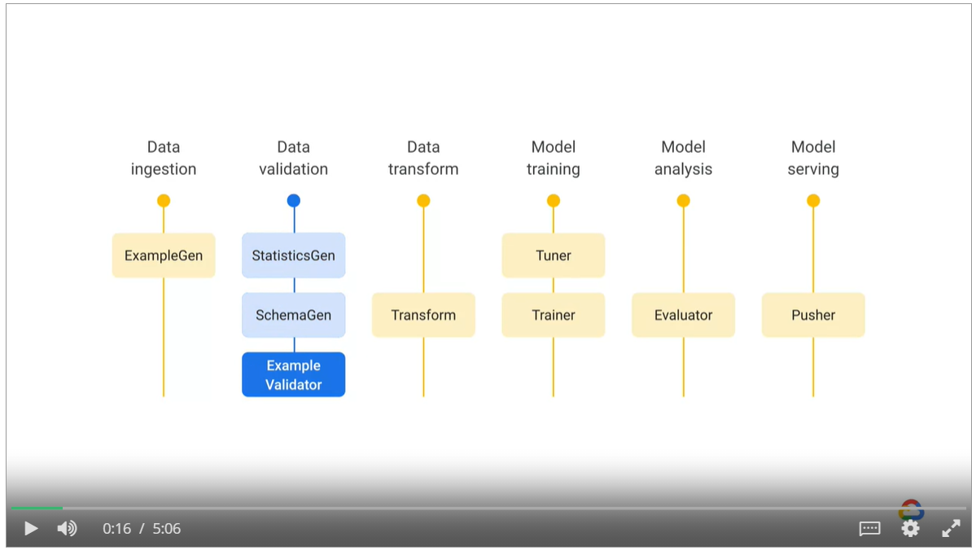

StatisticsGen compute sample statistics and compare the training and the new dataset

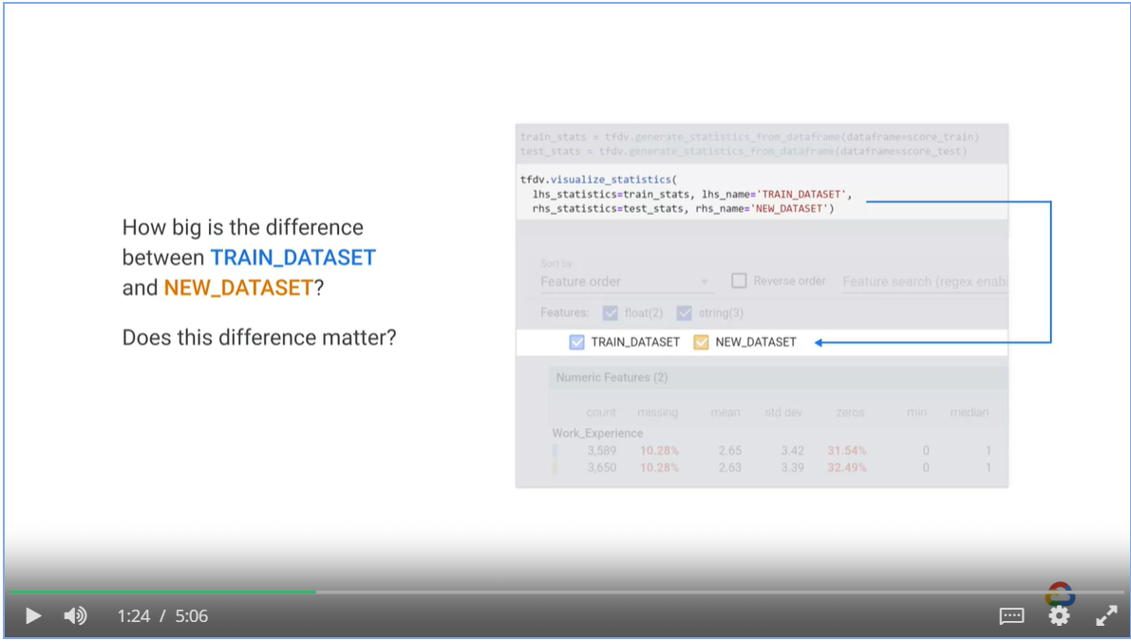

It can also help identify unbalanced data distribution

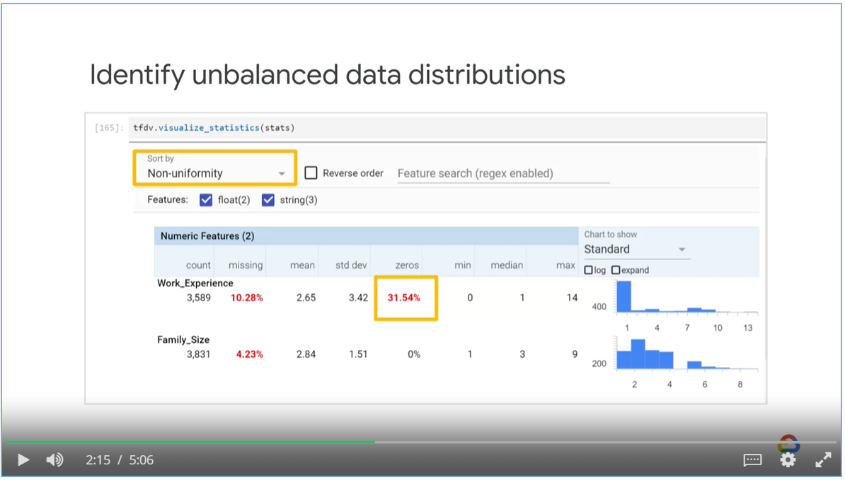

SchemaGen looks at the data, infers its type and nullability

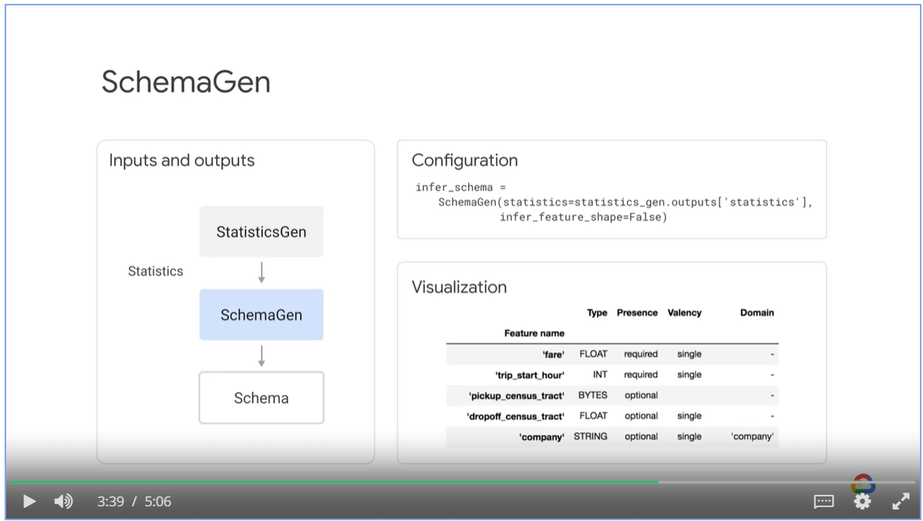

ExampleValidator compares the statistics generated by StatisticsGen to the schema from SchemaGen

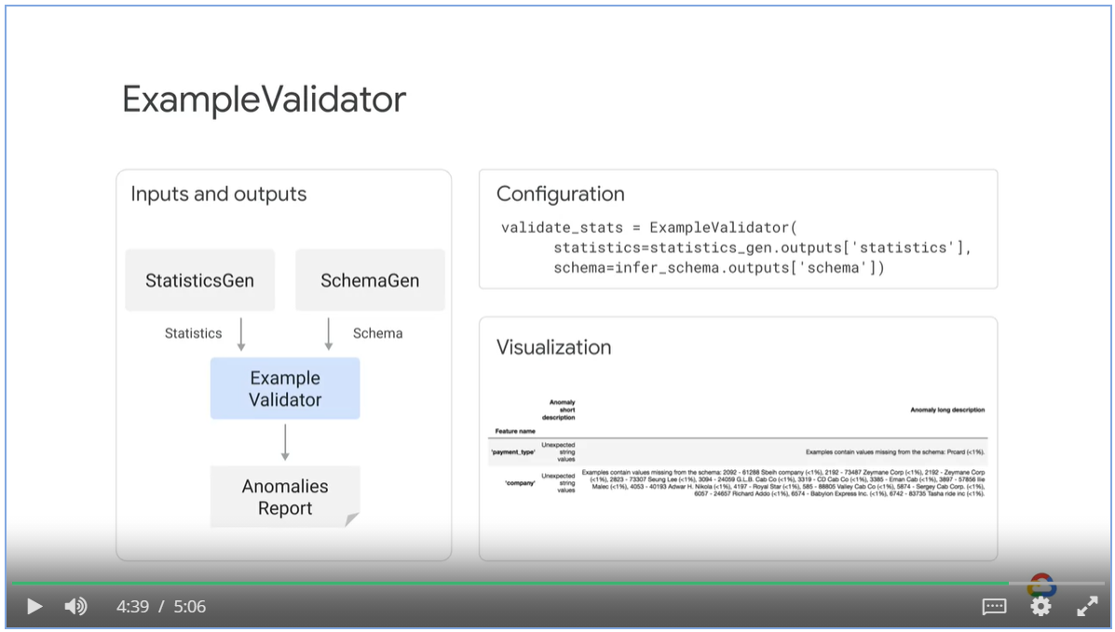

### Mitigating Training-Serving Skew

## Week 2: Designing High-Performance ML Systems

Objectives:

* Identify performance consideration for ML models (io vs computation)
* Choose appropriate ML infrastructure (scale up or scale out)
* Select a distribution strategy

### Aspect of Performance

#### Performance in Training

* When considering infrastructure, the performance of the model should remain the same
* You should not sacrifice model accuracy for model training time.

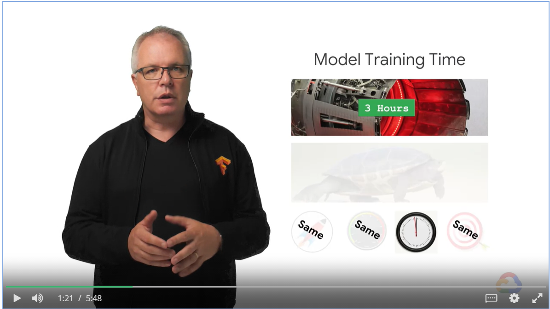

* If you train your model on a daily basis
* Account for the time it takes for the pipeline to ingest and transform the data
* Account for the time for testing and deployment
* You might end up with 18 hours for training

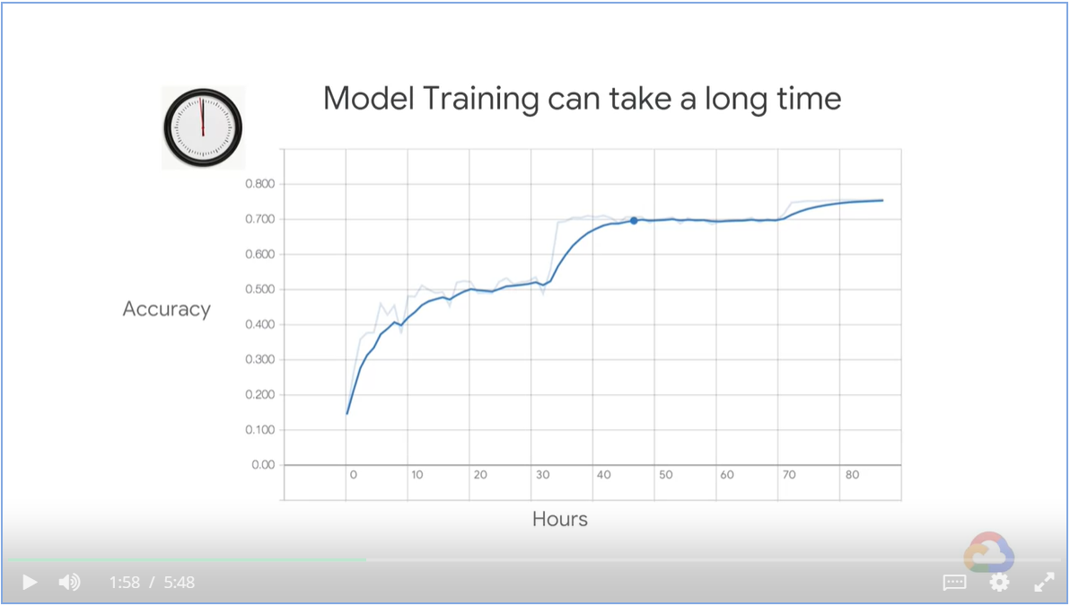

* Analyze benefit of Model vs Running Cost
* There might be diminishing return when you keep feeding training data into the model.

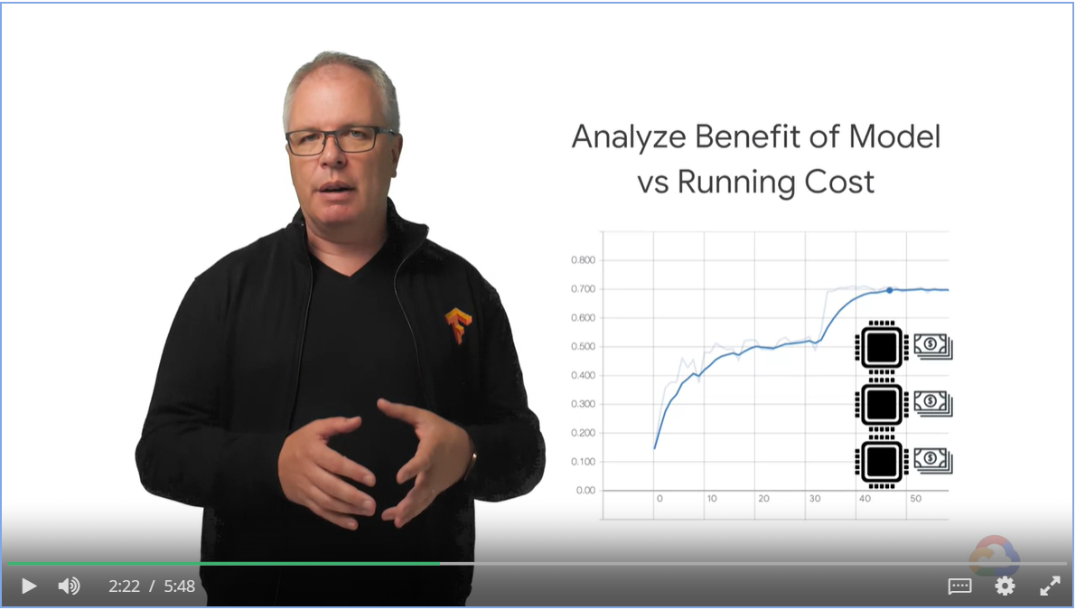

Use earlier model checkpoints to speed up the training.

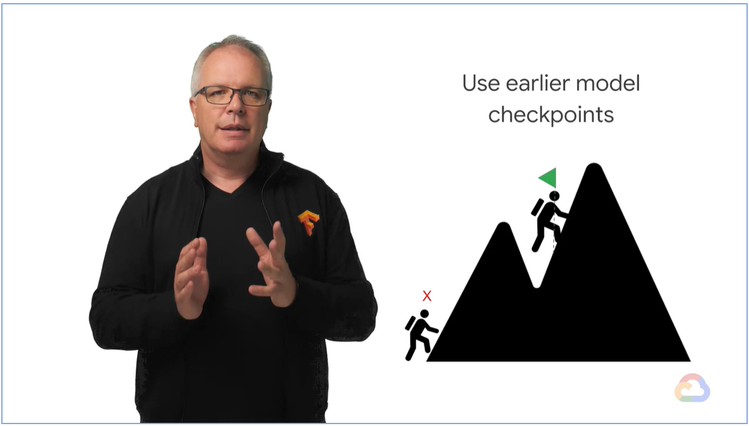

##### Tuning Performance

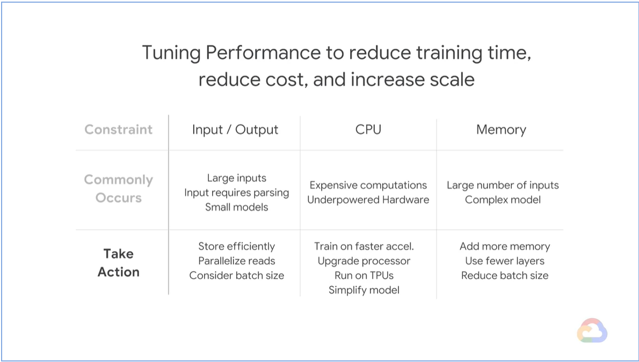

#### Performance in Predictions

* When doing batch prediction, the considerations are similar to those when training your model

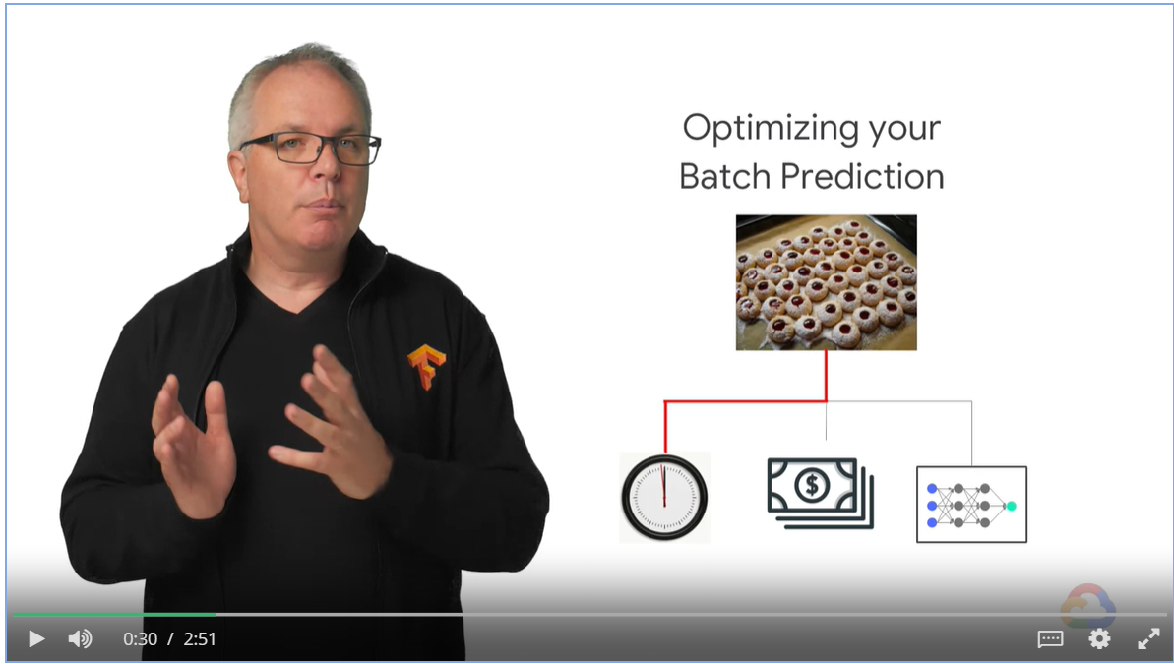

* When serving ad-hot prediction using APIs, they are deployed to multiple microservices.
* Query Per Seconds is an important metrics.

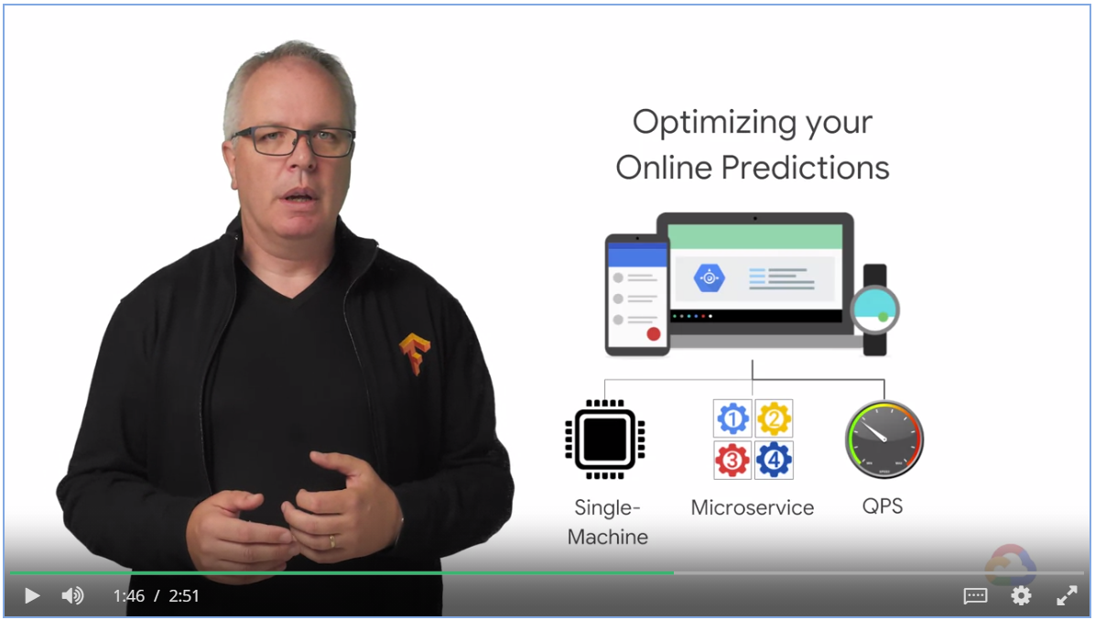

### Distributed Training

#### Why Distributed Training is Needed

* Large dataset decreases error (blue line)
* More complex model decreases error, compare orange line to the blue
* Size of training data set grow exponentially, while the validation error decreases linearly

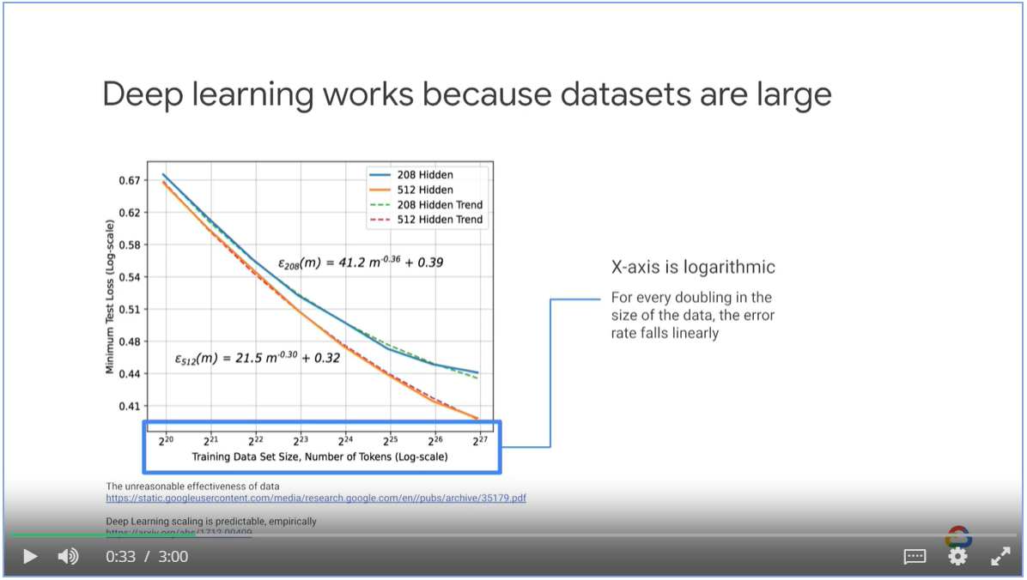

* Computational power required by the new algorithms grows 10x

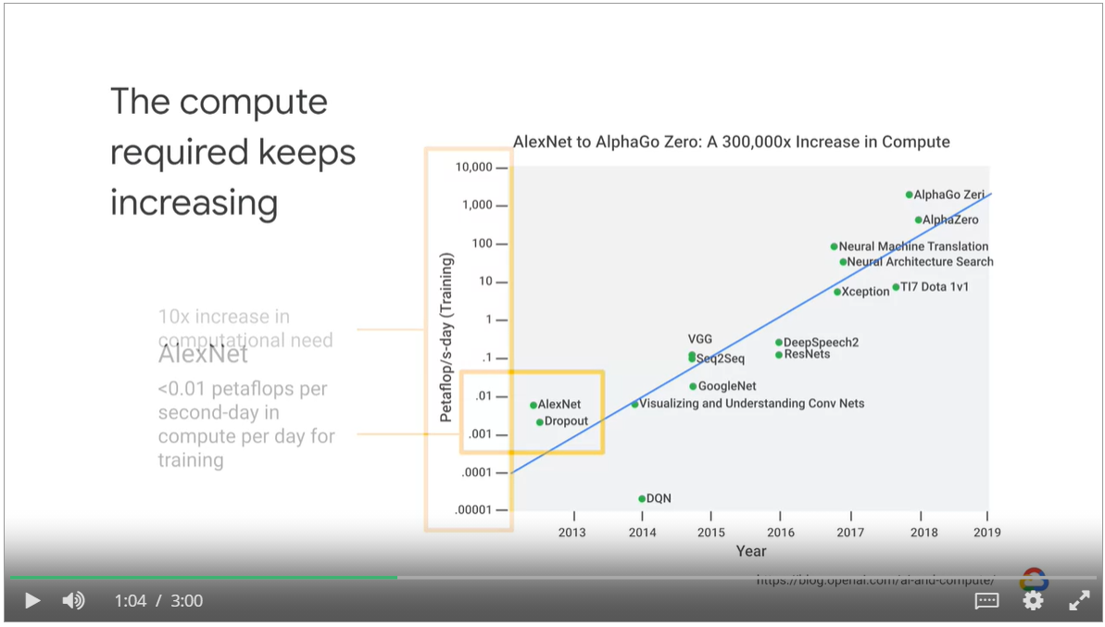

Longer training time prevents us from iterating new ideas quickly

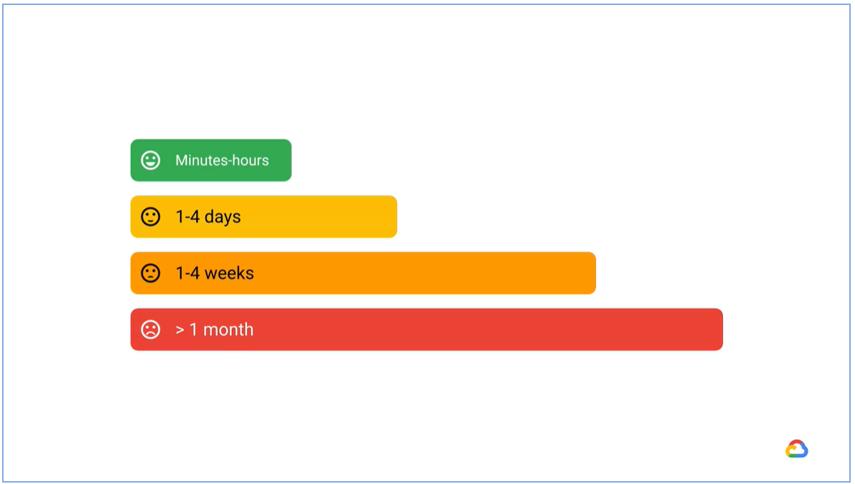

How to make training faster

* Use a more powerful device
* Optimize your input pipeline
* Try distributed training

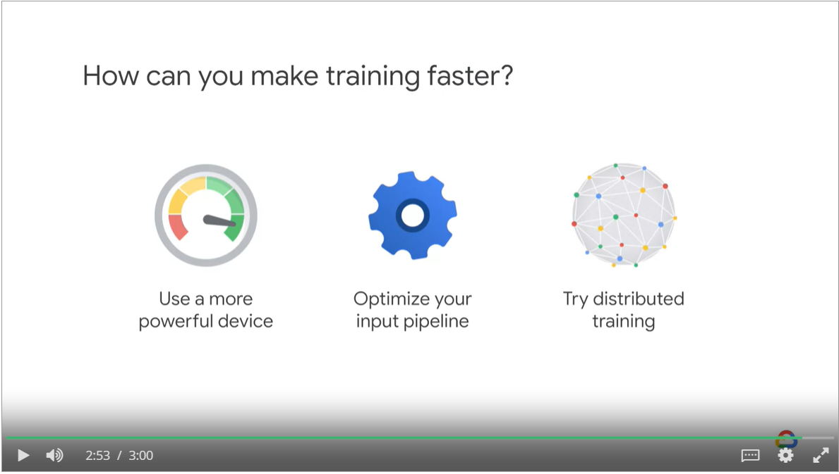

#### Distributed Training Architectures

* Distributed training distributes training workloads to across multiple mini-processors or worker nodes
* These worker nodes work in parallel to accelerate their training process.

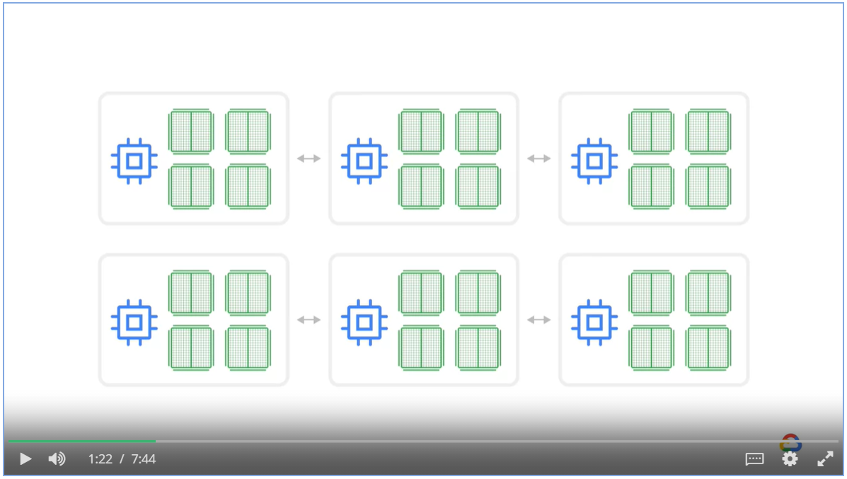

##### Types of Distributed Training Architecture

* Data parallelism, model agnostic
* Model parallelism

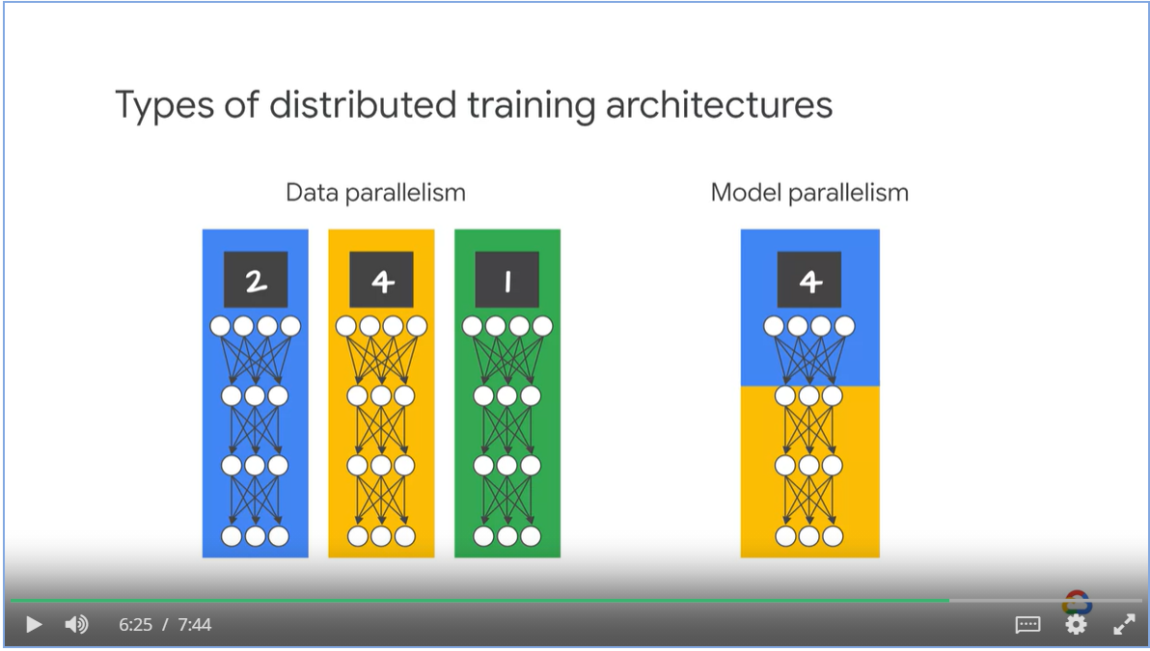

##### Data parallelism

* Each device compute loss and gradient based on their own slice of training samples
* Then they update model’s parameters using theses gradients.
* One machine compute 20 epochs vs. 2 machines compute 10 epochs each and they sync the weights with each other after every epoch.

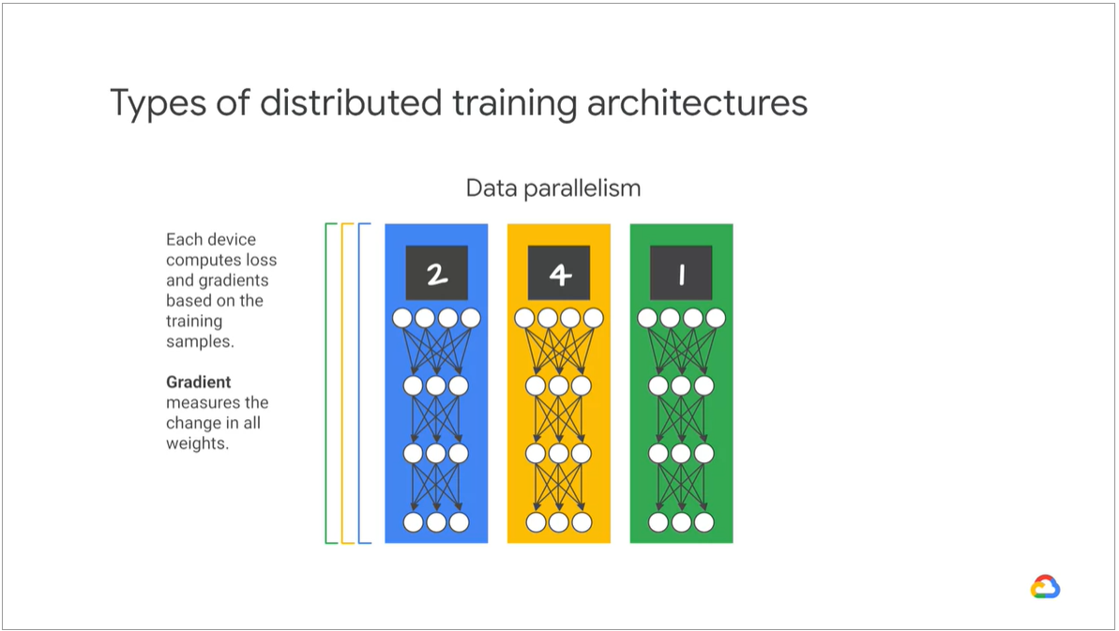

###### Updating weights in Data Parallelism model approaches

* Synchronous AllReduce architecture (p0, p1 are parameters)
* Asynchronous parameter server architecture (ps0 and ps1 are parameter servers )

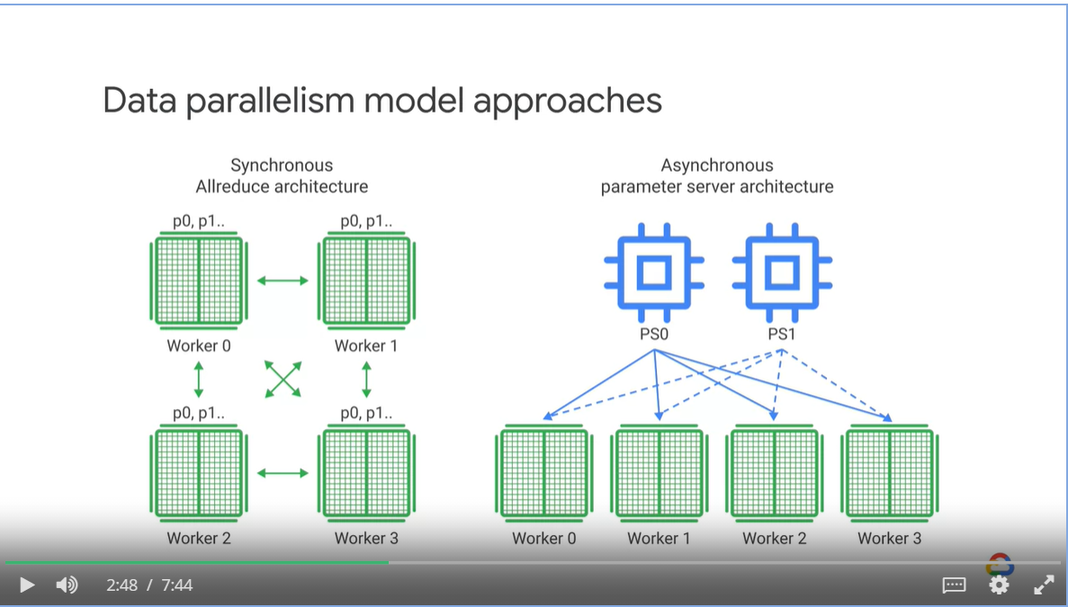

###### Synchronous architecture

* Each worker node get a slice of the data from the same mini-batch
* Each worker node compute forward and backward passes through the model to yield a gradients
* Each training mode exchanges the gradients via an AllReduce operation (usually the mean of all the gradients) at the end of each training iteration
* The optimizer performs the parameter updates with the reduced gradients, keeping the devices in sync.
* All works can only procced to next around of mini-batch training after all works have finished computing and synced their gradients.

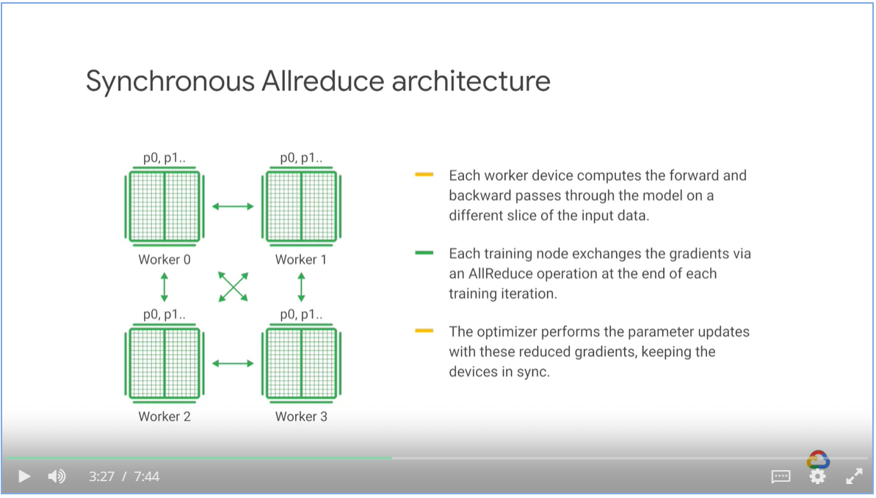

###### Asynchronous architecture

* Each works fetch parameters form parameters servers independently

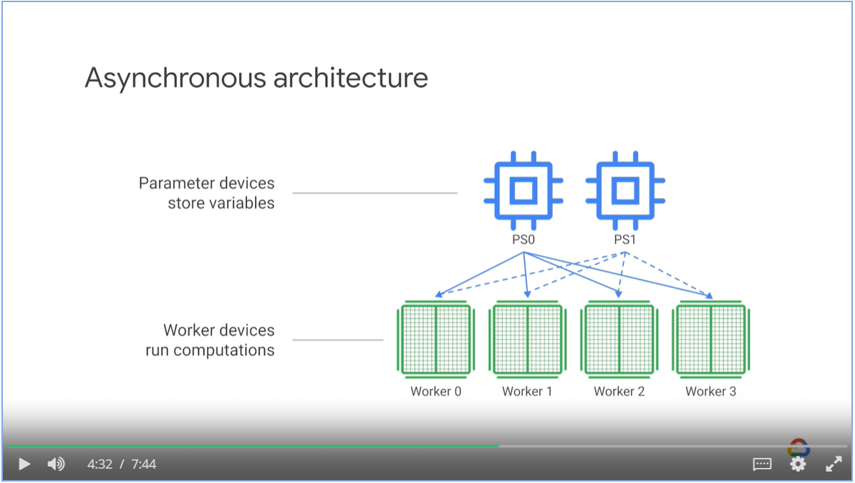

* However, workers might get out of sync and performs computation on weights that are already outdated.

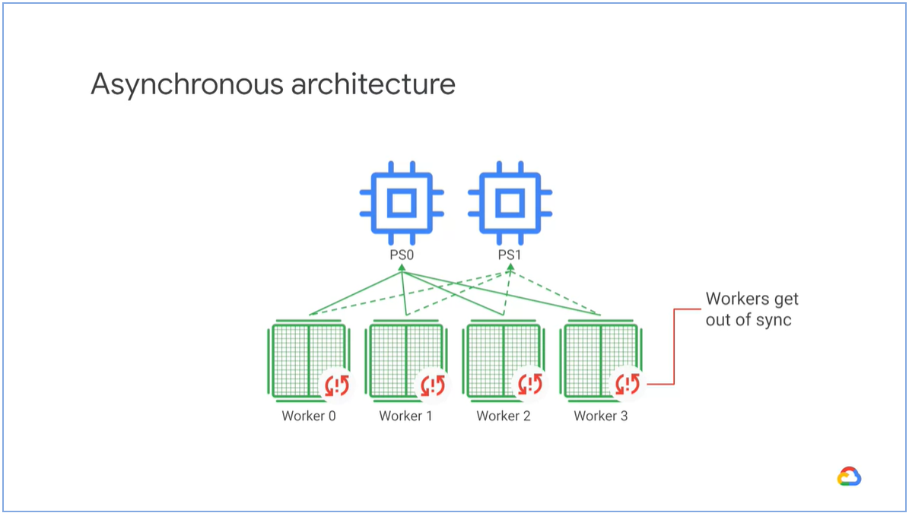

* Asynchronous approach works well for sparse models

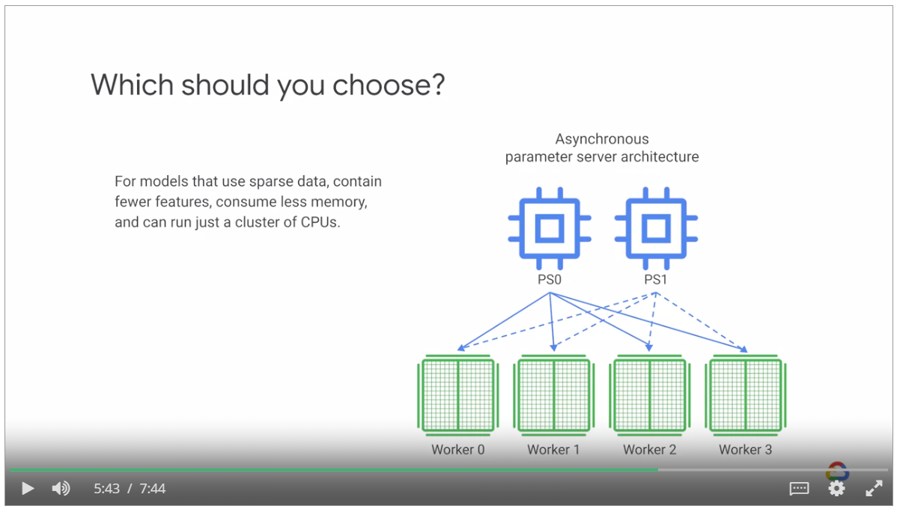

* The synchronous approach works well for dense models such as BERT

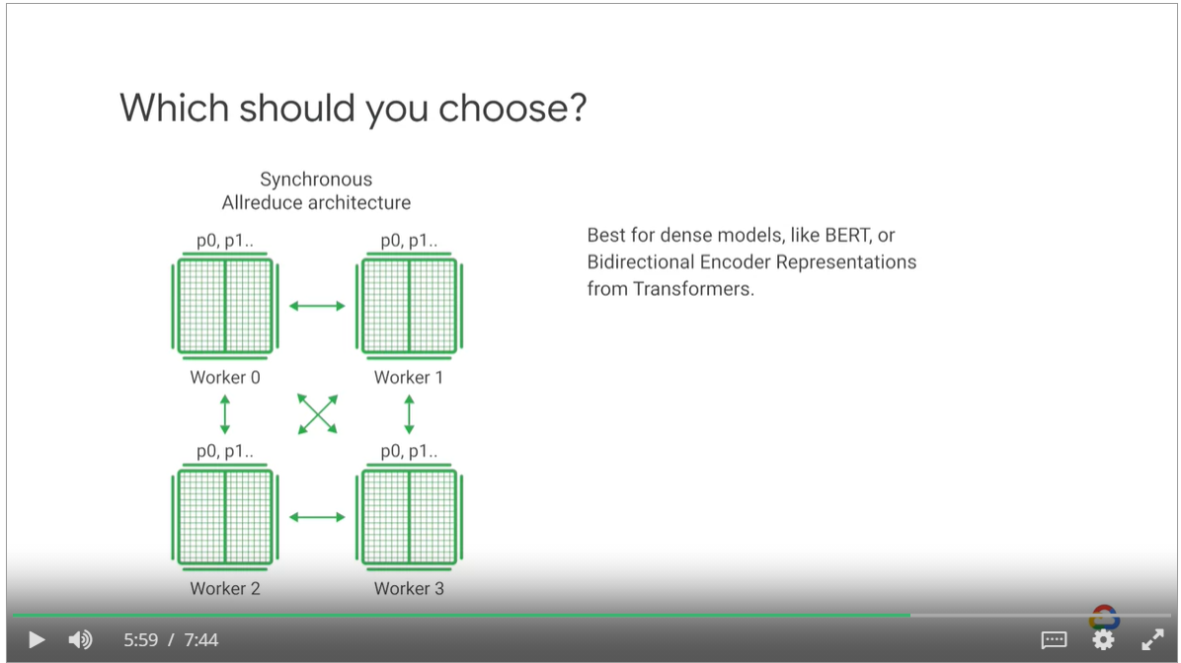

##### Model Parallelism

* Same data is provided to all GPUs
* Each GPU gets a slice of a model (one or several layers)
* Gradients from each model on each GPU are accumulated after a backward process and the parameters are synchronized and updated.

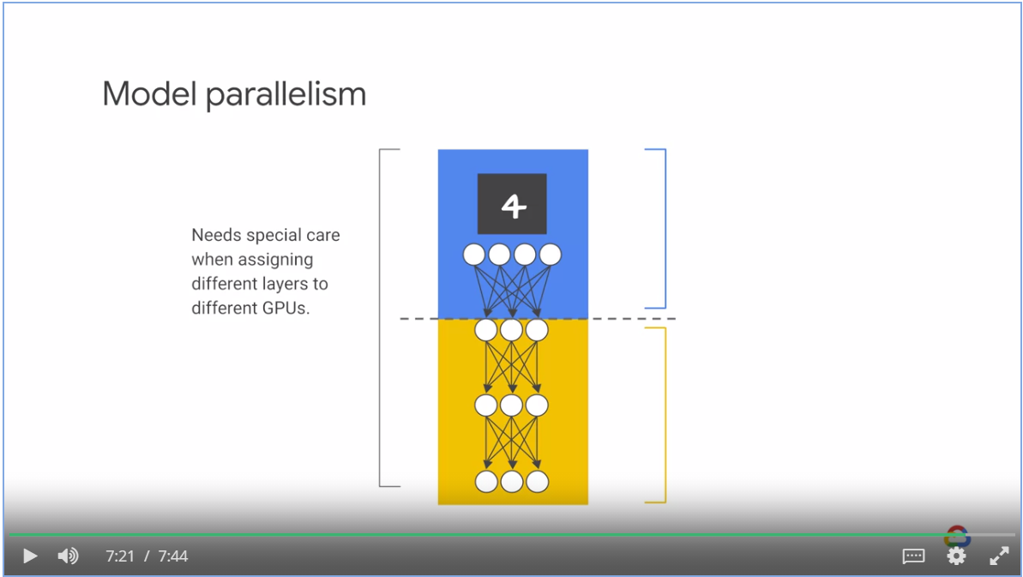

##### Hybrid approach: Model and data parallelism

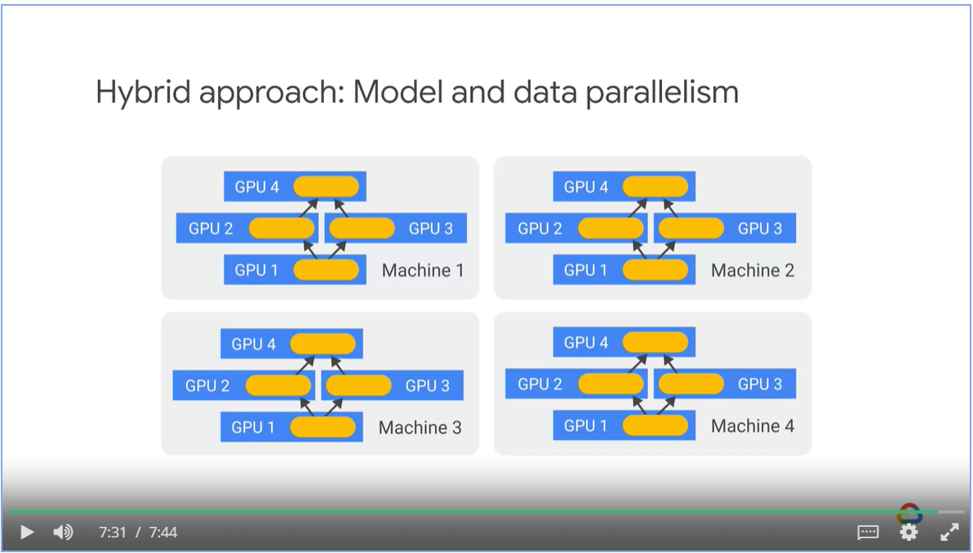

TensorFlow distributed training strategies

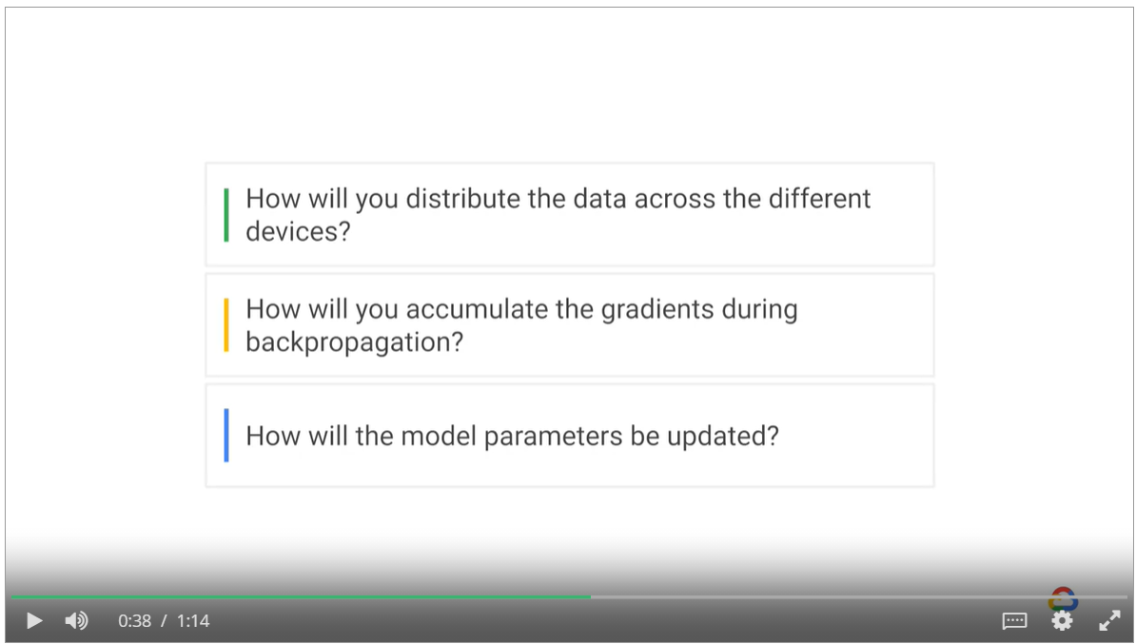

##### TensorFlow distributed training strategies

* Mirrored strategy
* Multi-worker mirrored strategy
* TPU strategy
* Parameter server strategy

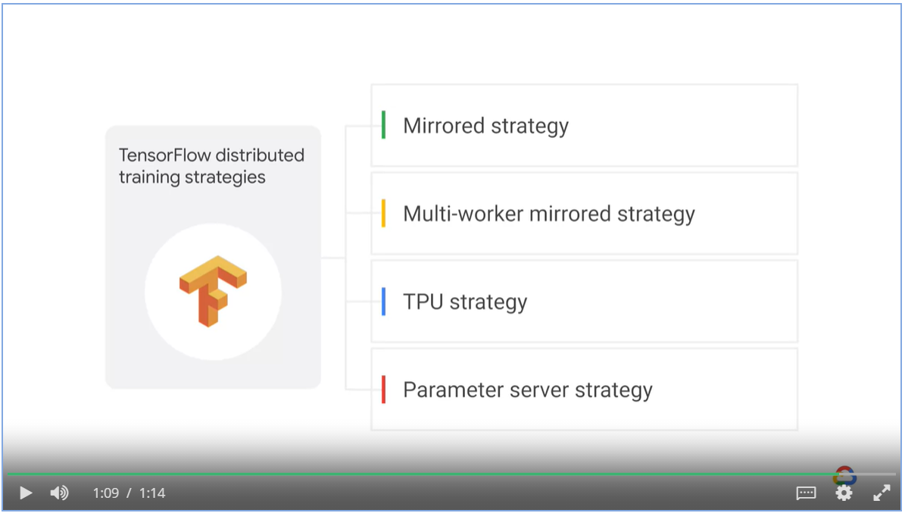

###### Mirrored strategy

* A single machine with multiple GPU
* Replica of models are created on each GPU, mini batch is split into n parts, n equals number of GPUs
* Mirrored strategy manages data distribution and gradient updates across all devices.

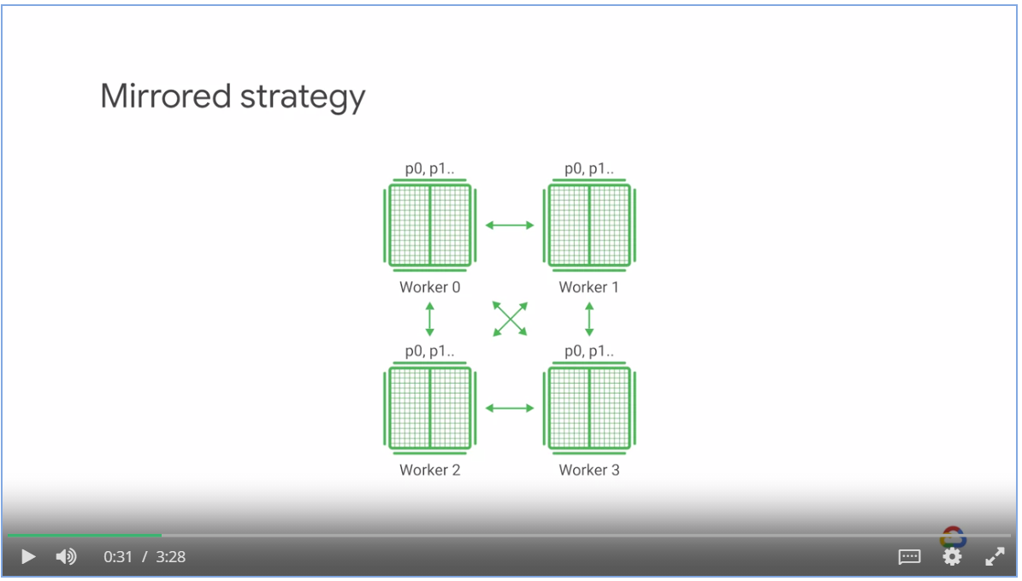

* Each replica will get 64 observations.
* Total batch_size for one epoch is 64 * strategy.num_replicas_in_sync

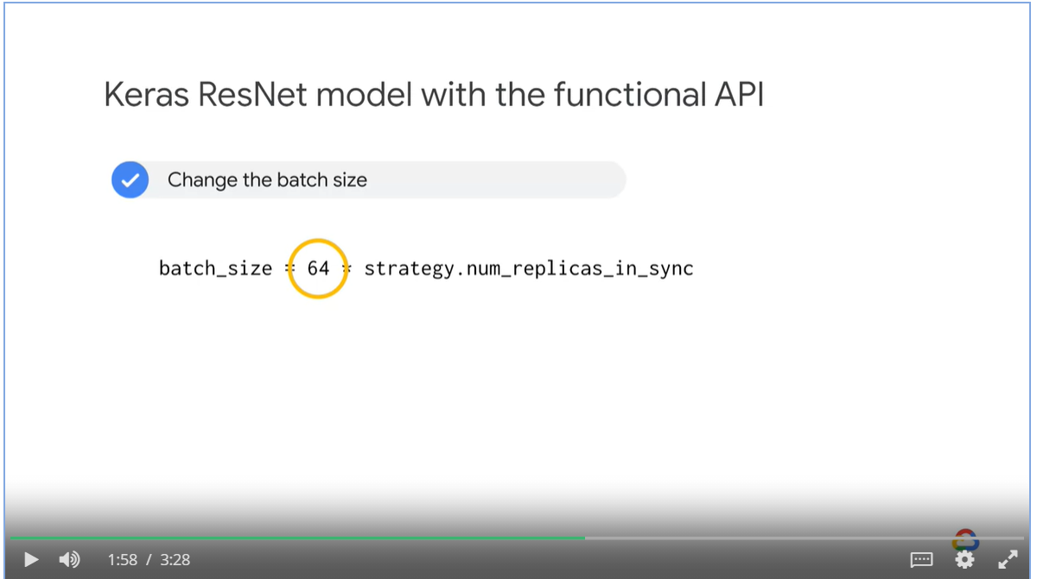

###### Multi-worker Mirrored Strategy

* It implements **synchronized** distributed training across multiple workers, each with potentially multiple GPUs.
* Similar to mirrored strategy, it creates copies of all variables in the model on each device across all workers.
* Use can use a cluster of machines that is CPU only or have one or more GPUs.
* It is a synchronized data parallelism strategy.
* Gradients need to be synchronized across all machines and all GPUs, create overhead.

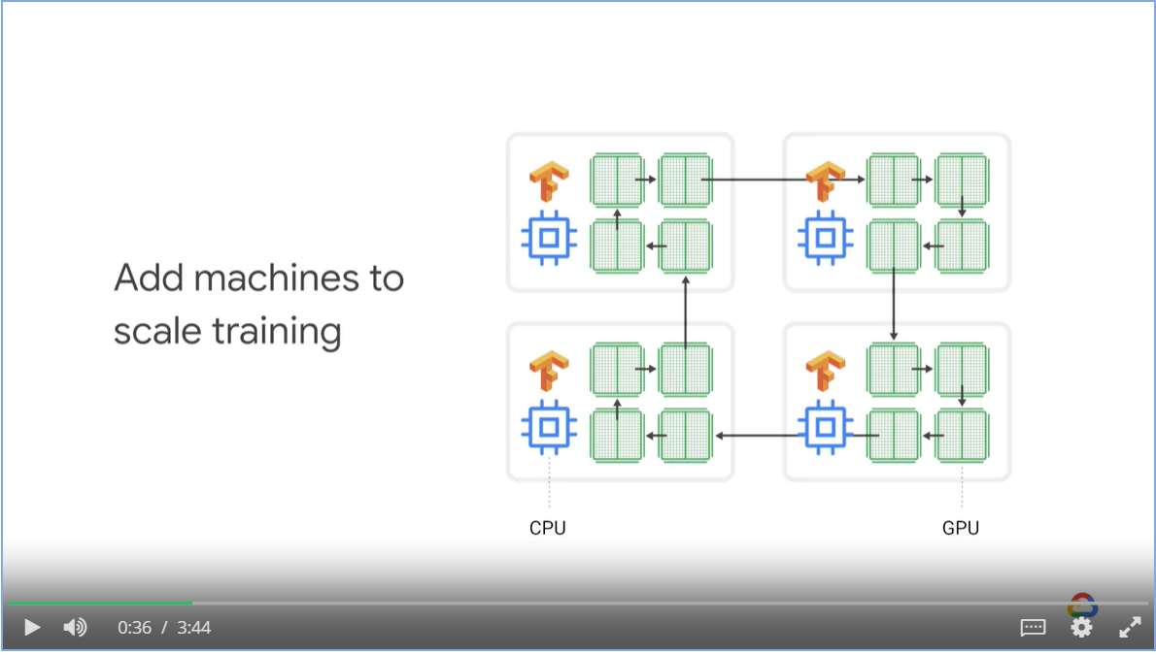

* Specify which machine is the chief in the cluster
* The chief has extra responsibility such as keep track of checking points and write models to storage.

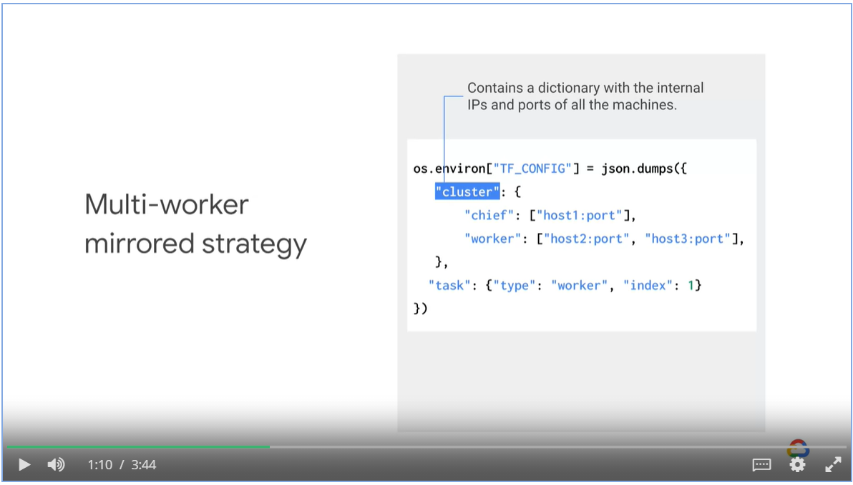

* Training data is sharded by default
* Chief worker saves the model to the desired model directory
* Other works save to temporary directories (these directories need to be unique)

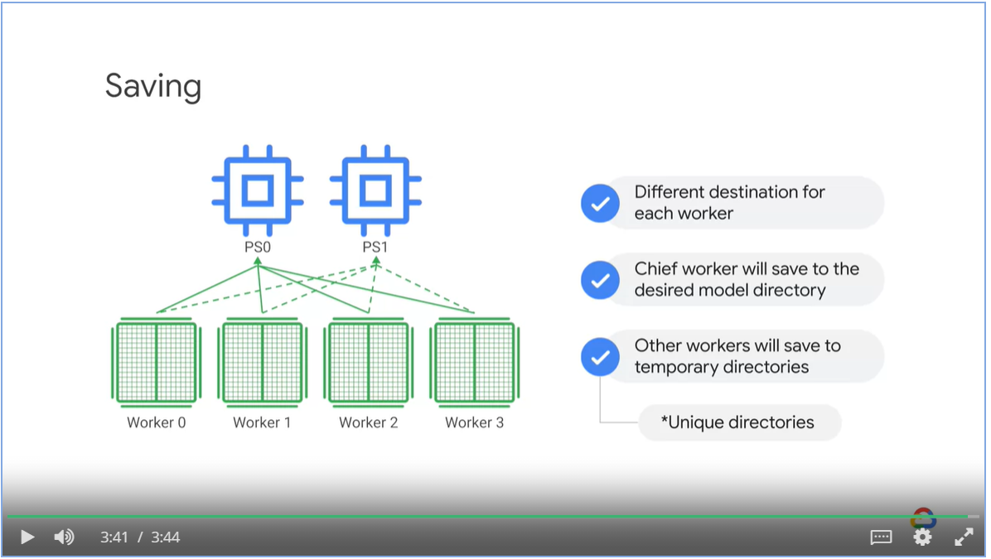

###### TPU Strategy

* TPU strategy all-reduce across TPU cores where as mirrored strategy will reduce across GPUs.

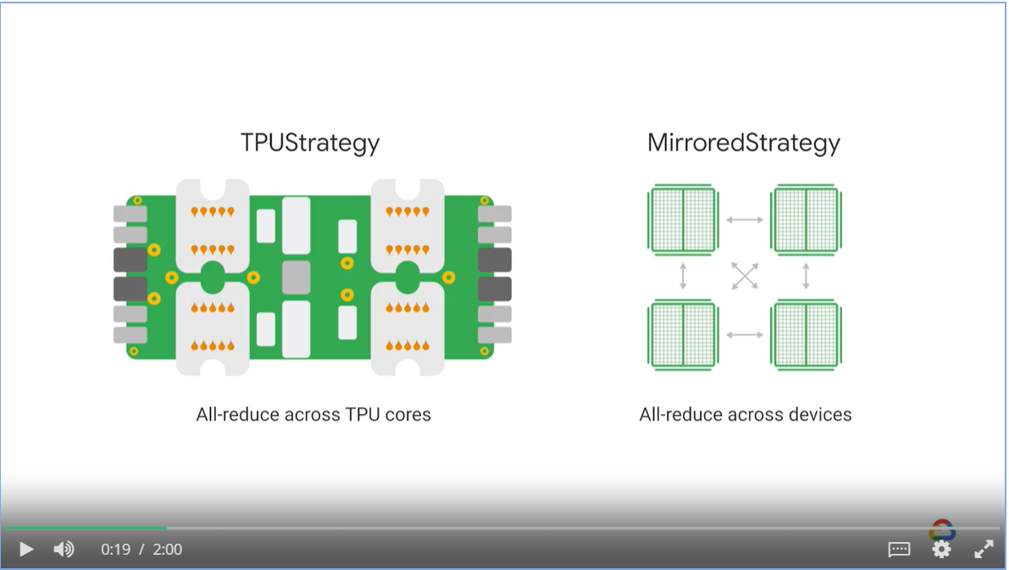

Data considerations:

* TPUs are fast, which result data bottle necks
* TPU can only read from Google Cloud Storage

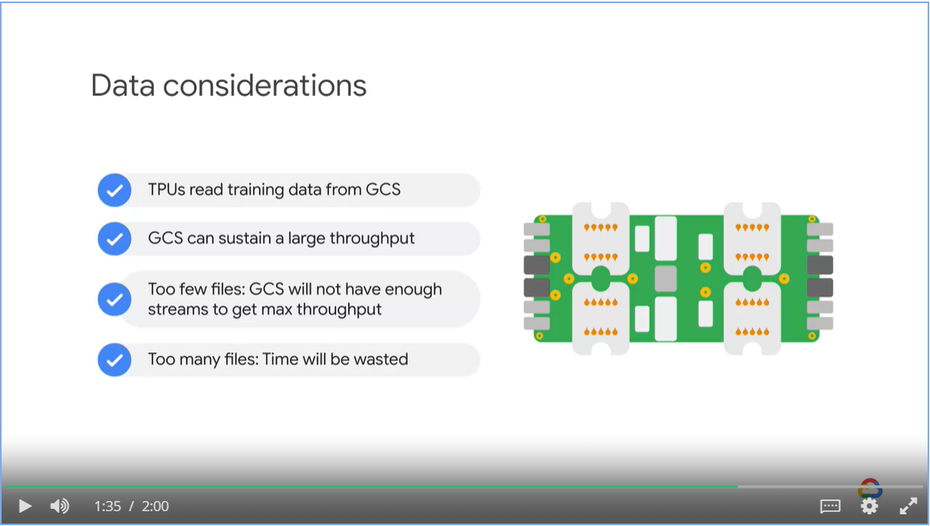

###### Parameter Server Strategy

* By default, in a parameter server strategy, each worker updates the parameters independently

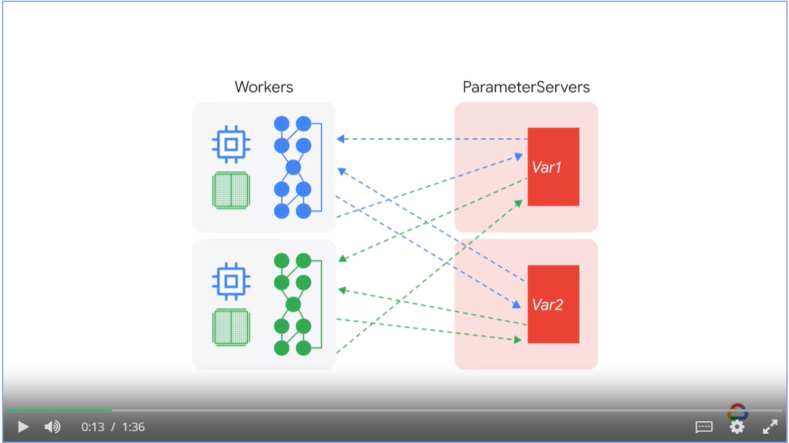

* TensorFlow parameter server strategy introduces a coordinator
* The coordinator creates resources, dispatches training tasks, writes checkpoints and deals with task failures.

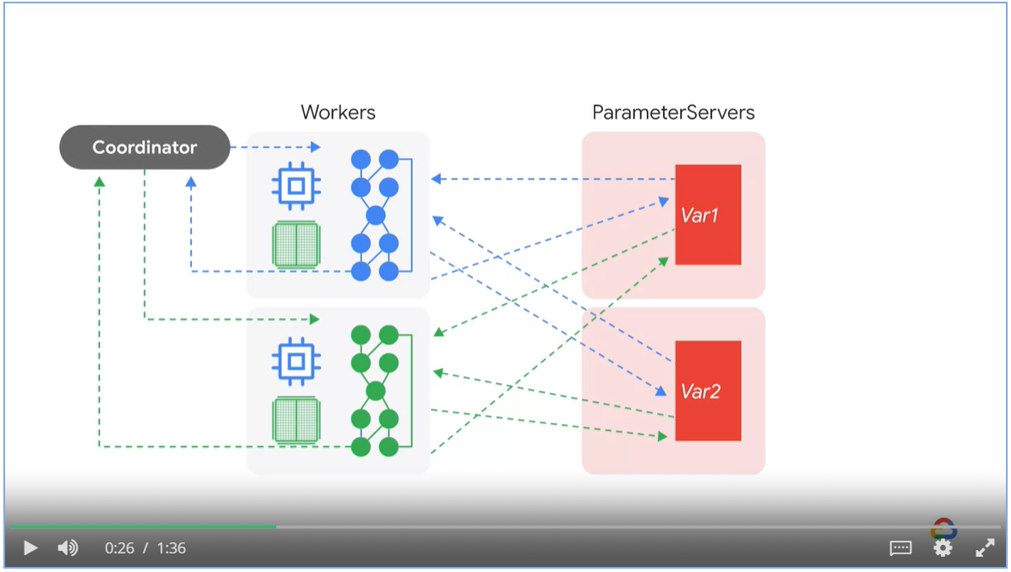

### Faster Input Pipelines

* Models deployed in production require lots and lots of data.
* The tf.dat API enables you to build complex input pipelines from simple reusable pieces.
* Structured dataset that requires normalization, feature crosses and bucketization
* Image model aggregates data from distributed system and apply transformation to images
* A text model extract symbols from raw text data, converting them to embedding identifiers with a lookup table, batching together sequences of different lengths.

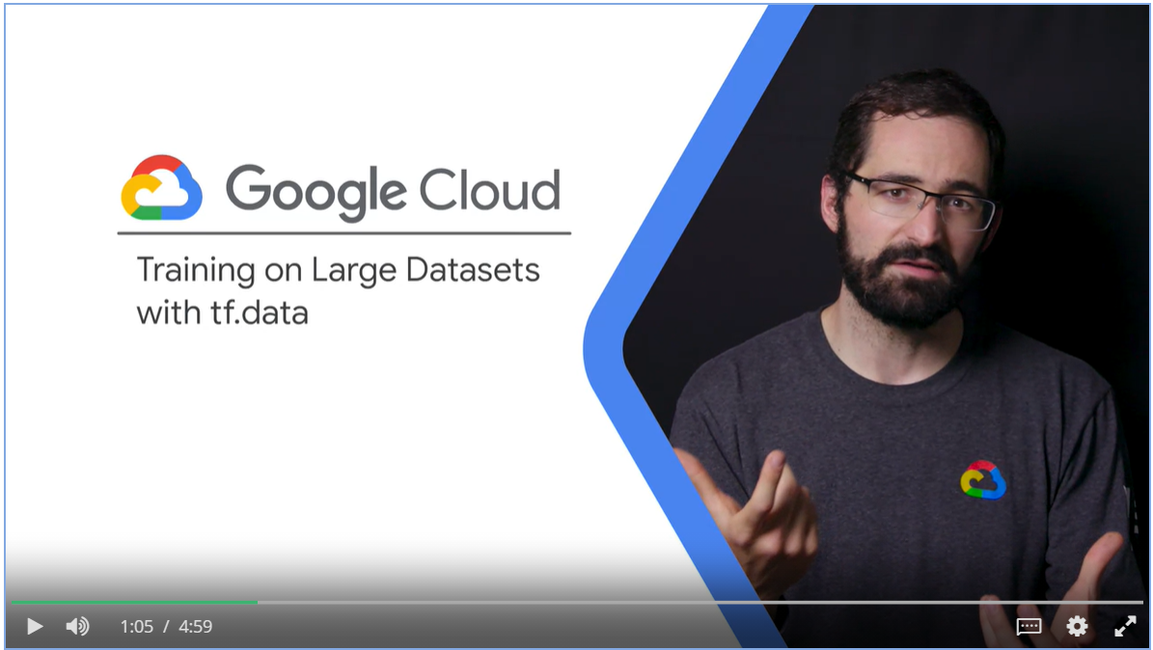

#### Features of tf.data.Dataset

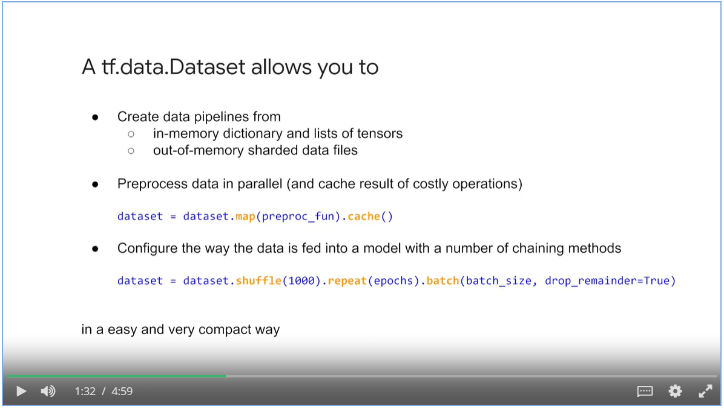

#### Lifecycle of tf.data.Dataset

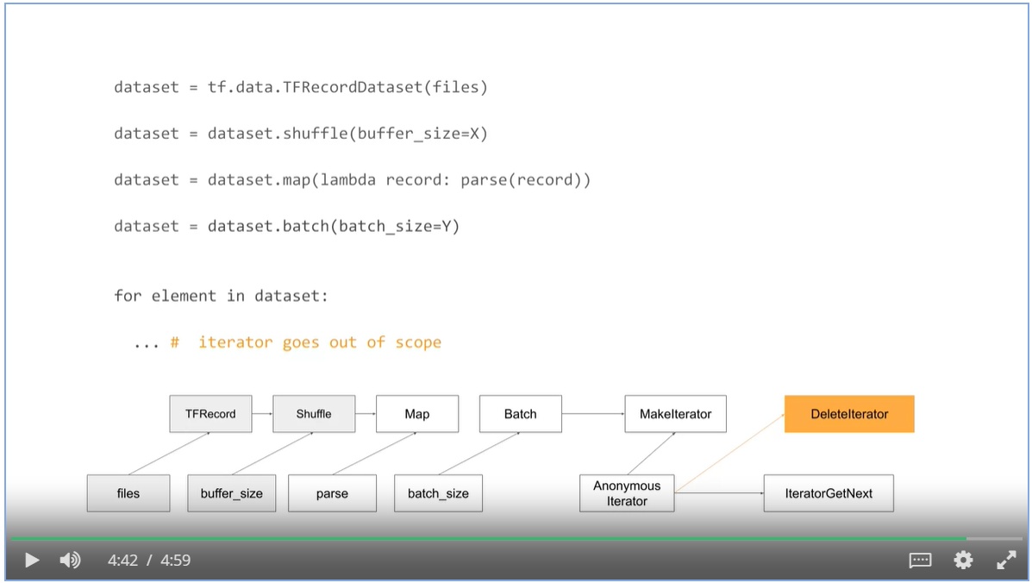

### Inference

#### Aspects of performance during inference

* Through put requirement, how many queries per second
* Latency requirement, how long does the query return result.
* Cost requirement,

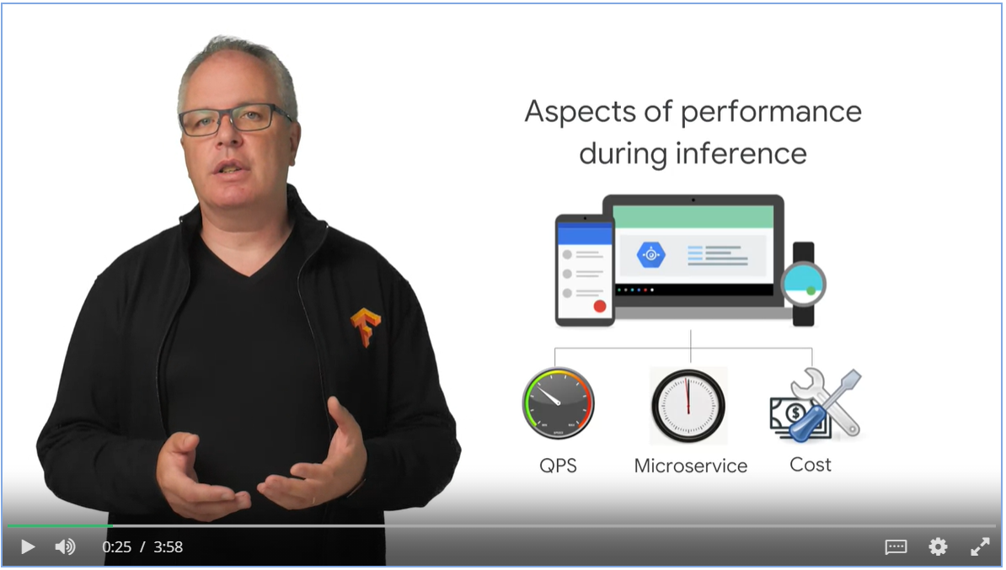

#### Implementation Options

* Rest/HTTP API for streaming pipelines
* Cloud Machine Learning Engine for batch pipeline
* Cloud Dataflow for both batch and streaming pipelines.

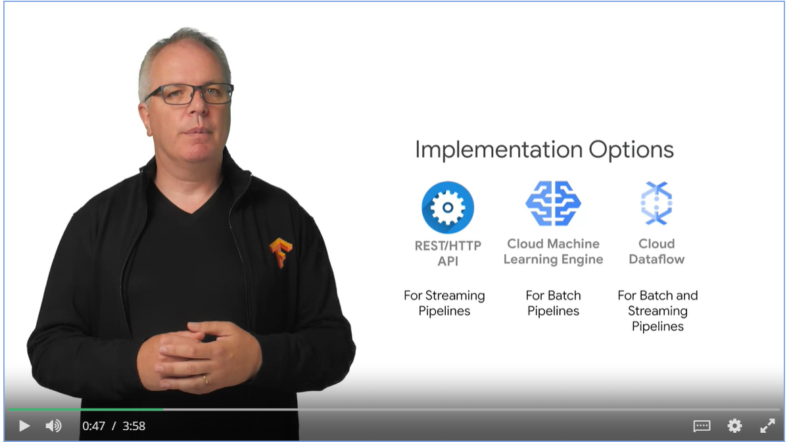

#### Batch Data Processing pipeline

* Here we define batch as a bounded dataset, such as BigQuery or Google Cloud Storage
* Option 1: Load Tensorflow SavedModel directly into Dataflow
* Option 2: Use tensor flow serving from AI Platform Notebooks or Cubeflow running on Kubernetes.

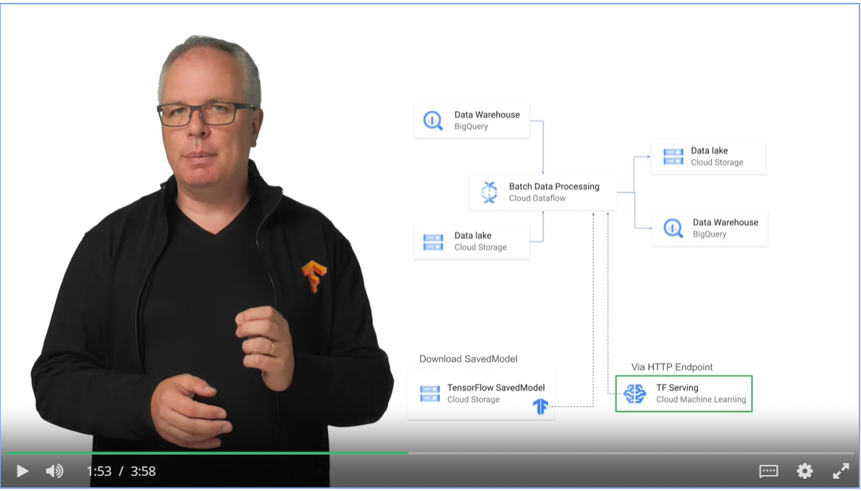

* Batch processing in AI Platform Notebooks have the fastest speed.
* TF serving using micro-services are well encapsulated and easy to maintain.

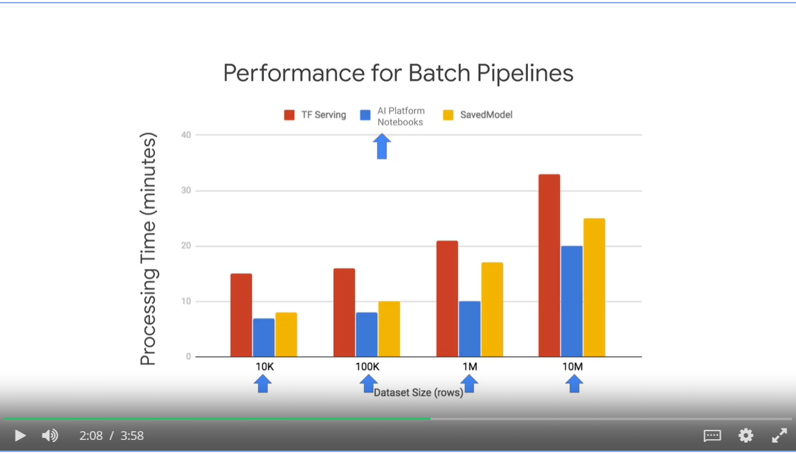

#### Streaming Data Processing Pipeline

* Use unbounded data source such as Pub/Sub

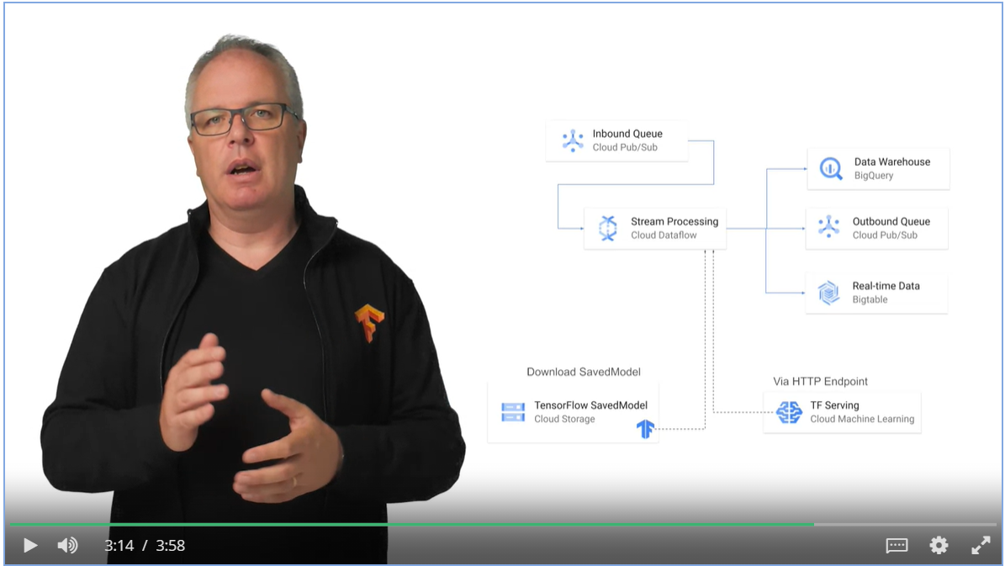

* Saved model is the best-option for high-speed inference below some limit
* Once the data start to grow, the SavedModel approach will hit a bottle neck while AI Platform Notebooks can scale indefinitely.

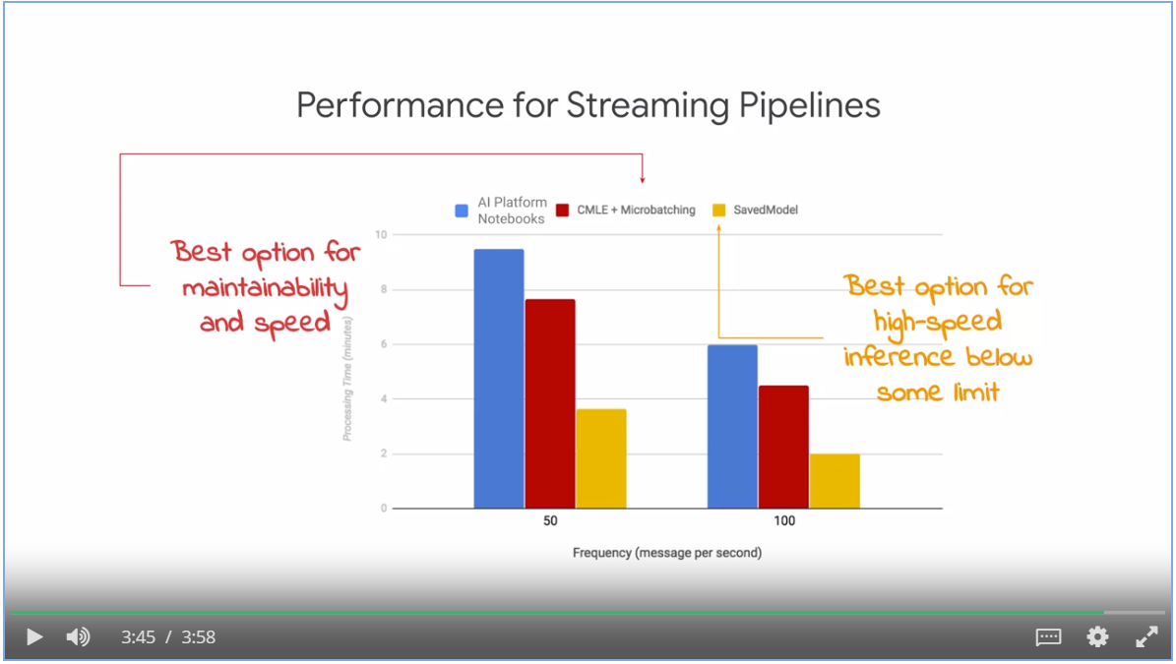

## Week 3: Building Hybrid ML Systems

### Introduction

What the Google Cloud-Native ML ecosystems can offer

* Ready-made models such as Vision, Translation, Speech and Natural Language APIs
* Customize ready-made ML models, Auto-ML
* Build, train and serve your own custom ML models with AI Platform Notebooks

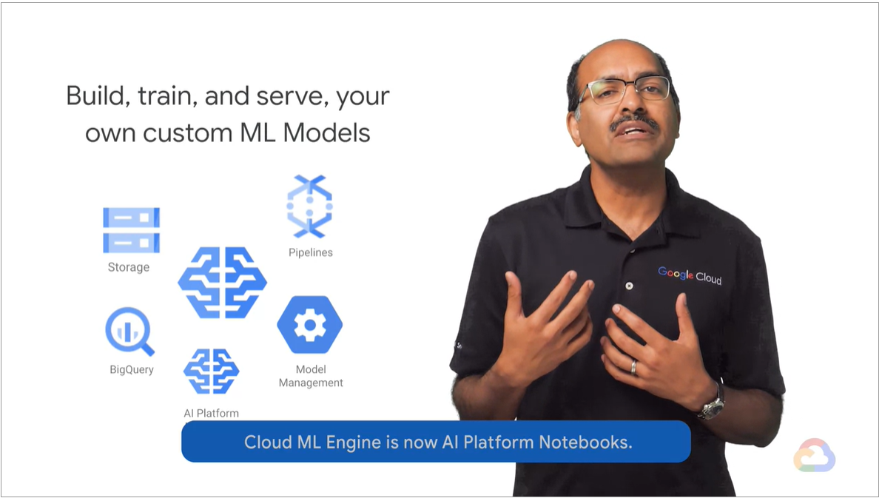

Not possible for cloud-native solutions

* Tied to On-Premise Infrastructure, i.e., data must be kept on premise
* Multi-cloud system architecture
* Have to do prediction on mobile, or IOT devices on Edge

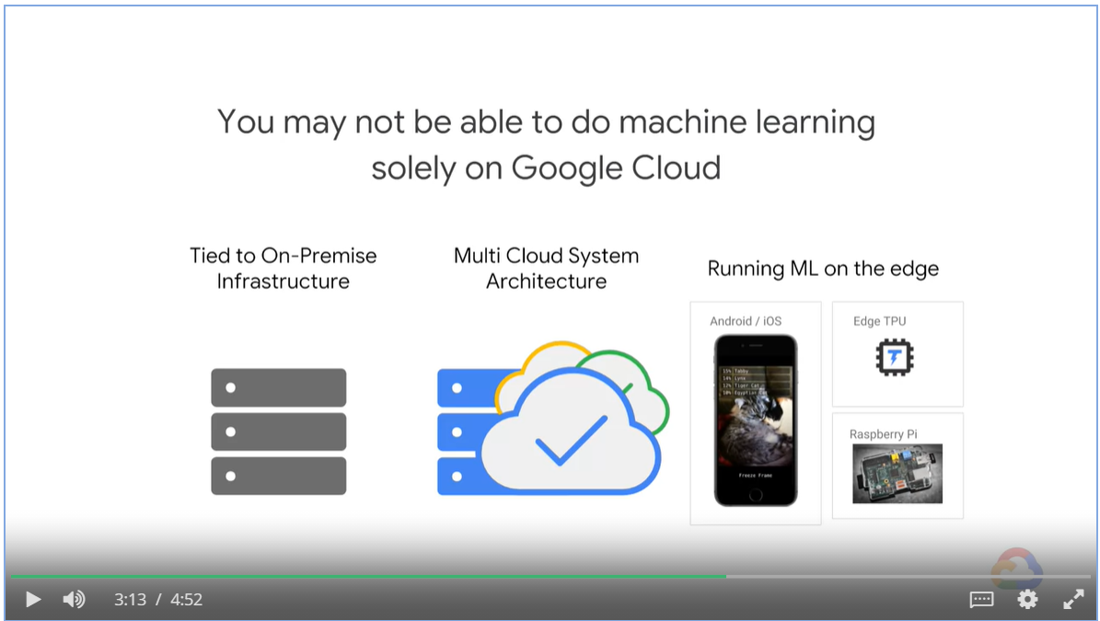

* With Kubernetes, it is possible to orchestrate containers whether they are running on-prem or on the Cloud.
* Kubeflow helps you migrate between Cloud and on-prem environments
* Kubeflow is executed on Google Kubernetes Engine, GKE.

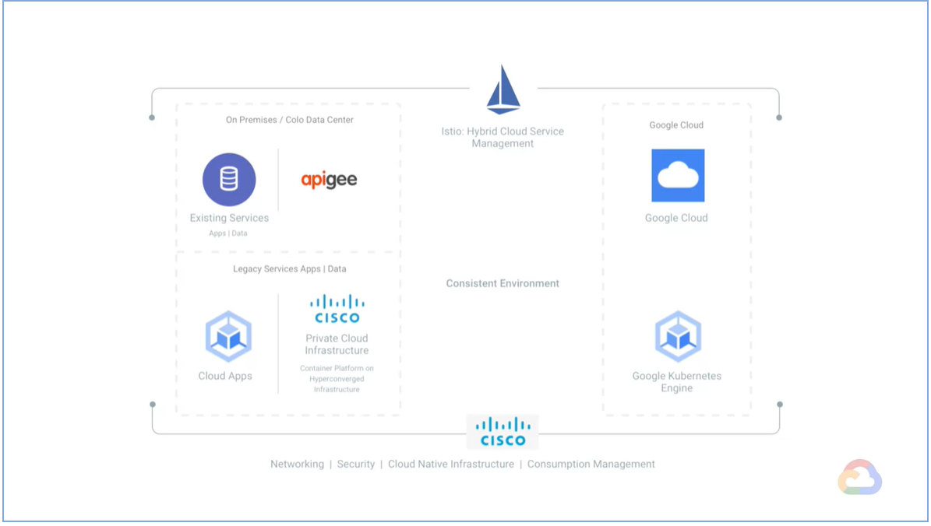

In order to build hybrid ML systems, your framework needs to support

* Compossibility
* Portability
* Scalability

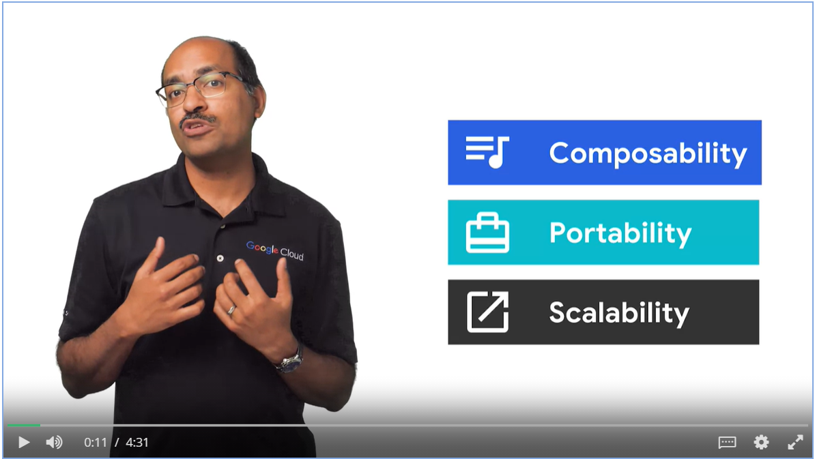

### KubeFlow

n/a

### Optimizing TensorFlow for Mobile

Scenario for hybrid model

* Instead of sending raw data from device to the cloud, we can preprocess the raw data and then send it to the cloud to reduce network traffic.
* Or we can have the model running locally on the device to reduce server workload.

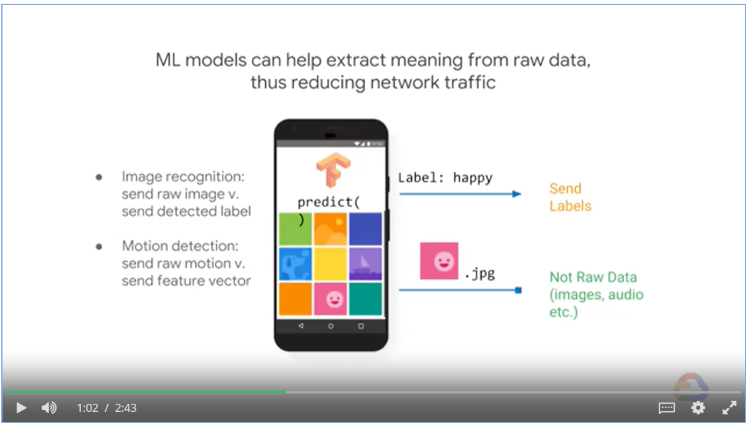

* Calling microservice form the device for prediction can add unwanted latency
* Instead, we train on the cloud and predict on device.

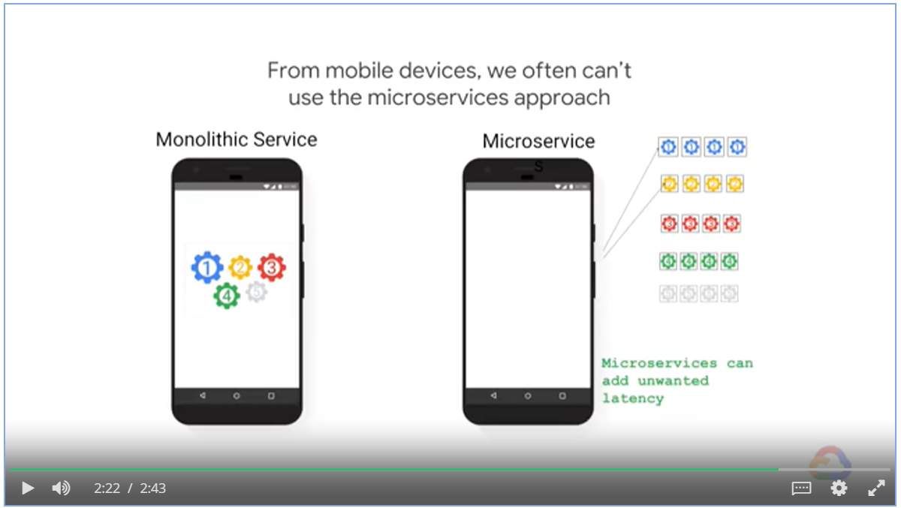

#### TensorFlow Lite

* Reduce code footprint
* Quantization
* Lower precision arithmetic

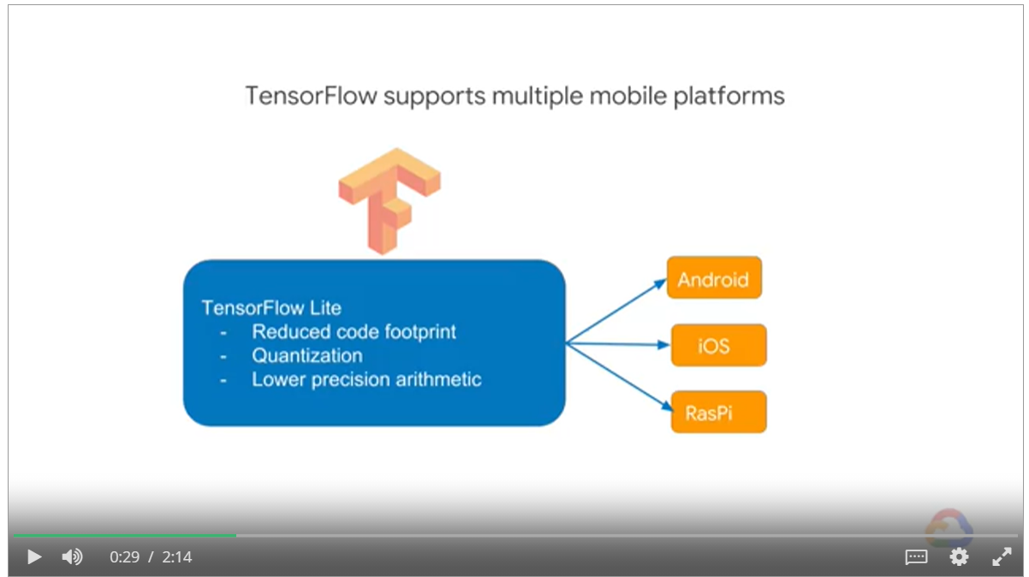

#### TensorFlow Inference code

* Create an Inference Object
* Feed data into inference
* Run and fetch result

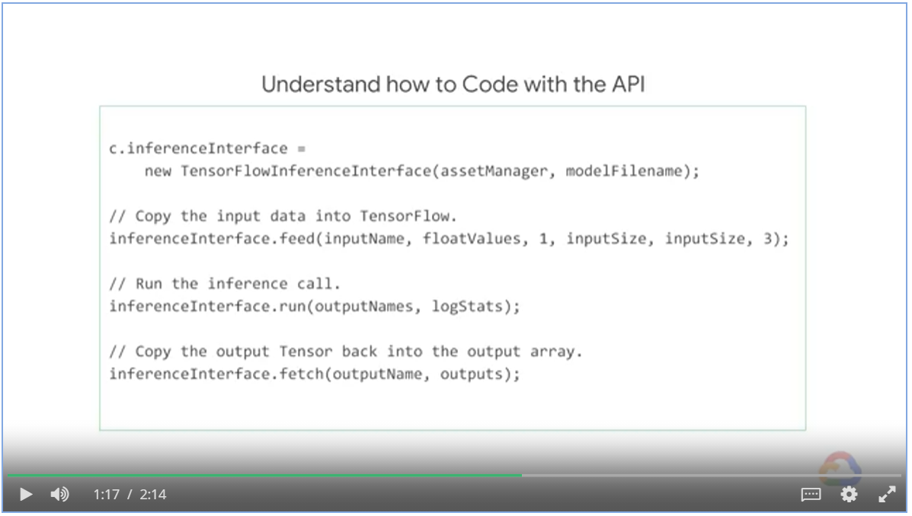

#### Federated Learning

* Train model on multiple devices that belong to the same user
* Update the model for all devices
* Continue with personalized training and prediction

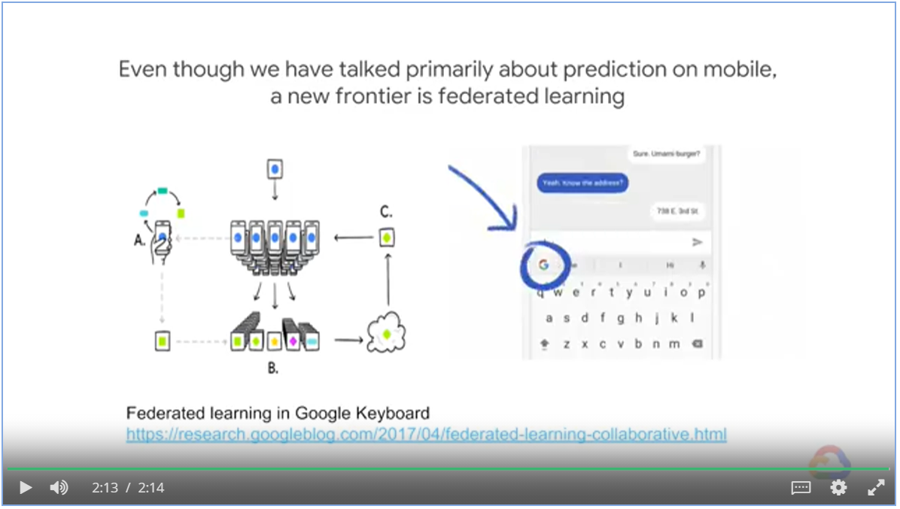

# MLOps

Agenda

* Why and When to Employ MLOps
* Understanding the Main Kubernetes Components
* Introduction to Machine Learning Pipelines
* Training, Tuning and Serving on AI Platform
* Kubeflow Pipelines on AI Platform
* CI/CD for Kubeflow Pipelines on AI Platform

## Week 1: Why and When to Employ MLOps

### Concerns from data scientists:

* Keep track of the meaning of the model
* Versioning of different code, hyperparameters and evaluation metrics
* Keep track of which ideas have been tried and which haven’t
* Reproducibility: rerun the best model with a more through parameter sweep.

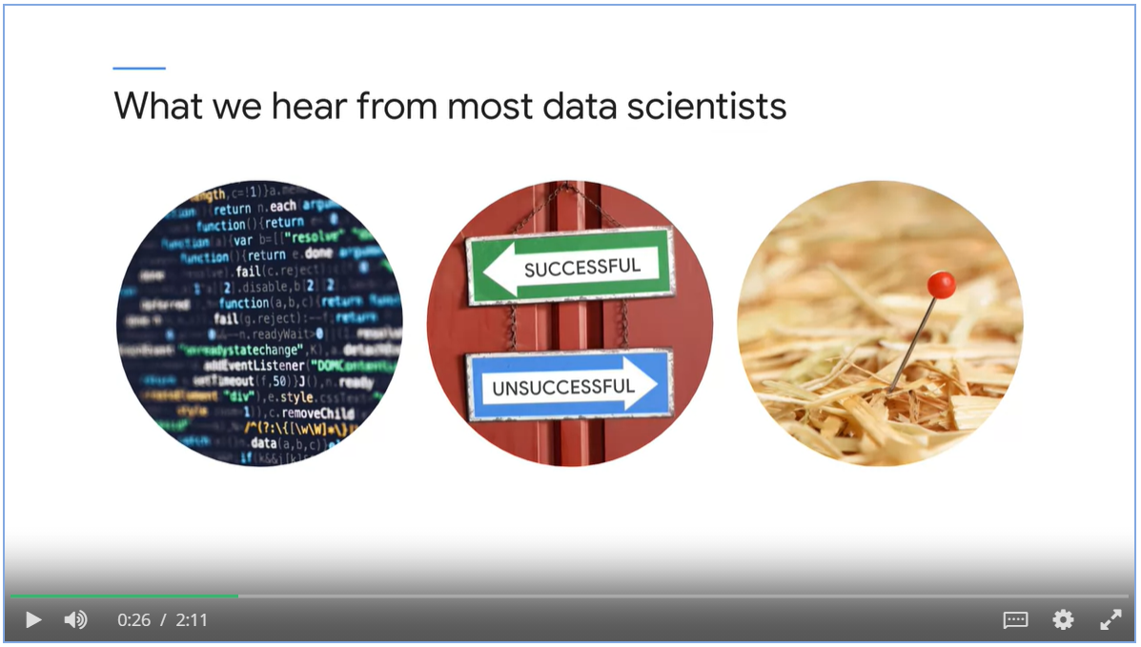

* Exam a machine learning system in the role as an operation person.
* Balancing time, resource and quality throughout the whole system.

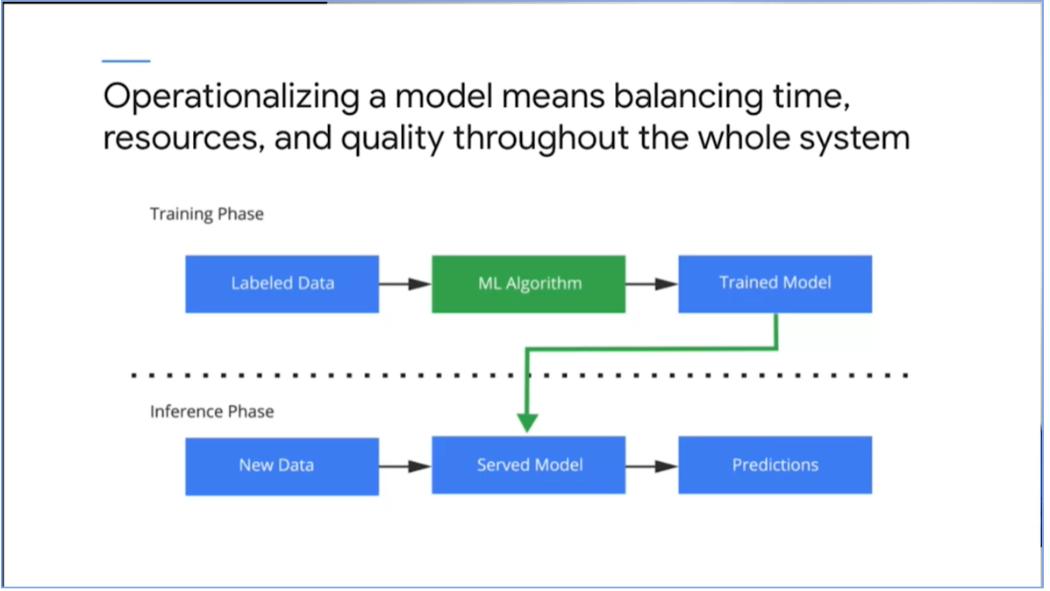

### Machine Learning Life Cycle

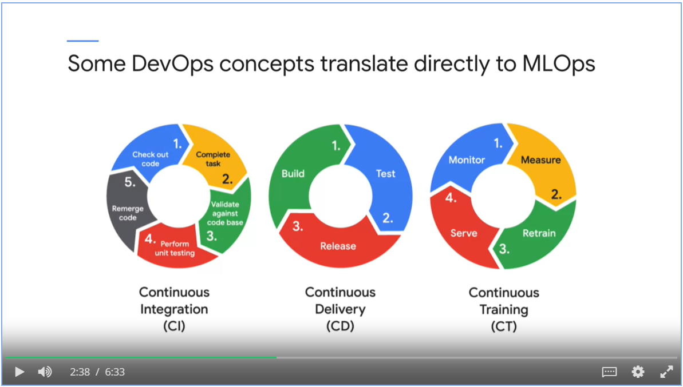

### MLOps differs from DevOps

* Not only testing and validating code, but also data, data schemas and models
* Consider the whole training pipeline
* Constantly monitor, retrain and serve the model

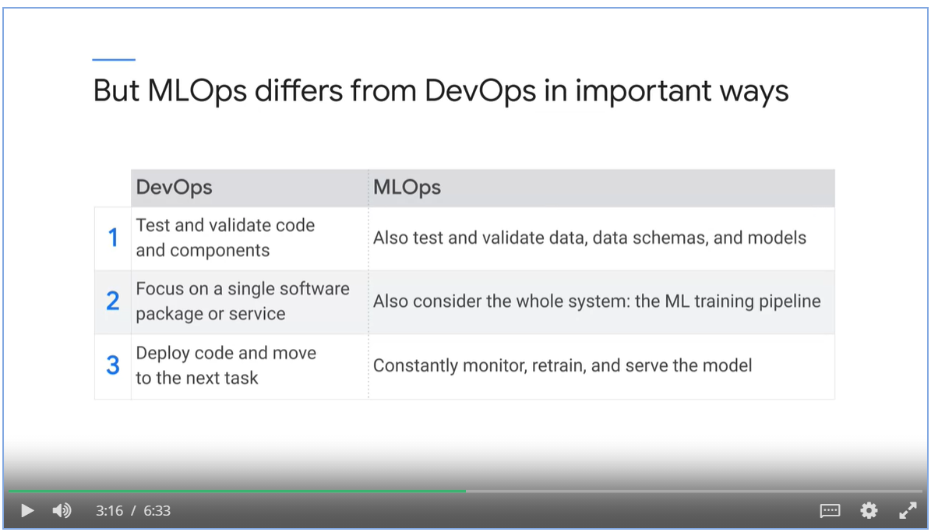

### ML systems can easily build up technical debt

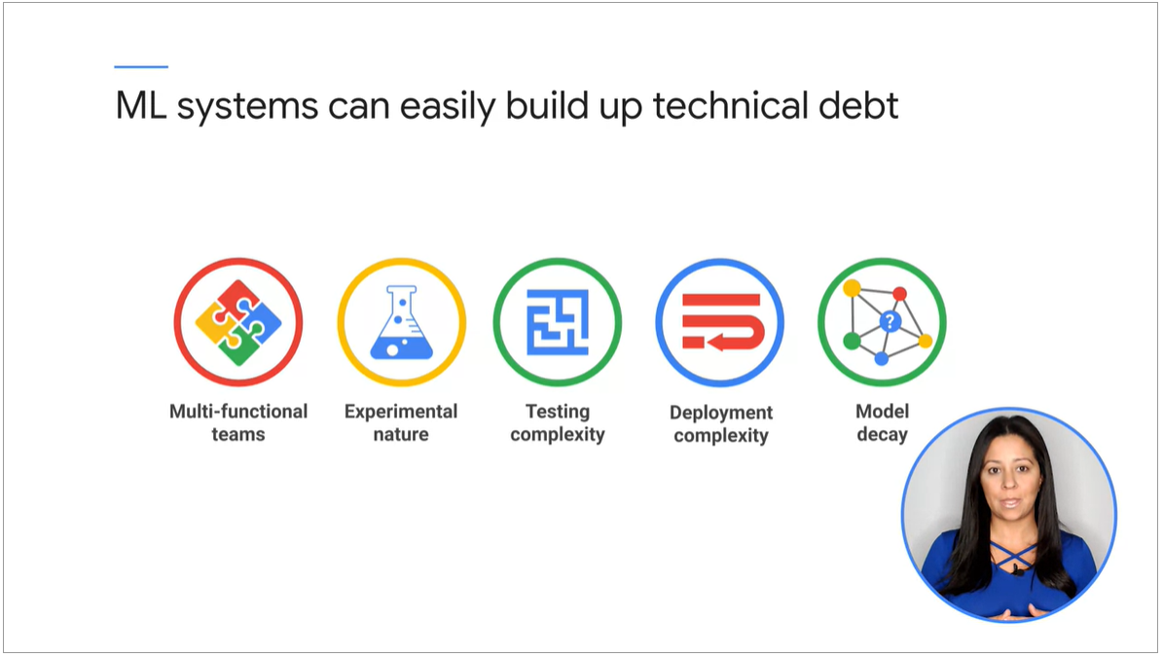

Phases of a machine learning project

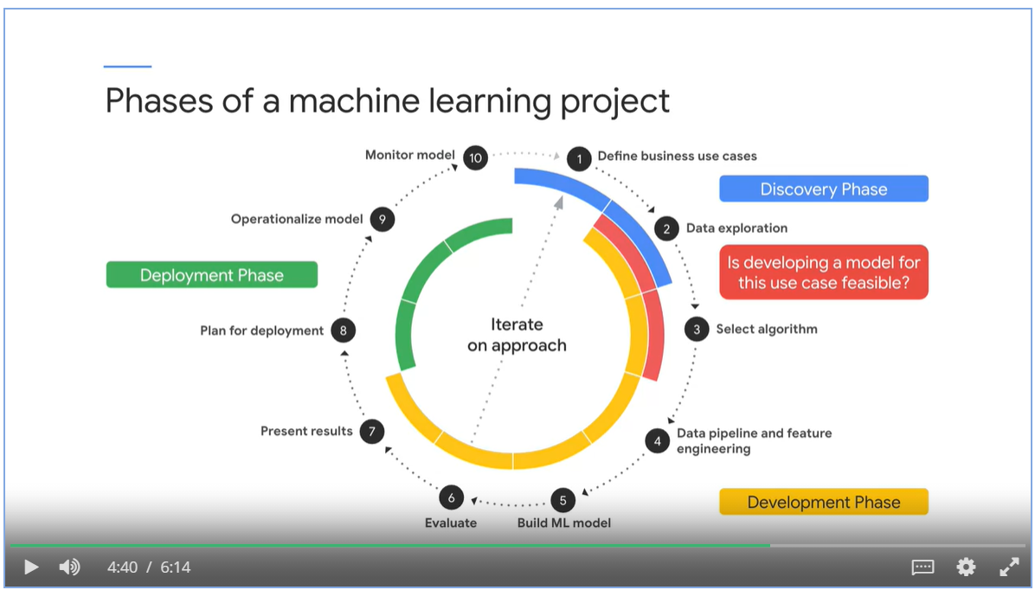

An ML pipeline contains well defined processes

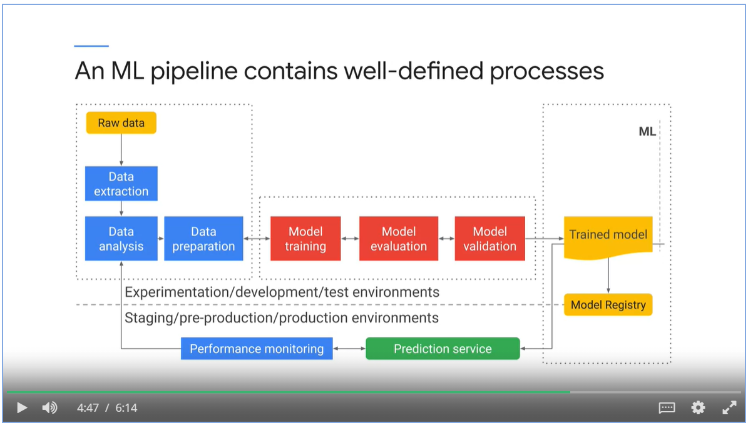

### Level of automation in ML projects

* Build and deploy manually
* Automate the training phase
* Automate training, validation and deployment

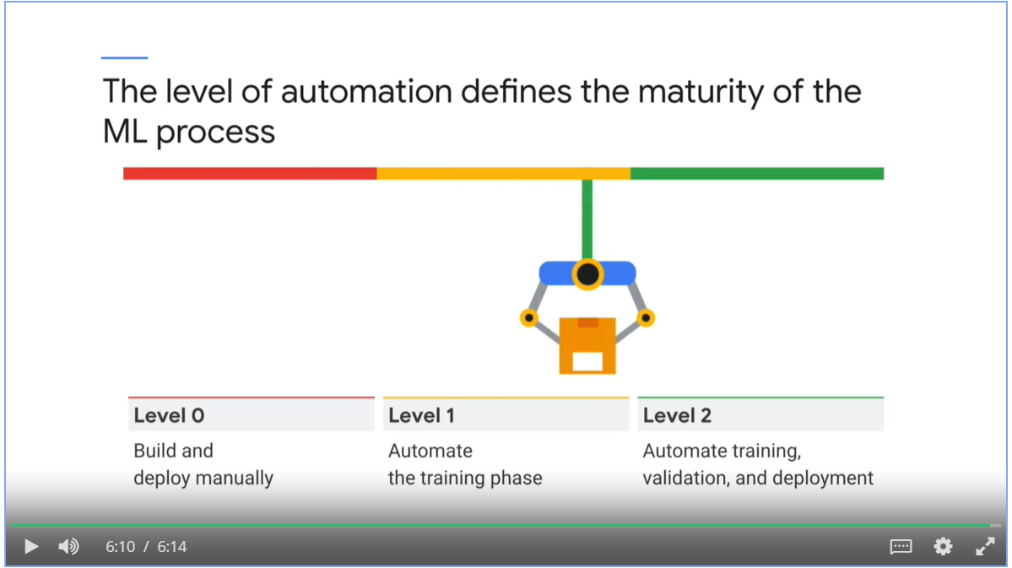

## Week 1: Introduction to Containers and Kubernetes

### Introduction to Containers

* Virtualization enables running multiple virtual servers and operating systems on the same physical computer.
* A hypervisor is a software layer that breaks the dependency of an OS with its underlying hardware.
* The images of the virtual machines can easily be moved around from one physical hardware to another.
* However, the application, dependencies and the kernel are still bundled together, hard to move it from one hypervisor product to another.

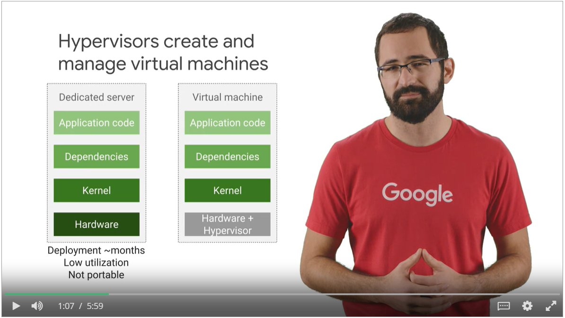

* Multiple apps run on same machine
* One app can starve out resources from another app
* Dependencies are mixed up

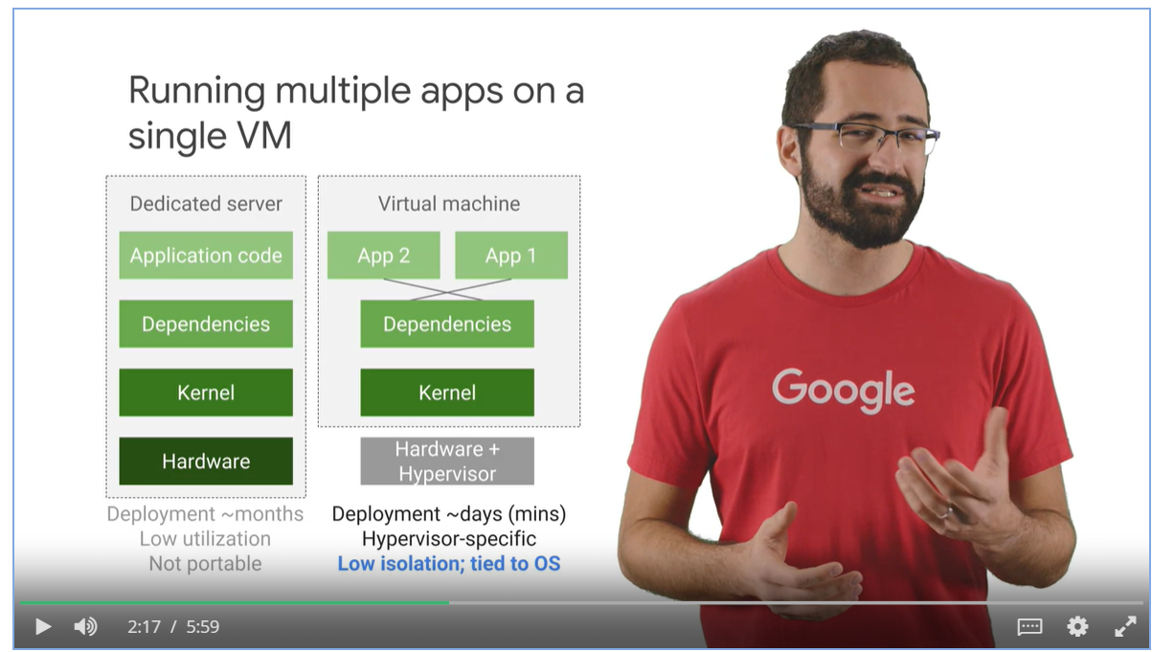

* One virtual machine per application
* Kernels are duplicated, updating kernel takes times
* Slow to start up new VMs and boot new OS

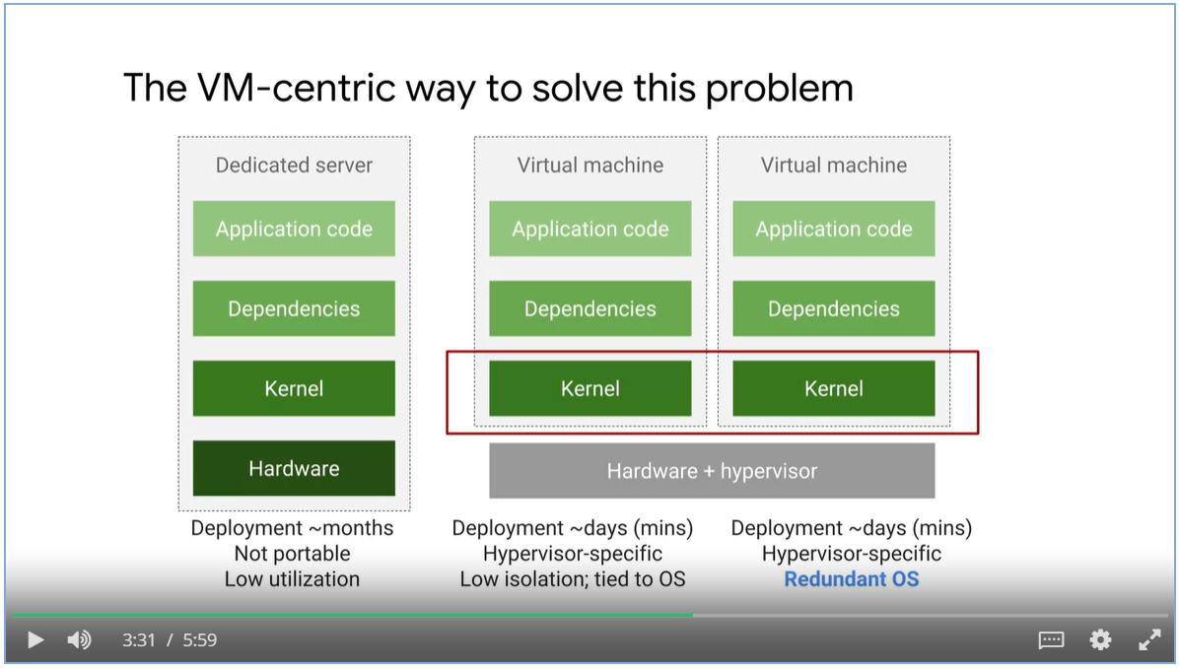

* Virtualize “User Space” only.
* A user space is all the code that resides above the kernel, including the applications and their dependencies.
* **Containers** are isolated user spaces per running application code.

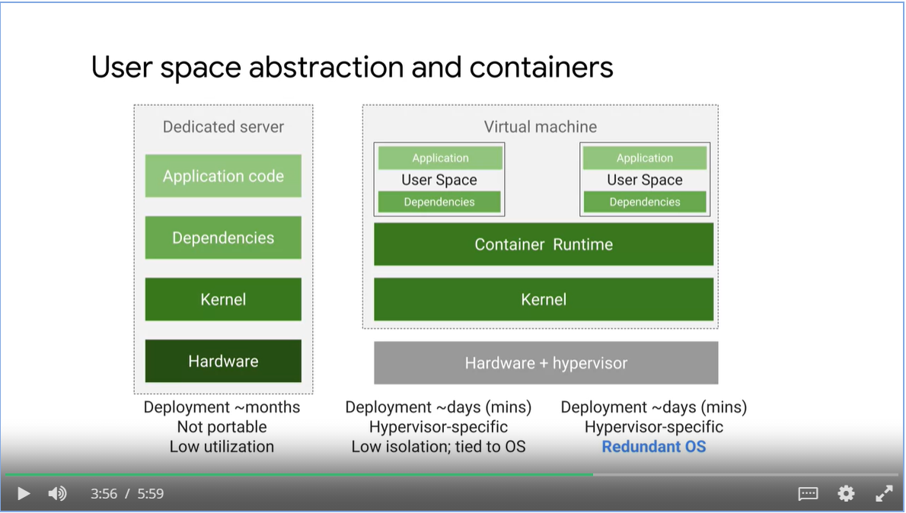

* Containers promotes app-centric development
* Developers don’t need to worry about software dependencies such as application runtimes, system tools, system libraries and other settings. The container execution engine makes it available for container images.
* Make incremental changes to a container based on a production image.
* Deploy quickly with a single file copy
* Align with microservice design pattern, that is, loosely coupled, fine-grained components.

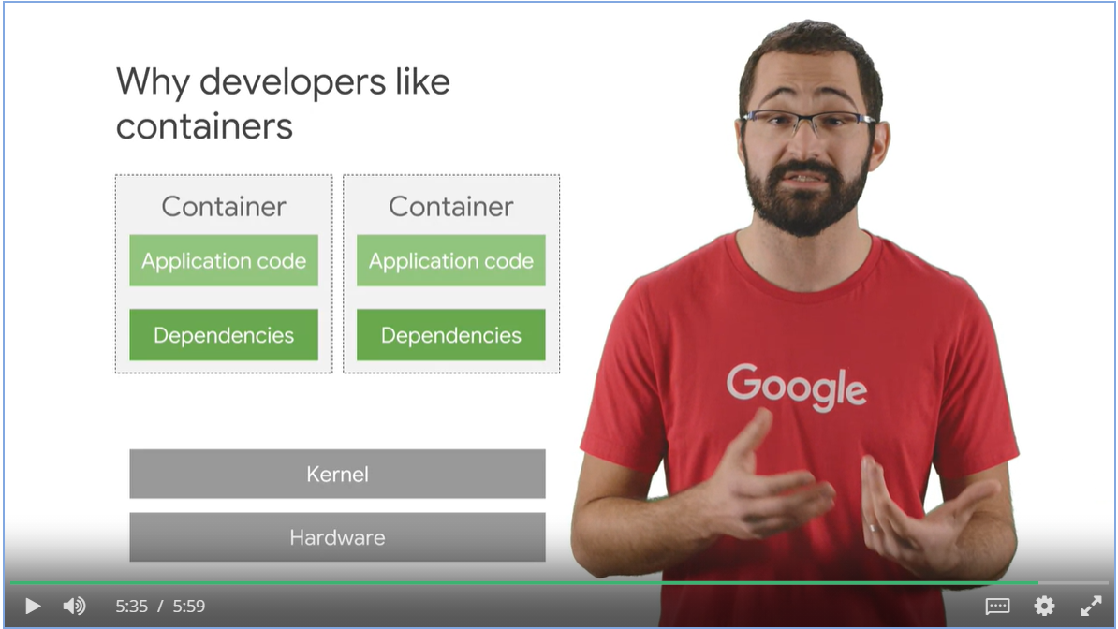

### Containers and Container Images

* Docker is tool that builds Container images
* It runs Container images
* Docker doesn’t offer a way to orchestrate those applications at Scale like Kubernetes does.
* Use Google Cloud Build to create docker formatted images.

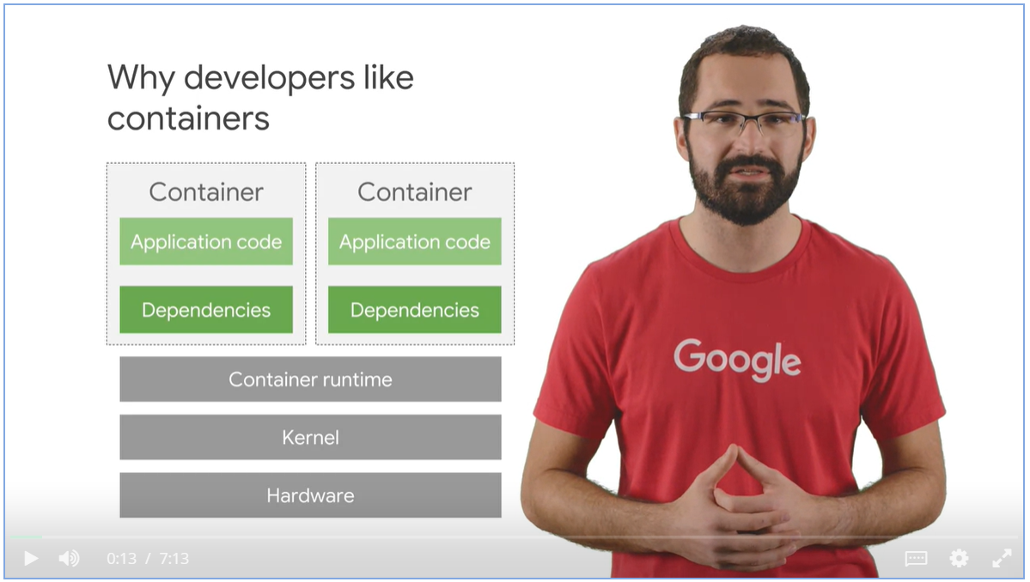

### Containers use a variety of Linux technologies

* Linux process, each has its own virtual memory address phase.
* Linux namespaces controls what an application can see, process ID numbers, directory trees, IP addresses and so on.
* Linux cgroups control what an allocation can use, its maximum consumption of CPU time, memory, IO bandwidth and etc.
* Union File systems efficiently encapsulate applications and their dependencies into a set of clean minimal layers.

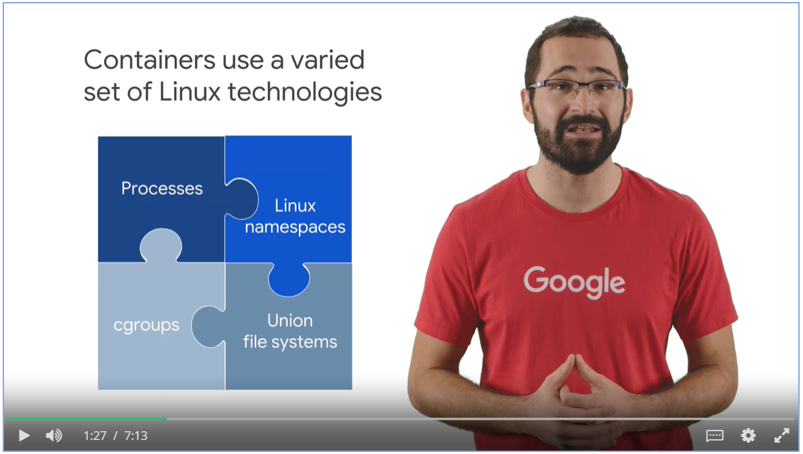

* Tools read from container manifest file and builds images in layered format.
* Each layer is read-only inside the image
* When running the image, it has a writeable ephemeral top-most layer.

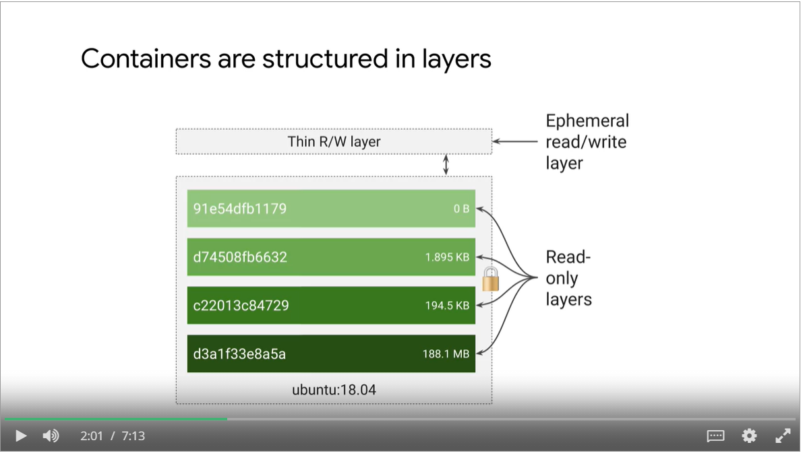

#### A Simple Docker Image

* Download ubuntu runtime, copy your application, compile your application, run your application
* We do not build container images by ourself
* Application packaging relies on a multi-stage build process in which one Container builds the final executable images. A separate container receives only what’s needed to actually run the application.
* The container runtime adds a thin writable layers and it is ephemeral, when the Container delete its content, the writeable layer is lost forever.

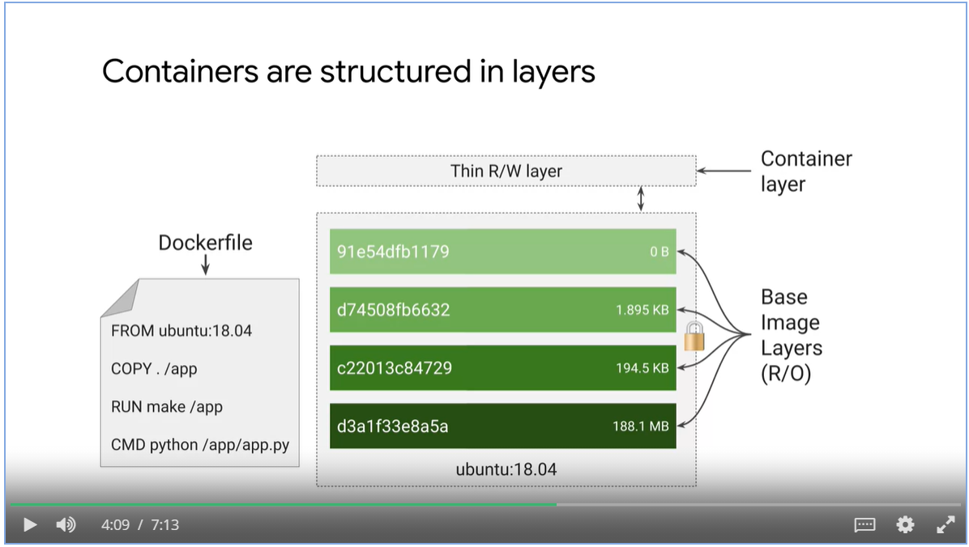

Containers promote smaller shared images

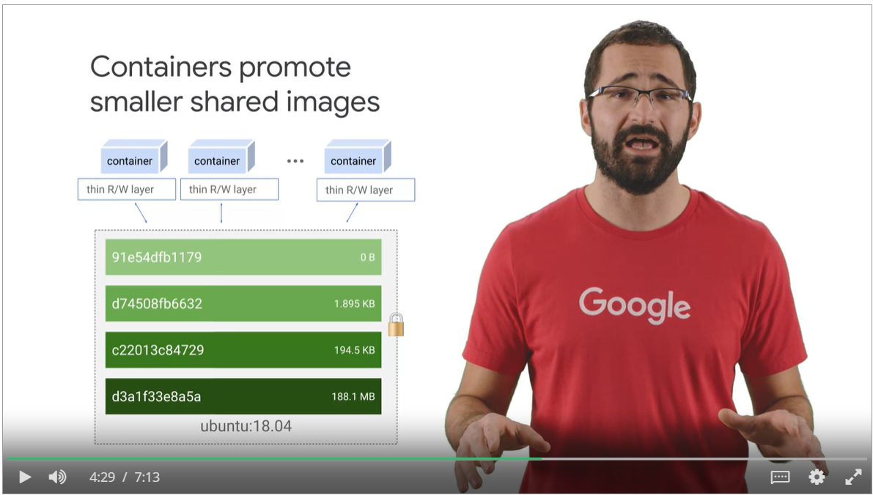

* Pull container images from a repository for unmodified use or start as a base for your own images
* Alpine is a popular Linux environment in a container, noted for being very small.
* NginX is a popular web server.
* Googles maintains a Container Registry, gcr.io.
  + Hosts open-source public images
  + Host private images integrated with Cloud IAM

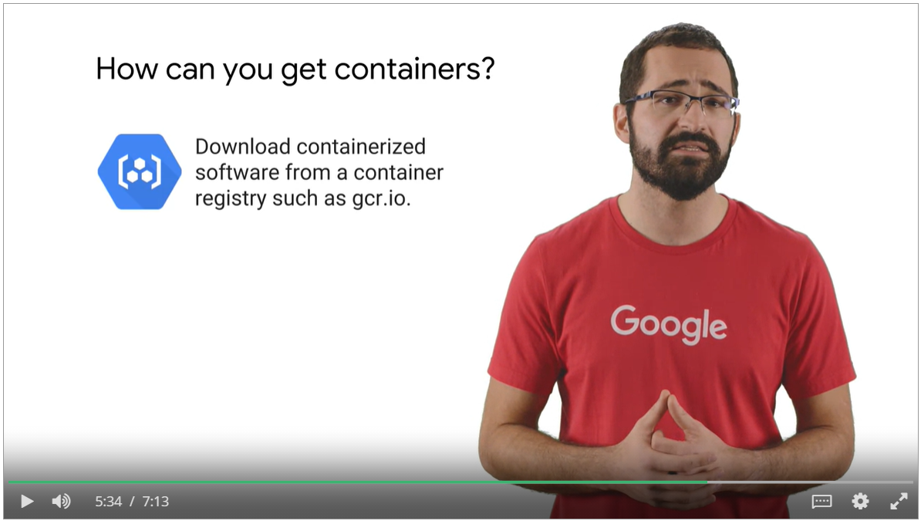

* Docker command is a popular why to build your own Container images
* However, you must trust the computer that you do your builds on.
* Google offer a managed service for building Containers that is integrated with Cloud IAM

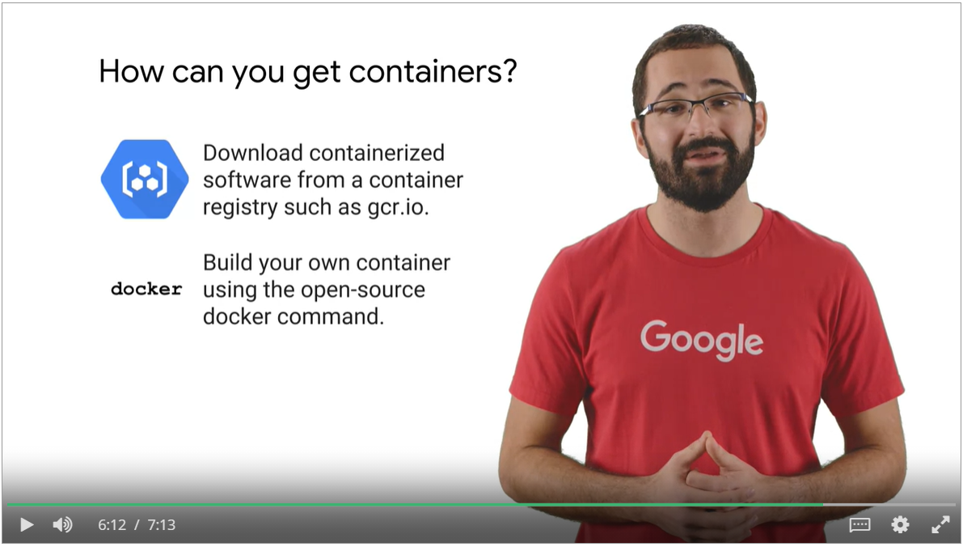

#### Google Cloud Build

* It fetches images from a variety of sources
* You configure build steps to fetch dependencies, compile source code, run integrated tests or use tools such as Docker, Gradle and Maven.
* Each build step and Cloud build runs in a Docker container.
* Then Cloud build delivery images to Cloud Functions, GKE and App Engine.

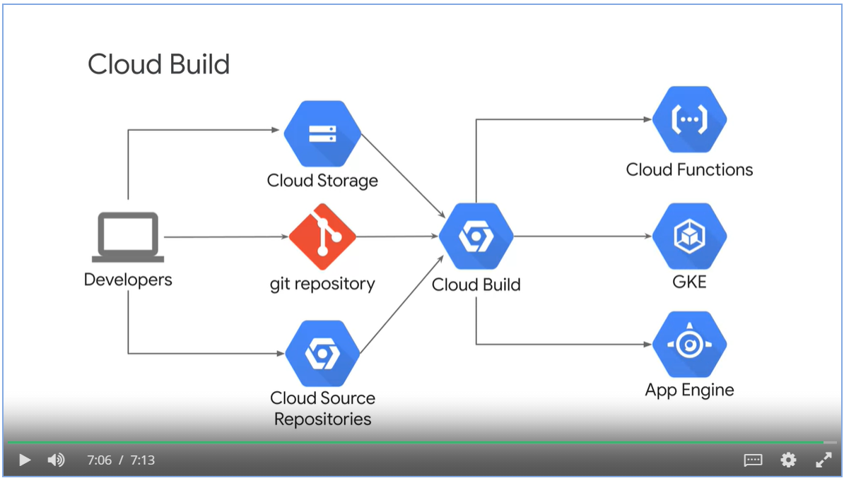

### Kubernetes for Container management

* Kubernetes is an open source platform that helps you orchestrate and manage your container infrastructure on-premises or in the cloud.

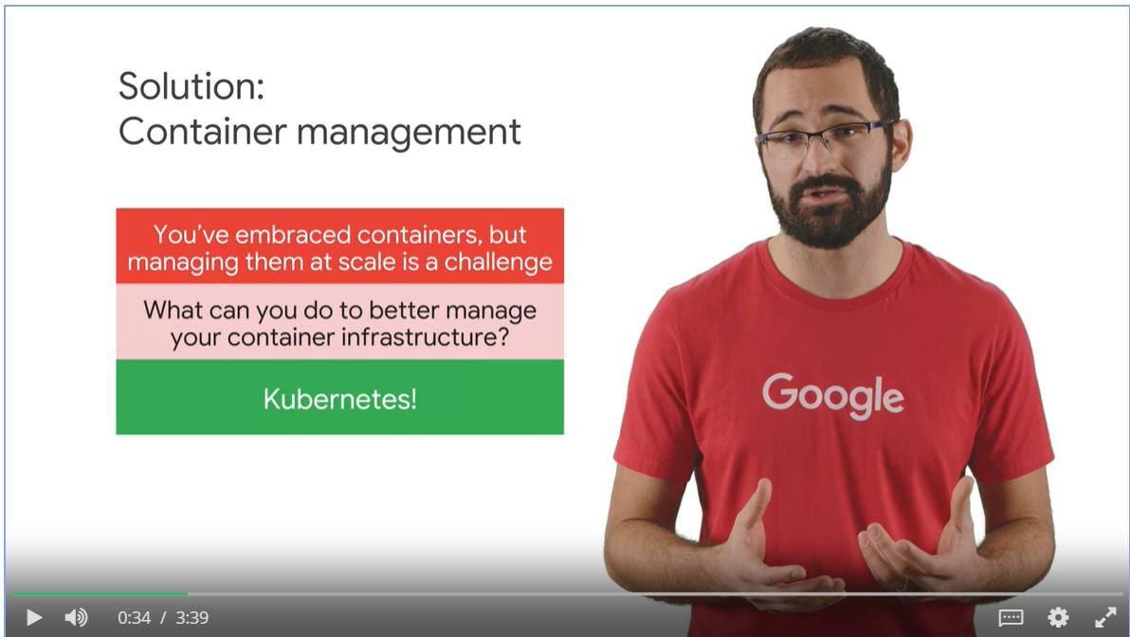

#### What is Kubernetes?

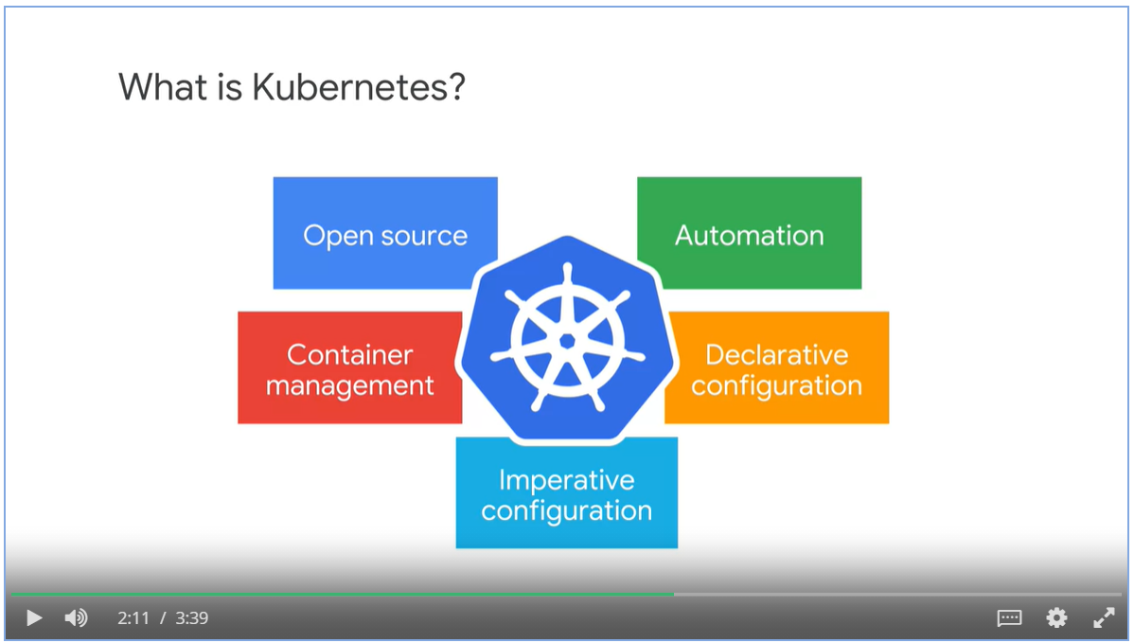

#### Kubernetes Features

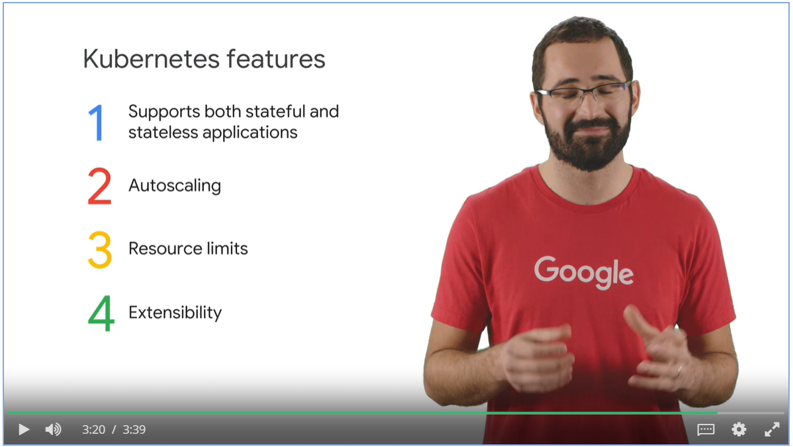

Google Kubernetes Engine

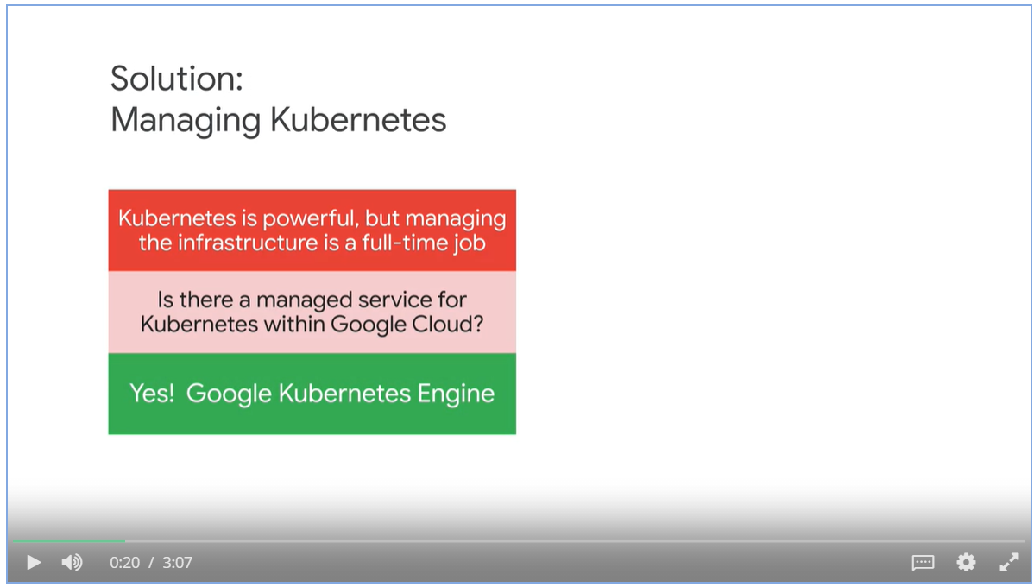

GKE is a component of the GCP component offerings.

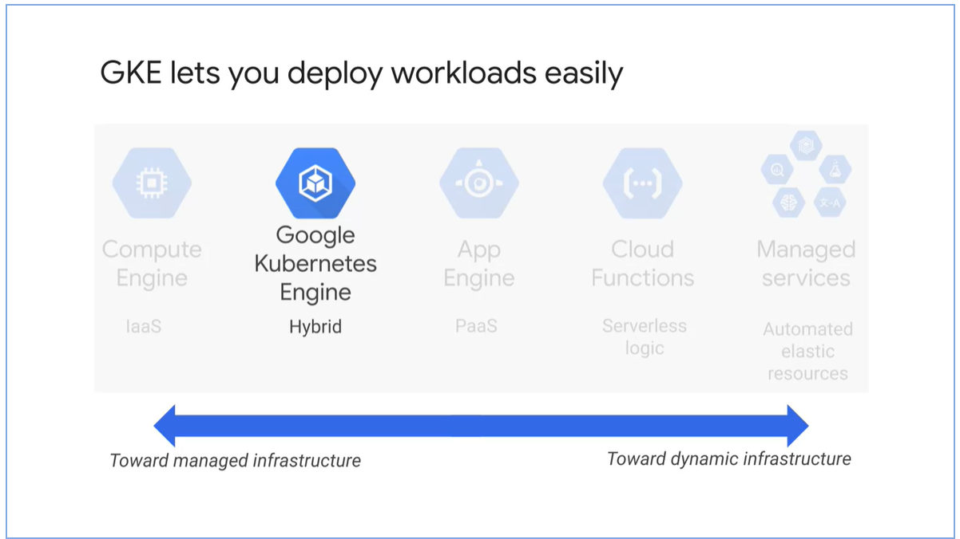

GKE features

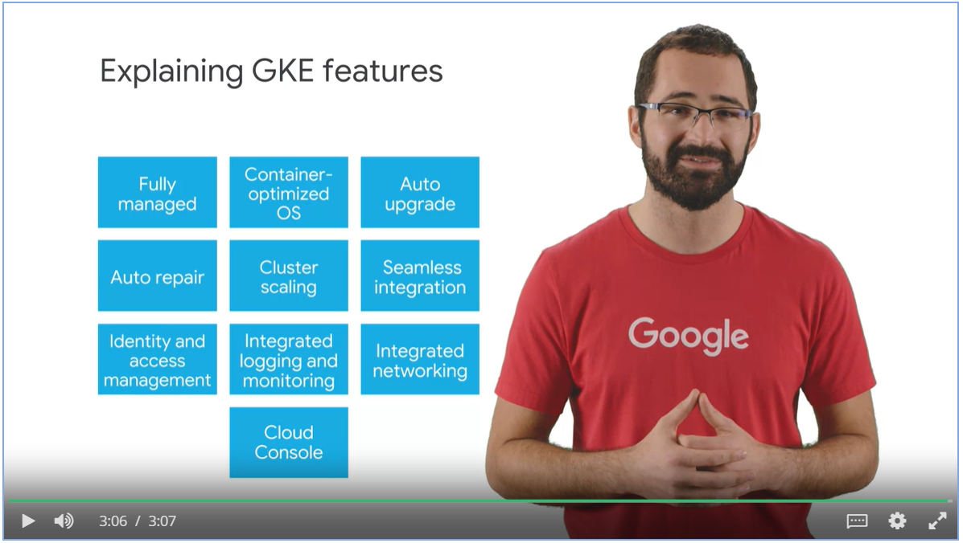

### Compute Options Detail

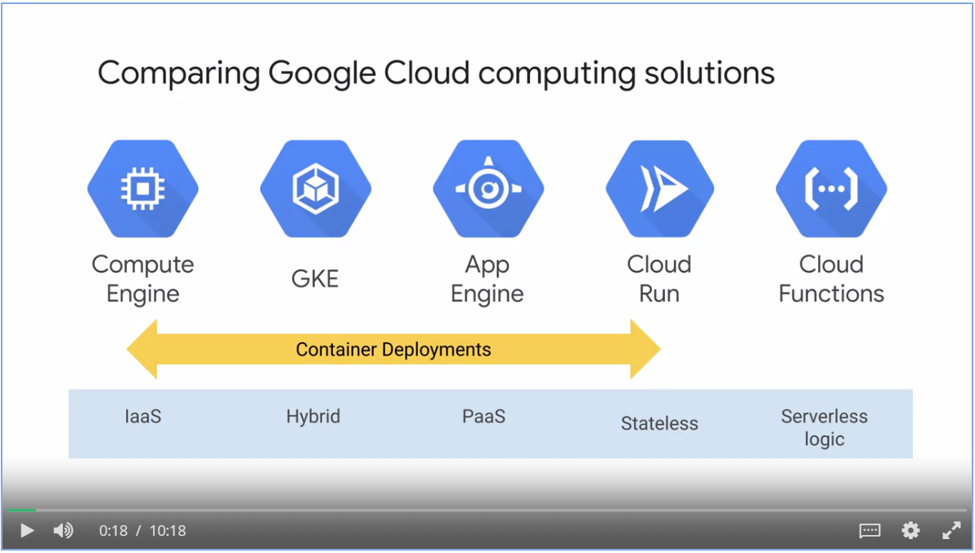

#### Compute Engine

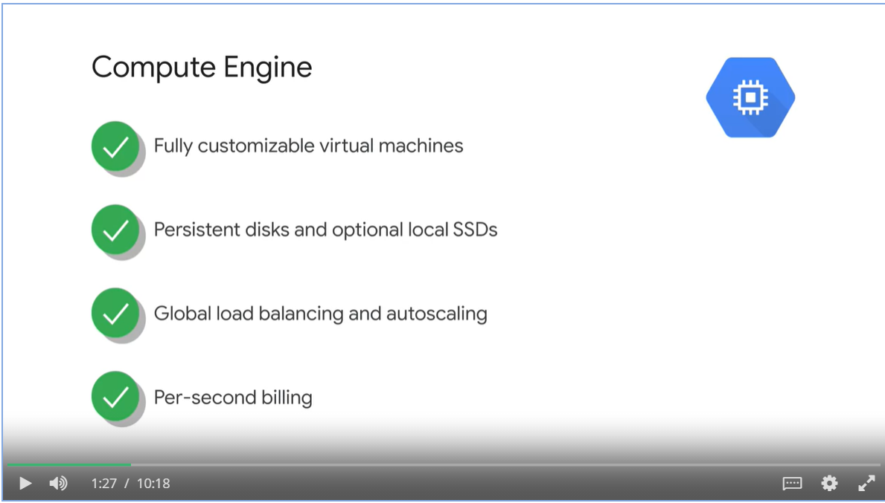

Use case

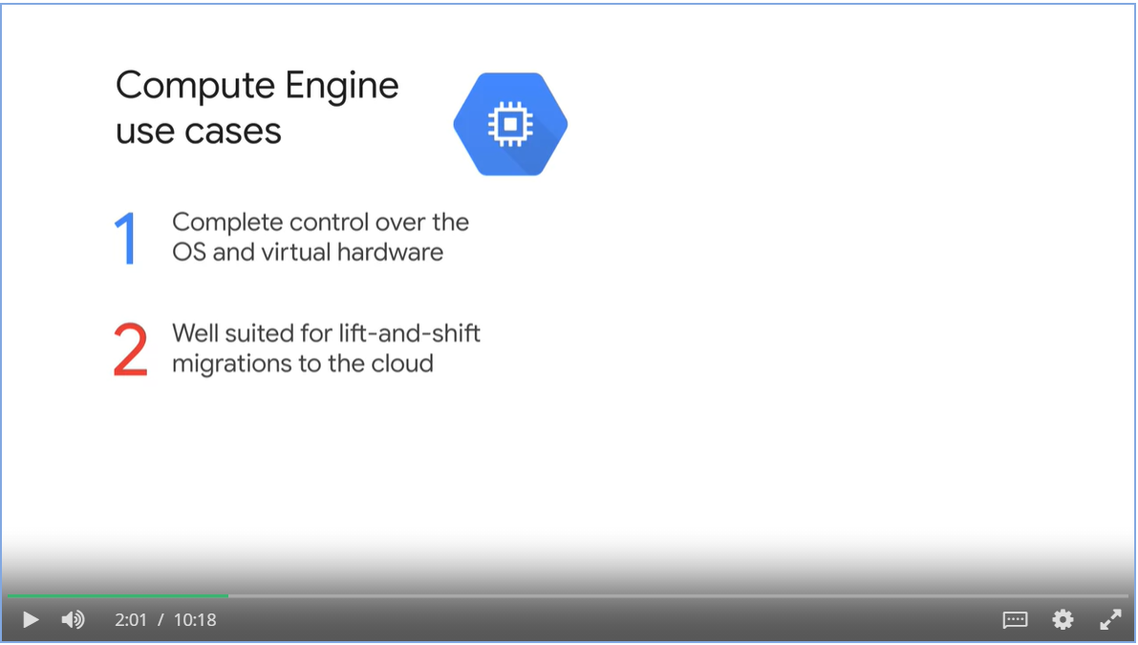

#### App Engine

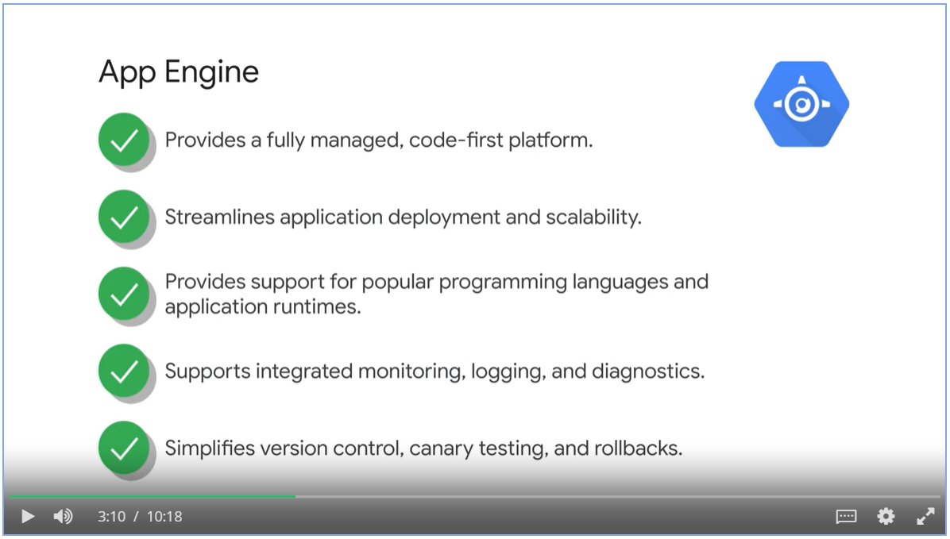

App Engine use cases

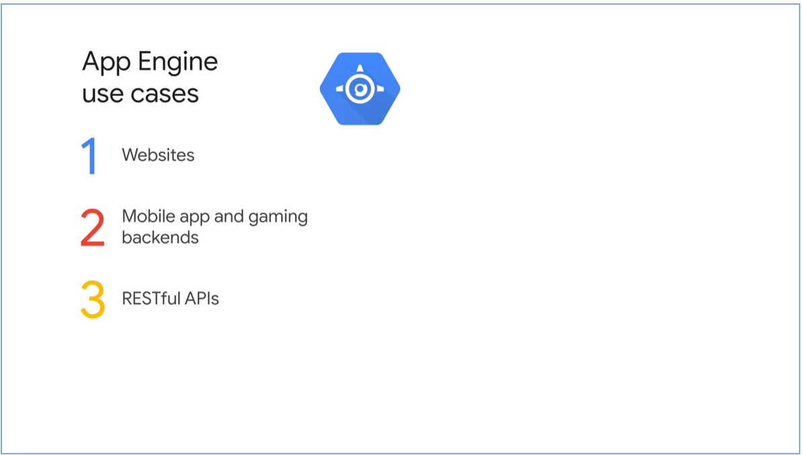

#### Google Kubernetes Engine

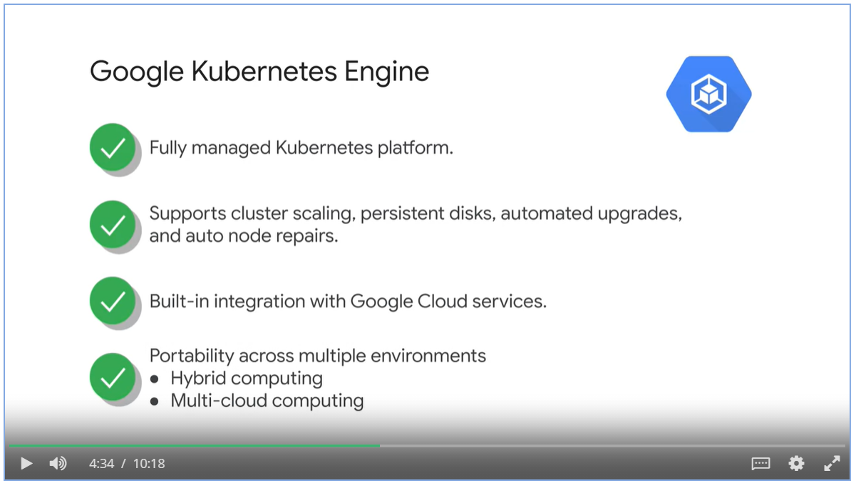

GKE use case

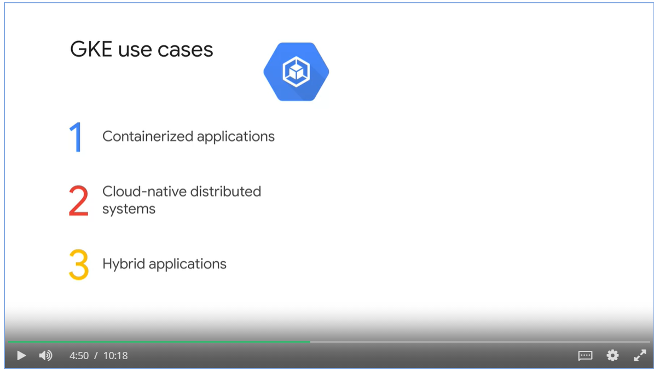

#### Cloud Run

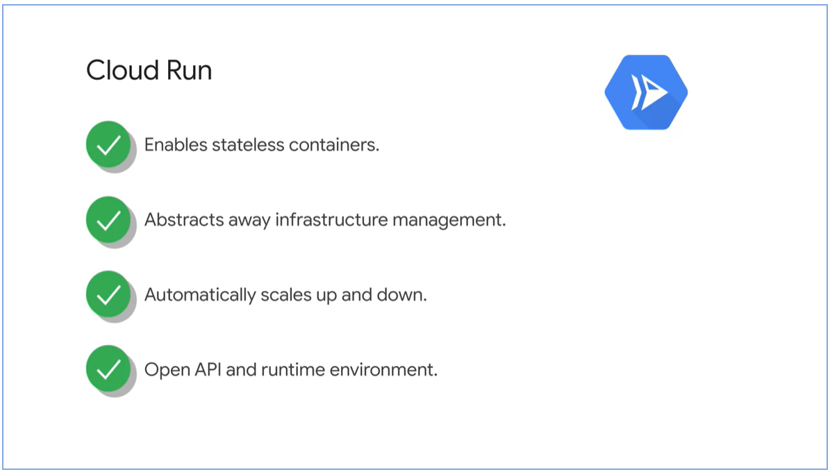

Cloud Run use cases

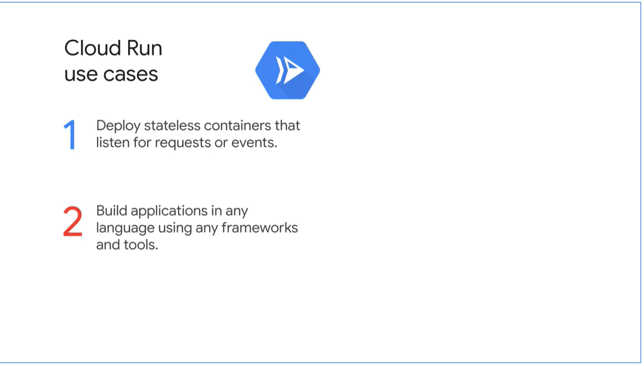

#### Cloud Functions

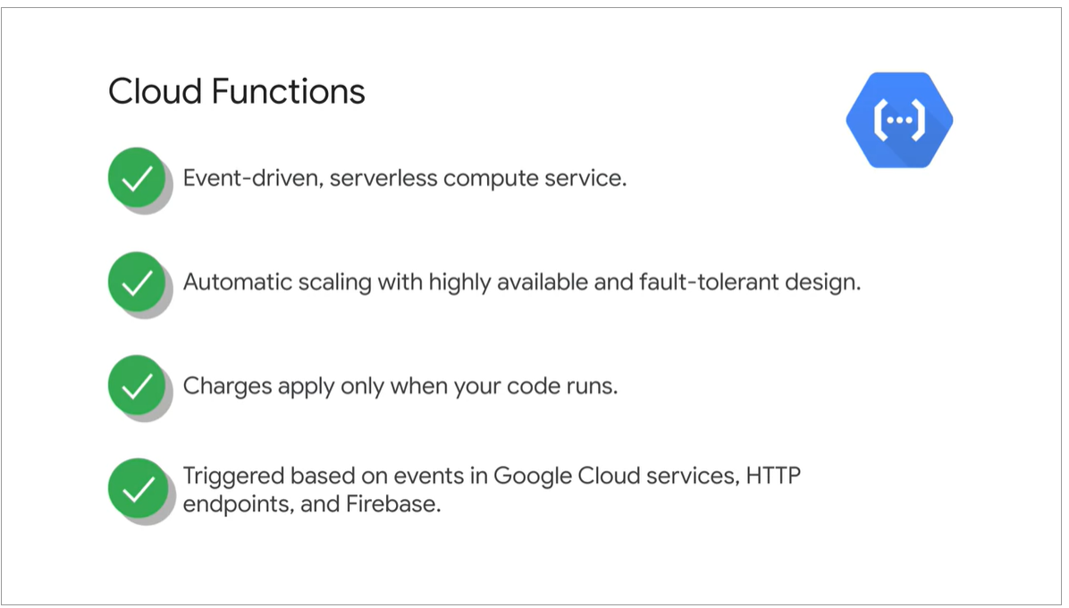

Cloud Functions use cases

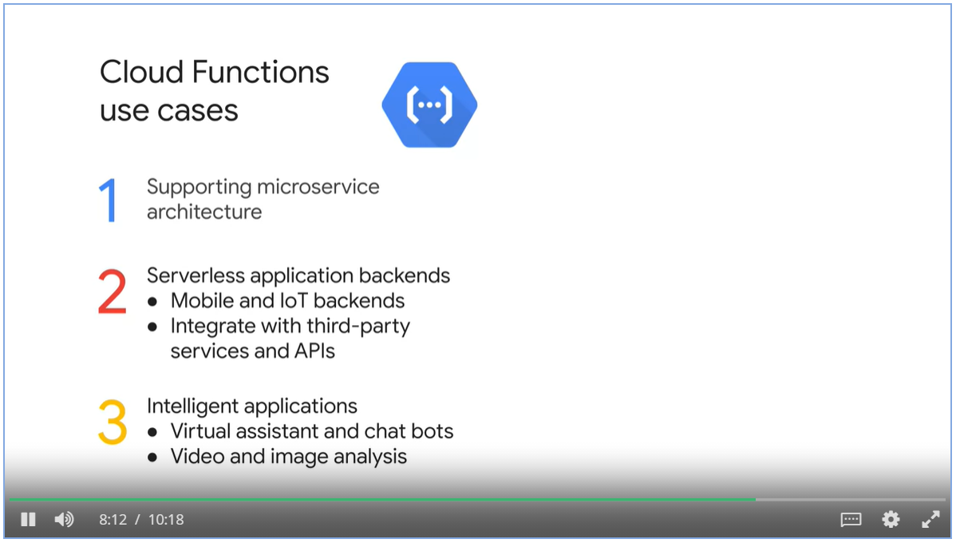

#### How to decide?

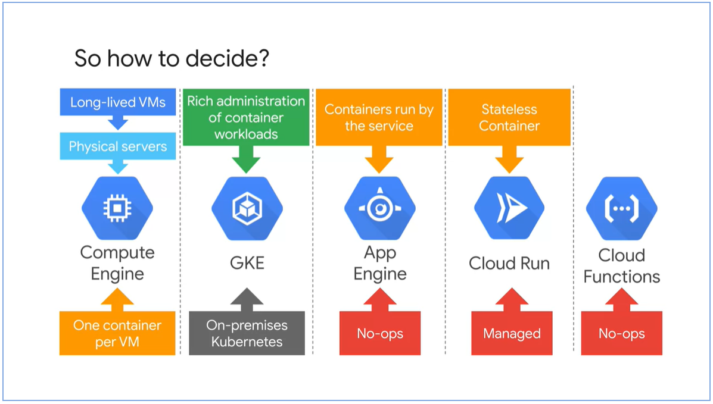

## Week 1: Kubernetes Architecture

### Kubernetes Concepts

#### Object Model and Declarative Management

* Kubernetes object is a persistent entity that represents the state of something running in a cluster.
* Object specs describes the desired state.
* Object status describes the current state.

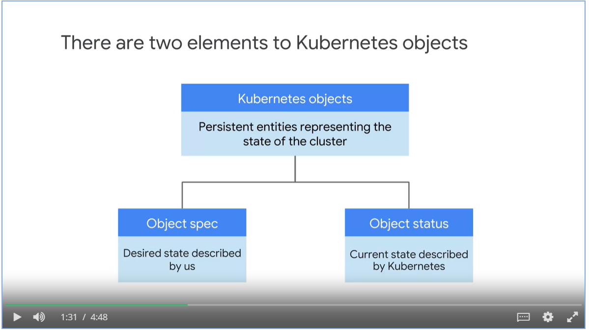

#### Pods

* Pods are the smallest deployable Kubernetes object.
* A pod embodies the environment where the container lives, one or more container can live in one pod.
* Each pod has a unique ip address, containers share the network namespace.
* Storage can be shared by containers live in the same pod. Storages can be shared across pod.

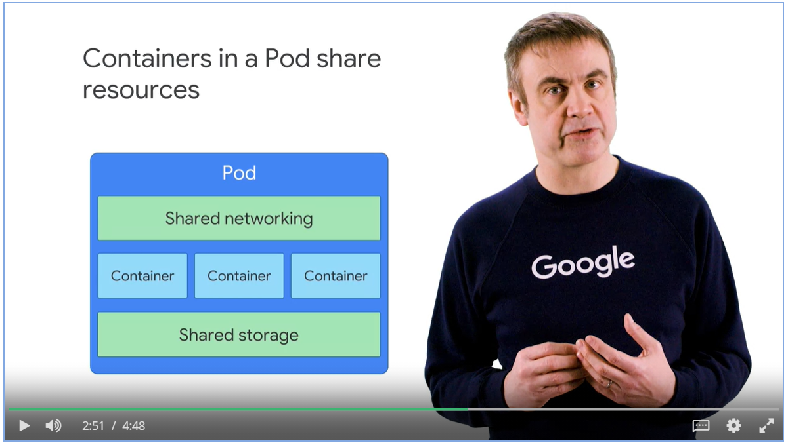

#### Example: Running three nginx containers

* You declare objects that represents 3 nginx containers
* Kubernetes launches those objects and maintains them.

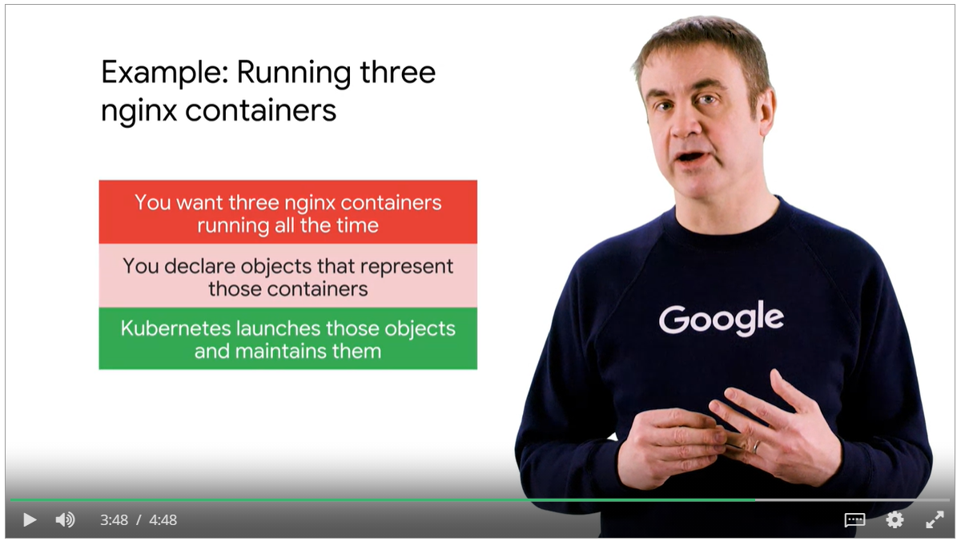

* Kubernetes constantly compares the current state with the desired state.
* Kubernetes Control Plane takes remediation actions so that the current state can match the desired one.

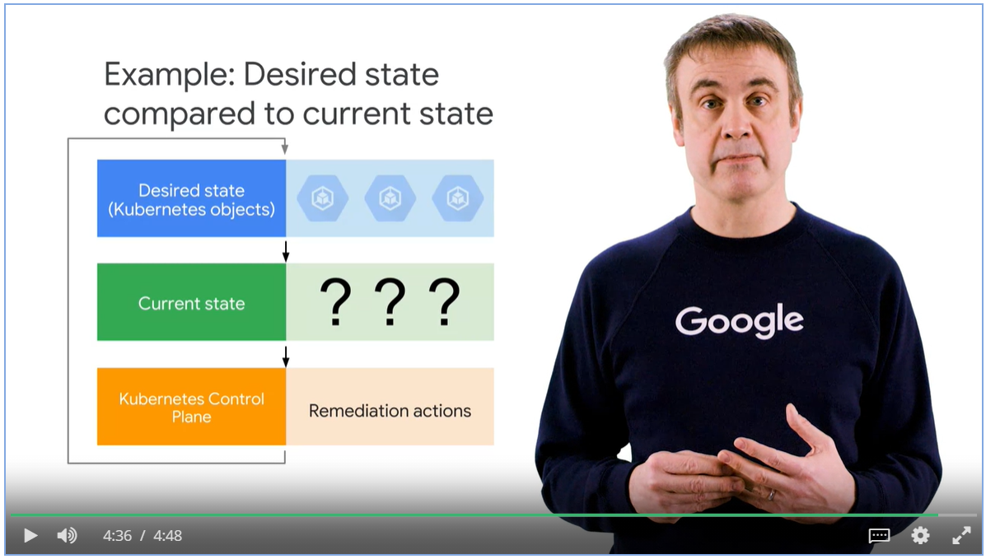

### Kubernetes Control Plan

* Master coordinates the cluster and nodes run pods
* kube-APIserver receives commands from kubectl, to view and change the state of the clusters, including launching pods.
* Etcd is the cluster’s database. It stores the state of the cluster. You don’t interact with etcd directly, but instead using kube-APIserver.
* Kube-scheduler is responsible for scheduling pods onto the nodes.
  + Choose nodes for pods based on the defined constraint
  + Memory constraint, version of software etc
  + Affinity specification, which cause groups of pods to prefer running on the same node, or vice versa

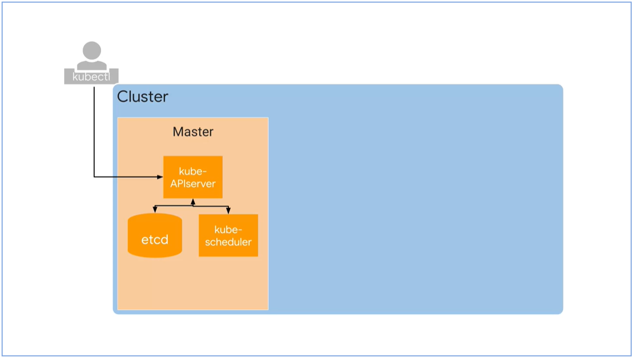

* Kube-controller-mangers monitors the state of the cluster, make changes to achieve the desired state.
* We use Kubernetes controllers to manage workloads, such as bringing pods into deployment and keep them running.

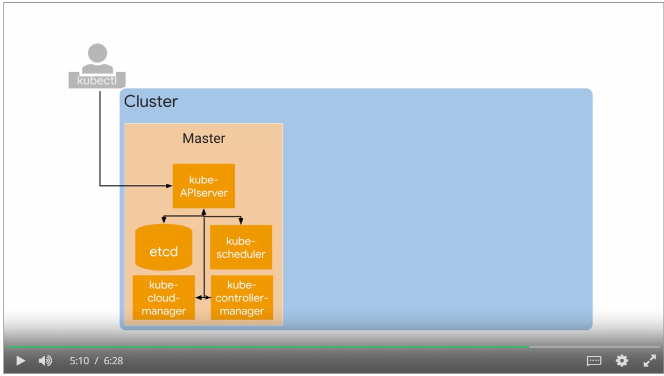

* Each node runs a small family of control-plane component too. For example, Kubelet.
* Kubelet acts as an agent. Kube-APIserver contacts the Kubelet to start a pod, Kubelet monitors and reports back to APIserver.
* Container Runtime is the software component that knowns how to launch a container from a container image.
* GKE uses container D, the runtime component of docker to launch containers.
* Kube-proxy’s job is to maintain network connectivity among the pods in a cluster.

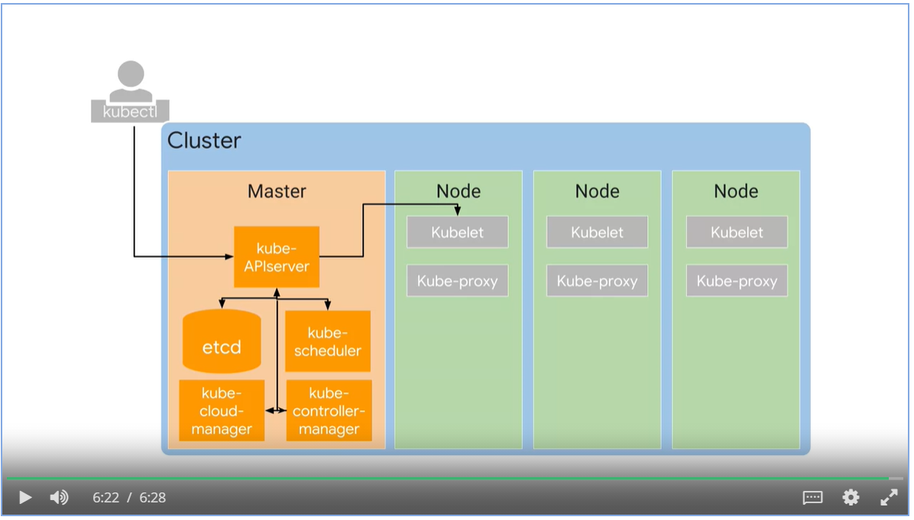

### Google Kubernetes Engine Concepts

#### GKE Abstractions

* GKE exposes an IP address to which we send all of our Kubernetes API requests.
* GKE take the responsibility for provisioning and managing all the master infrastructure behind it.
* GKE abstract away having a separate master.

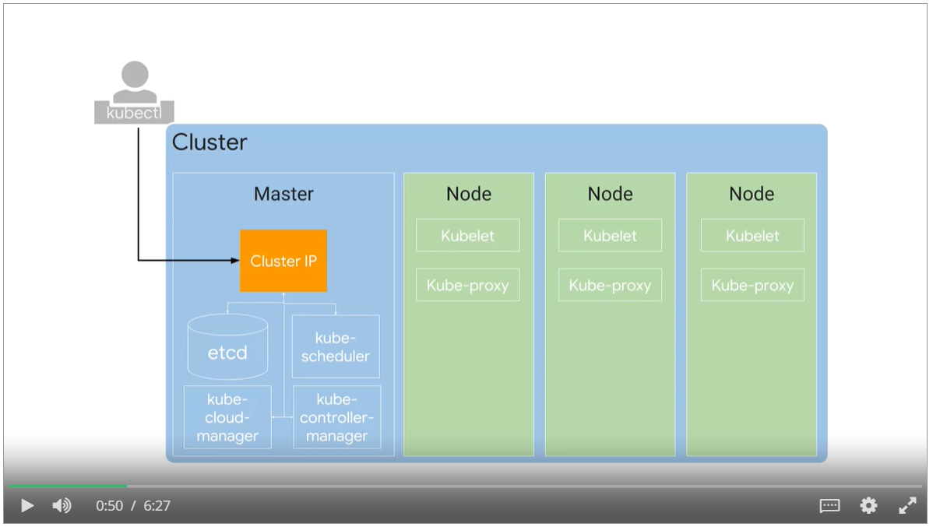

* Kubernetes doesn’t create nodes. Cluster admins create nodes and add them to Kubernetes
* GKE manages by deploying and registering Compute Engine instances as nodes.

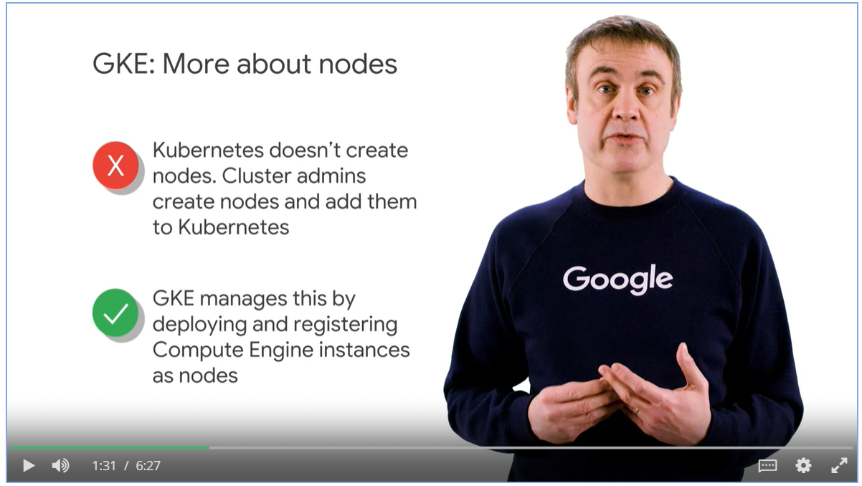

#### Compute Engine as Node

* Compute Engine instances are registered as node, you need to specify the machine types when creating nodes.

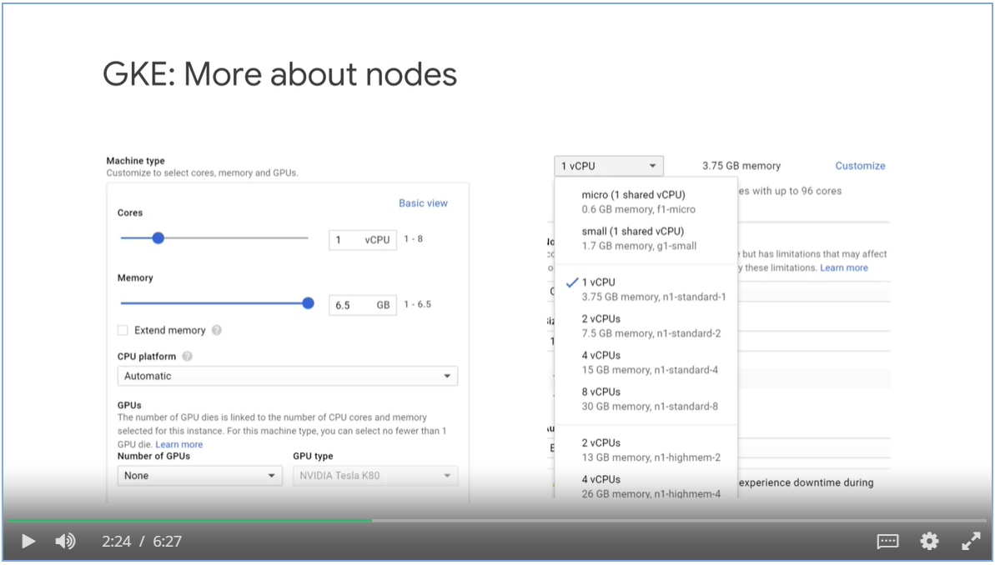

#### Node Pool

* You can assign several nodes with similar specs into a Node pool (a GKE feature, not Kubernetes)
* Enable automatic node upgrades, automatic node repairs and cluster auto-scaling on node-pool level

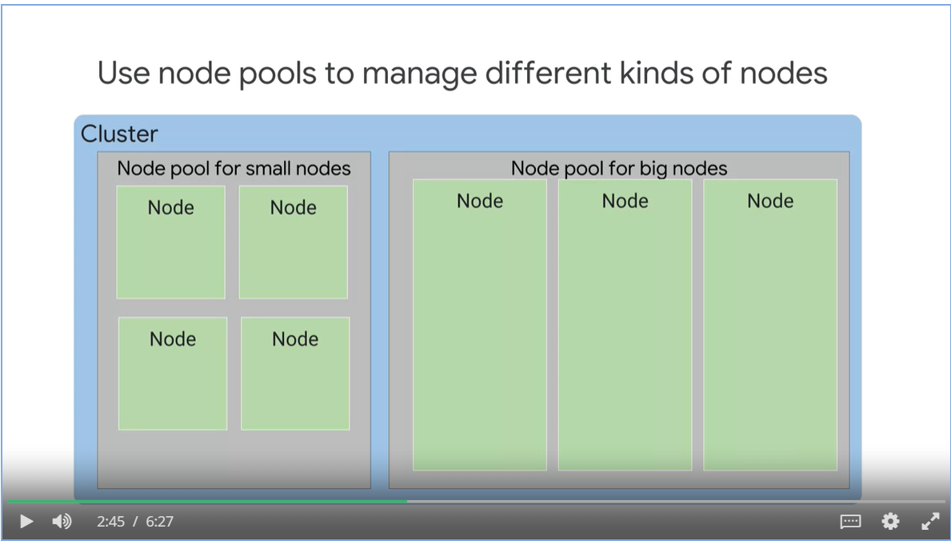

#### Regional Cluster

* By default, a cluster launches in a single GCP Compute Zone with three identical nodes, all in one pool.
* Use GKE regional clusters for better reliance and availability.

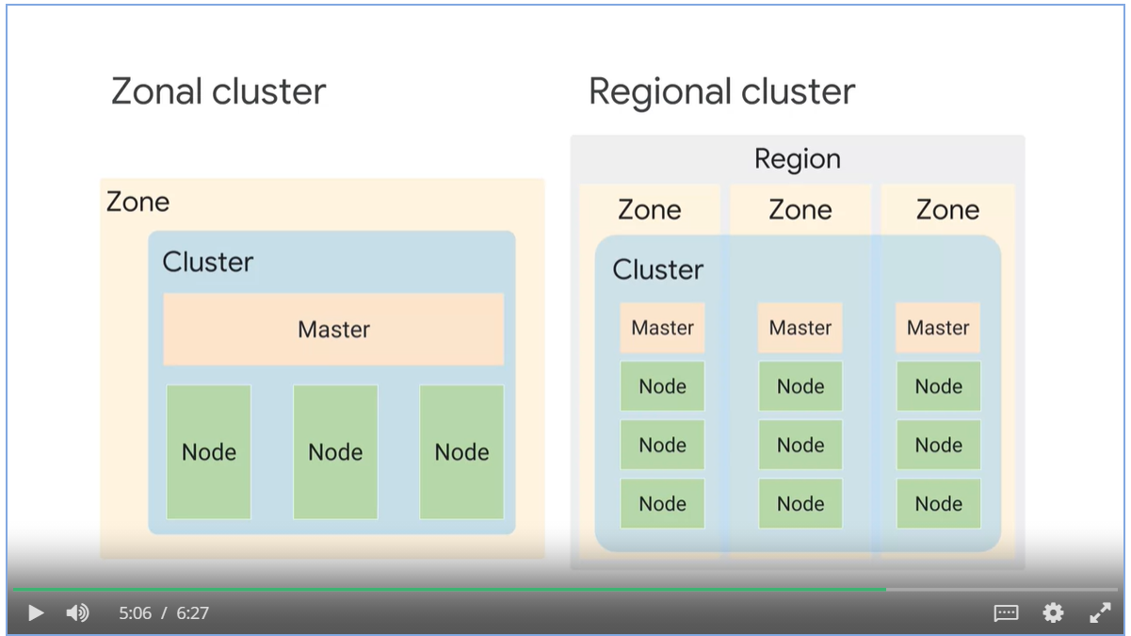

#### Private clusters

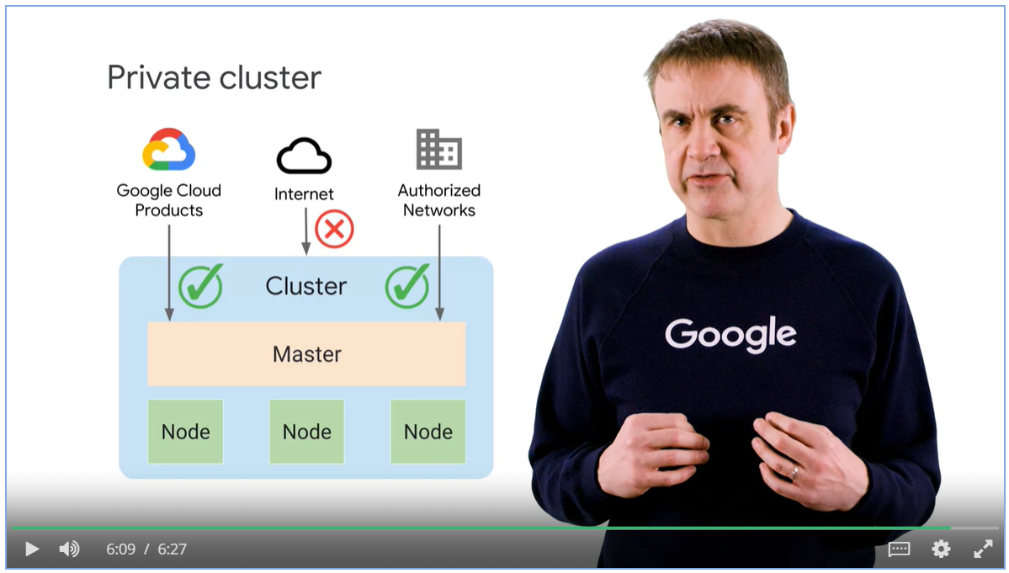

## Week 1: Deployments and Jobs

* Deployment describes the desired state of the pods.

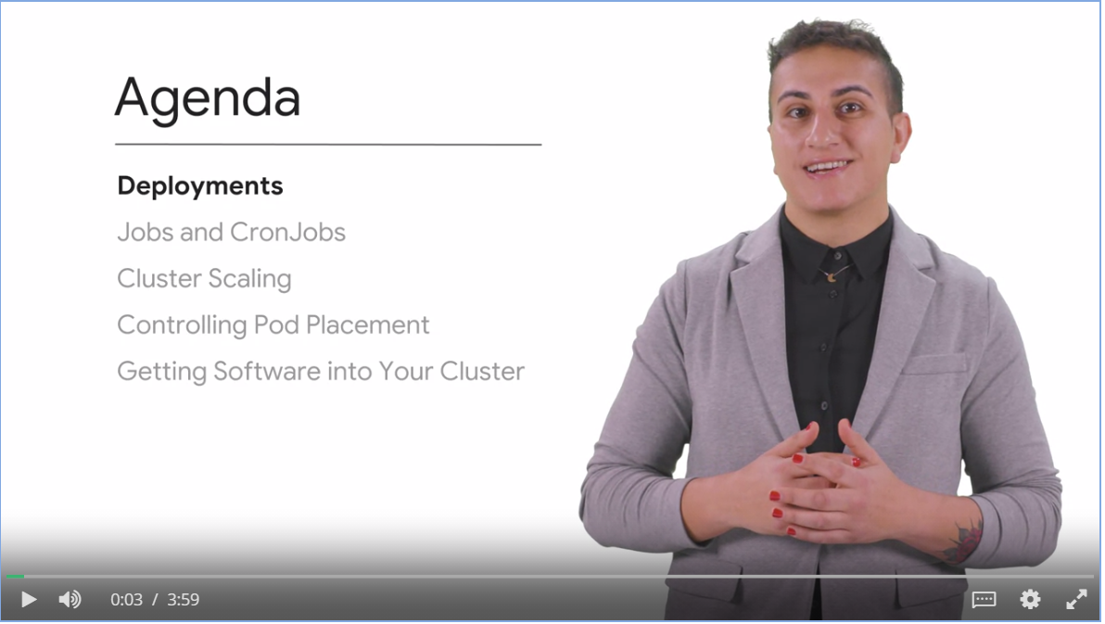

### Deployments

#### Deployment Usage

* Deployment declares a stat of pods. Every time you update the specification of the pods, a newer replica set is created to match the altered version of the deployment.
* If the newly created pods are unstable, we can rollback to previous revision.
* You can scale the pods manually or automatically.
* Well-suited for stateless applications.

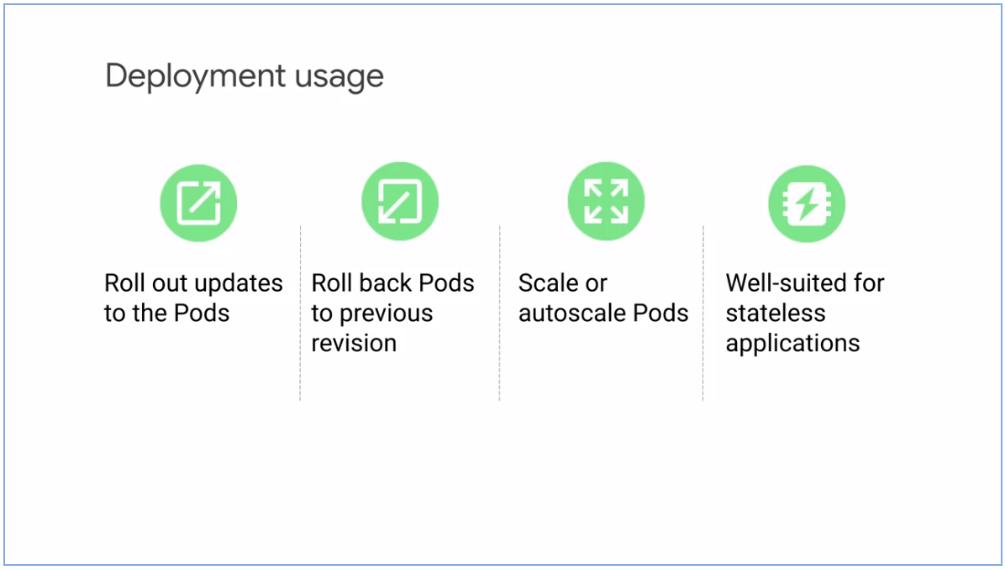

* Deployment .yaml file consists of the characteristics of the pod and how to operationally run these pods and handle their lifecycle events.
* After you submit the yaml file to Kubernetes Master, it creates a deployment controller.
* A controller is a loop prosses that takes care of meeting the desired state.
* A replica set is created to match the number of pods described.

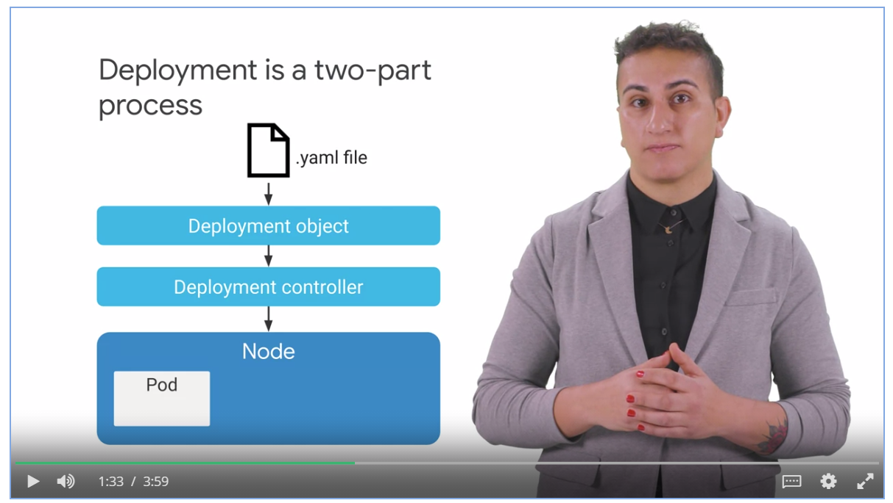

#### Example of deployment object file in YAML format

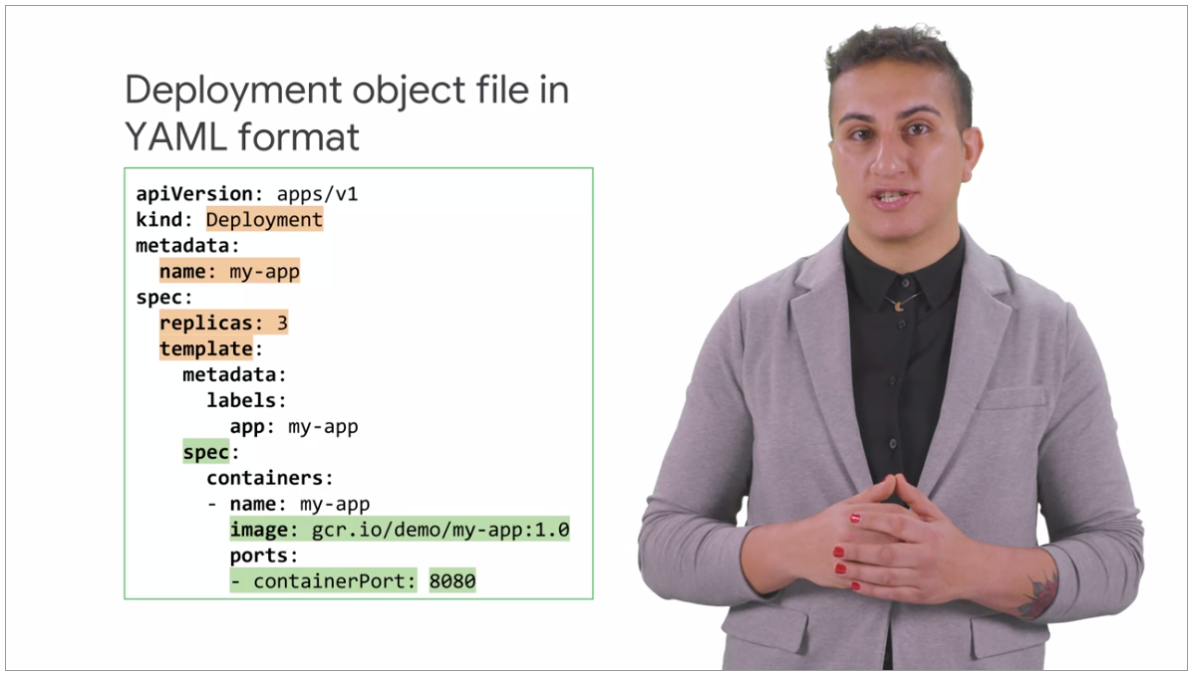

#### Deployment Lifecycle States

* Progressing state: such as creating a replica set, scaling up or scaling down a replica set.
* Complete state: all replicas are available and running
* Failed state: creation of a new replica set cannot be completed.

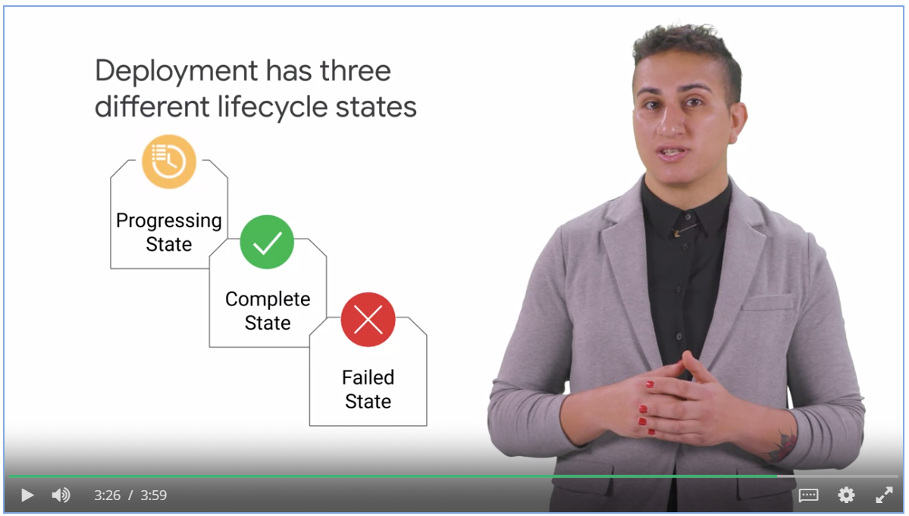

How to manage complexity

* When you apply many small fixes across many rollouts, that translates to a large number of revisions to manage complexity.
* Keep your yaml files in a source code repository to manage complexity.

### Ways to Create Deployments

* Declaratively with yaml file.
* Imperatively with commands
* Use GKE workloads menu in GCP console.

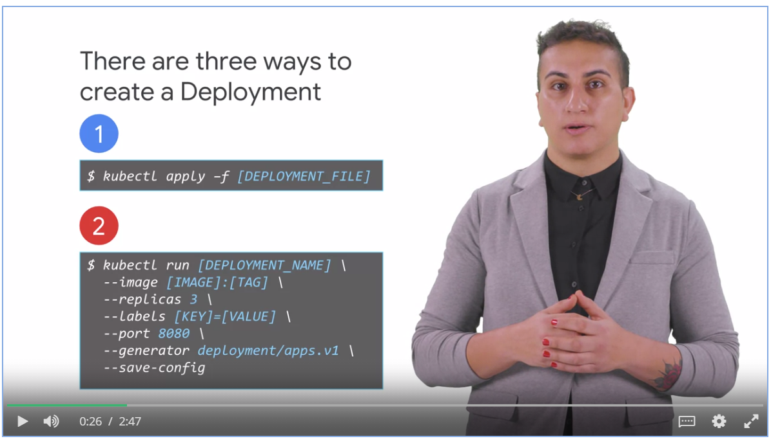

* Use kubectl to get a list of deployment
* Use kubectl to convert deployment to a yaml file for reusability.

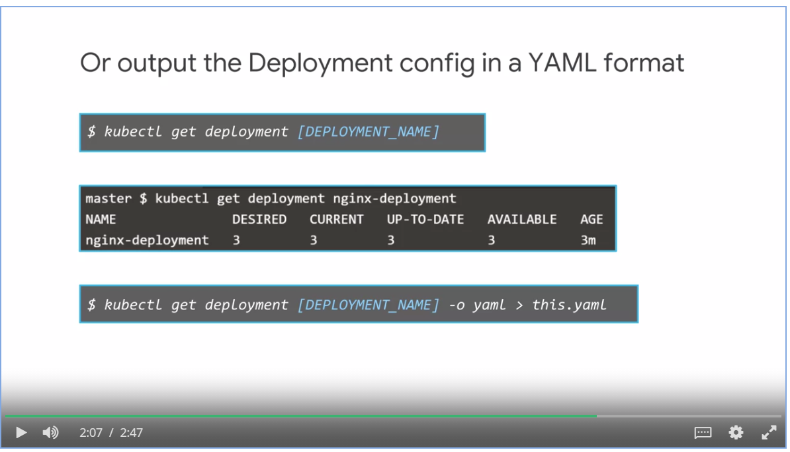

### Serving and Scaling

* Manual scaling
* Automatic scaling creates a Horizontal Pod Autoscaler (**HPA**).
* HPA performs the scaling to match the target CPU utilization.

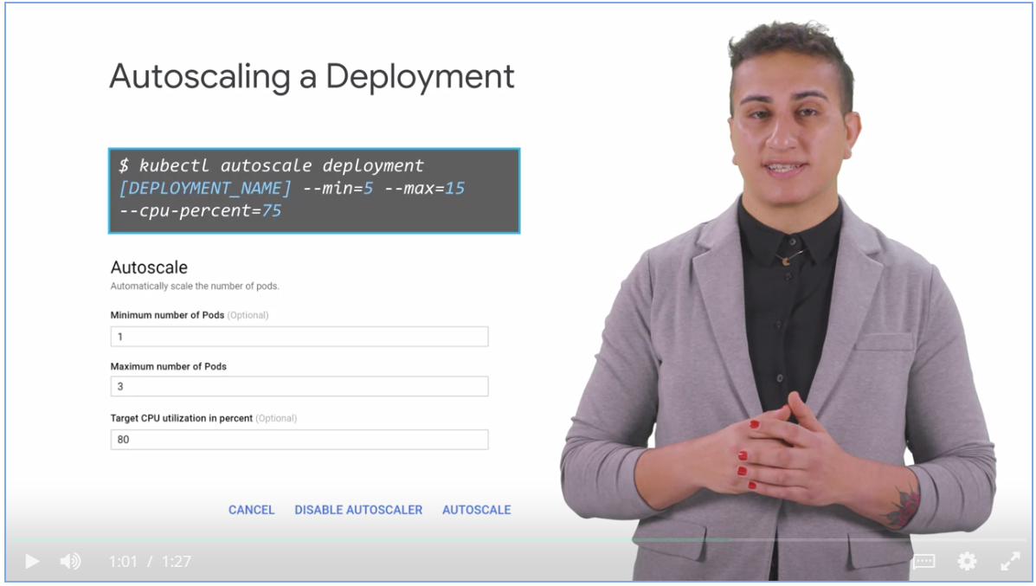

* Thrashing is a problem when the number of deployed replicas frequently fluctuates, because the metrics used to control scaling also frequently fluctuates.
* The horizontal pod auto-scaler has a cool-down or delay feature to control thrashing.

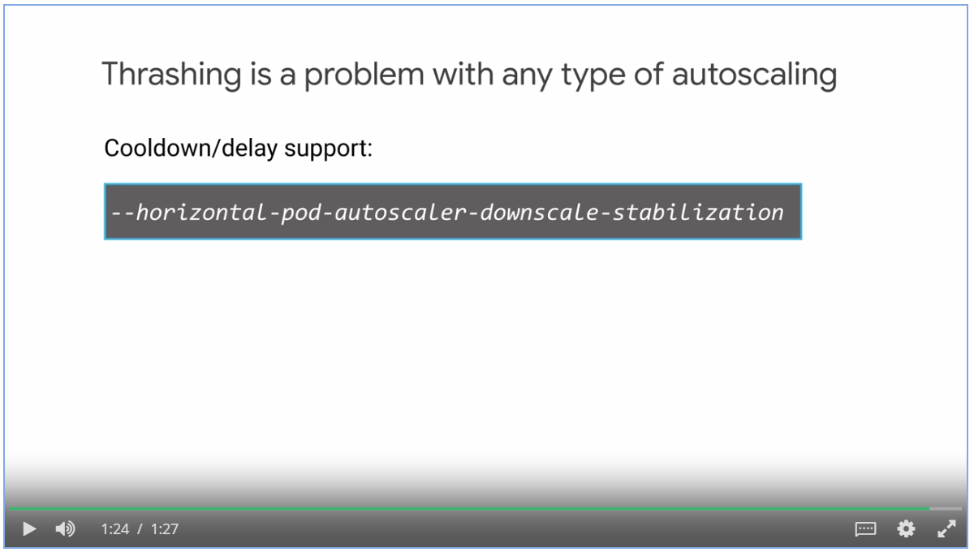

### Updating Deployments

Ways to update a deployment:

* Use **kubectl apply** command with an updated deployment specification YAML file.
* Use **kubectl set** command, opens the spec file in editor, once saved, deployment is updated automatically.
* **Edit** a deployment manifest from the **GCP console** and perform a **rolling update**.

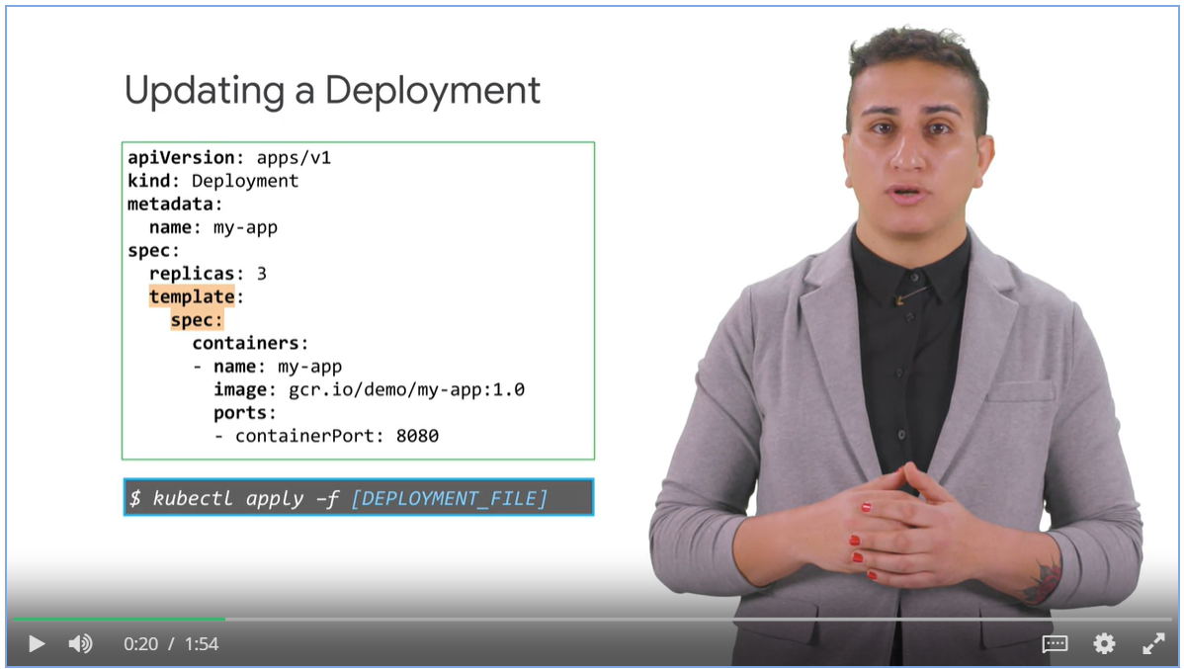

Process behind updating a deployment

* New pods are created in the new replica set one by one
* Old pods are removed from old replica set one by one
* This is known as **rolling updates** or a **rampt strategy**.
  + Availability of application is insured
  + No control over traffic between new and old replica.

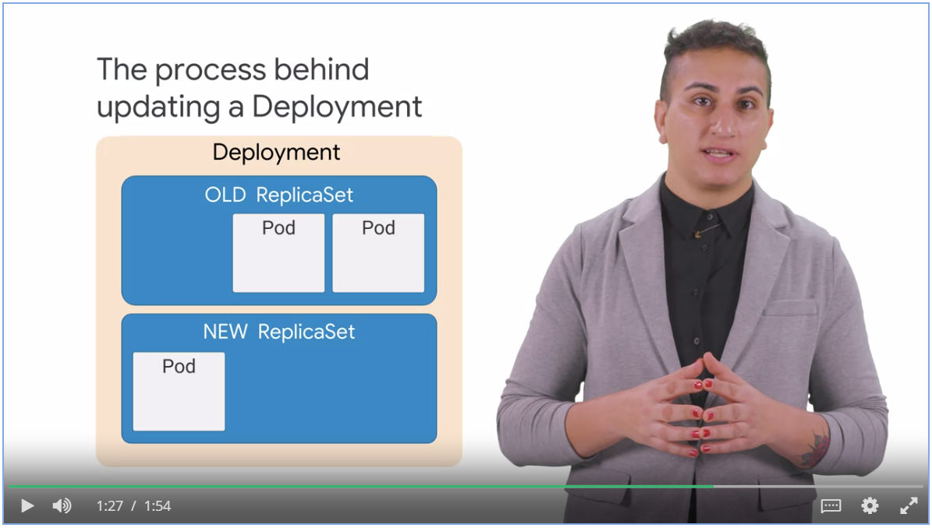

### Rolling Updates

In rolling updates strategy, the ***“max unavailable”*** and ***“max surge”*** fields control how the pods are update.

* Max unavailable lets you specify the maximum number of pods that can be unavailable during the roll out process
* Max surge allows you to specify the maximum number of pods that can be created concurrently in a new replica set.

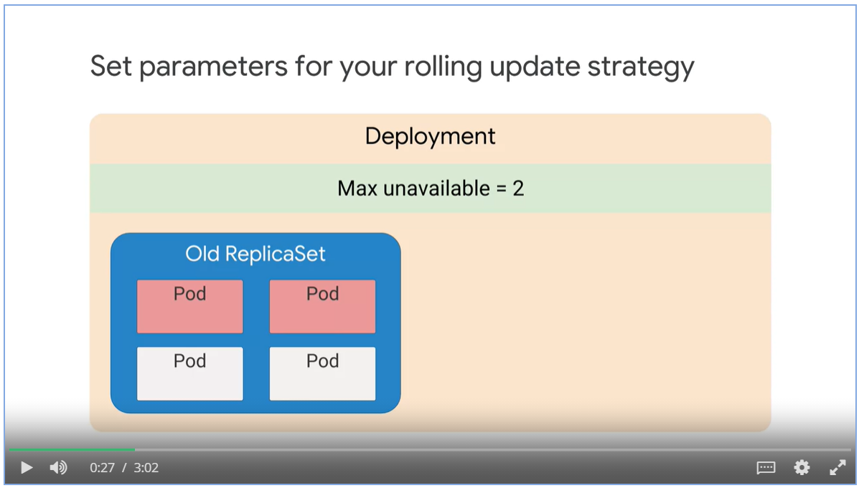

#### Example of rolling update

1. 5 new pods are created because max surge is 5.
2. Max unavailable is 30%, 10 * (1 – 0.3) = 7. Which means 7 pods need to be up and running
3. 10 old pods + 5 new pods – 7 up and running = 8. 8 pods to be removed from the old replica set
4. 5 more new pods created in the new replica set. 2 old pods removed.

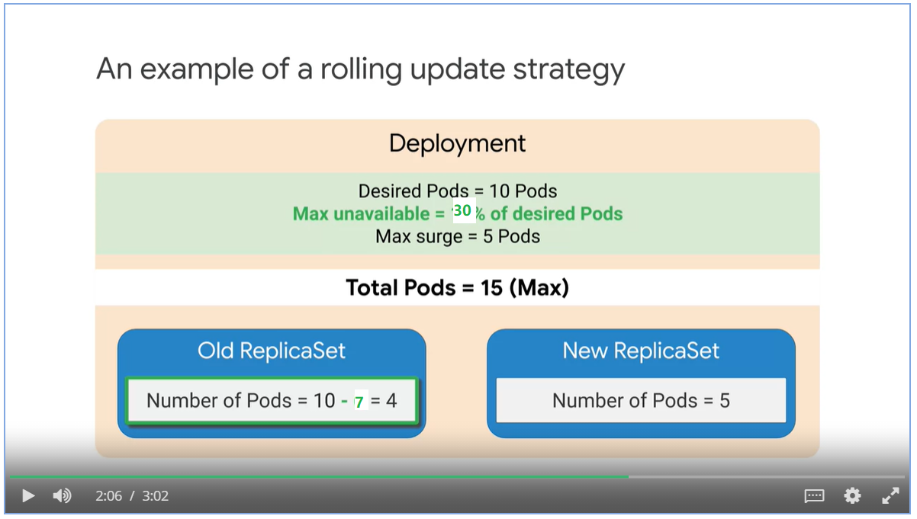

#### Recreate strategy

* Recreate is a strategy type where all the old pods are deleted before new pods are created.
* If the contract information between parts of your application is changing, you need a clean break between the system, use create strategy.

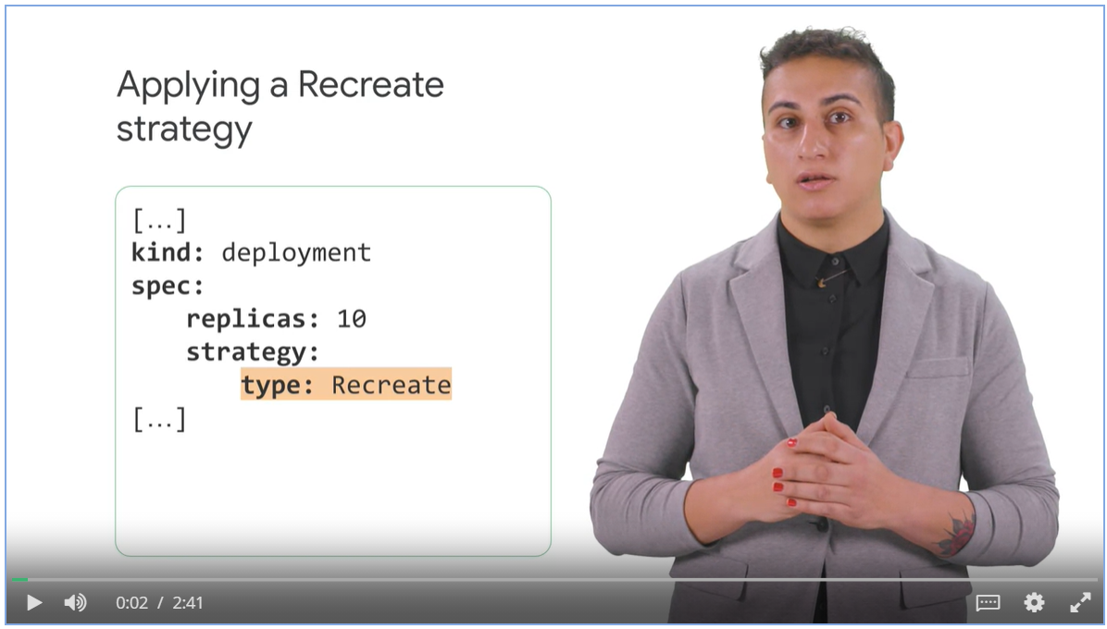

#### Blue-Green deployment strategy

* Deploy a new version of an application, also make sure that the application is available during update.
* New versions or deployment is created, old deployment is redirected to new version and shut down.
* Kubernetes service selects the pod using a label selector.

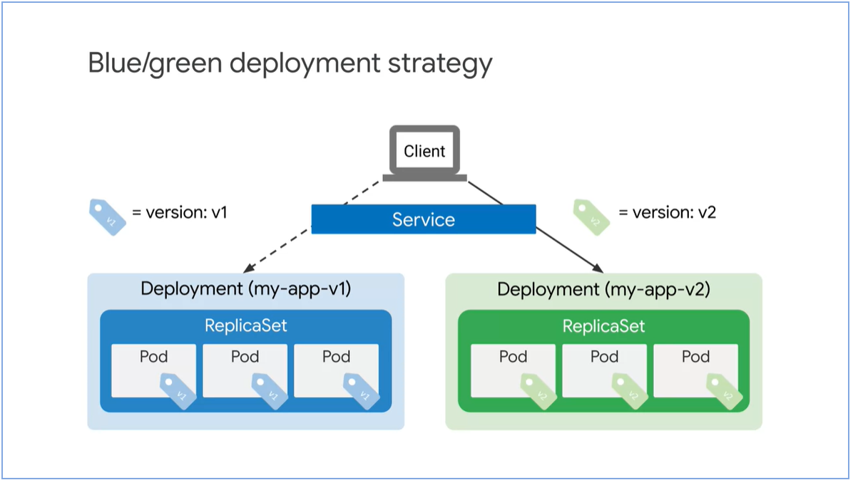

Apply a blue/green deployment strategy.

* Specify a new version label as part of a selector.

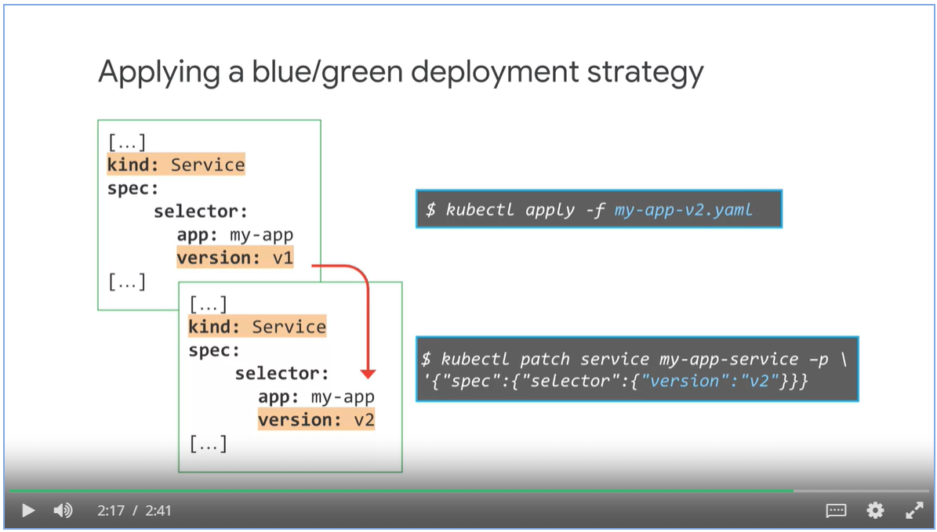

#### Canary deployment

* Canary deployment strategy is based on the blue-green strategy
* Traffic is gradually shifted to the new version.

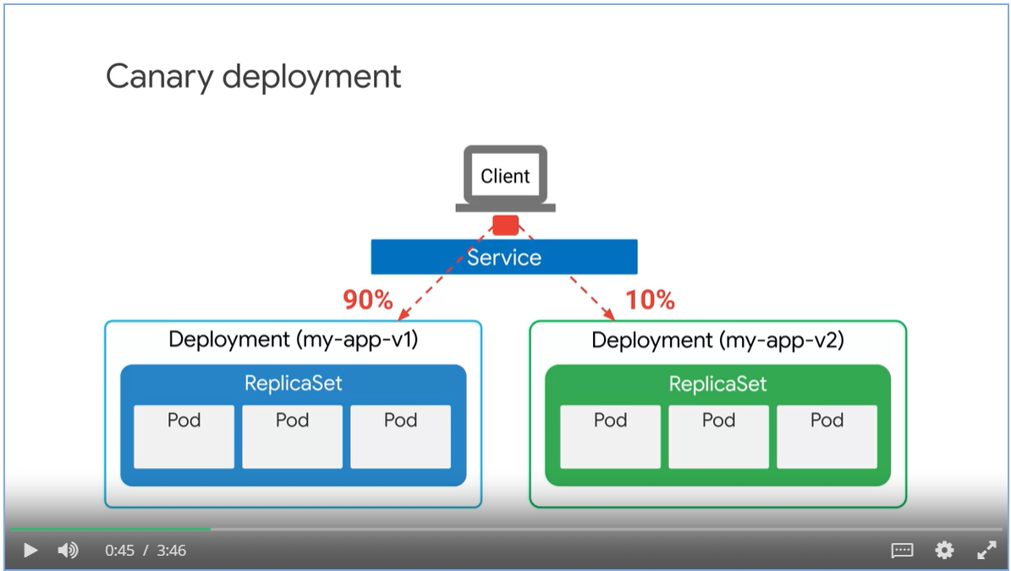

* Selector does not specify a version, only the app name

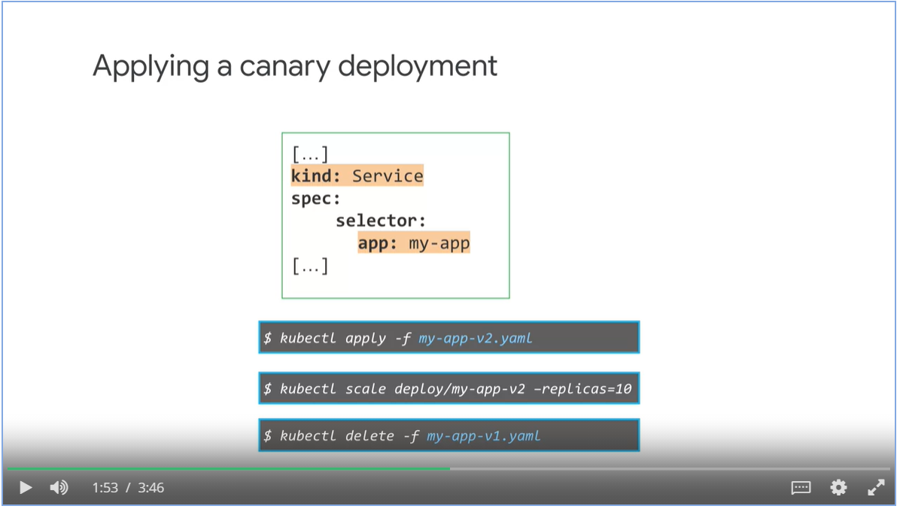

##### Session affinity

* Sometimes, we need to make sure that requests from the same user sessions are sent to the same version of pods.
* Set the session affinity fields to client IP

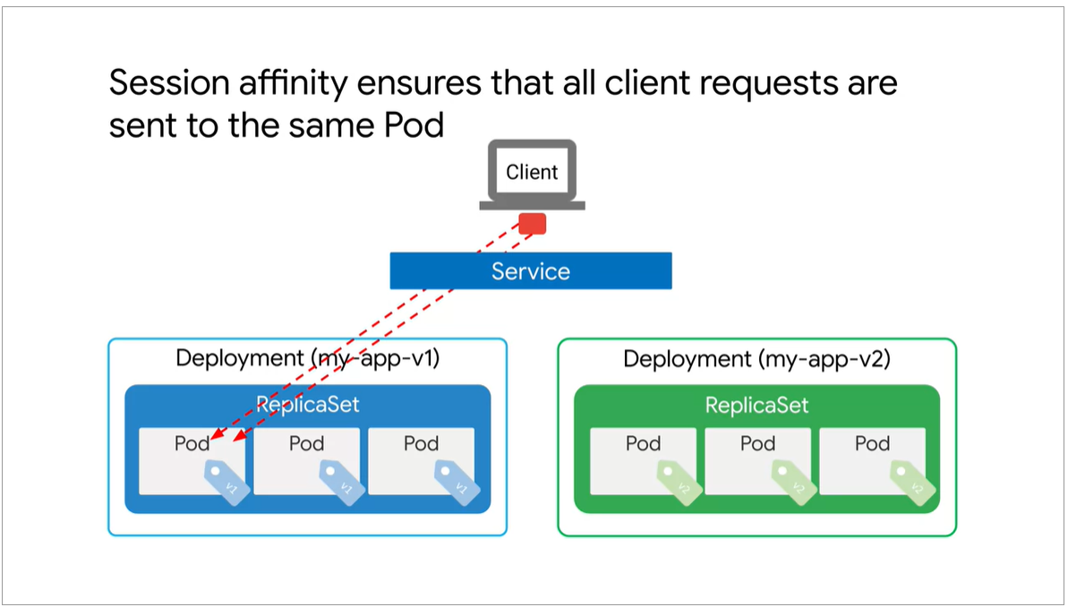

#### Rolling back a deployment

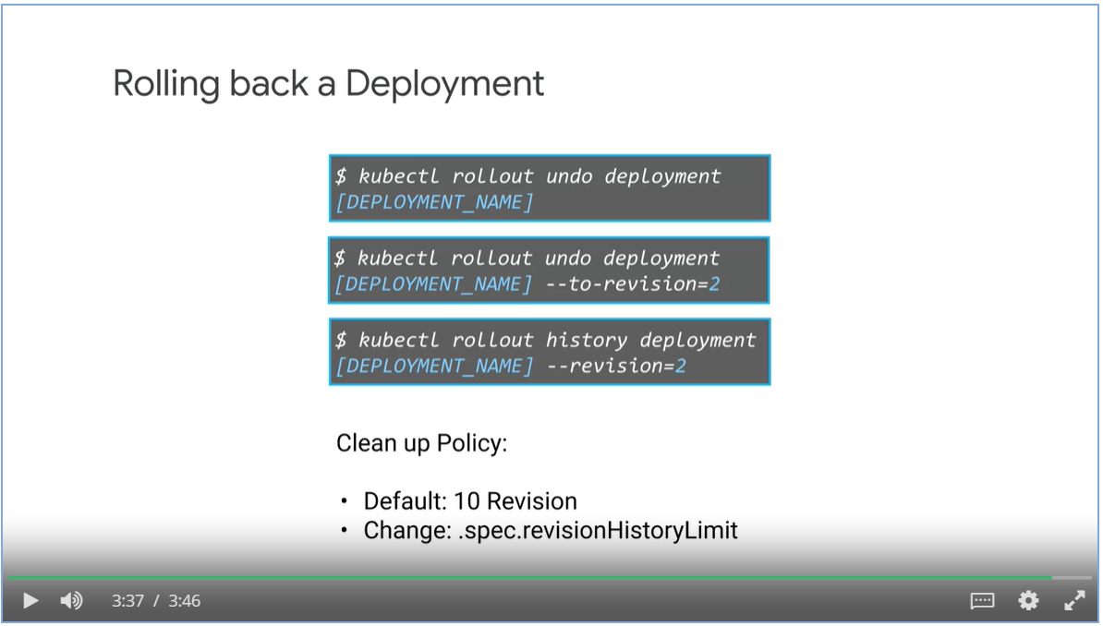

### Jobs

* A jobs is a Kubernetes object like a deployment, a job creates one or more pods to run a specific task reliably.
* When the task is completed, it will terminated the pod and report that the job has successfully finished.

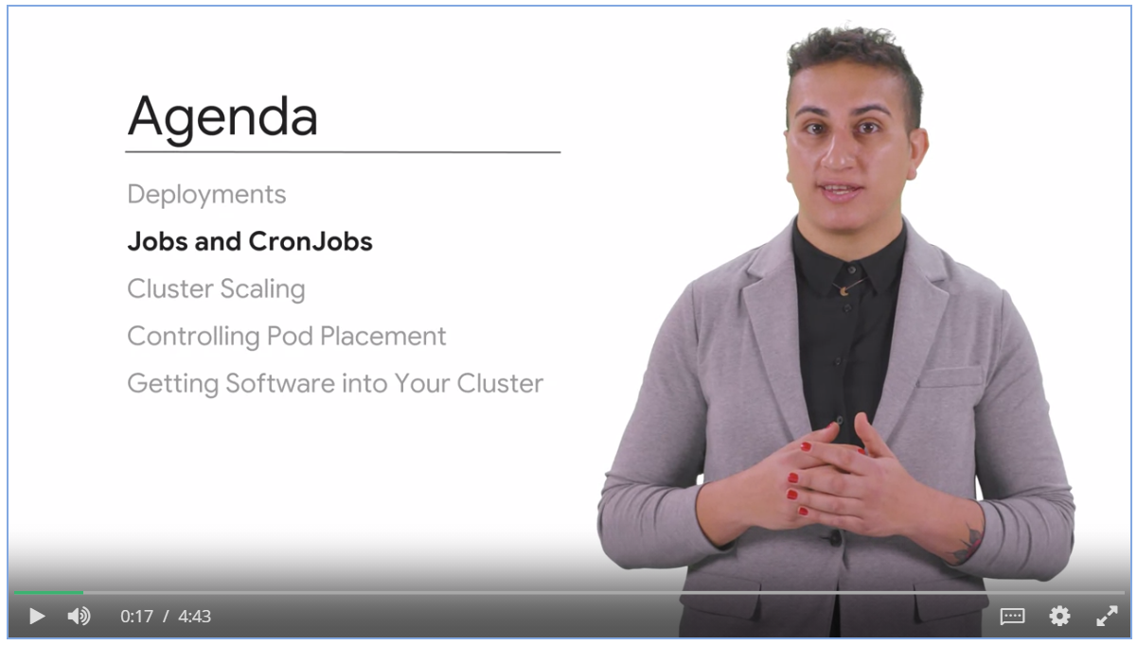

#### Running a job

* The user uploads a video file for transcoding
* Web server creates a job manifest
* A job controller takes the manifest and schedule a pod for the job on a node.
* If the job fails, the job controller schedules the job on another node
* When job is completed, nodes are deleted.

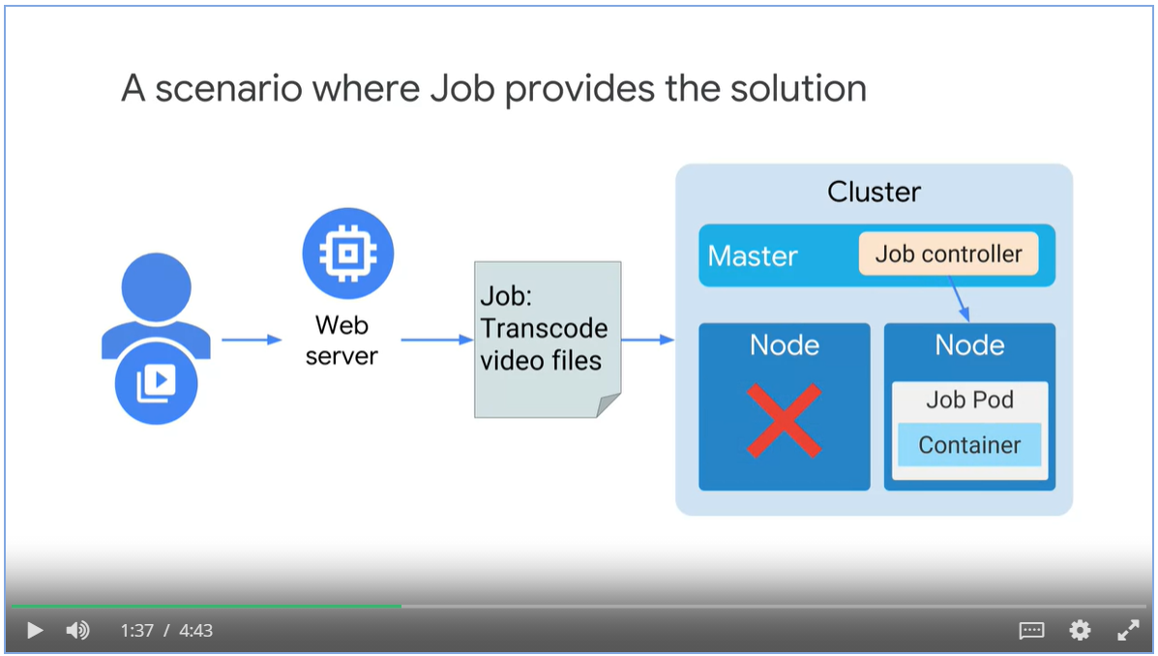

#### Non-parallel job manifest

* Kind: job
* restartPolicy: never, when job fails, don’t restart it
* BackoffLimits controls how many restart attempts before declare the job as failure. Job restart interval doubles every time.

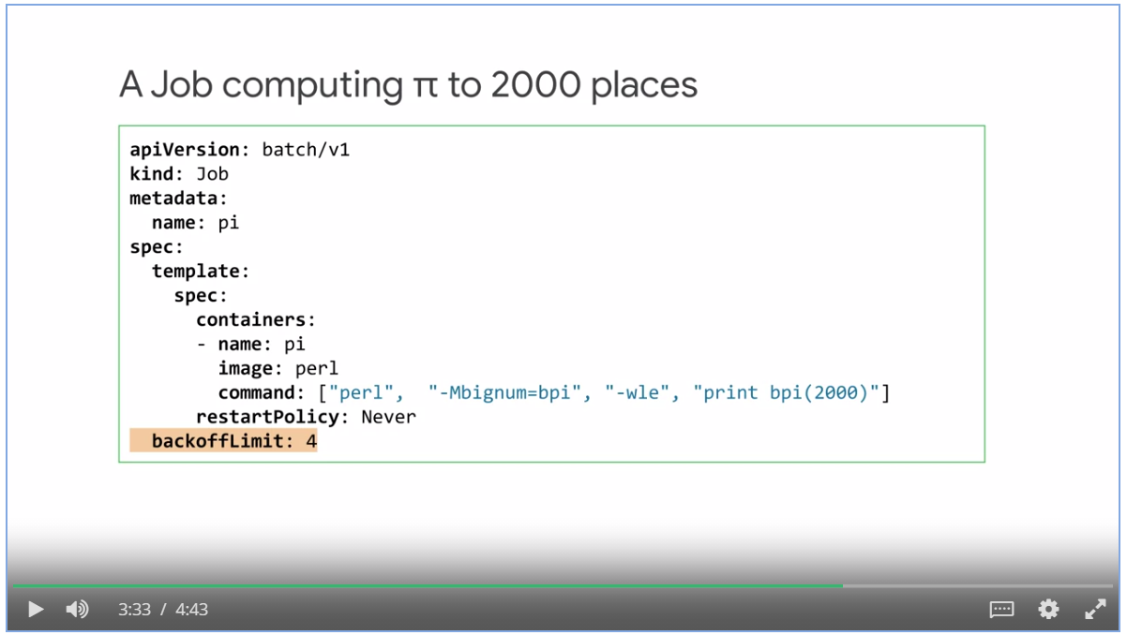

#### Parallel Jobs with completion count

* Parallel jobs creates multiple pods that work on the same task at the same time.
* Two types of parallel jobs:
  + With fixed task completion count
  + Process a work queue
* Parallel job with a fixed task completion count.

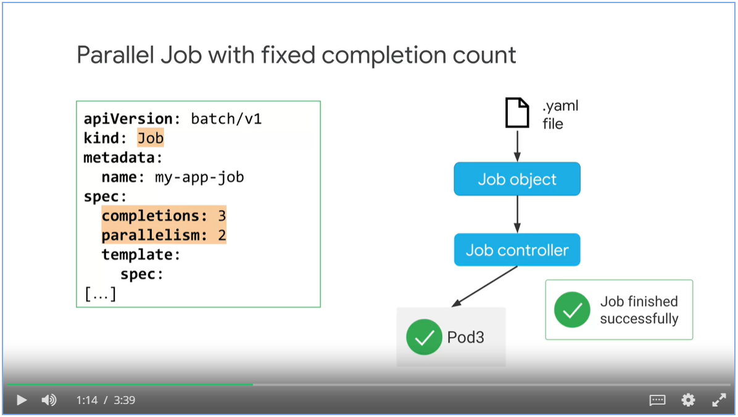

#### Parallel jobs with a worker queue

* Specify the value for parallelism, leave the completion value empty
* As long as one of the pod finishes the workload, the job is considered as finished and remaining pods are shut down.

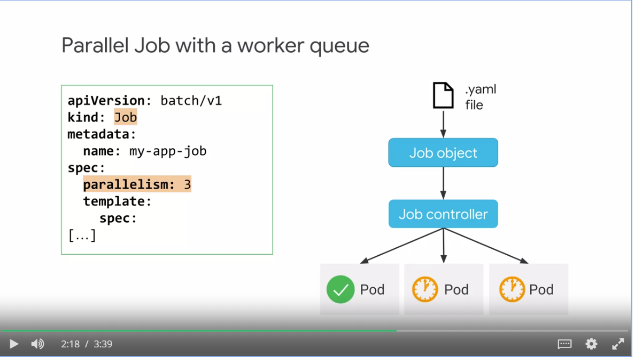

#### Failing jobs

* Use activeDeadlineSeconds to fail a job if it is running longer than the value
* activeDeadlineSeconds takes precedent over backoffLimit.

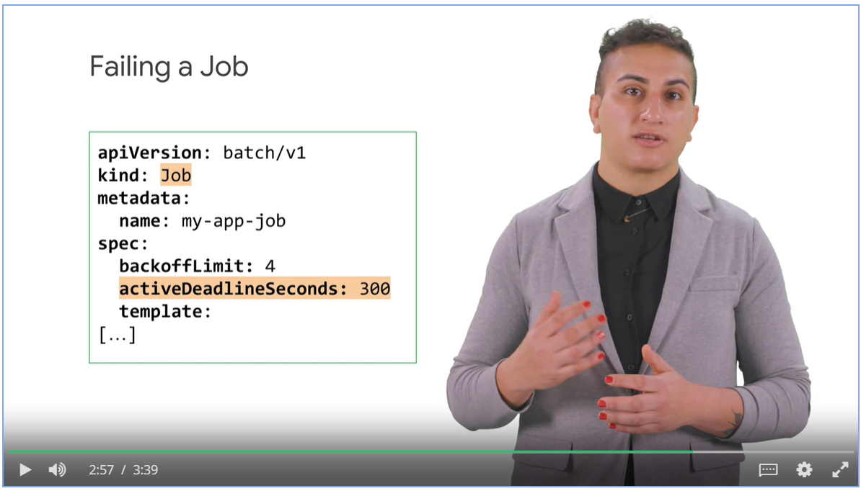

#### CronJobs

* A Cron job is a Kubernetes object that creates jobs in a repeatable manner to a defined schedule.,
* Cron is the stand Unix/Linux mechanism for scheduling a process.

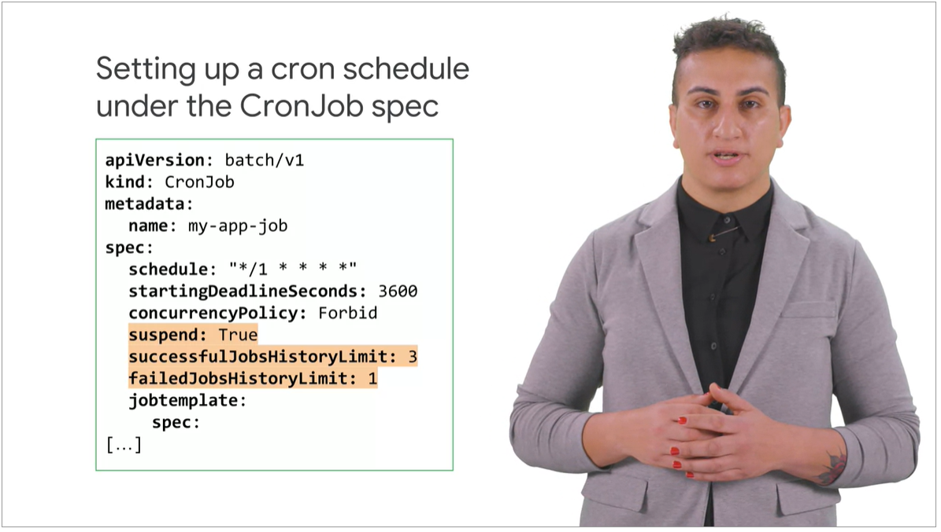

## Week 2: Introduction to AI Platform Pipelines

### Overview:

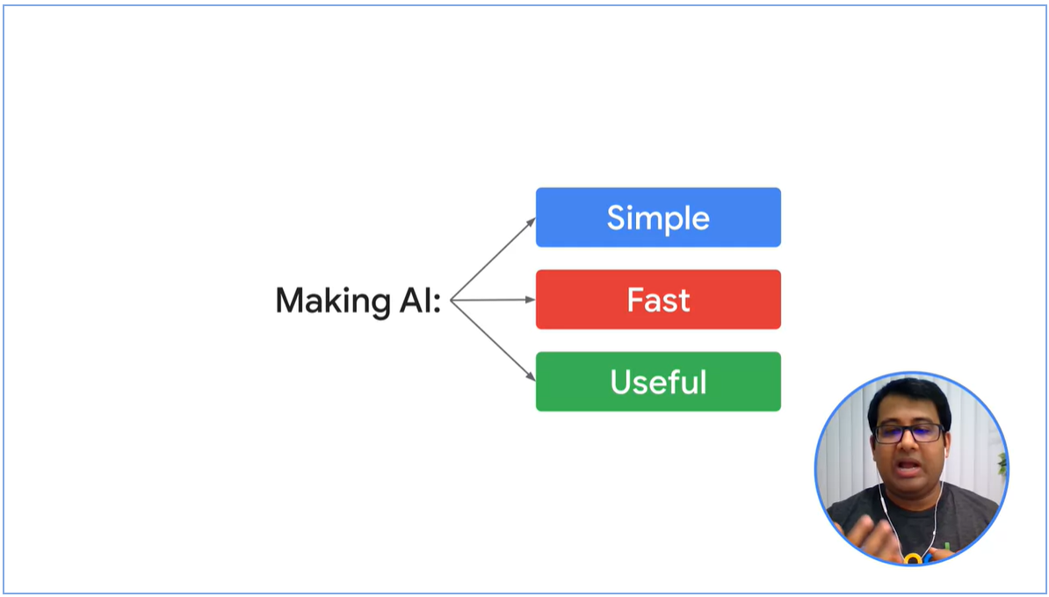

Three Common AI problems

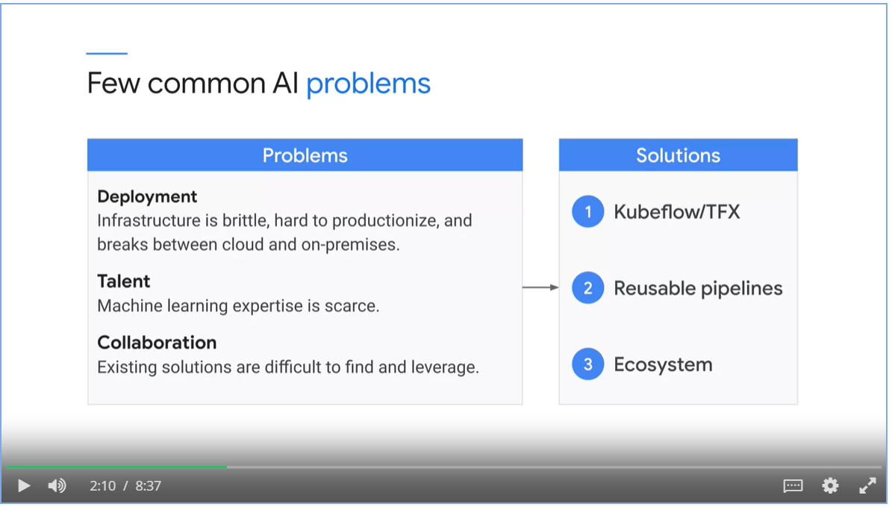

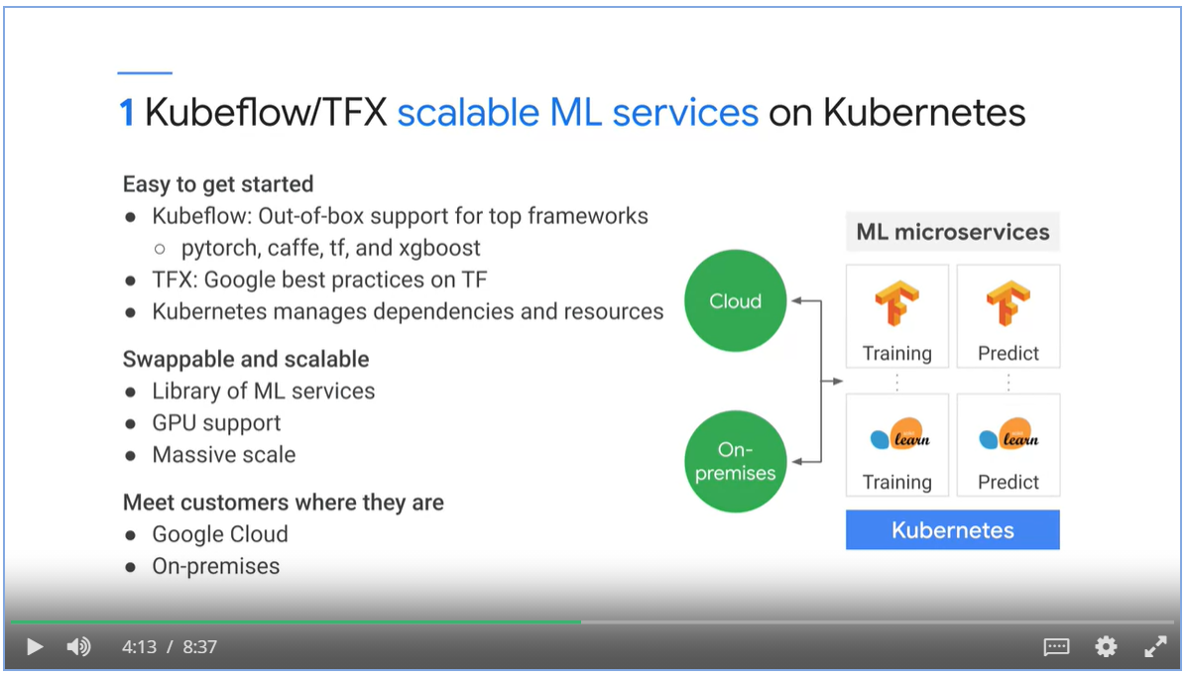

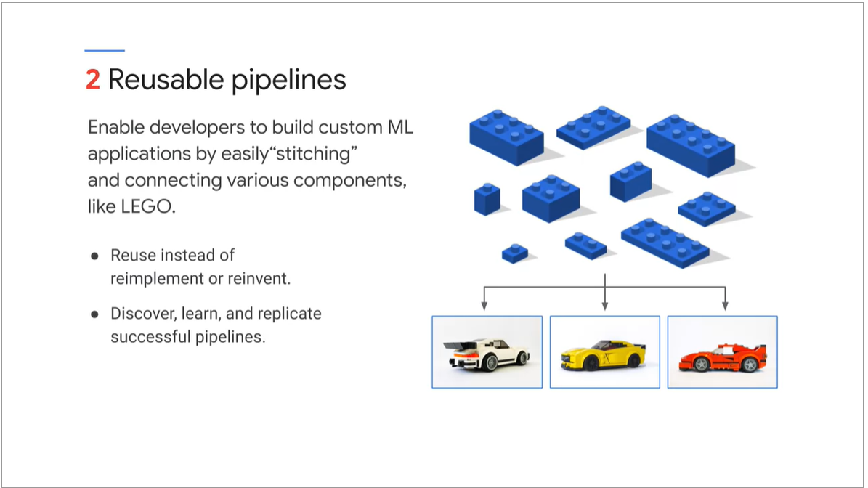

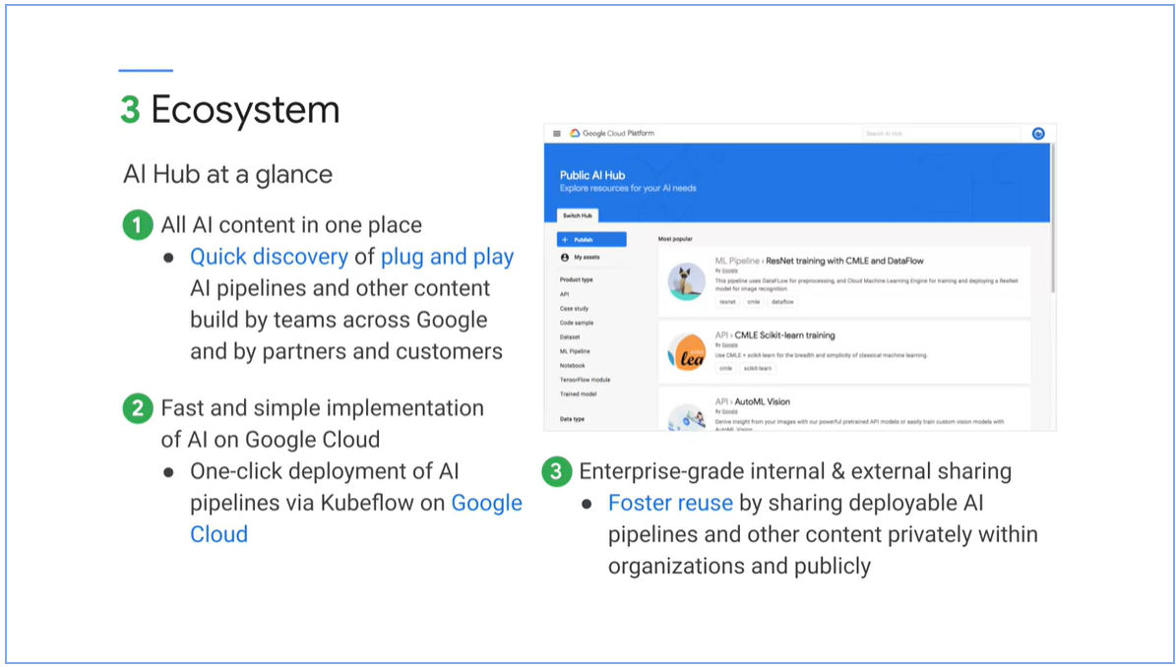

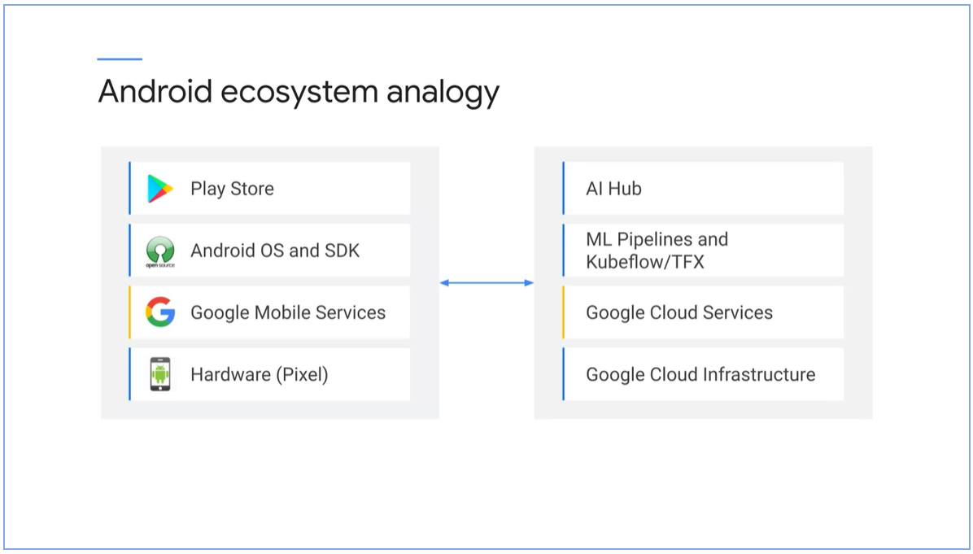

#### AI Platform Pipelines

* ML pipelines are portable, scalable ML workflows based on containers.
* ML pipelines are composable of set of input parameters and list of tasks

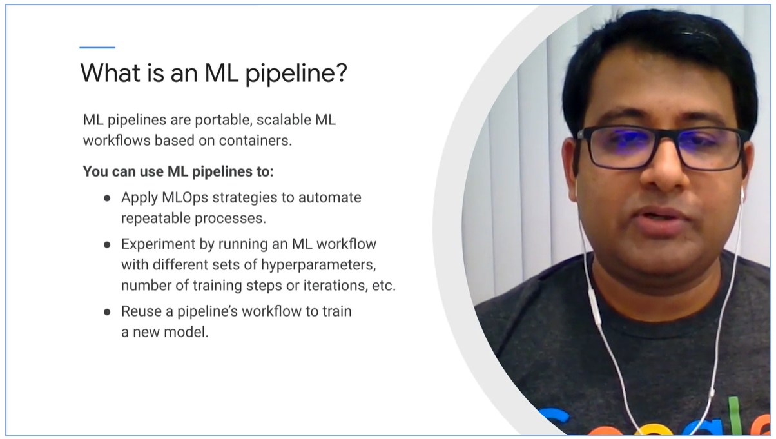

#### Pipeline components

* Self -contained set of code to perform various operations
* Set of input/output parameters and location of container image
* Container image: package that includes executables and definition of environment.

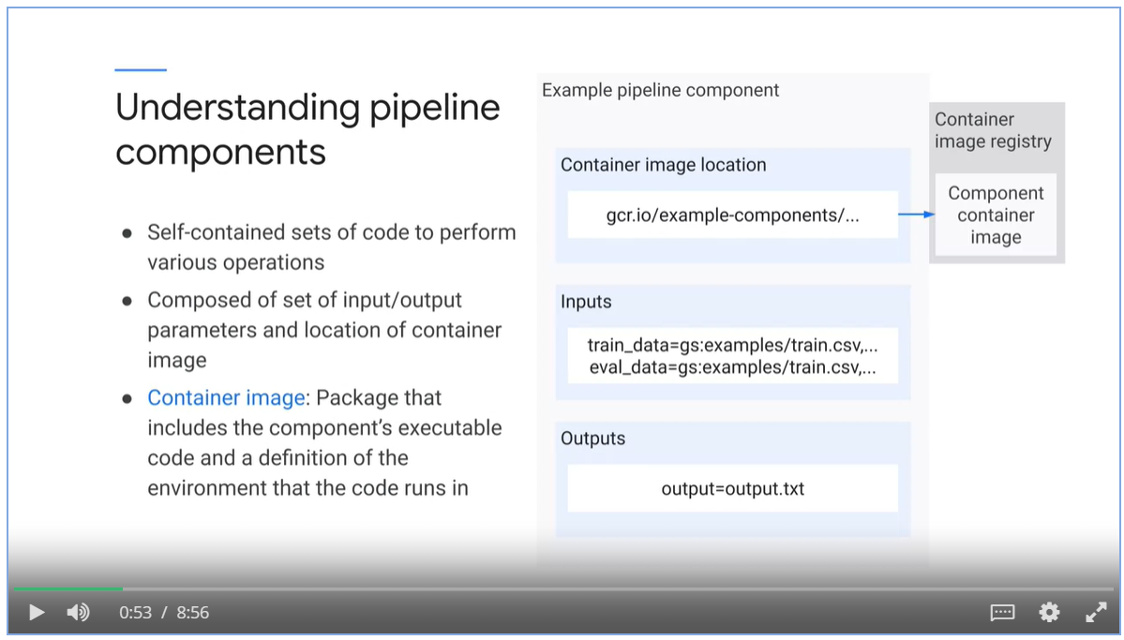

* Each task in a pipeline performs a step in the pipeline workflow. Task is an instance of pipeline component.
* Kubeflow pipelines / AI Platform pipelines uses dependencies to define the pipelines workflow as DAG.

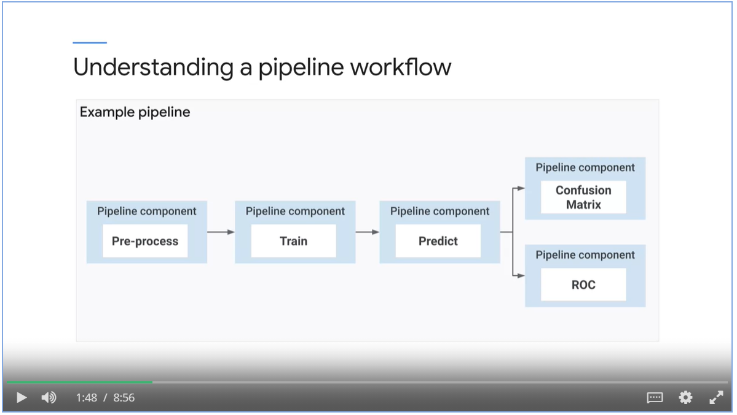

#### Process of Building an MLOps pipeline

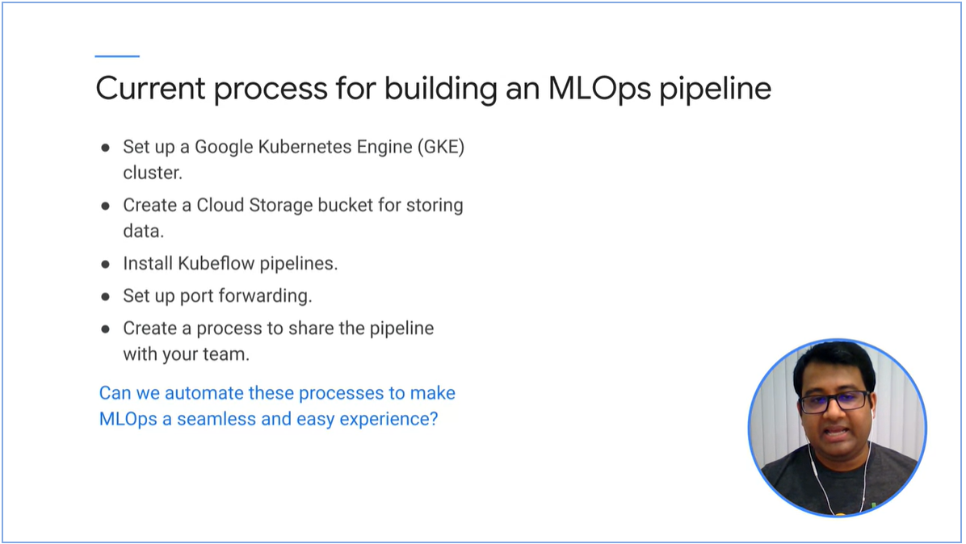

AI Platform Pipelines as an off the shelve product.

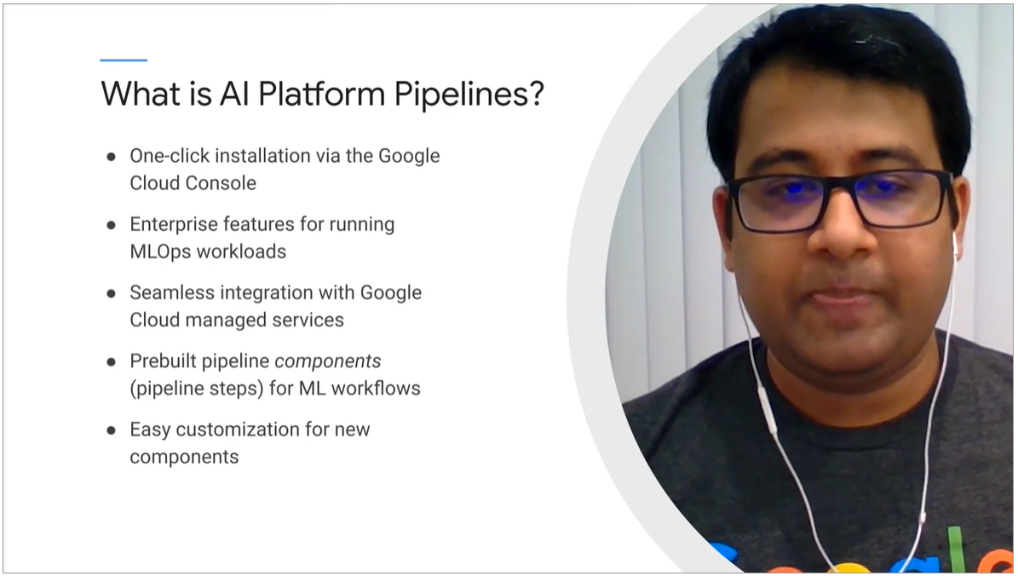

### AI Platform Pipelines

#### Concepts

* Create pipeline components using Kubeflow Pipeline SDK or TensorFlow Extended SDK.
* SDK codes are submitted to AI Pipeline Rest API server
* Argo Workflow Engine executes pipeline tasks.
* Pipeline components can leverage GCP services such as data-flow, AI platform training and prediction, BigQuery and so on.

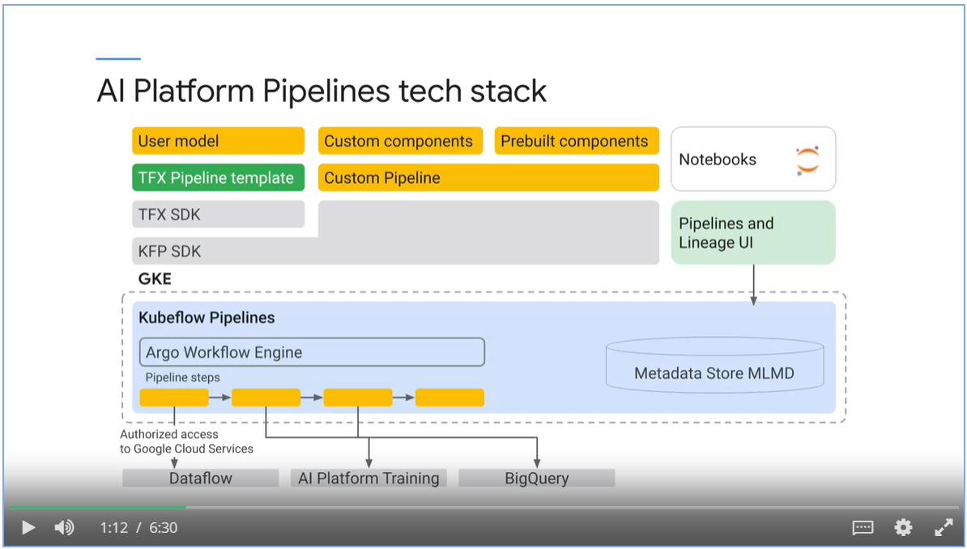

##### Kubeflow Pipelines vs TensorFlow Extended

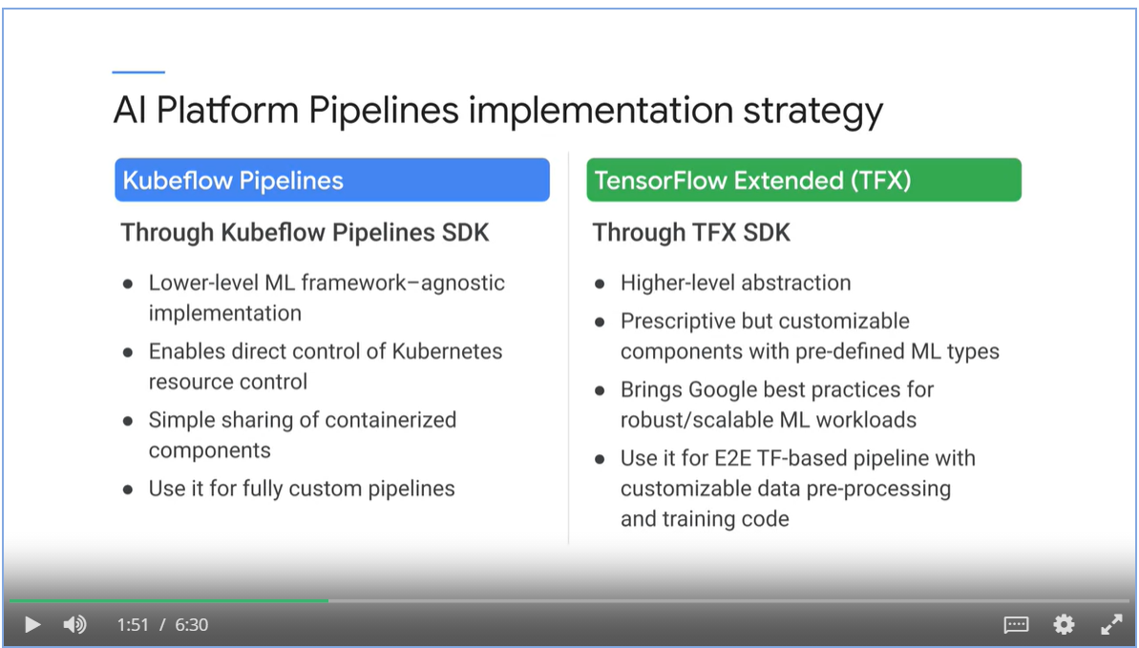

##### TFX templates scaffolds step-by-step guidance.

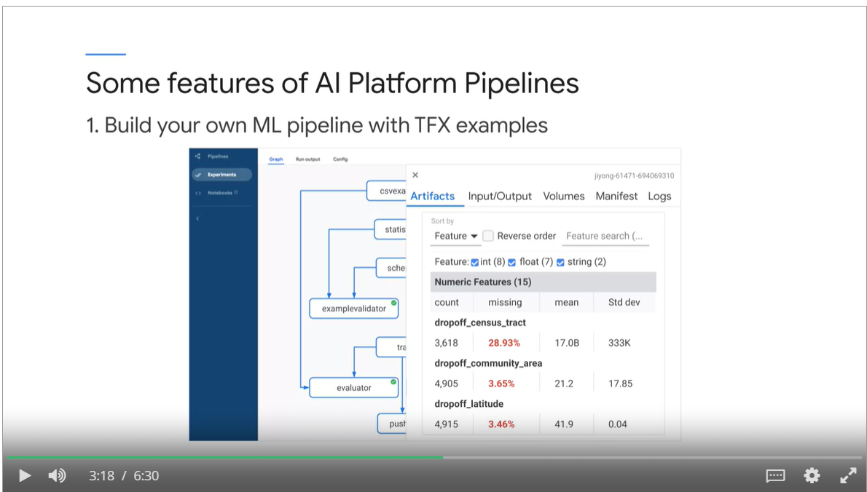

##### Versioning and grouping

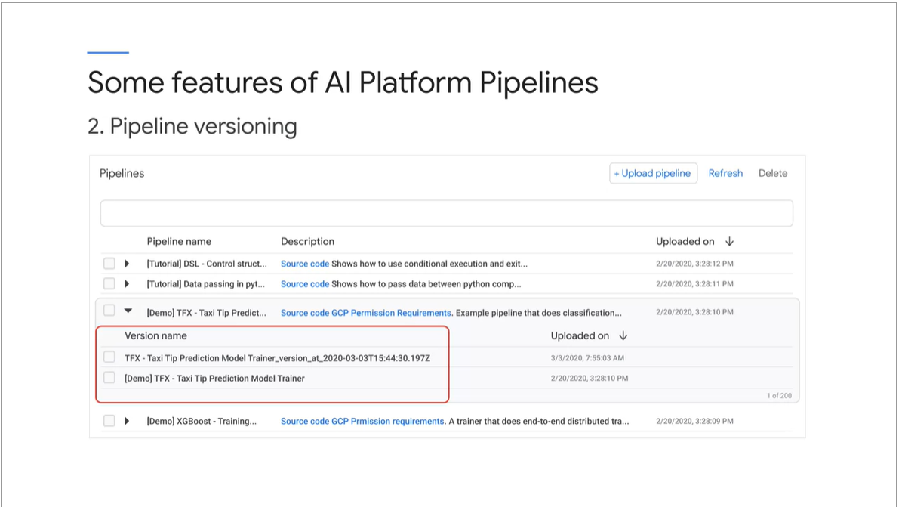

##### Artifacts tracking.

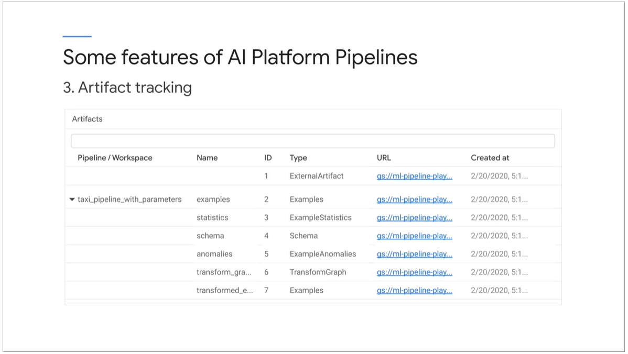

##### Lineage tracking

* Lineage tracking shows the history and versions of your model.

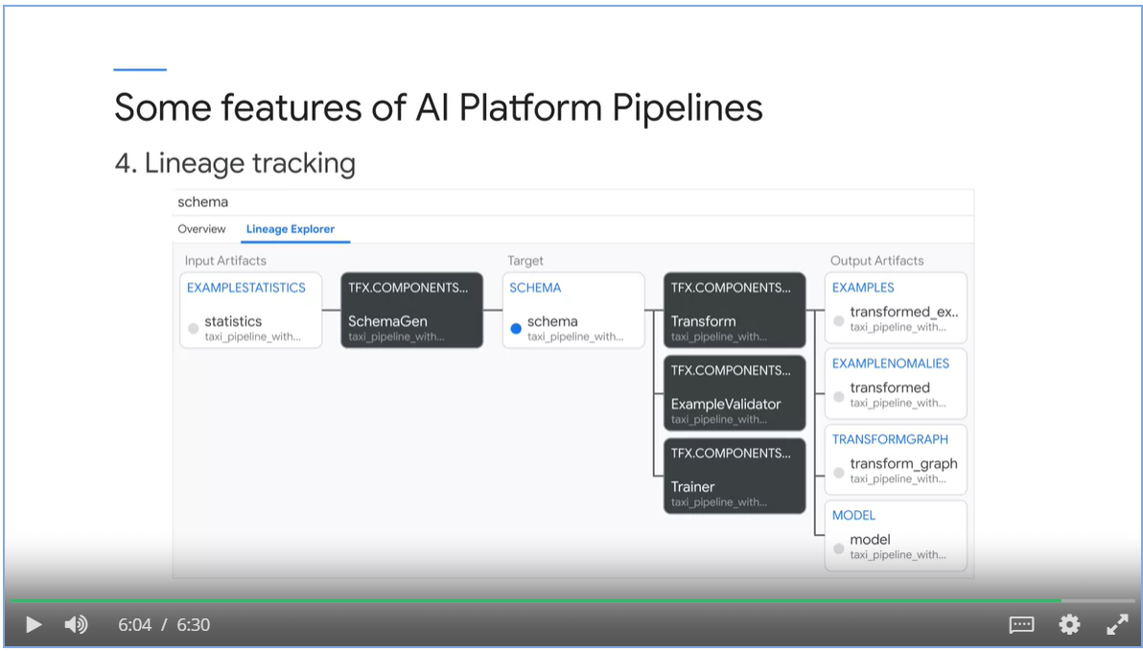

#### When to use

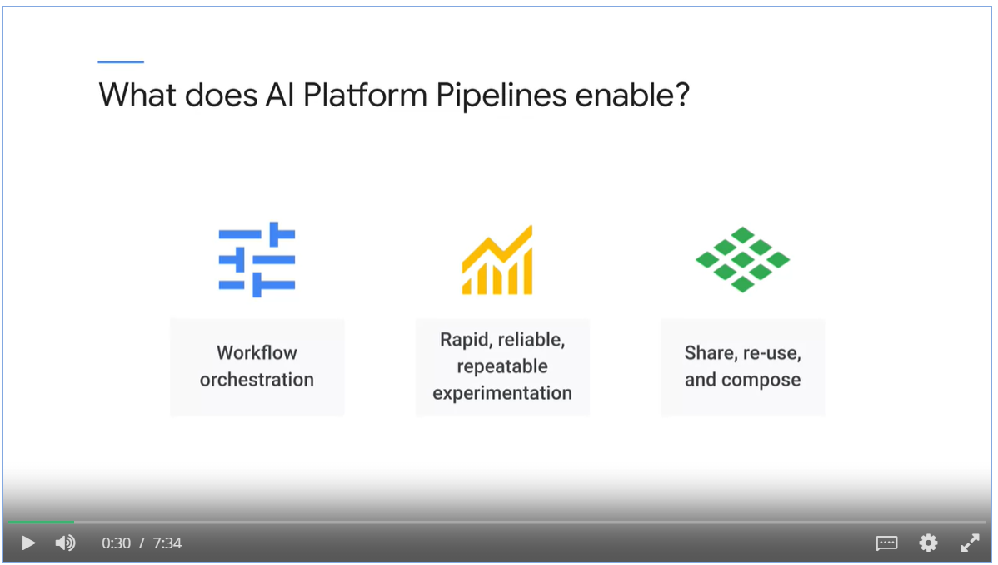

#### Ecosystem

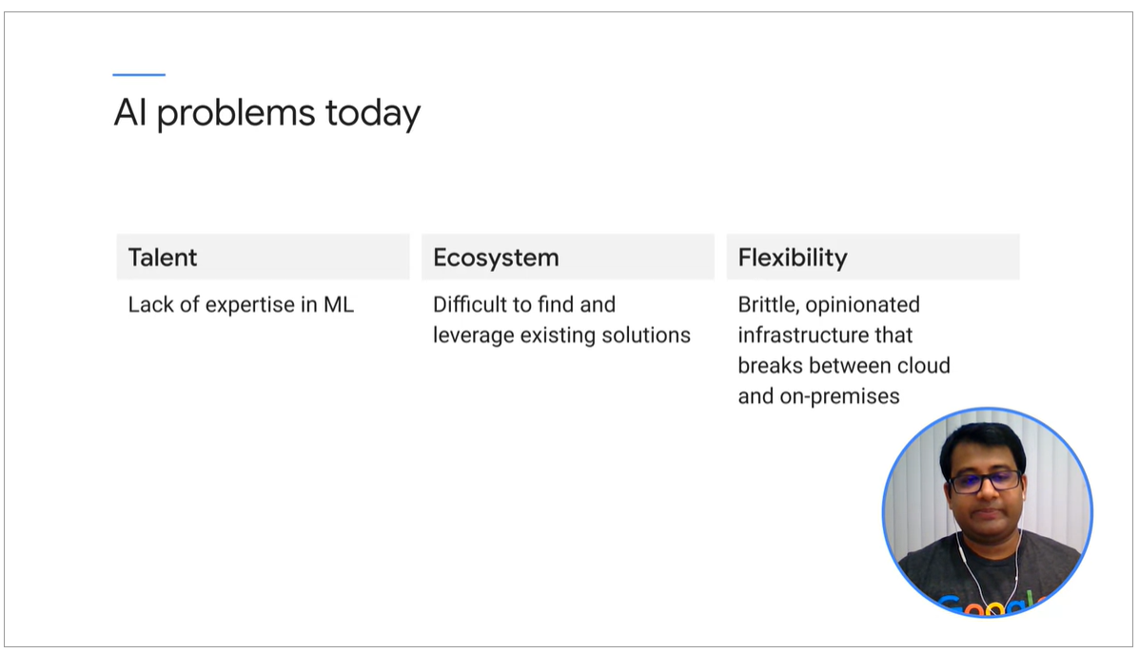

Reusable pipelines

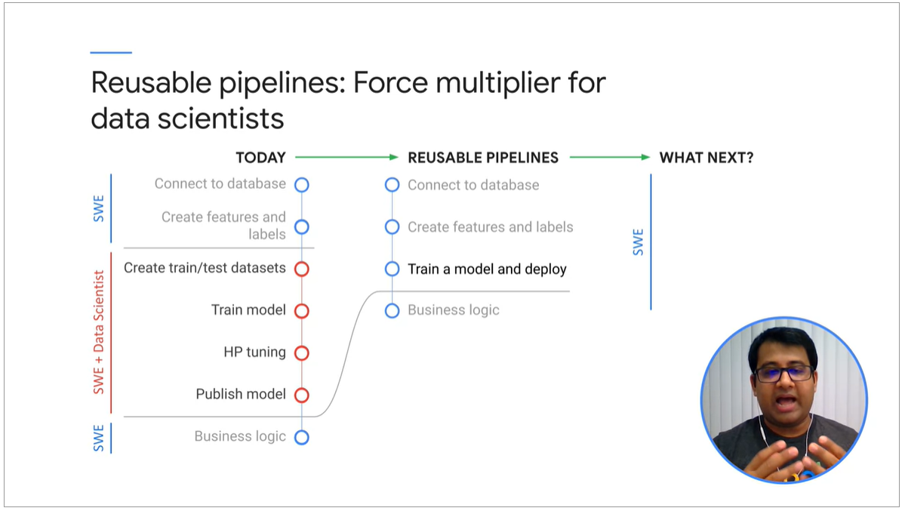

AI Hub

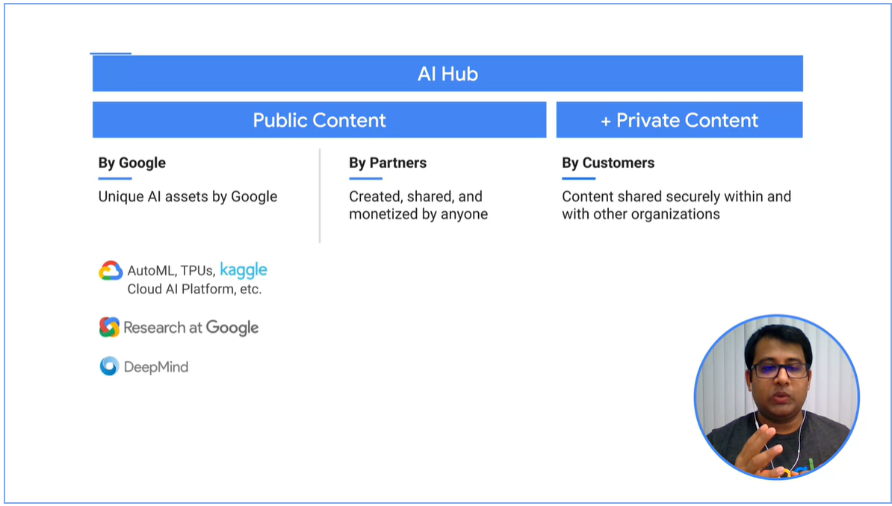

## Week 2 Training, Tuning and Serving on AI Platform

### Overview

To build and operationalize the model, there are 3 steps

* Implement the model in Jupyter Notebook.
* Package the model in docker file
* Configure and start an AI platform job with an YAML file.

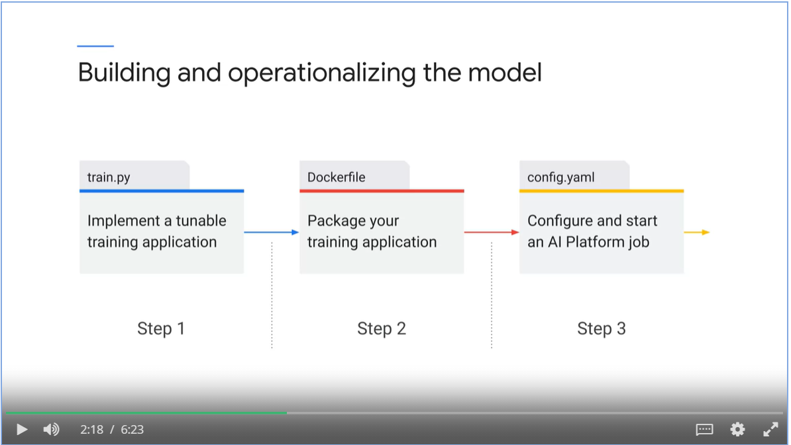

#### MLOps building blocks on GCP

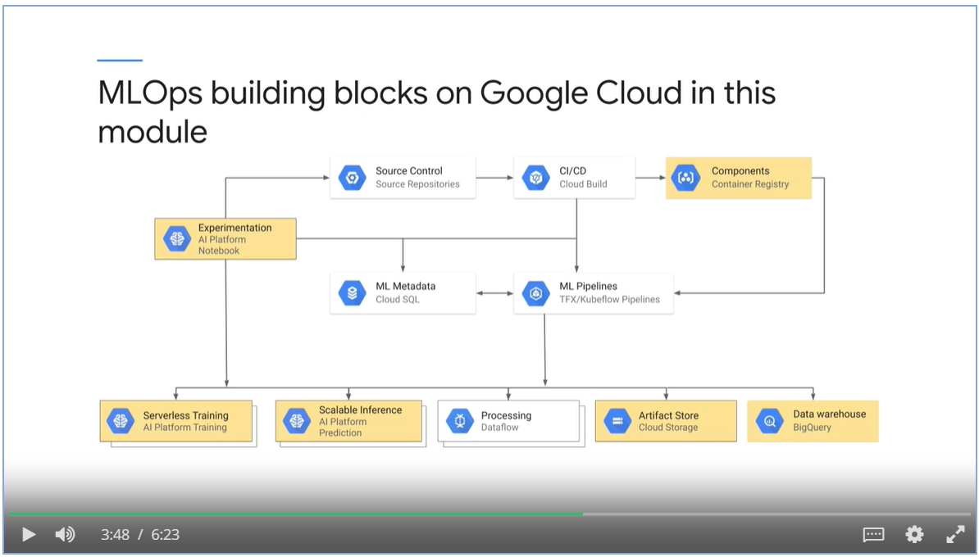

#### Activities in ML project

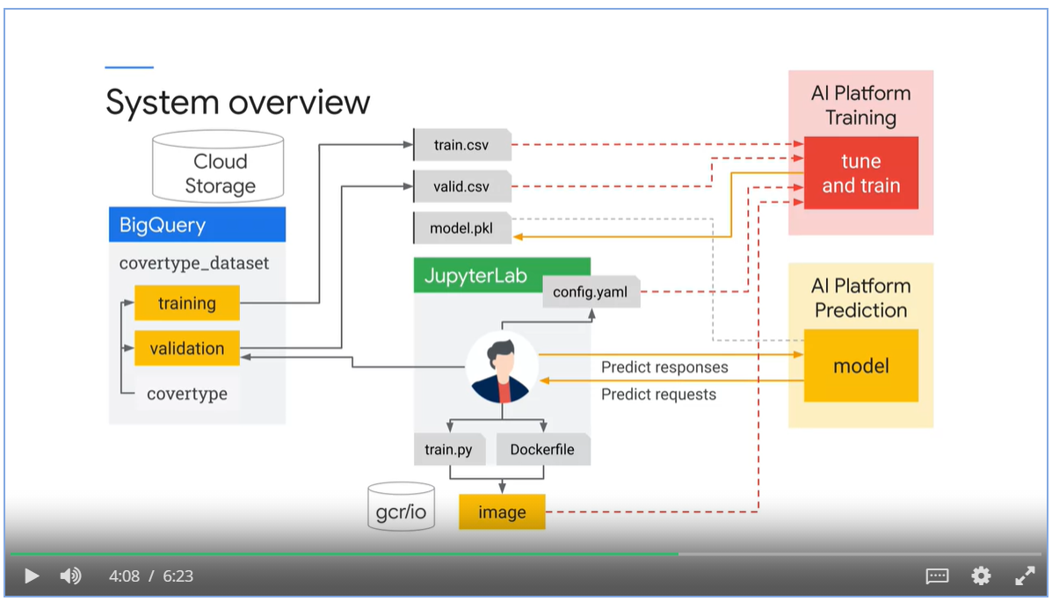

#### Automated ML pipelines

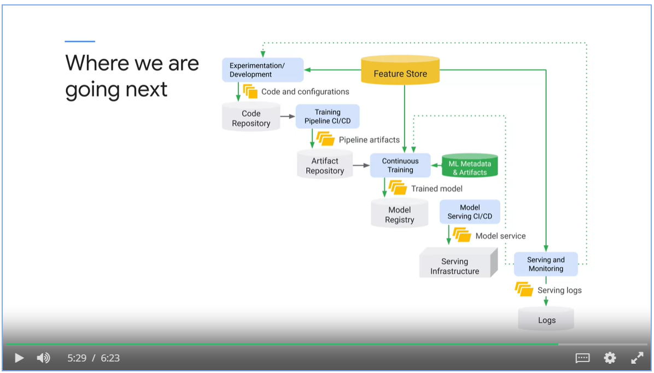

### Create a Reproducible Dataset

* Use the Covertype dataset.
* Predict forest cover type from features such as elevation, slope or soil type.

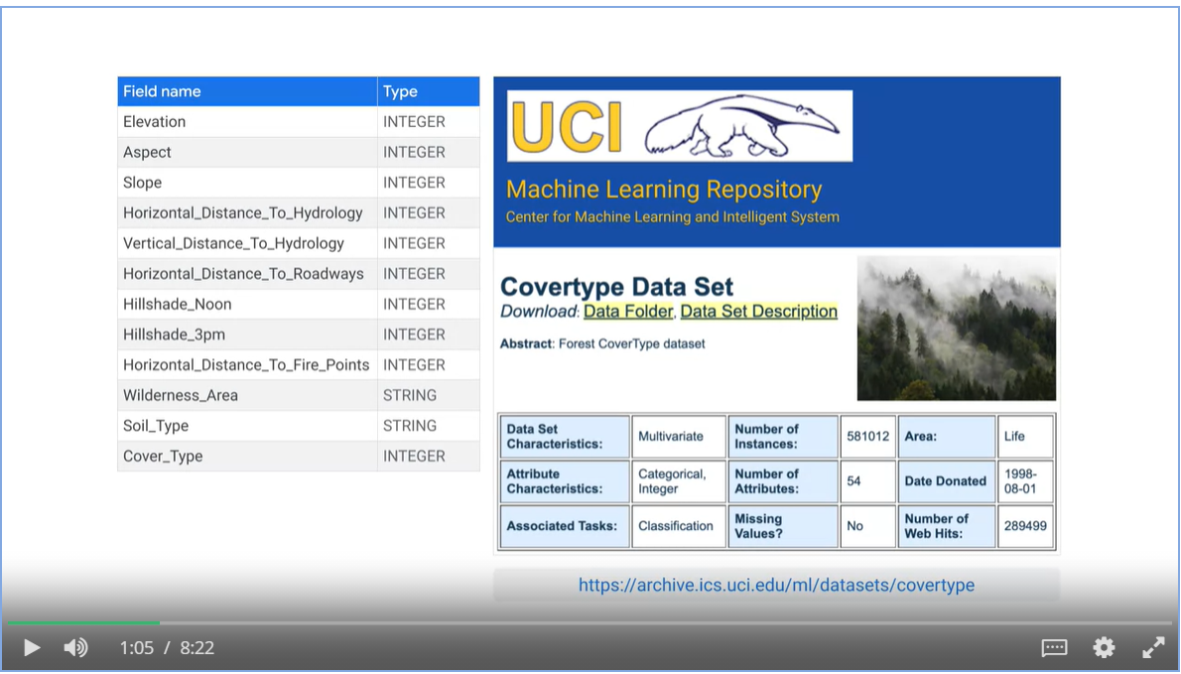

#### Train, validate and split

* A training set used by gradient descent to learn model parameters.
* A validation set used to choose best hyperparameter and best architecture of the model.
* A test set to report the performance metrics of the model with data the model has never seen before.

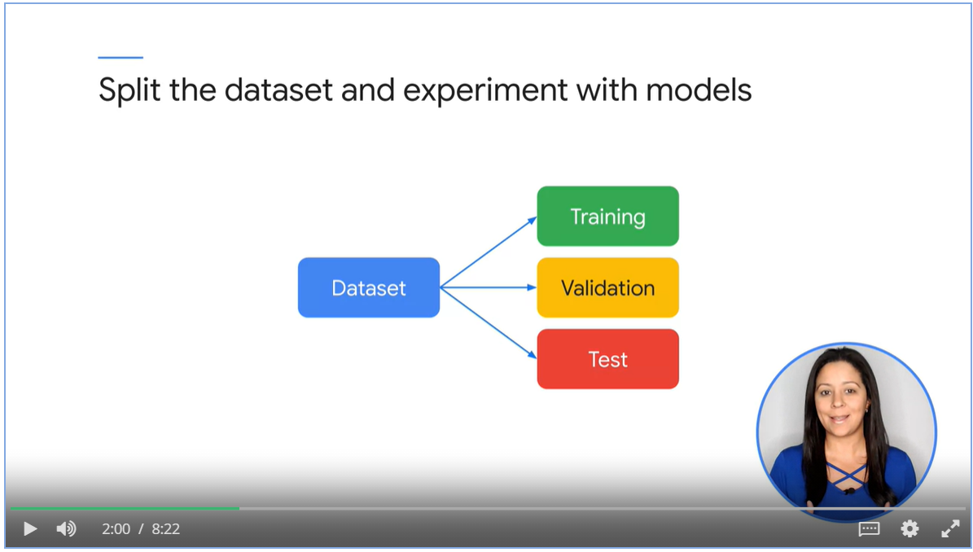

#### Use RAND() function to split the data

* By random, not reproducible
* Training data might not be a good representation of the population

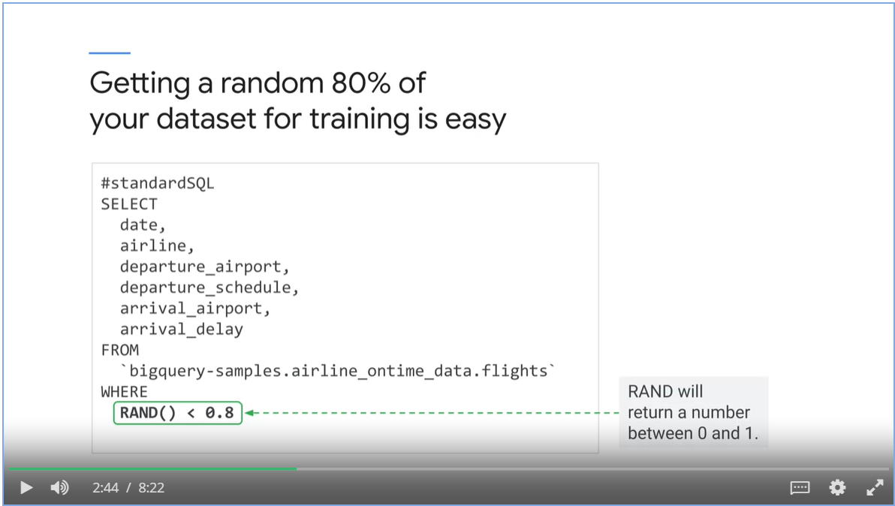

#### Hashing and Modulo Operator

* For training: MOD(ABS(FARM_FIGERPOINT(field_to_hash)), 10) < 8
* For validation: MOD(ABS(FARM_FIGERPOINT(field_to_hash)), 10) = 8
* For training: MOD(ABS(FARM_FIGERPOINT(field_to_hash)), 10) = 9

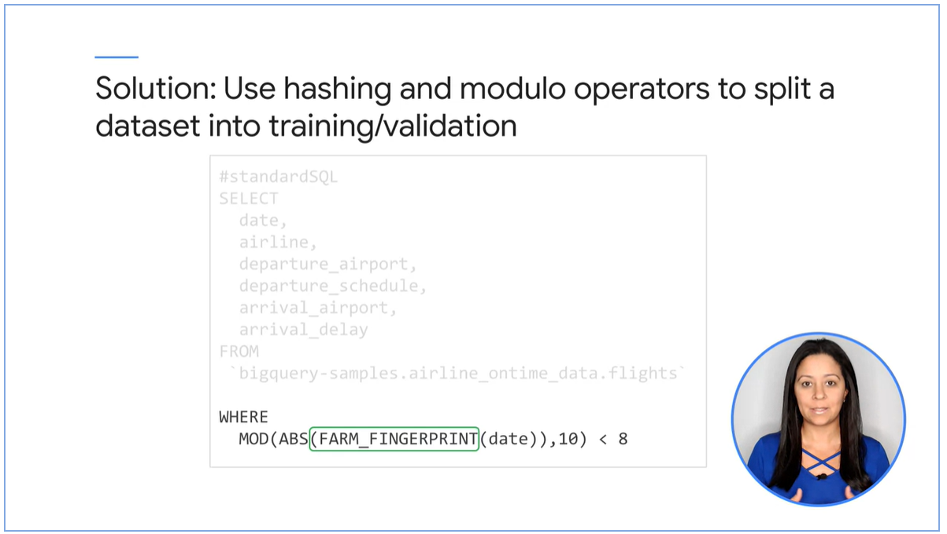

#### Which field to hash on?

* Choose a non-correlated label. We need to feed correlated features into the model for it to learn.
* Granular enough for your desired module split.

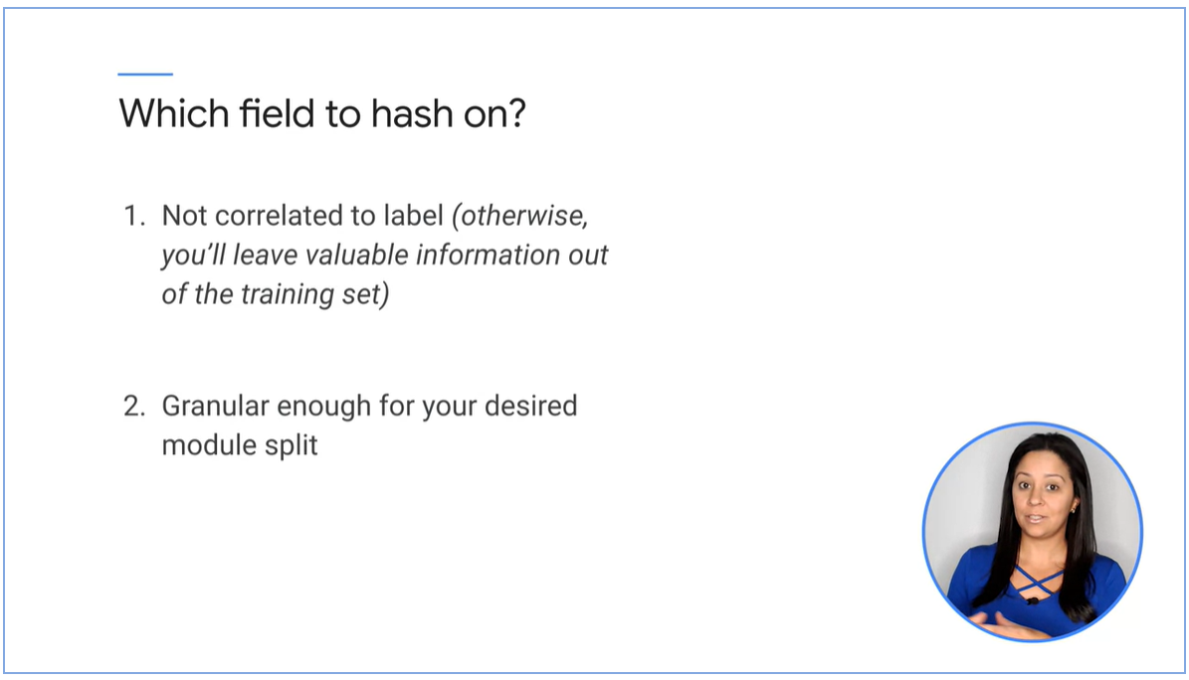

* Concatenate all the fields as JSON string and hash on that

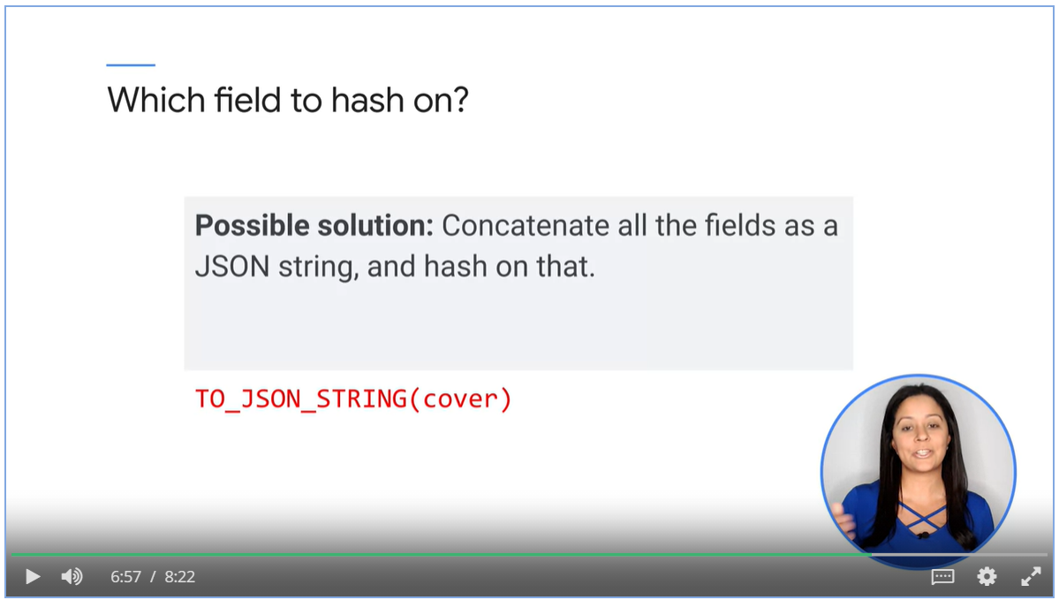

#### Use BigQuery

* To create training dataset
* To extract into csv files.

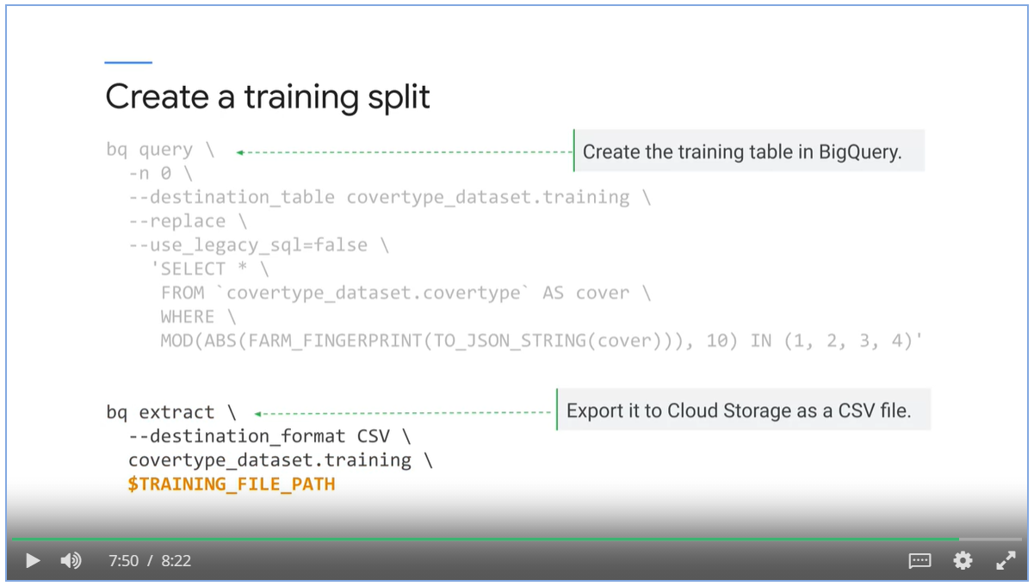

### Implement a Tunable Model

### Build and Push a Training Container

### Train and Tune and Model

### Server and Query the Model /*

# ML Pipelines on Google Cloud